- Create VPC with 2 private and 2 public subnets.
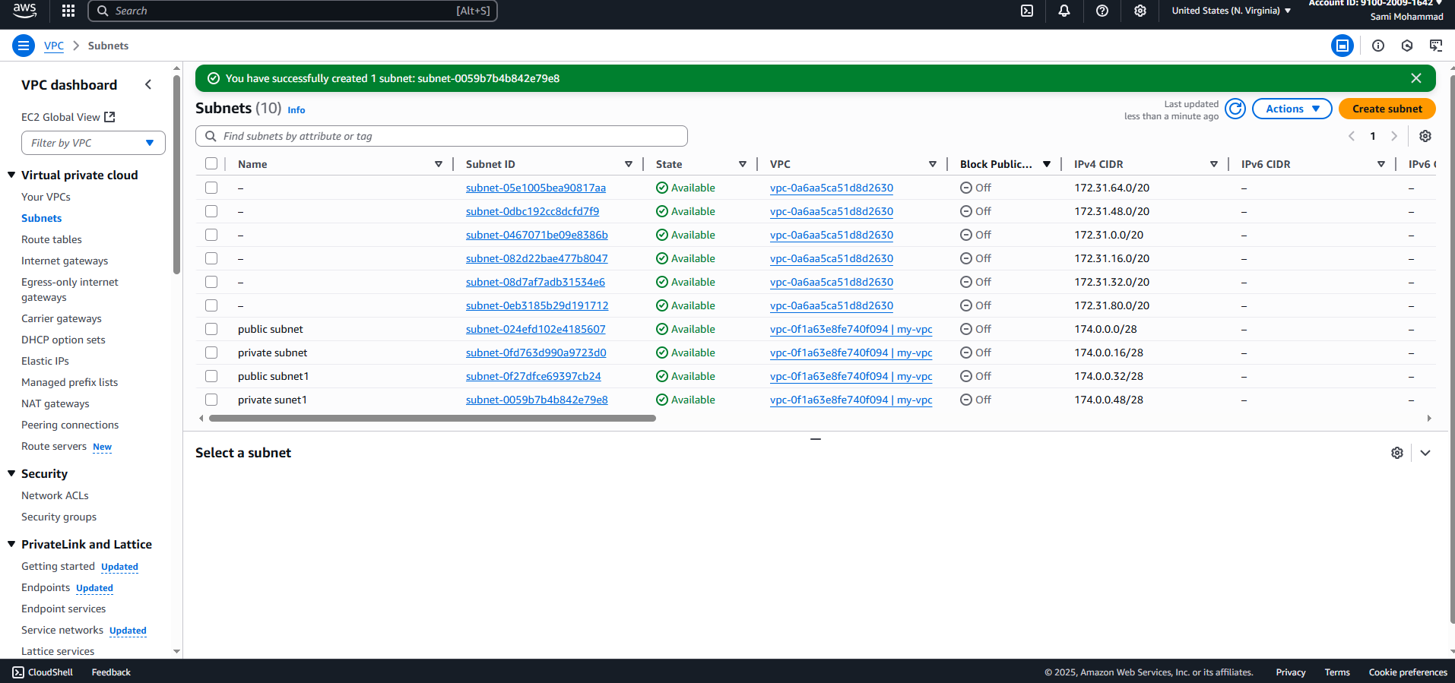
- Enable DNS Hostname in VPC
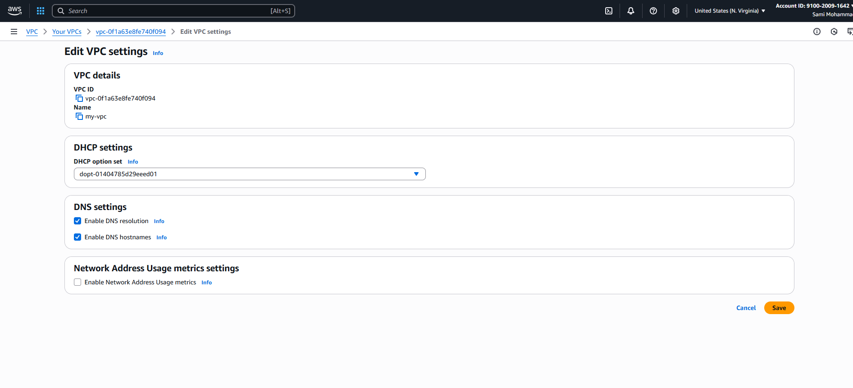

- Enable Auto Assign Public ip in 2 public subnets
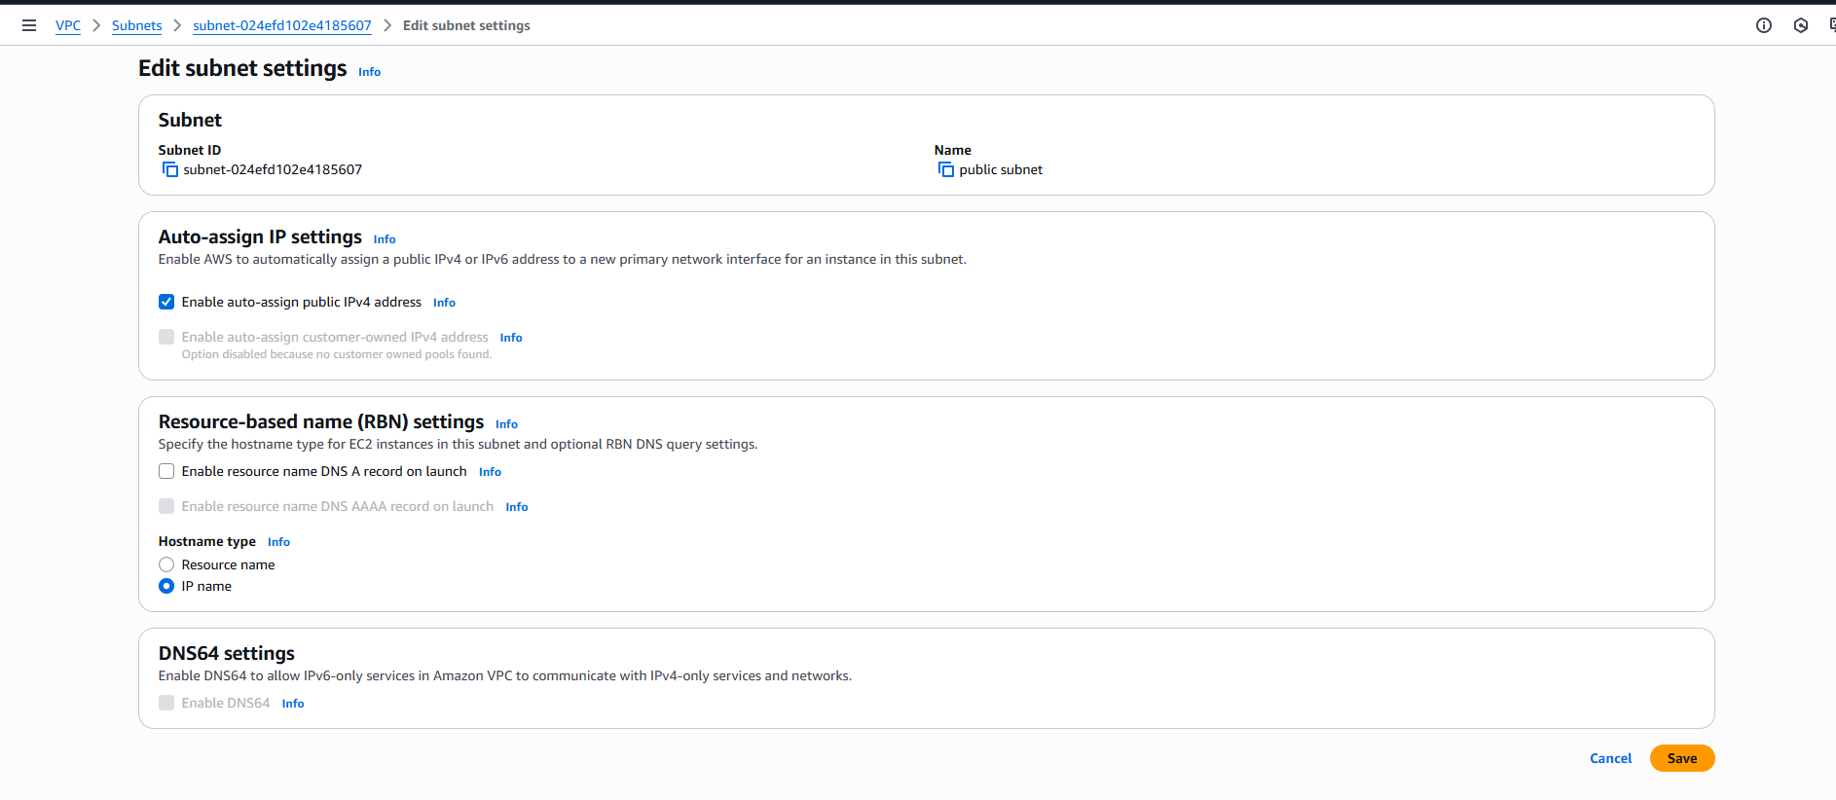
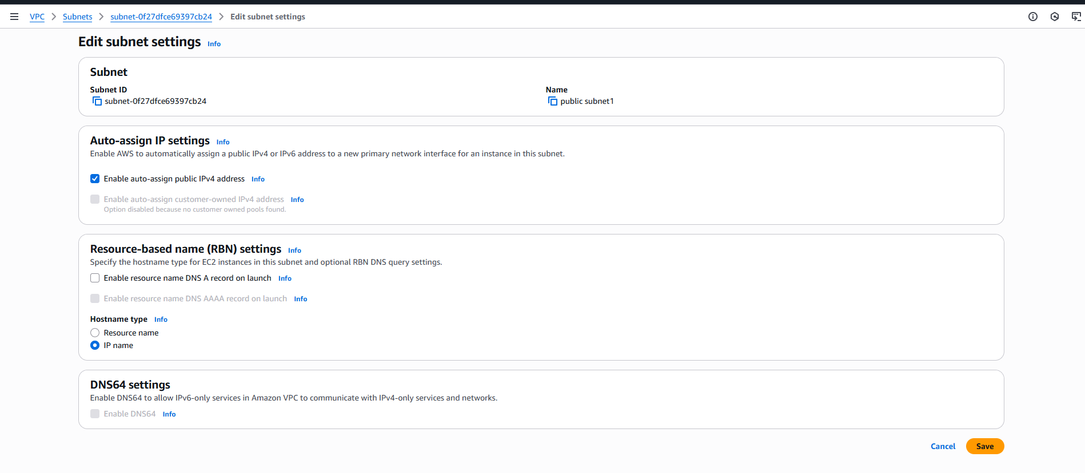

- Add 2 private subnets in private route table
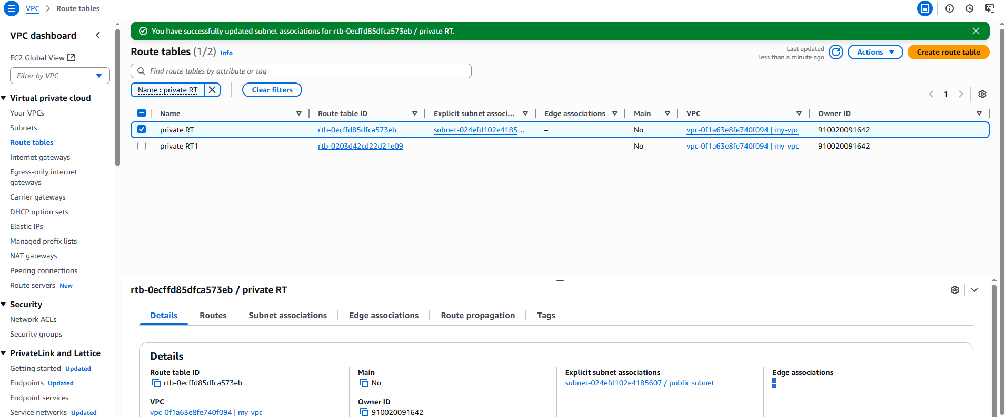
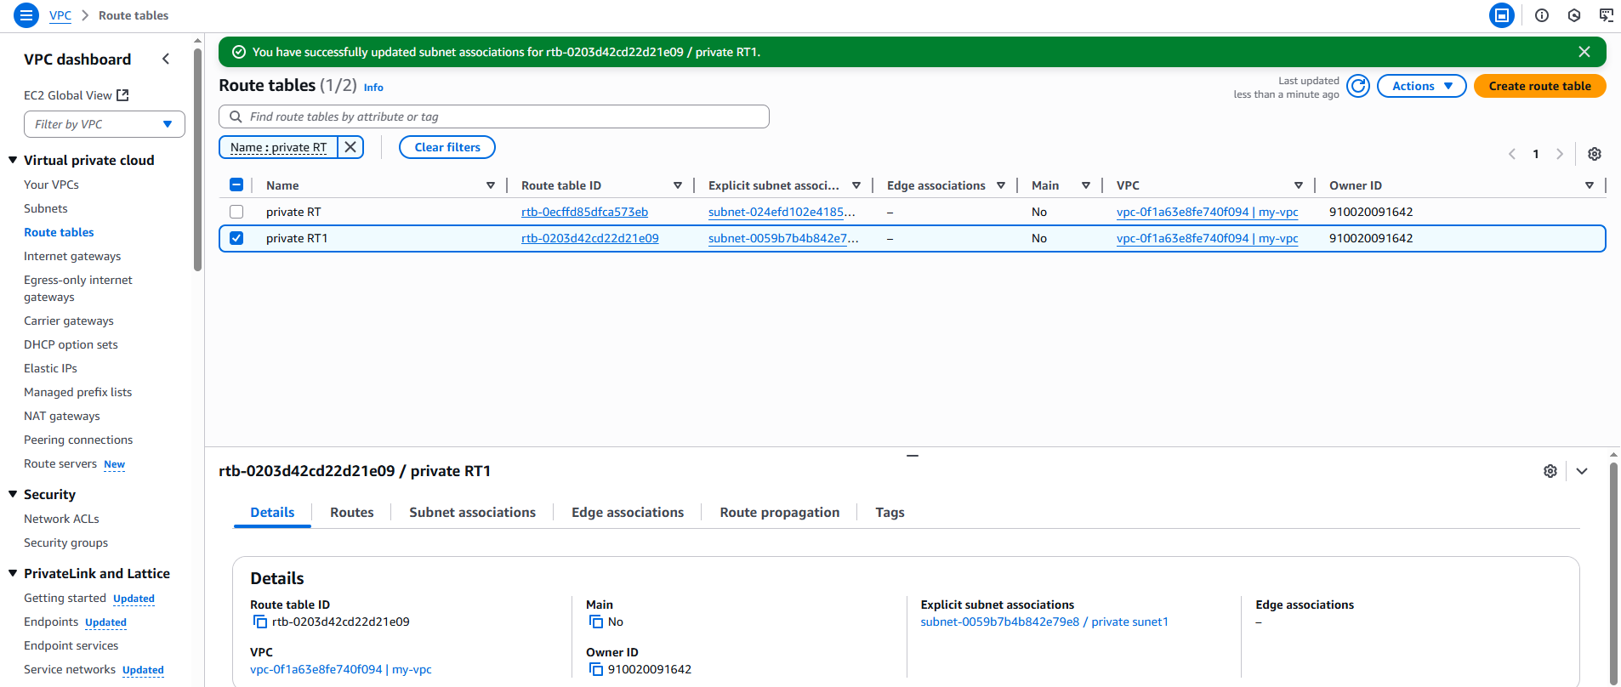
- Add 2 public subnets in public route table
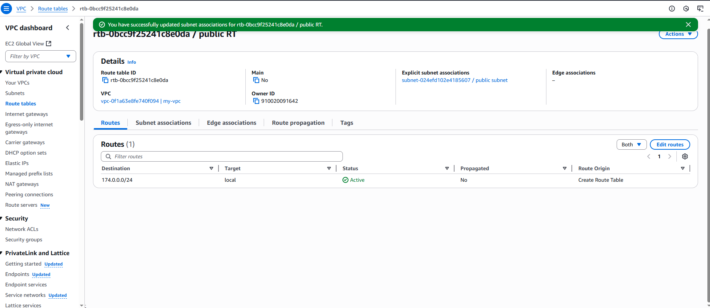
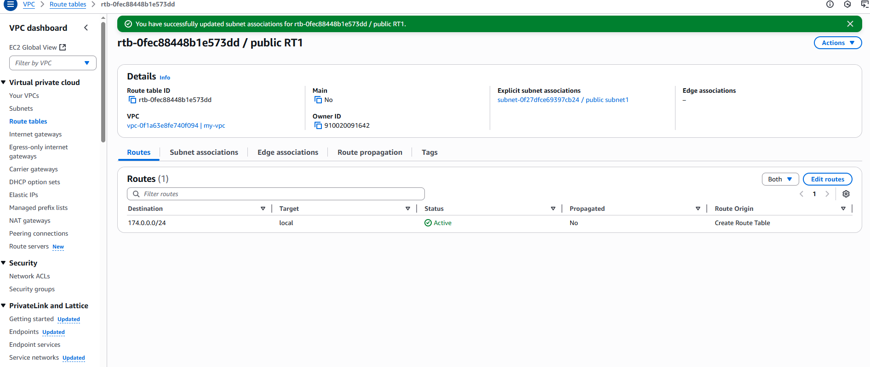
- Public route table will have the routes to internet and local
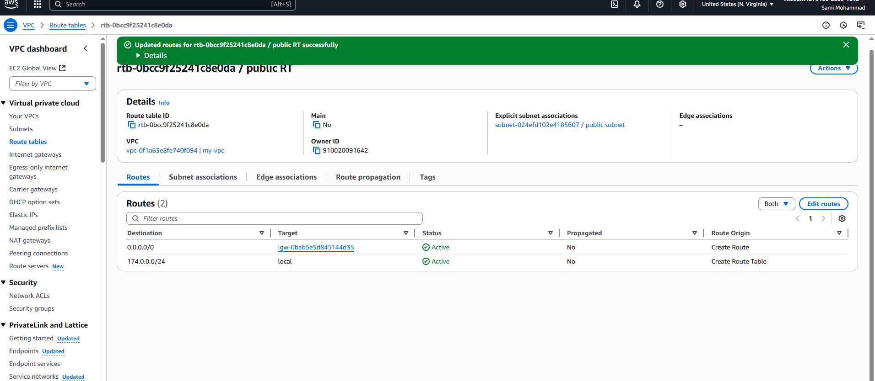
- Create Ec2 in public subnet with t2micro and install php
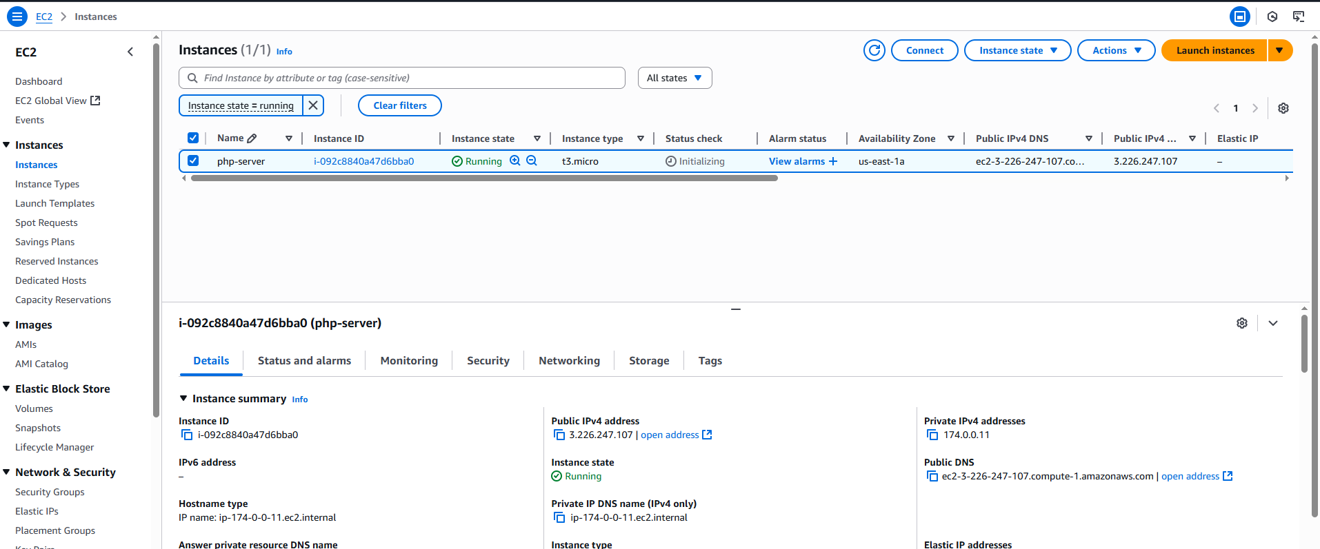
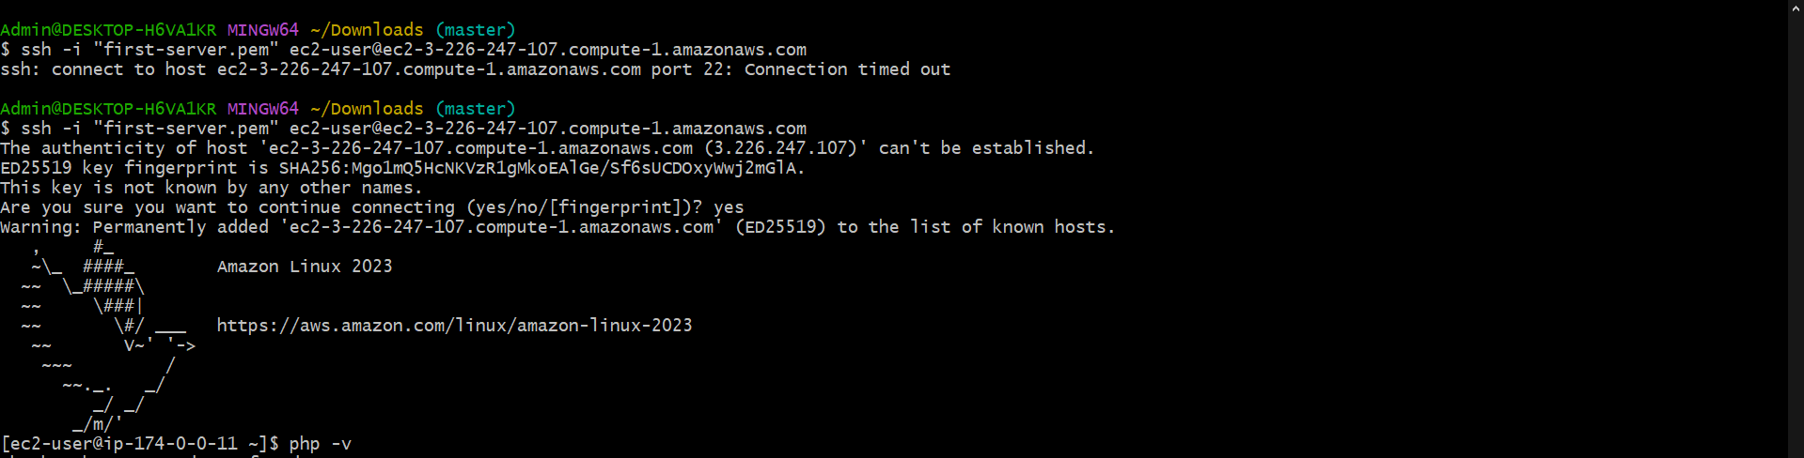
- Configure Nat gateway in public subnet and connect to private Instance
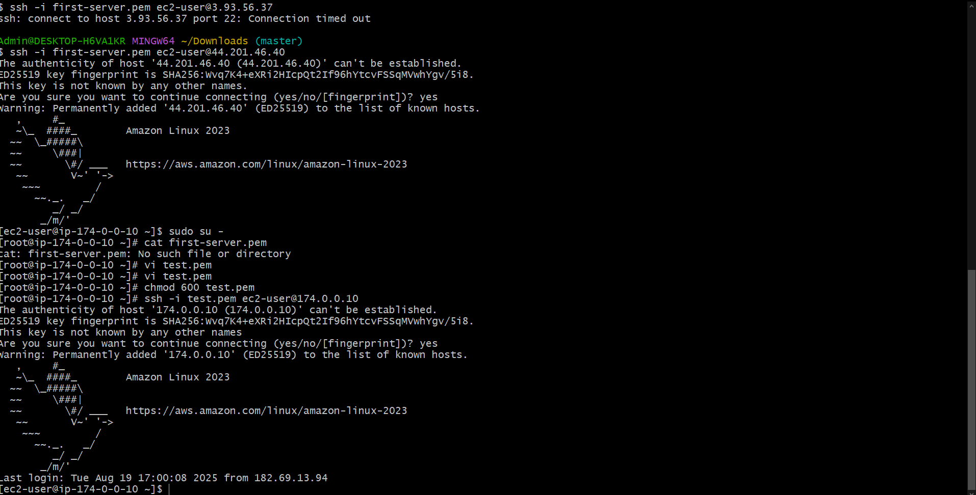
- Install Apache Tomcat in private ec2 and deploy a sample app.
After above setup i created 1 public instance with public subnet (enable public ip) and created 1 private instance with private subnet (disable public ip)with same VPC to both instance.
I copied the (cat first_server1.pem from my local machine)
I created pub instance as jump or bastion server, i ssh to my public ec2 and came to root and create test.pem and paste the pem key.
Give permission chmod 600 test.pem
Now ssh -i test.pem ec2-user@(private ip of private ec2)and go to root.
Check internet access ping google.com
Cd /opt
Sudo wget https://dlcdn.apache.org/tomcat/tomcat-9/v9.0.107/bin/apache-tomcat-9.0.107.tar.gz

sudo tar -xzf apache-tomcat-9.0.107.tar.gz
sudo mv apache-tomcat-9.0.107 /opt/tomcat9
cd /opt/tomcat9/bin
sudo chmod +x *.sh
./startup.sh -> can see output tomcat started
sudo netstat -tuln | grep 8080

- Configure VPC flow logs and store the logs in s3 and CloudWatch.
