JENKINS TASK -03
- Create one jenkins job using the below code and create three stages.
- stage1: Git clone to download the source code.
- stage2: Sonarqube Integration to check the quality of code
- stage3: Slack Integration to send the alerts to slack.
- URL: https://github.com/betawins/VProfile-1.git
stage1: Git clone to download the source code.

Go to Jenkins GUI Create job name it as
In New item name it V-profile
Choose Freestyle
In source code management option git paste this URL: https://github.com/betawins/VProfile-1.git
Select Master or Main
Save it

Build Now
Now check console output
V-profile job is successfully done
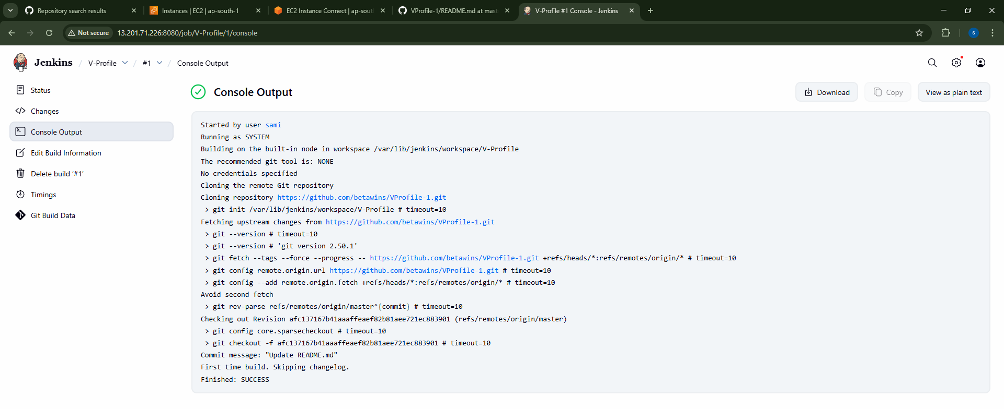

Now we can check in Jenkins master EC2

Cd /var/lib/Jenkins/workspace
There we can see our created V-profile
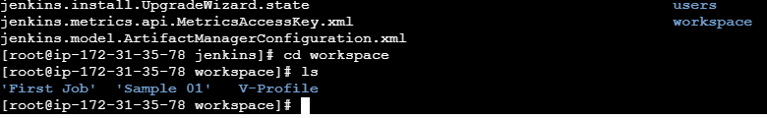

stage2: Sonarqube Integration to check the quality of code
1-Ec2 installation with java
2-Use T2large with atleast 20 gb memeory to run sonarqube
3-MYSQL Database 0r MYSQL RDS
Step -1
We have create Sonarqube instance with specification of t2large with 20 gb of volume
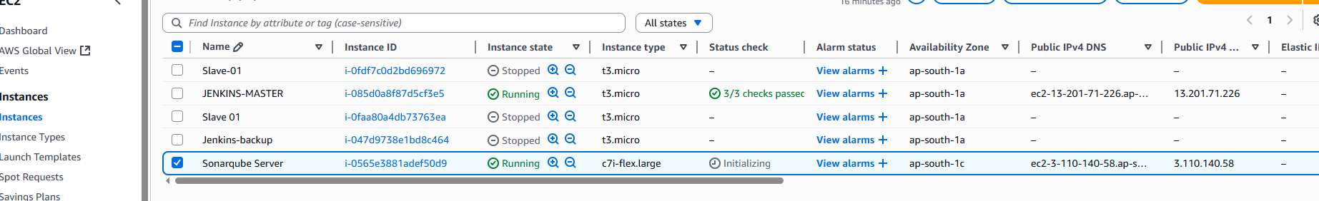
Step 2
It is java Prerequisite
Yum install java-1.8*
To check java –version
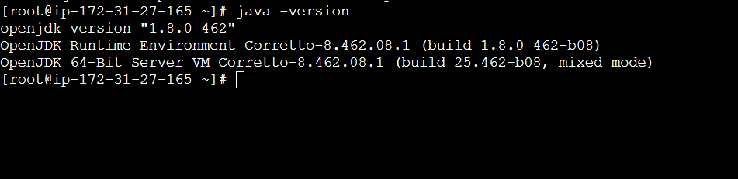
Step -3

Install Mysql
sudo wget https://dev.mysql.com/get/mysql57-community-release-el7-11.noarch.rpm
sudo yum localinstall -y mysql57-community-release-el7-11.noarch.rpm
sudo rpm --import https://repo.mysql.com/RPM-GPG-KEY-mysql-2022
sudo yum install -y mysql-community-server
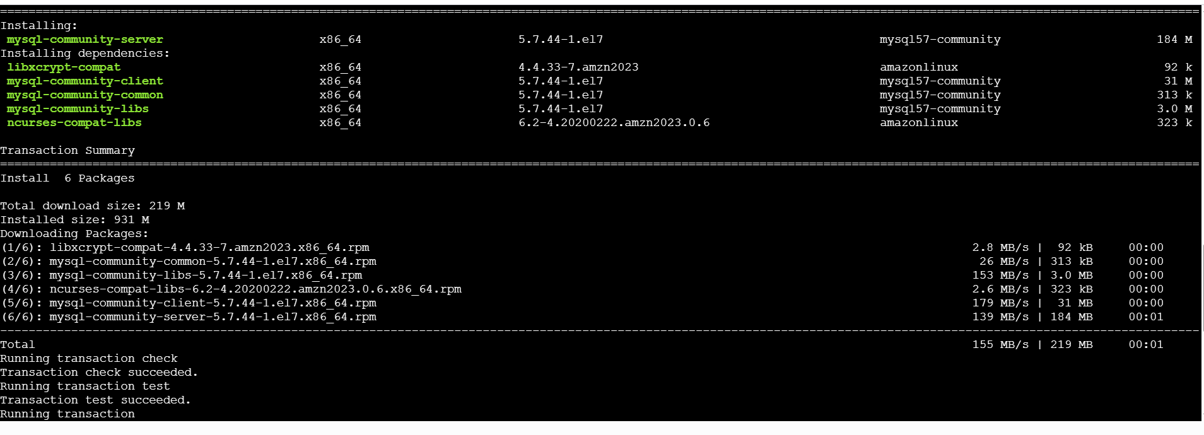

Start MYSQL
systemctl start mysqld
systemctl enable mysqld
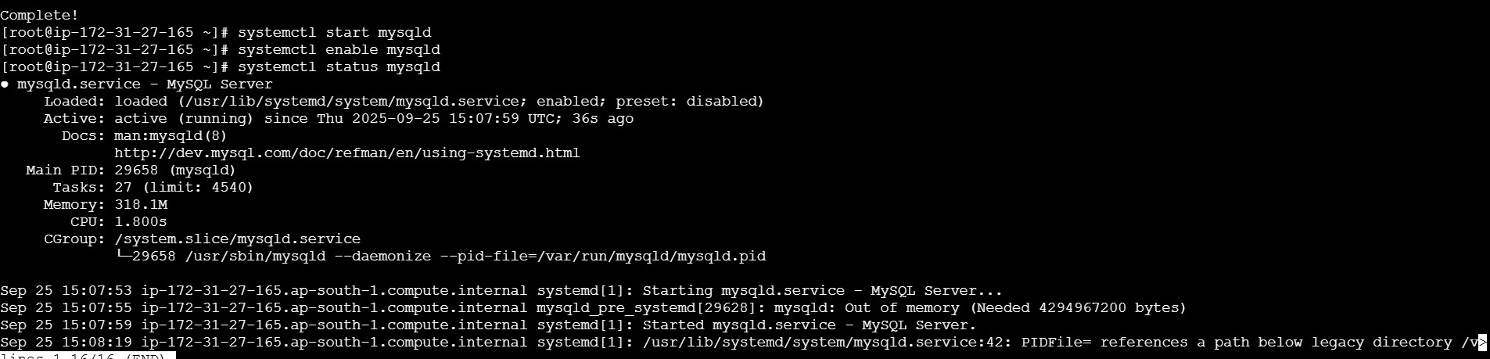
Check if mysql is running or not
netstat -na | grep 3306

By Default it create a password now create new password
Grep ‘temporary’ /var/log/mysqld.log
Login into mysql server

Mysql –u root –p
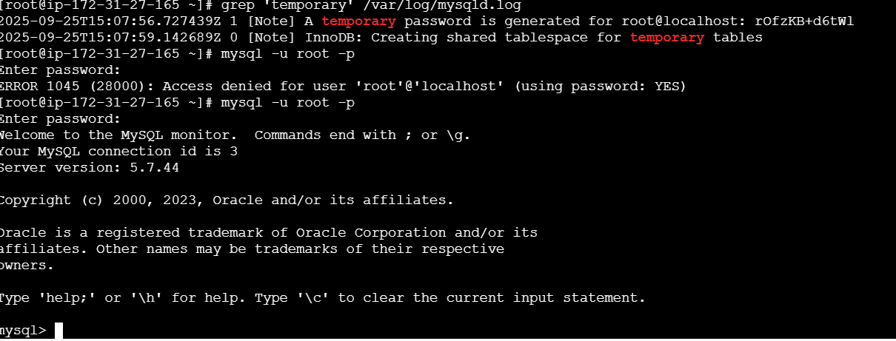
Sucessfully login to MYSQL

Now change password
ALTER USER 'root'@'localhost' IDENTIFIED BY 'Admin@123'
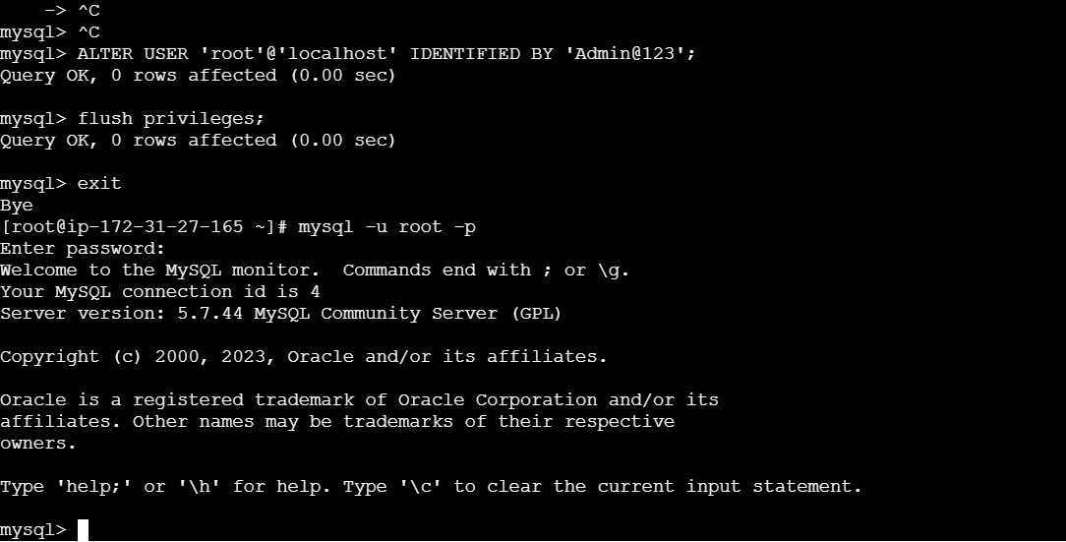

Exit from mysql

Install Sonarqube
Download in /opt/
wget https://binaries.sonarsource.com/Distribution/sonarqube/sonarqube-6.6.zip
unzip sonarube-6.6
Rename mv /opt/sonarqube-6.6/opt/sonar
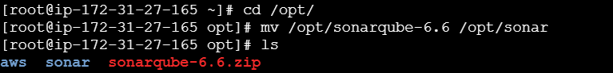

Login to MYSQL

CREATE DATABASE sonar CHARACTER SET utf8 COLLATE utf8_general_ci;

To check database whether sonar created

Show databases;
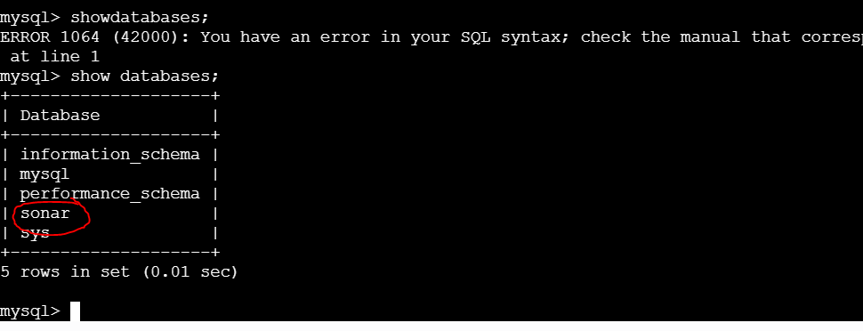

Create one local user
CREATE USER sonar@localhost IDENTIFIED BY 'Sonar@123';
Create one remote user
CREATE USER sonar@% IDENTIFIED BY sonar@123;
CREATE USER sonar@'%' IDENTIFIED BY 'Sonar@123';

Provide Full Permission
GRANT ALL ON sonar.* TO sonar@localhost;
GRANT ALL ON sonar.* TO sonar@'%';
check users and databases
SELECT user from mysql.user;
FLUSH PRIVILEGES;
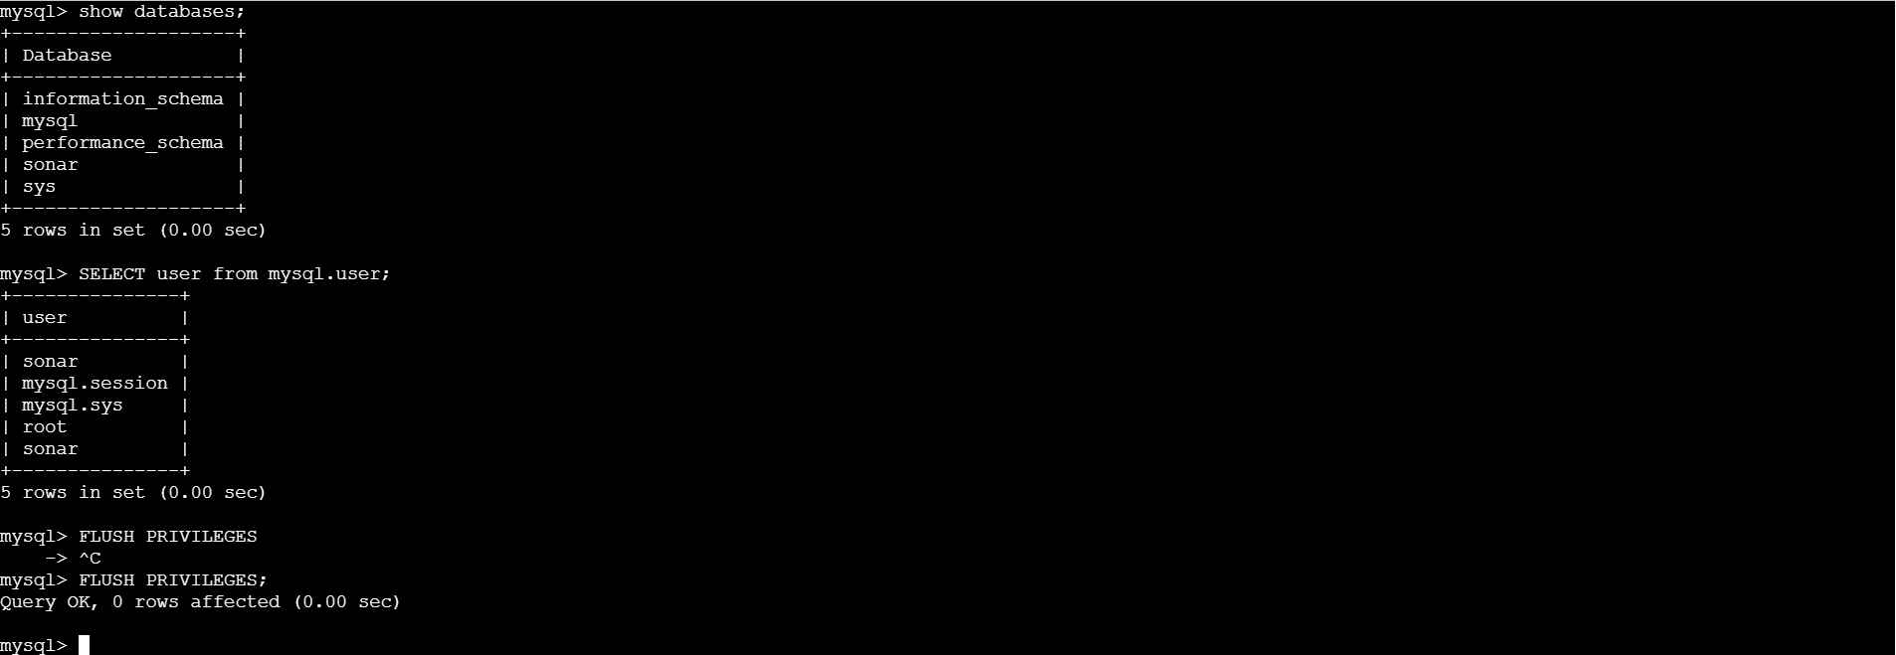

Exit from database
Now lets configure sonarqube with mysql
File Name Sonar Properties we have to edit inside database
File Name: /opt/sonar/conf/sonar.properties
Edit properties file:
Vi sonar .properties
Uncomment and update:
- sonar.jdbc.username=`sonar`
- sonar.jdbc.password=`Sonar@123`
- sonar.jdbc.url=jdbc:mysql://`localhost:3306`/sonar?
useUnicode=true&characterEncoding=utf8&rewriteBatchedStatements
=true&useConfigs=maxPerformance&useSSL=false
- sonar.web.host=`0.0.0.0`
- sonar.web.context=`/sonar`
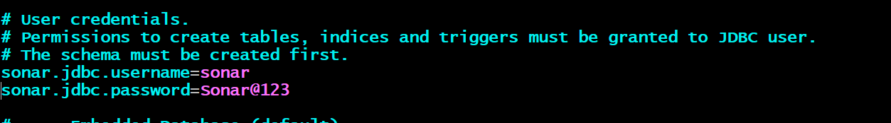

8. Start SonarQube
Sonarqube will execute with root user
Start SonarQube service
# cd /opt/sonar/bin/linux-x86-64/
It will fail
Then change chown chown –R ec2-user:ec2-user sonar
Cd /opt/sonar/bin/linux-x64
./sonar.sh start

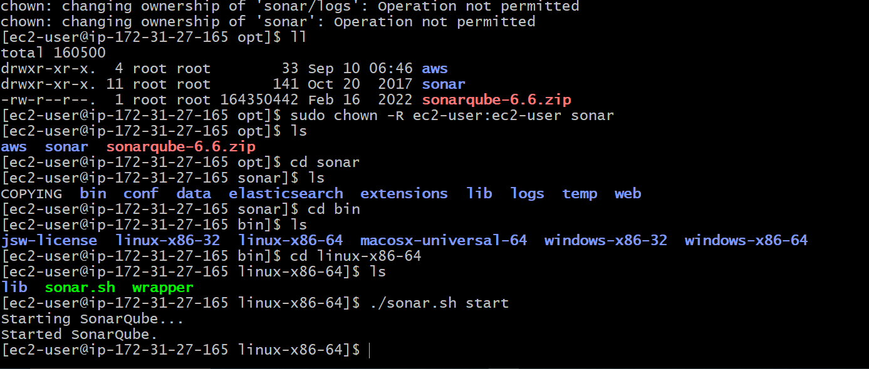

Sonarqube<Public id>:9000/sonar
Successfully done
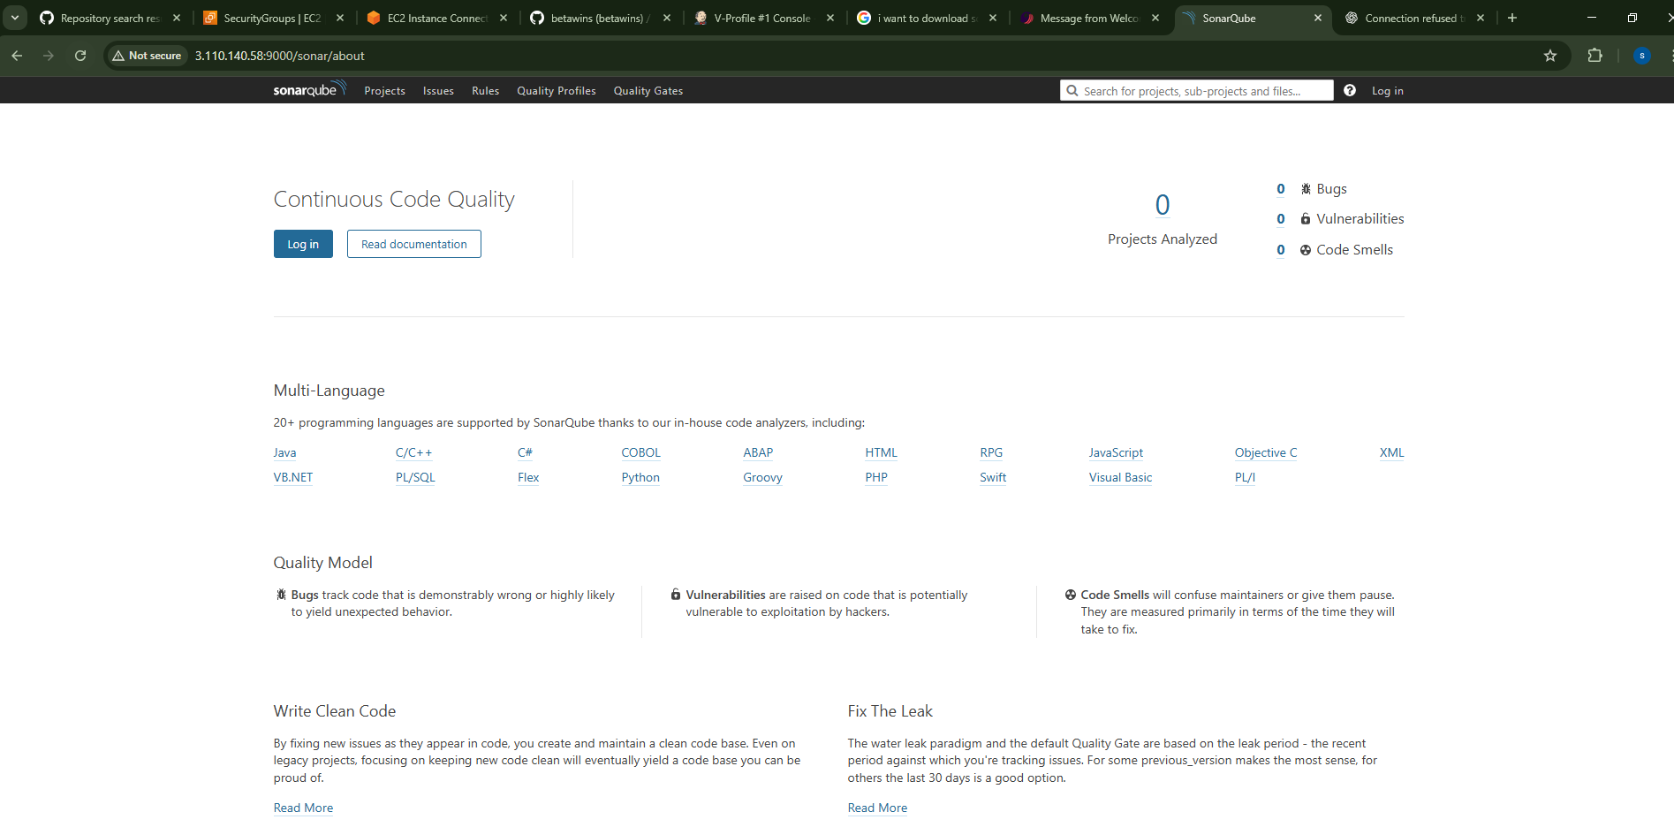

Integrate Sonarqube with Jenkins
Install sonarqube scanner
Goto Manage Jenkins PluginsInstall Sonarqube Scanner
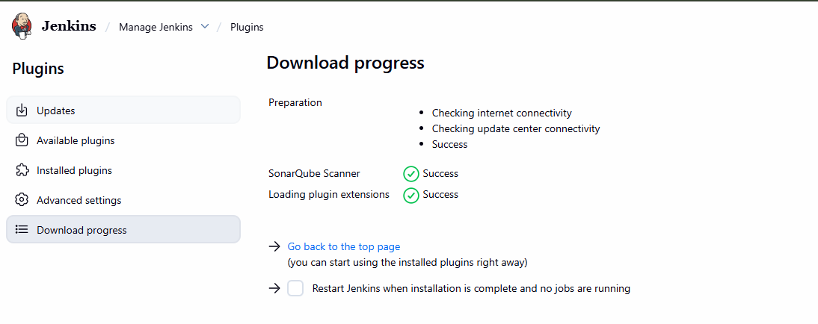
Now configure with sonarqube server
Go to Manage Jenkins System Sonar Installation
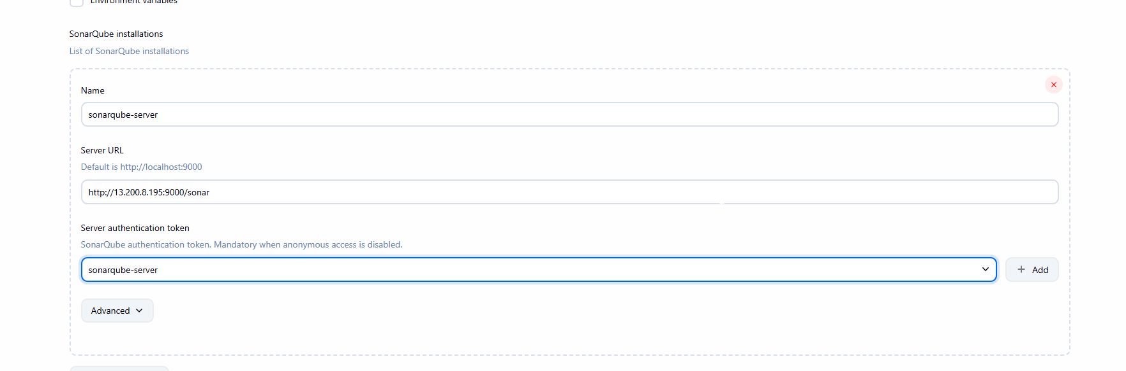
Login to Jenkins server and install sonar-scanner
wget https://binaries.sonarsource.com/Distribution/sonar-scanner-cli/sonar-scanner-
cli-4.6.2.2472-linux.zip
unzip sonar-scanner-cli-4.6.2.2472-linux.zip

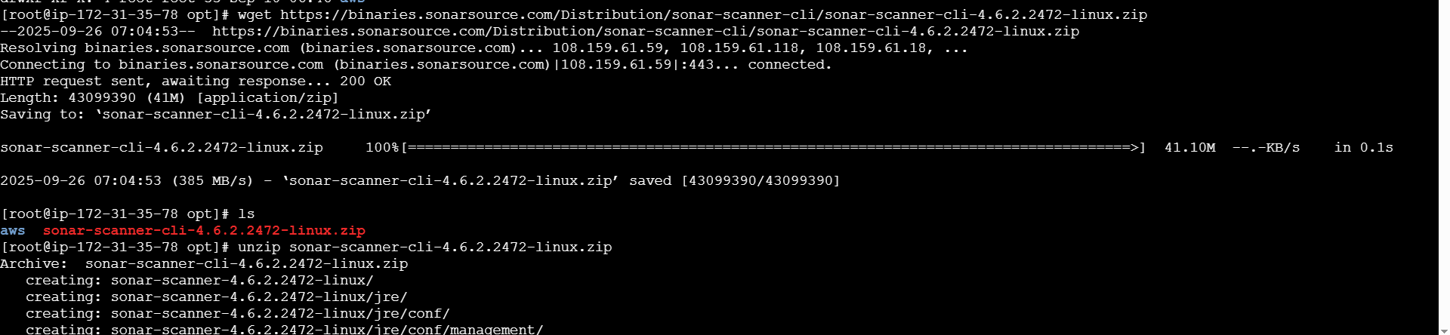

Go to Manage Jenkins Tools go to sonarqube_scanner
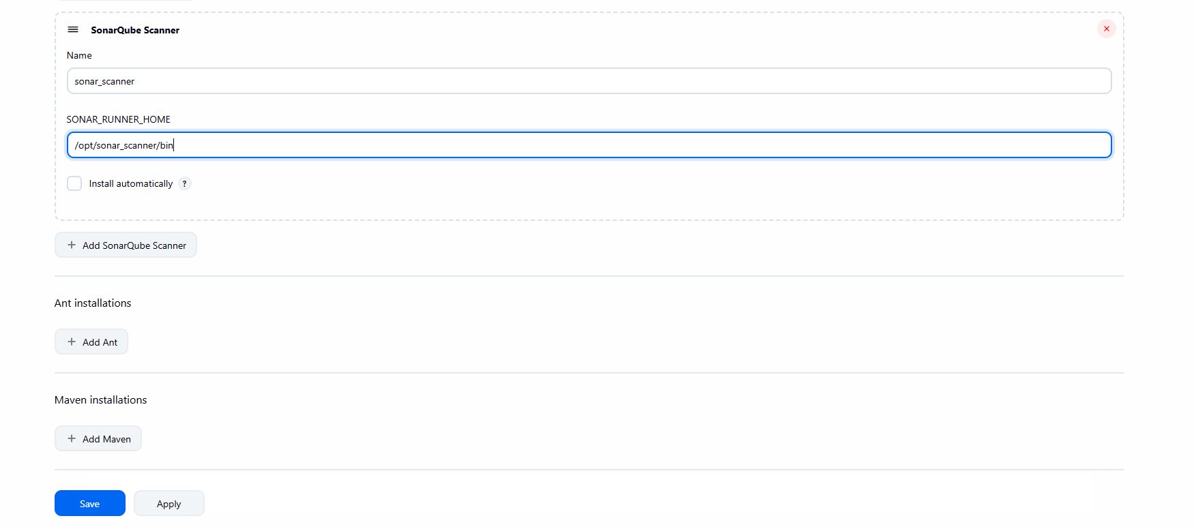
Now Test the sonarqube
Already we had V-Profile
Goto configure in buildsetup execute sonarqube scanner
In Analysis Properties (The information we will get from Developer team)
sonar.projectKey=sami
sonar.projectName= sami
sonar.projectVersion=1.0
sonar.sources=/var/lib/jenkins/workspace/$JOB_NAME/src/
sonar.binaries=target/classes/com/visualpathit/account/controller/
sonar.junit.reportsPath=target/surefire-reports
sonar.jacoco.reportPath=target/jacoco.exec
sonar.java.binaries=src/main/java/com/visualpathit/account/

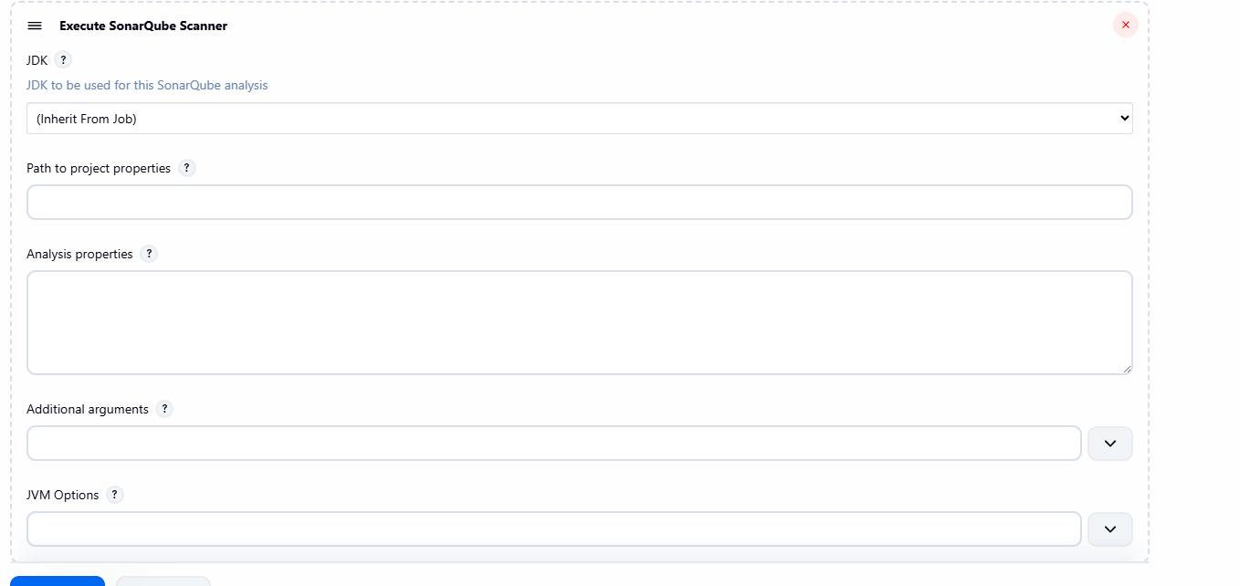
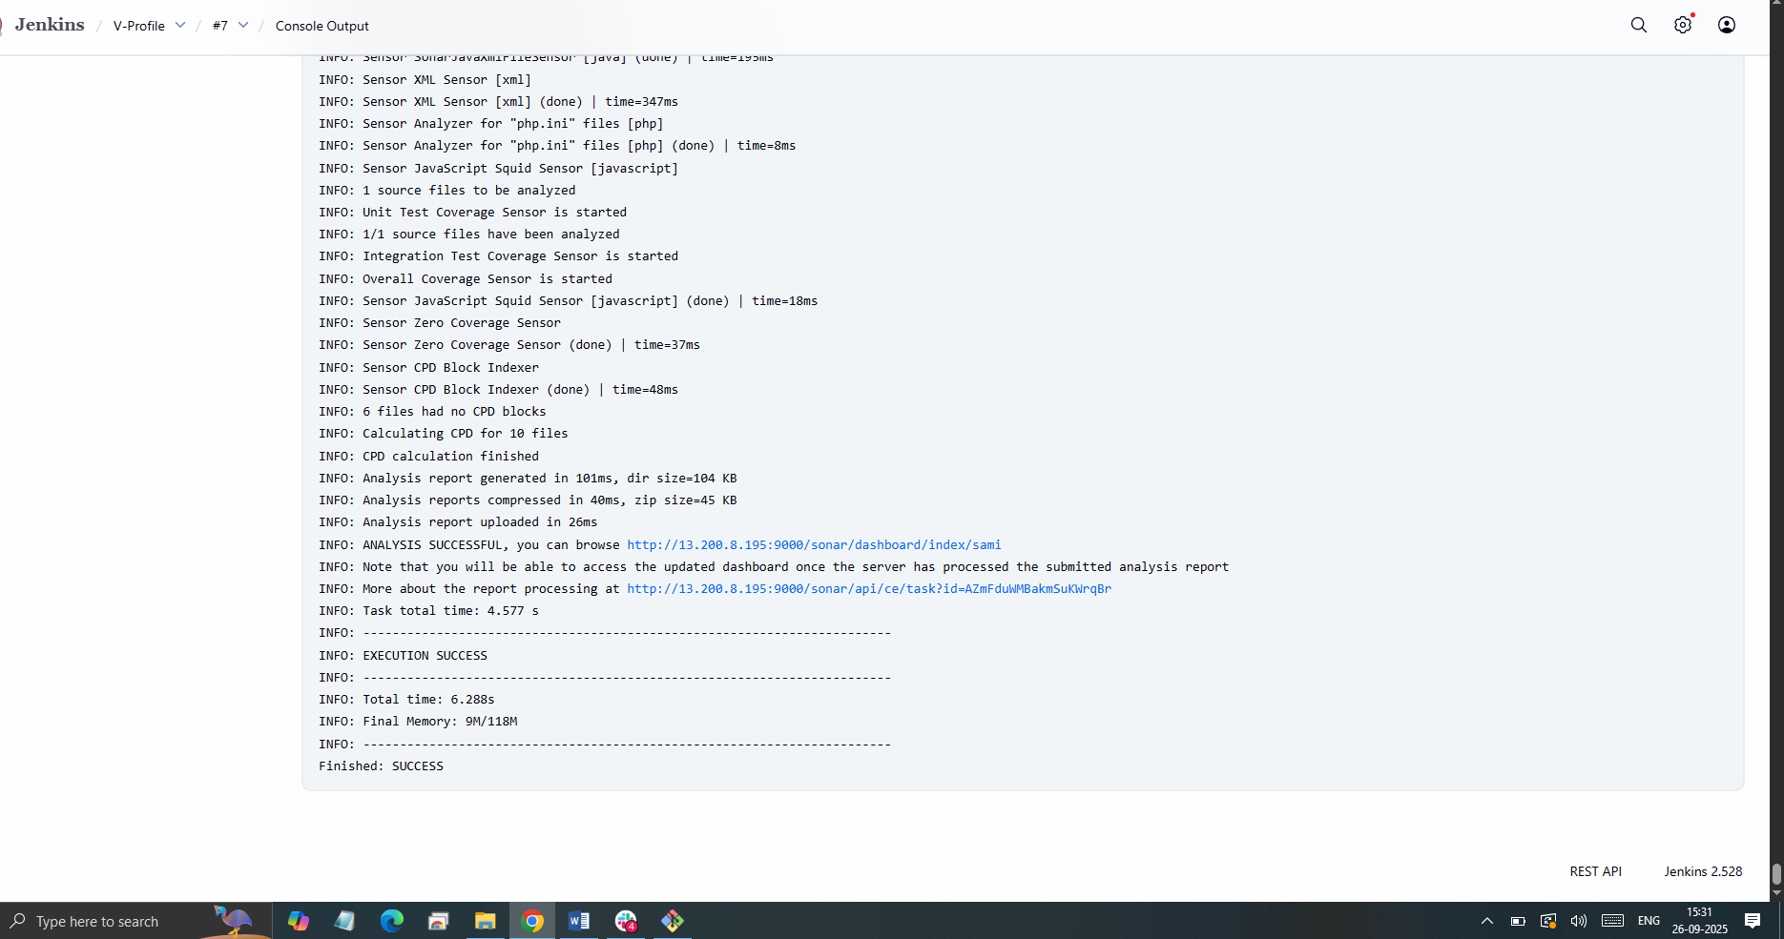

Verify in SonarQube
Goto sonarqube and refresh
http://13.200.8.195:9000/sonar
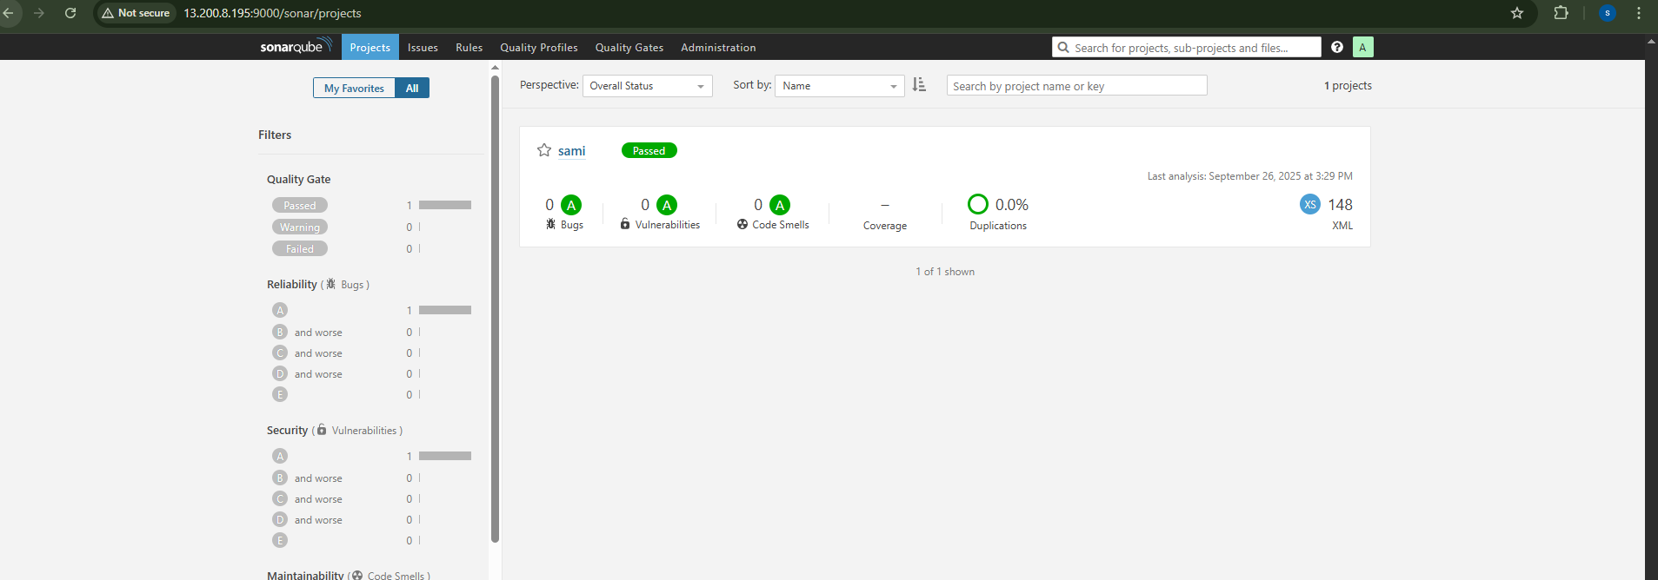

stage3: Slack Integration to send the alerts to slack.
URL: https://github.com/betawins/hiring-app.git

Install plugin slack notification in jenkins
2. Go to your slack dashboard → apps → jenkins CI → configure →add channel
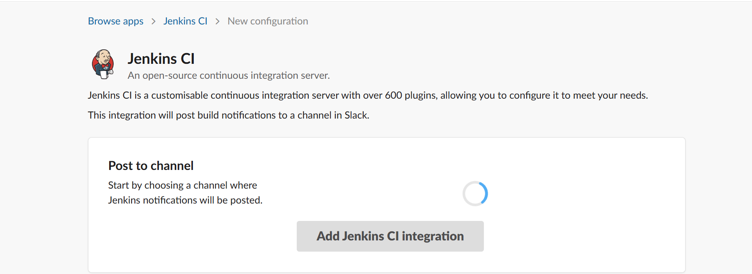
Install slack plugin in jenkins
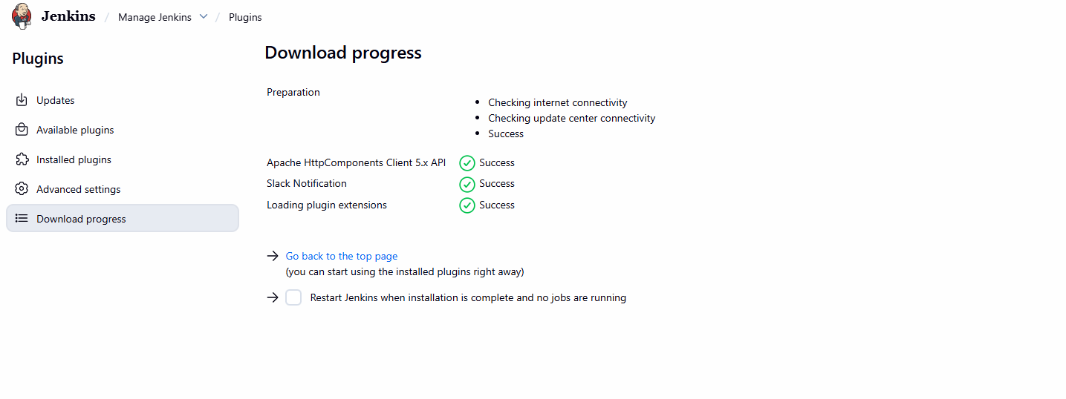
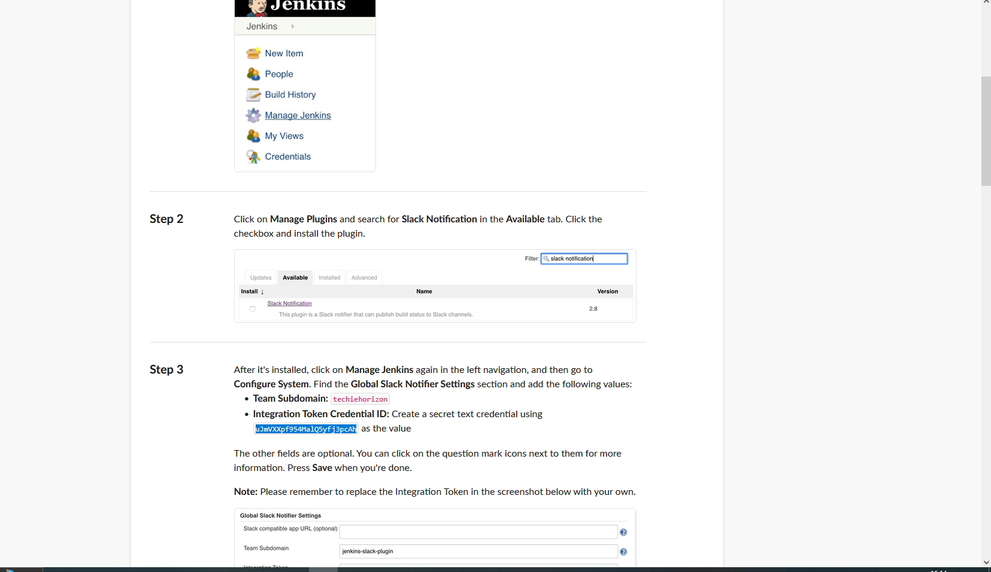

Now build your job then after success you got
notification
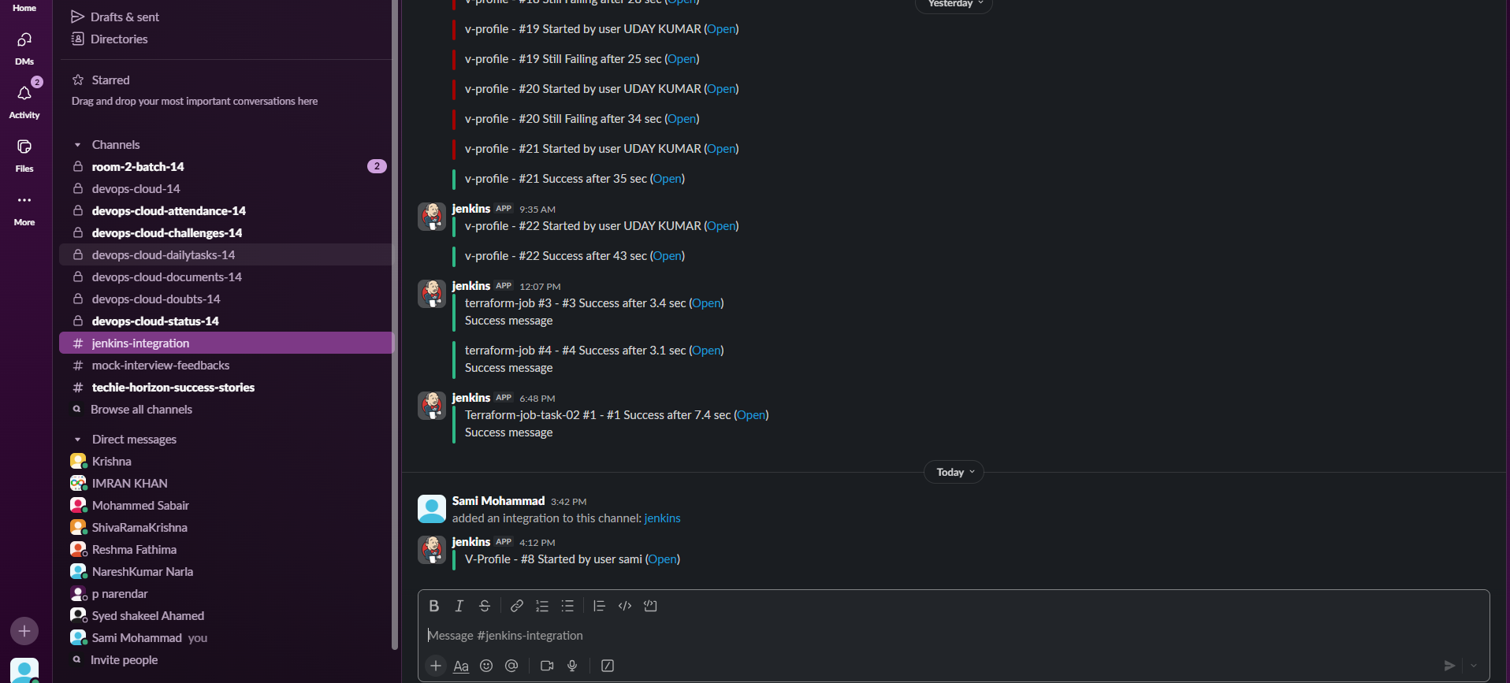

2) 1) Create one jenkins job using the below code and create three stages.

stage1: Git clone to download the source code.
Go to Jenkins create
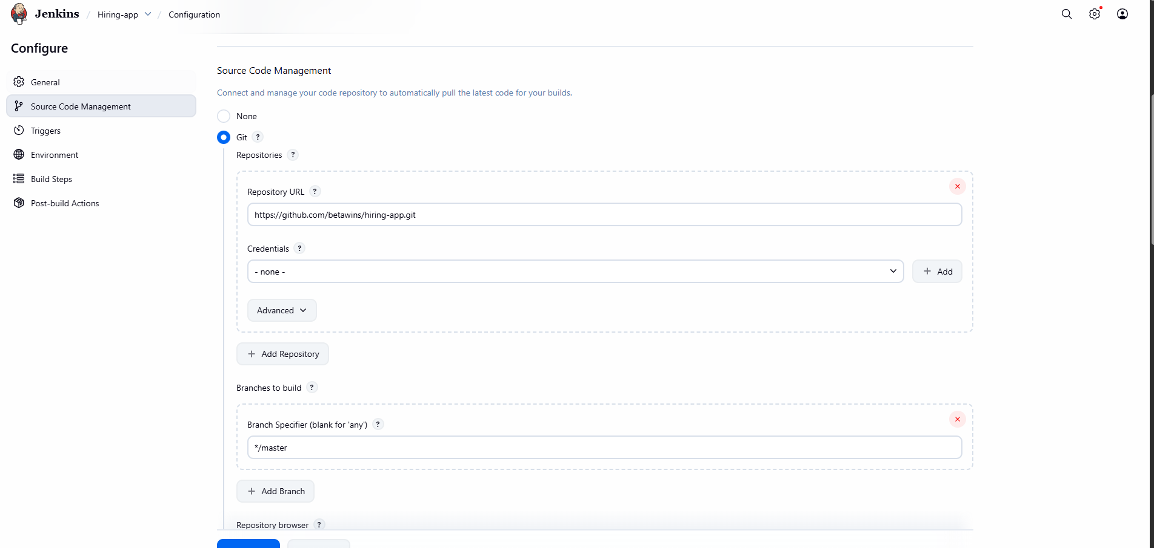
stage2: Sonarqube Integration to check the quality of code
Add the Analysis properties
(sonar.projectKey=Test
sonar.sources=.)
Then build now
