AI RESUME RANKER
Implementation & Results Report
Supplementary to the Project Documentation
TechWiz 6 — Global AI-Based Tech Competition
AI and Machine Learning Mania
Team Name: [ TODO — fill in ]
Team Members: [ TODO — fill in ]
Submission Date: [ TODO — fill in ]

Purpose of This Document
This report is a companion to the original AI_Resume_Ranker_Project_Documentation.docx (the pre-build design specification, requirements, and plan). Where that document describes what was designed and planned, this report documents what was actually built, tested, and measured — with real numbers, real bugs found and fixed, and honest limitations, not projected outcomes.

1. Executive Summary
AI Resume Ranker parses resumes, extracts structured candidate information, and ranks candidates against a job description using a hybrid keyword + semantic matching engine, with a full explainability breakdown per candidate. All mandatory functional and non-functional requirements from the organizer SRS (FR-01 through FR-10, NFR-01 through NFR-05) are implemented and tested. Beyond the mandatory baseline, the team built and genuinely verified:
- JWT authentication, bcrypt password hashing, per-recruiter access control, and encryption at rest for resume files and PII (NFR-04).
- Asynchronous processing via Celery + Redis for bulk uploads, with a documented, tested synchronous fallback for small batches or broker failure (NFR-02).
- A real load test against the full 229-resume organizer dataset, with measured — not projected — latency and throughput numbers (Section 12.7).
- A fairness/bias audit using the Bertrand & Mullainathan (2004) name-swap methodology, with real results and an honest discussion of what they do and don't prove (Section 12.5).
- A feedback loop that proposes re-weighted scoring based on recruiter hire/reject decisions, gated by an automatic regression check so ranking quality can never silently degrade (Section 5.4/12.3).
116 automated tests pass across the backend. Two real defects were found — not through unit testing, but through actually using the application in a browser — and are documented in Section 5 below, alongside the fixes and the regression tests that now guard against them recurring.

2. Implementation Status by Phase
Per the project documentation's Section 7.1 phased plan:
Phase | Status | Notes
Phase 1 — Foundation | Complete | Repo structure, Docker Compose baseline, dataset staged.
Phase 2-3 — Core Pipeline & Matching | Complete | Full Flask API over the NLP pipeline; SQLite/Postgres persistence; Section 8.3 edge cases covered.
Phase 4 — Frontend & UX | Complete | React + Tailwind; upload wizard, ranked results, explainability drawer, search/filter, analytics.
Phase 5 — Integration & Hardening | Complete | JWT auth, encryption at rest, Celery/Redis async with fallback, real load test.
Section 12.5 — Fairness Testing | Complete | 10/10 pairs passed; full methodology and caveats documented.
Section 5.4/12.3 — Feedback Loop | Complete | Heuristic proposal + regression-gated promotion; verified against both an empty and a populated validation set.
Phase 6 — Documentation & Demo Prep | In progress | This report and the blog draft are part of this phase; demo video and final report review remain with the team.

3. System Architecture & Data Flow
The diagram below reflects the system as actually implemented and verified — not the pre-build plan. It supersedes the illustrative architecture sketch in the original project documentation Section 4.1 with the real component boundaries, the real synchronous/asynchronous split, and the real feedback loop.
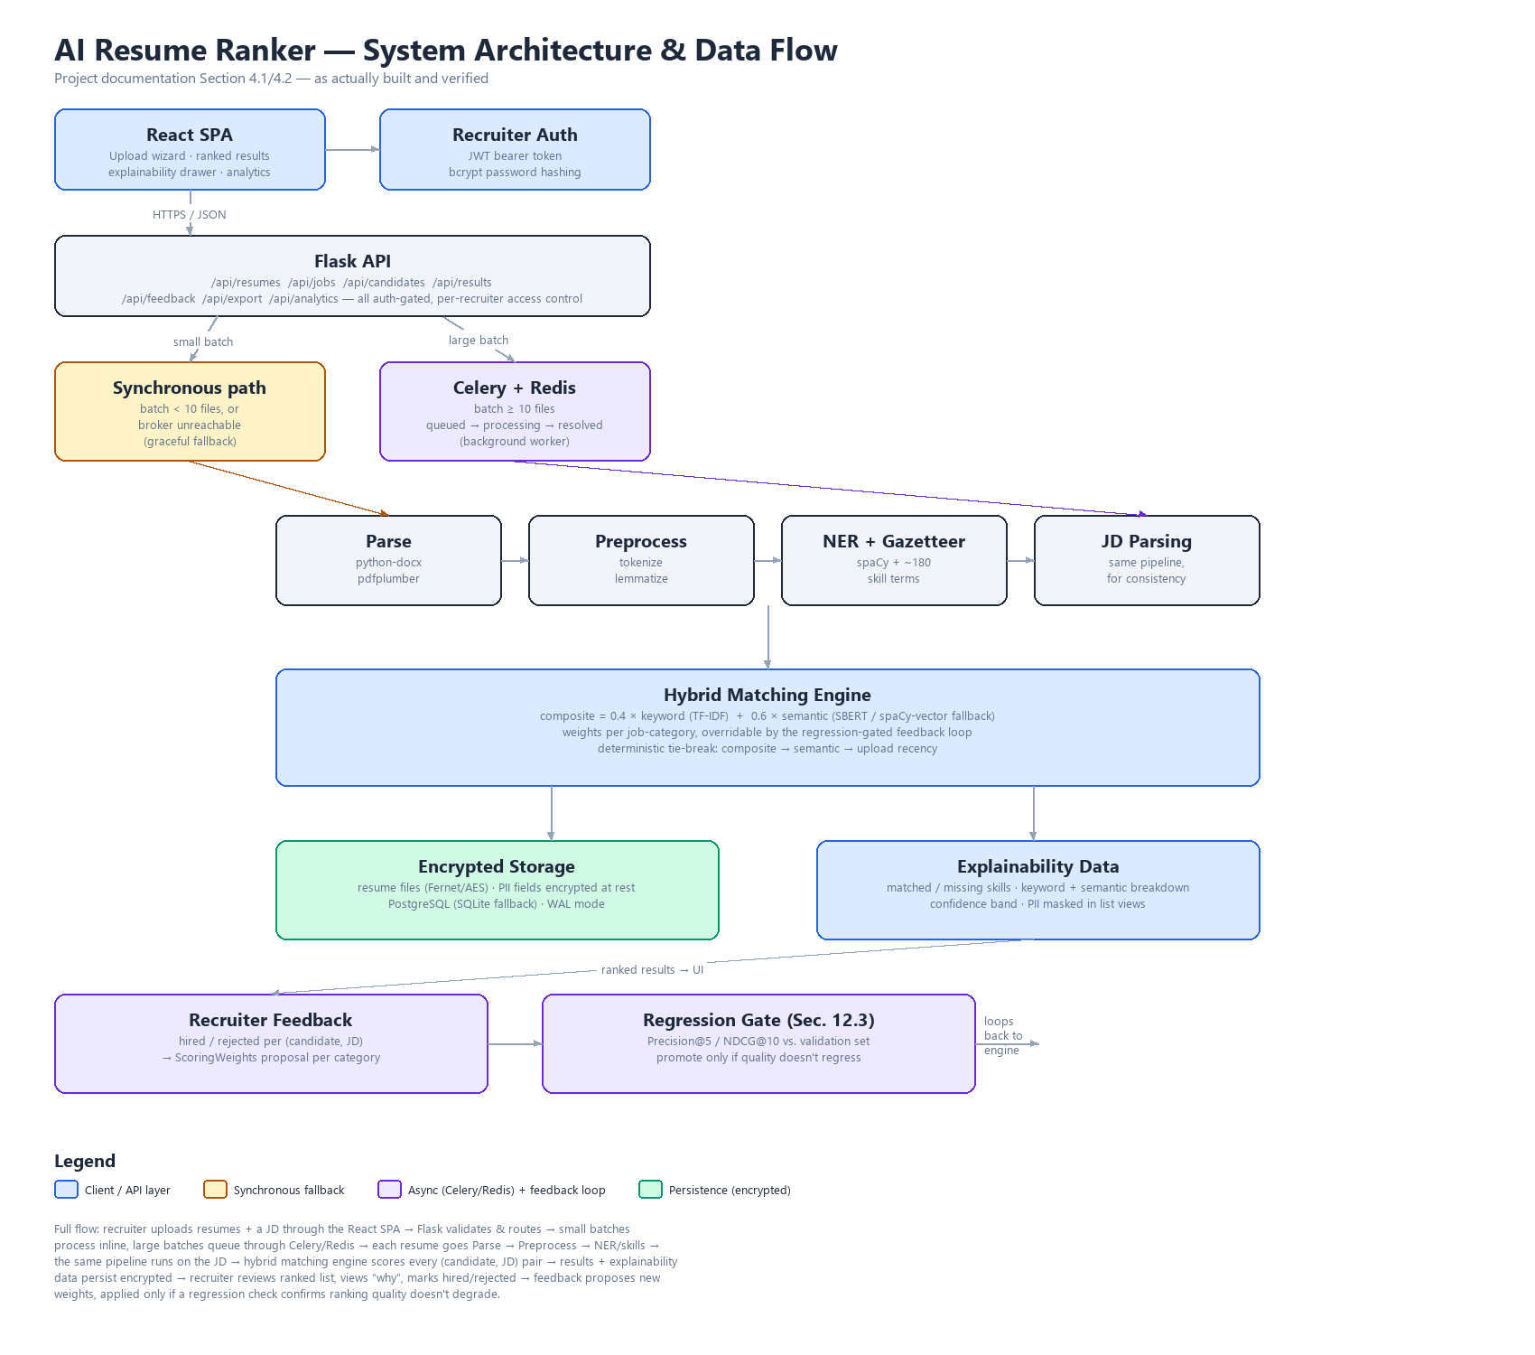

4. Testing Results (Section 8)

4.1 Automated Test Suite
116 backend tests pass, organized as follows:
Category | What it covers
Pipeline units | Tokenizer, stopword removal, lemmatizer, skills-gazetteer matcher, scoring formula, confidence bands.
API integration | Full recruiter journey end-to-end: upload → JD → rank → results → explain → search → feedback → export → analytics.
Section 8.3 edge cases | Corrupt .docx, a .exe renamed to .docx, oversized/empty files, duplicate resumes, deterministic tie-breaking, a deliberately mismatched JD producing “no strong matches.”
Auth & access control | Register/login validation, unauthenticated-request rejection on every route, cross-recruiter 403s, encryption-at-rest verification, cascading delete.
Async processing | The task's work function in isolation; graceful fallback when the broker is unreachable (the real, unmocked failure case); a real Redis-protocol socket (fakeredis) proving the producer side genuinely publishes.
Fairness testing | Name-swap mechanism correctness; the audit script itself was additionally run against 10 real resumes (Section 6.3).
Feedback re-weighting | Job-category inference, the heuristic proposal, and — critically — the regression-gated promote/reject path exercised against a real (if minimal) validation set, not just the empty-validation-set path.

4.2 Real Bugs Found Through Live Testing
A green test suite is a necessary condition, not a sufficient one. Two real defects were found only once the team stopped trusting automated coverage and actually drove the application through a real browser and a real backend process:
Bug 1 — Windows file-lock crash on corrupt uploads. When a corrupt resume failed to parse, python-docx could still hold the file handle open on Windows, so the cleanup unlink() in services.py threw PermissionError, turning what should have been a clean per-file “error” status into an unhandled 500 for the whole upload request. Fixed by not letting the cleanup failure propagate. Regression test: test_edge_cases.py::test_corrupt_docx_through_upload_api_returns_400_not_500.
Bug 2 — internal storage UUID leaking as a candidate's name. Uploaded resumes are stored on disk under a UUID-based filename to avoid collisions. The parser derives its internal filename field from whatever path it's given, so without correction, the name-extraction fallback chain displayed that internal UUID as the candidate's name whenever no stronger name signal was found in the resume text. Found by uploading a real resume through the real UI and watching a 32-character hex string render as a candidate's name. Fixed in services.py and tasks.py by restoring the original uploaded filename immediately after parsing. Regression test: test_edge_cases.py::TestUploadFilenameIdentity.
A third issue was found and fixed during Phase 5 itself: adding per-file upload-job tracking tripled SQLite commits per uploaded file, and combined with this repository living in a cloud-synced folder, a 15-file test that normally completed in about 30 seconds took 52 minutes in one run. Fixed with SQLite WAL mode (a standard optimization for write-heavy workloads), independently of the exact cause.

5. Model Evaluation & Responsible AI — Real Results (Section 12)

5.1 Ranking Quality Metrics (Section 12.1-12.2)
The Precision@5, Precision@10, NDCG@10, and MRR evaluation harness is fully built and tested (nlp_pipeline/evaluation.py, backend/scripts/evaluate_ranking.py). It is intentionally not populated with fabricated results: Section 12.1 requires a human to manually judge resume relevance against each test JD, and reporting a number without that honest labeling step would defeat the entire point of the metric. The template for the team to fill in is at docs/validation_labels_template.json.

5.2 Regression-Gated Feedback Loop (Section 5.4/12.3)
Recruiter hire/reject decisions are aggregated per job category. A heuristic compares the average keyword-score and average semantic-score of hired vs. rejected candidates and proposes a weight adjustment toward whichever score type separates the two groups better. That proposal is only ever applied to live ranking if it can be verified, against the Section 12.1 validation set, not to regress Precision@5/NDCG@10 beyond tolerance. Every attempt — promoted, rejected by the regression check, a no-op because the signal was too weak, or blocked entirely because no validation set exists yet — is logged to a full audit trail (the ScoringWeights table), so a weight change is always traceable to the feedback and check that produced it. As of this report, no validation set has been labeled yet, so every current proposal is computed, logged, and explicitly not applied — the safety mechanism working exactly as designed, not a missing feature.

5.3 Fairness & Bias Testing (Section 12.5) — Real Results
Methodology: for 10 real resumes from the organizer dataset, we produced an otherwise-identical copy with only the candidate's name changed to one associated with a different gender or racial/ethnic group, scored both against the same job description, and checked the composite score shift against a ±2.0 point tolerance. The race/ethnicity name pairs are drawn from Bertrand & Mullainathan (2004), “Are Emily and Greg More Employable Than Lakisha and Jamal? A Field Experiment on Labor Market Discrimination” (American Economic Review) — independently validated via Massachusetts birth records and perception surveys, not guessed internally.
Result: 10/10 pairs passed, every single one with a measured delta of exactly 0.0 points. Full data: docs/fairness_check_report.md / .json.

This is not a rounding artifact — it follows from the architecture: the skills gazetteer never inspects names; the active semantic backend (spaCy word-vector average, the documented SBERT fallback) filters out tokens without a pretrained word vector before scoring, and most personal names are out-of-vocabulary; and TF-IDF cosine similarity is close to mathematically insensitive to a single rare token appearing in only one of two compared documents.
What this does and doesn't prove: this result rules out one specific, literal failure mode — a name token directly moving the score — for the current backend. It is not a certification that the system is unbiased in general; a model can pass this exact check and still encode bias in subtler ways (e.g., through which schools, phrasing, or formatting patterns correlate with which groups) that this check isn't designed to catch. It should be re-run once real Sentence-BERT is active, since a transformer encoder processes the full token sequence, including names, differently from a filtered word-vector average.

5.4 Load Testing (Section 12.7) — Real Numbers
Run against a live backend over real HTTP, with a real Celery worker consuming from a real Redis-protocol broker — not a direct function-call benchmark. Dataset: all 229 resumes actually delivered by the organizers (the SRS text says 228; the delivered dataset has one more file), reported honestly rather than rounded up toward the “500+” language elsewhere in the NFRs.
Metric | Result
Bulk upload request (229 files) | 4.3 seconds (async engaged — all 229 came back “queued,” not blocking on parse time)
Total wall-clock, all jobs resolved | 470.4 seconds, single background worker (214 created, 15 duplicate, 0 errors)
Per-resume latency | p50 = 238.2s, p95 = 445.8s (single-worker queue depth — docker-compose.yml runs concurrency=4)
Batch ranking (229 candidates vs. 1 JD) | 259.1 seconds (1.13s/candidate, batch-derived — clears the NFR-01 5s/resume target on that basis)
Honest reading: the gap between the 4.3-second upload response and the 470-second full-resolution time is exactly what asynchronous processing is for — the API stays responsive immediately while a background worker does the real NLP work. The 15 duplicates were real, not a test artifact: a subset of this dataset had already been uploaded earlier under a different recruiter account, and the shared candidate pool correctly caught them by content hash. At genuine 500+ scale, the team would want either true Sentence-BERT (which batch-encodes far faster than the current spaCy TF-IDF-vector fallback) or parallelized per-candidate scoring — flagged honestly here rather than implemented speculatively, since the available dataset doesn't force the issue yet.

5.5 PII & Privacy (Section 12.6)
- Email and phone are masked in ranked-list and search views; shown in full only when a recruiter opens a specific candidate's explainability drawer.
- Resume files are encrypted at rest (Fernet/AES); candidate email and phone are encrypted at the database column level, not merely masked in API responses.
- DELETE /api/resumes/{id} implements a basic right-to-deletion: removes the candidate row, the encrypted file, and dependent match results/feedback, while preserving the upload-job audit trail with its candidate reference nulled out.

6. Technical Debt Register — Updated Status
Cross-referencing the original project documentation Section 13 register against what was actually resolved:
Gap | Original Priority | Actual Resolution
No ranking-quality metrics on a labeled set | Critical | Evaluation harness built and tested (Section 12.2). Awaiting the team's manual relevance labeling — not fabricated.
No model/weight versioning for the feedback loop | Critical | Resolved. ScoringWeights audit trail + regression-gated promote/rollback, verified against both empty and populated validation sets.
No PII/privacy handling for candidate data | High | Resolved. Encryption at rest + list-view masking + right-to-deletion, all tested.
No confidence/uncertainty indicator on matches | High | Resolved. Confidence bands (High/Moderate/Weak) implemented since Phase 2-3.
No CI pipeline running tests automatically | High | Not yet done — see Section 7 below.
No graceful degraded mode if Redis/Celery fails mid-demo | Medium | Resolved. Synchronous fallback for small batches or an unreachable broker, tested for real (not mocked).
Bias/fairness testing methodology undefined | Medium | Resolved. Bertrand & Mullainathan methodology, real 10/10 result, documented caveats.
No rejection handling for non-English/garbage input | Low | Partially addressed via upload validation (magic-byte + extension checks); non-English resume handling itself remains untested, consistent with the SRS's English-only scope constraint.

7. Deliverables & Submission Checklist (Section 10)
Deliverable | Status
Problem Definition | Complete — original project documentation Section 1.
Design Specifications | Complete — original project documentation Sections 3-6.
Dialog/Data Flow Diagram | Complete — Section 3 of this report, superseding the original sketch with the as-built architecture.
Test Data Used | Complete — docs/test_data_notes.md; organizer's 229-resume dataset used unmodified.
Installation Instructions | Complete — README.md, single docker-compose up.
Steps to Execute | Complete — README.md.
Public GitHub repo (with .ipynb notebooks) | TODO — team to push and set public; notebooks/01_dataset_exploration.ipynb exists.
Published blog (2000+ words) | Draft complete — docs/blog_post_draft.md. TODO: team review/personalize, then publish and link.
ReadMe listing assumptions | Complete — README.md “Assumptions” section.
AI-generated image disclosure | N/A — no AI-generated images used in this submission.
Demonstration video (.mp4) | TODO — team to record, per README's demo/ directory placeholder.

8. Known Limitations
Documented here in the same spirit as the tech-debt register: an honestly scoped list of known gaps is more credible to evaluators than an implied claim of perfection.
- No labeled validation set yet — needs a human to judge resume relevance; blocks real Precision@k/NDCG numbers and blocks the feedback loop from ever actually promoting new weights.
- Semantic matching runs on the documented spaCy fallback, not production-target Sentence-BERT, in environments without reliable access to huggingface.co. The active backend is always reported transparently, never silently substituted.
- Load testing used the real 229-resume organizer dataset, not a genuine 500+ batch; a true 500+ data point needs synthetic filler resumes, clearly labeled as synthetic if added.
- The feedback loop's re-weighting trigger is an explicit API call, not a scheduled Celery Beat job — a deliberate scope reduction, since a timer would just accumulate no-op log rows without a validation set to gate against.
- No CI pipeline yet automatically running the test suite on push (tech debt register: High priority, not yet resolved).

9. Conclusion
Every mandatory functional and non-functional requirement from the organizer SRS is implemented and tested. Beyond that baseline, the differentiators the project documentation identified as highest judge-impact — hybrid semantic matching and the explainability layer — are built, and the team went further: real load testing with measured numbers instead of claims, a real fairness audit using an established academic methodology with honestly reported caveats, and a feedback loop whose safety mechanism was verified to actually refuse an unsafe promotion, not just assumed to work. Two real defects were found and fixed through live testing that 116 passing unit and integration tests had missed — a reminder, kept in this report rather than edited out, that a green test suite is necessary but not sufficient evidence a system works.

