

**Class Project(task 2)**

**Title:**

Creating a LAMP Stack on Virtual BOX

**Group Members:**

Muhammad Hassaan (19-10641)

Muhammad Samiullah (19-10698)

Amna Ali (21-10909)

**Introduction**

In this project we enter temp value in server database using nodemcu esp8266.

Components:

* nodemcu esp8266
* temperatuer sensor
* ubuntu server
* client machine
* wires

In task1, we make a database and then write a code in ardiuno which get the temp from temperature sensor and add the value of temp in server database after 1 mint. Our code enter the values in server database by using their url on same networks. After completing the task1, we move on task2. In task2, we done the task1 on two different networks. For task2, we do a port forwarding. Before port forwarding, we download Xampp (apache server) and install in client machine. Open the Xampp and start the apache and mysql. Then create a database in mysql. Also write a view php file which show the database. Then copy the insert.php and view.php in htdoc folder in Xampp. Then go to .conf in Xampp and change the port no 80 to 6000. In order to connect Xampp publically you need to change “Require all local” in http-xamp-conf to “Require all granted”.

**Port Forwarding**:-

1. Open CMD and type **‘ipconfig’** and from there find your **local IP** and default gateway as below

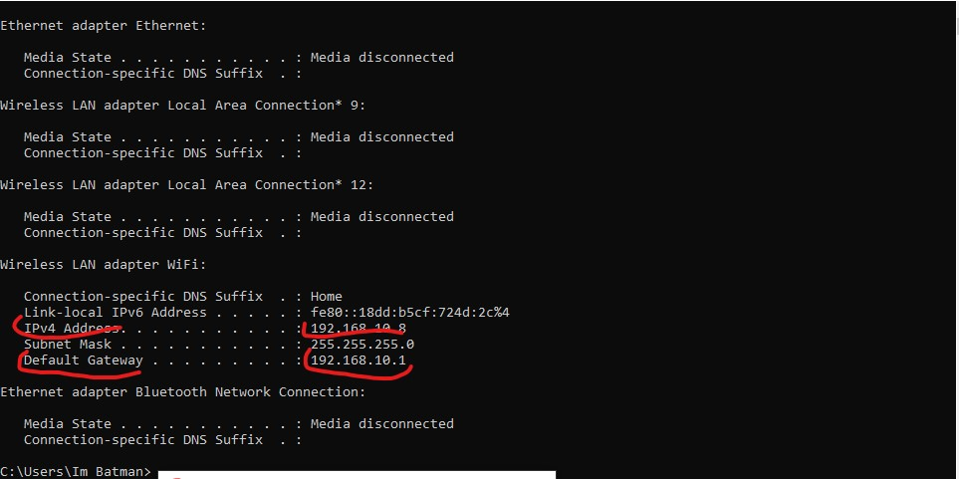

2) Next step is to make your local ip a static Ip. For this go to **Control Panel->Network and Internet->Network Connections**, click on **WiFi properties** and there choose **IPV4 properties** like below.

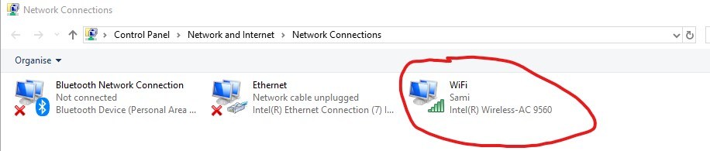

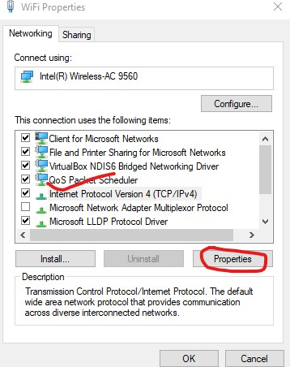

3) In it’s properties write your local IP where it states **‘Ip address’** and your gateway where it says **‘default gateway’** by clicking on **‘use this following ip’**. click on **‘use the following DNS server’** and write server as follows

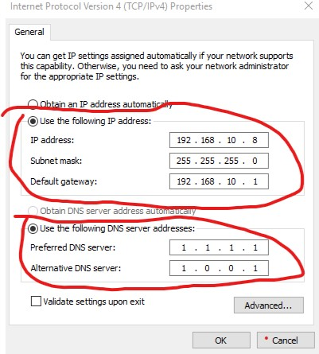

4) Now, login to your router by writing **default gateway**(which we found by CMD) on your browser https bar. Provide in the username and pass and login to your router settings. Now go to **advanced setup->NAT->Virtual Servers** and Click add there. Now choose **internal and external port to be 6000,** and write your local IP where it says **‘server IP’**. and click add. It should look like this.

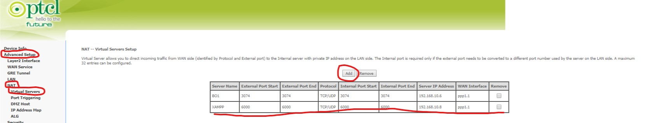

5) Last part, open your XAMPP control panel and click on ‘config’ next to to XAMPP.

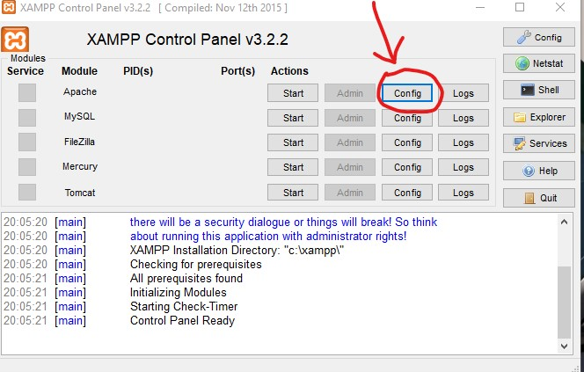

Open the file **‘Apache (httpd.conf)’**. Find in the file where it says **‘Listen’** and change the **Listen 8080** to **Listen 6000** and click save.

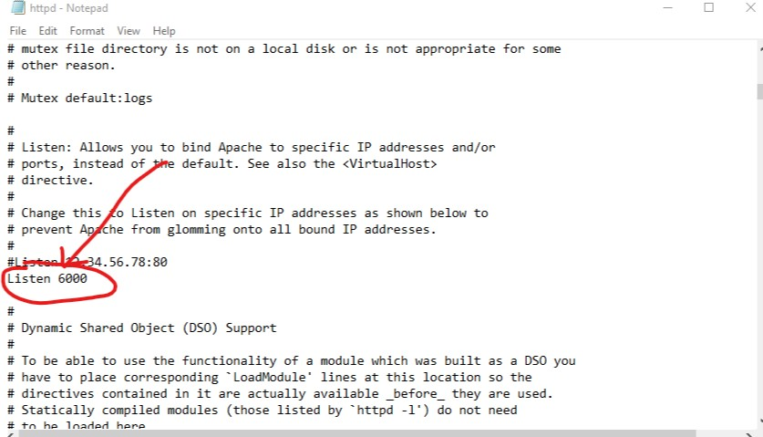

Now click on config again and find **‘Apache (httpd-xampp.conf)’** file and go to where it says **‘Allow Override AuthConfig Limit’** and below that write these 3 lines as below

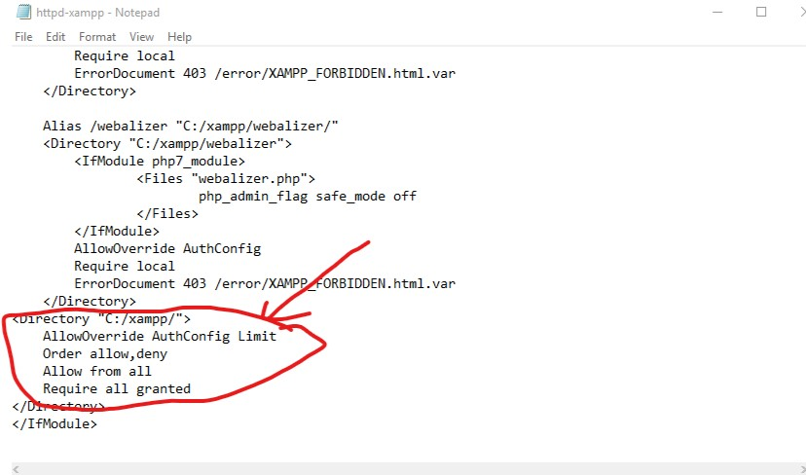

and you are good to go. Now you have successfully port forward. Congratulations. Now write on google “my ip” it give us the public IP of our router which can access by any network at any place.

Then we write on URL like.

Our-Public-IP:6000/var/www/html/apis/view.php

Turn on Xampp and MySQL

and we get to see the view.php file.