

**Project Proposal (Information System Management)**

**Title: Smart Online Warehouse Management Support System**

**Submitted by:**

**Name:** Md. Sami Alam

**ID:** 222-16-656

**Section:** 15_16_A

**Subject Code:**  CIS 315

**Course Title:** **Information System Management**

**Semester:** Spring 2025

**Department** Of **CIS**, **DIU**

**Due Date:** 19th April, 2025

**Group Members ID’s:** **222-16-657, 222-16-672, 222-16-681, 222-16-673**

**Submitted to:**

**Name:** Mr. Nasimul Kader

**Department:** Computing and Information System, DIU

Submission date 19th April, 2025

Acknowledgment

I would like to express my heartfelt gratitude to Allah for providing me with the strength and guidance throughout the completion of this project.

I would like to extend my special thanks to Mr. Nasimul Kader, our honorable teacher, for giving me the invaluable opportunity to work on this exciting and challenging semester project. His constant guidance and encouragement helped me develop a deep understanding of the ML based Smart Online Warehouse Management Support System, allowing me to explore various aspects of machine learning, data visualization, and recommendation systems. This project has enriched my knowledge and skills in both the theoretical and practical application of these technologies.

I would also like to thank my parents for their unwavering support, encouragement, and understanding throughout this project. Their constant belief in me helped me stay focused and complete this project within the given time frame.

Lastly, I would like to express my gratitude to my classmates who have been a source of constant help and motivation. Their insights, advice, and collaboration were instrumental in overcoming various challenges during the project.

Project Overview

This project aims to design and implement a Smart Online Warehouse Management Support System (MSS) tailored for retail stores. The proposed MSS will utilize modern web technologies and machine learning to offer decision-making support, automate routine warehouse tasks, and improve operational efficiency through predictive analytics and inventory forecasting. The system will serve as a centralized platform for warehouse administrators to manage product stocks, sales forecasting, performance tracking, and restocking suggestions.

Problem Statement

Small retail stores and warehouses often lack access to intelligent inventory and warehouse management solutions. They typically rely on manual or semi-digital systems that lead to issues like:

1. Inefficient inventory tracking
2. Overstocking or stock outs
3. Difficulty forecasting future sales
4. Delayed decision-making due to lack of real-time data
5. Manual workload and operational delays

These inefficiencies reduce profit margins, increase operational costs, and limit growth potential.

Project Objectives

1. **Data Integration:** Consolidate historical sales, inventory, and warehouse activity into a centralized online platform.
2. **Reporting and Analytics:** Generate reports and interactive dashboards to visualize key performance indicators (KPIs), sales trends, and stock levels.
3. **Workflow Automation:** Automate inventory updates, stock alerts, and restocking workflows to minimize manual intervention.
4. **Decision Support:** Implement an AI-powered forecasting system to predict future product demands and offer stock management recommendations.
5. **User-Friendly Interface:** Develop an intuitive and responsive interface that supports desktop and mobile platforms for real-time accessibility.

Proposed Solution

The system will be developed using the following technologies:

1. **Frontend:** React.js, Tailwind CSS for responsive and modern UI
2. **Backend:** Node.js, Express.js
3. **Database:** MongoDB for storing inventory, sales data, and user info
4. **Machine Learning API:** Python (Flask) for prediction and recommendation services

**Key Components:**

1. **Data Warehouse:** Centralized storage for inventory, sales, and historical data.
2. **BI Dashboards:** Real-time visualizations using chart libraries (e.g., Chart.js or Recharts).
3. **Inventory Management Module:** CRUD operations for product stock, category-wise filtering.
4. **Forecasting Module:** Predictive ML model (Linear Regression/Random Forest) to estimate future sales and restock quantities.
5. **Stock Suggestion System:** Rules-based engine (e.g., "low sales + high stock -> reduce order") to aid procurement decisions.
6. **Role-Based Interface:** Access control for Admin, Moderator, and Staff roles.

System Architecture

Better Visualization: <https://drive.google.com/file/d/1s3wVypmPSwVSdQ1dBeidYhFey-Y8AGnZ/view?usp=sharing>

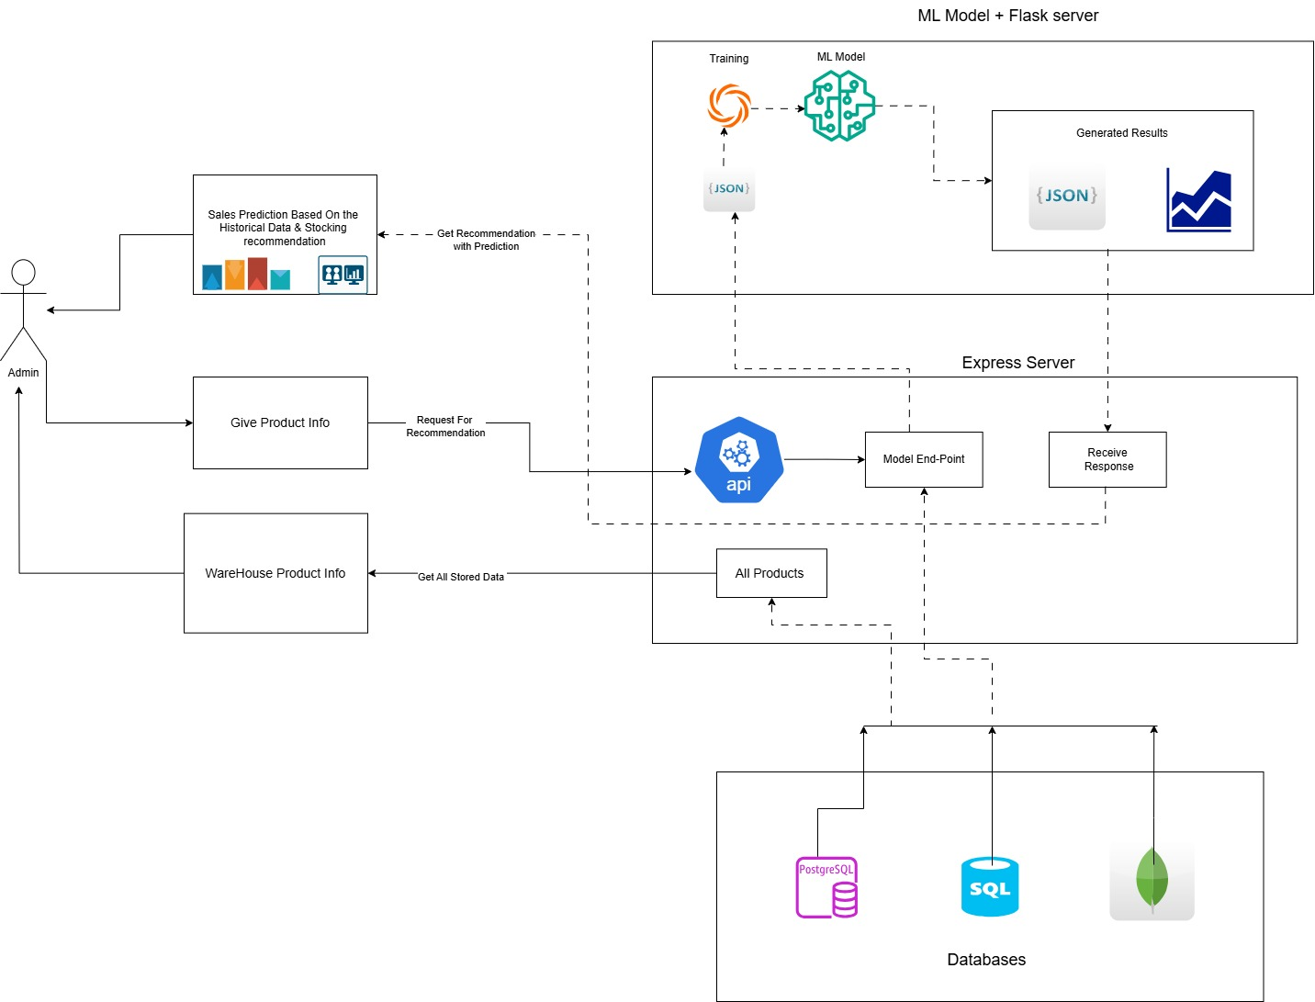

Project Methodology

We will follow the **agile methodology** using iterative development and continuous feedback.

**Phases:**

1. **Requirements Gathering:** Interview local store managers and gather system needs.
2. **System Design:** Design UI/UX, database schemas, and ML pipeline architecture.
3. **Development:** Build the MERN stack application and integrate the ML API.
4. **Testing:** Unit and integration testing with real/fake data.
5. **Deployment:** Deploy on cloud servers (Vercel/Heroku) with Git-based CI/CD.
6. **Maintenance:** Provide post-deployment support and gather feedback for future upgrades.

Expected Outcomes

1. **Smarter Decisions:** Predictive insights for sales and inventory planning.
2. **Reduced Manual Tasks:** Automation of stock updates and reorder alerts.
3. **Increased Efficiency:** Faster warehouse operations and improved data access.
4. **Improved Profitability:** Reduced wastage and better sales planning.
5. **Scalable System:** Easily adaptable to new retail outlets or categories.

Timeline

|  |  |  |
| --- | --- | --- |
| **Phase** | **Duration** | **Completion Date** |
| Requirement Analysis | 1 week | March 10, 2025 |
| Design Phase | 1 week | March 20, 2025 |
| Development | 2 weeks | May 10, 2025 |
| Testing & Feedback | 1 week | May 16, 2025 |
| Final Deployment | 1 week | May 24, 2025 |

Resources

* **Hardware:** Personal computers/laptops
* **Software:** VSCode, MongoDB Atlas, Postman, GitHub, Figma
* **Technologies:** React.js, Node.js, MongoDB, Flask, Python, Tailwind CSS
* **Team:** 3 Software Developers, 1 Data Scientist (ML), 1 Project Manager
* **Budget:** Estimated BDT 15,000 for hosting, data collection, and third-party tools

Conclusion

The proposed Smart Online Warehouse Management Support System (MSS) provides an end-to-end solution for the challenges faced by small retail businesses. By combining real-time analytics, machine learning, automation, and intuitive UI, this system will enable better decision-making, reduce operational overhead, and contribute to the organization's overall growth and competitiveness in the digital age.