- SGeneral topics for the BOM configurator.
- For all components, we need to have the possibility to add more articles in the future (main + subcomponents). Important here is, that it will be easy for us, to fill in dependencies
- Articles and article numbers must be easily changeable, in case in the future, parts need to be changed (especially with sub-components that is very likely). Meaning: The main components stays the same, but a sub-component needs to be exchanged.
- Article numbers must be easily changeable. In the future, we are planning for a new ERP System and it probably will happen, that for the same article, we will use different article number than today.
- It should be possible, that we can change the order of the drop down menus
- The code for the BOM configurator has to be given to us
- The user interface is not necessary to be via streamlit. If you have a better and more user friendly idea, that would be great.

- Tab – „Schacht“

This Tab needs to be in the UI. The user must choose what type of “Schachttyp” is necessary.

That is a main component

I changed the sequence of the “Schachttyp”, starting with “Verteiler” (manifold).

Quick explanation for this: If “Verteiler” is selected, no “Schacht” (from now “chamber”) is necessary.
A chamber is just the “body” to put the installation in the ground. The manifold is the inside installation in the chamber. A manifold can also be installed in the house. In this case, a chamber is not necessary

Chambers: https://erdwaerme-gnv.de/erdwaermeschaechte-verteilerschaechte/
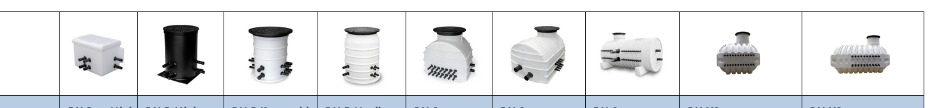

Manifolds: https://erdwaerme-gnv.de/erdwaermeverteiler/
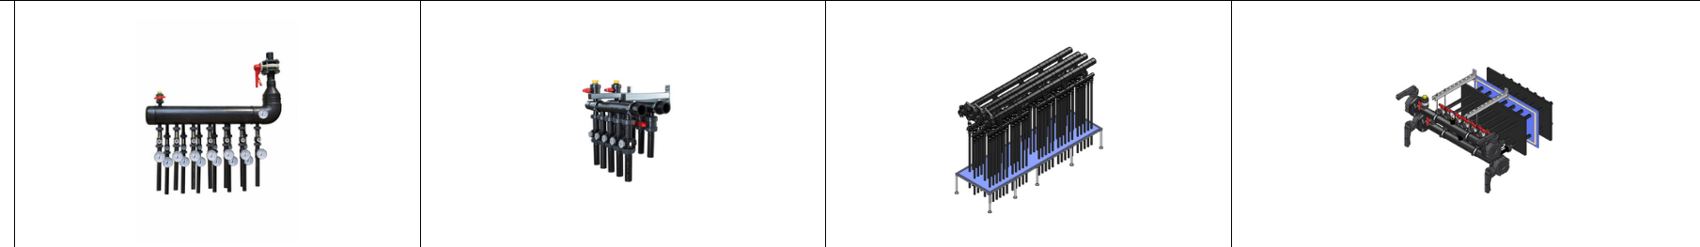
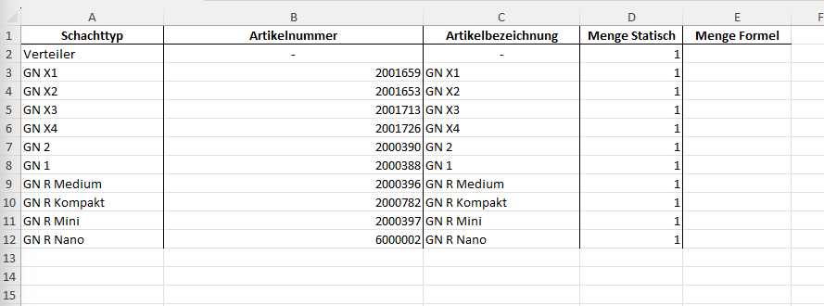

- Tab – “Schachtgrenze”
This Tab does not need to be in the UI.

This Tab will be a “Living” tab. That means, step by step we will fill in more information. It is important that we are able, to change this Tab afterwards and the Software can work with it.

This Tab is made for “hard” borders. Hard border are:
- Maximum number of probes
- Maximum diameter of HVB (“Erlaubte HVB“)
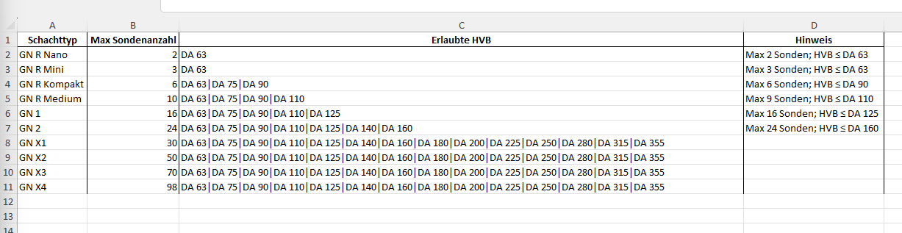
- Tab – „Schachtkompatibilität“
This Tab does not need to be in the UI.

This Tab is made for “soft” borders. For your understanding, here an example:
You can see in the Tab “Schachtgrenze” that in a “GN R Kompakt” are fitting in total 6 probes inside (Tab “Schachtgrenze” “Max. Sondenanzahl”). But if you need a main valve (see column H in the Tab “Schachtkompatibilität”) this will not fit inside anymore.

This Tab will be a “Living” tab. That means, step by step we will fill in more information. In general, I am not super happy how I have done it. If you have a better idea, feel free to change it. It is important that we are able, to change this Tab afterwards and the Software can work with it.

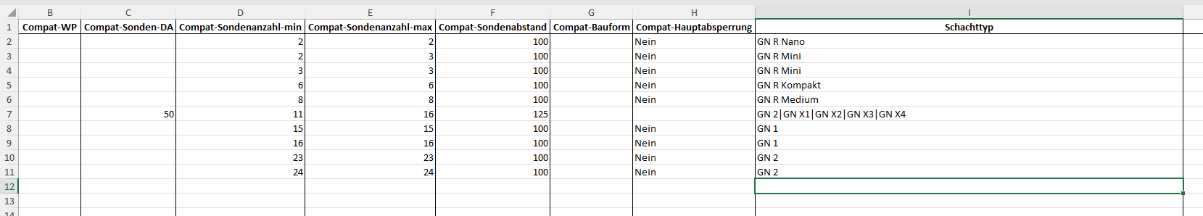

- Tab – „HVB“
This Tab needs to be in the UI. The user must choose what type of “HVB” is necessary. The user should be capable of choosing the following: “HVB”, “Anschlussart” (einseitig or beidseitig), and Bauform (“I” shape or “U” shape”)

That is a main component

In this Tab we have the HVB.

The quantity is via a formular. The formular is defined by:
“= (Number of probes – 1) * distance of probes * 2 + addition left side + addition right side”

There is one dependency which would be important for the GN X1, GN X2, GN X3 and GN X4. That is the so called “Bauform”. This is explained in the other document named “Pictures Instructions – GNV”. We have the HVB either as a “I” shape or a “U” shape. It would be necessary that we have this dependency considered in the software.

If we have 20 probes as an “I” shape. We have our “standard” formular:
“= (Number of probes – 1) * distance of probes * 2 + addition left side + addition right side”

With this formular, we have more or less the correct meters of HVB (which is nothing else than a plastic pipe).

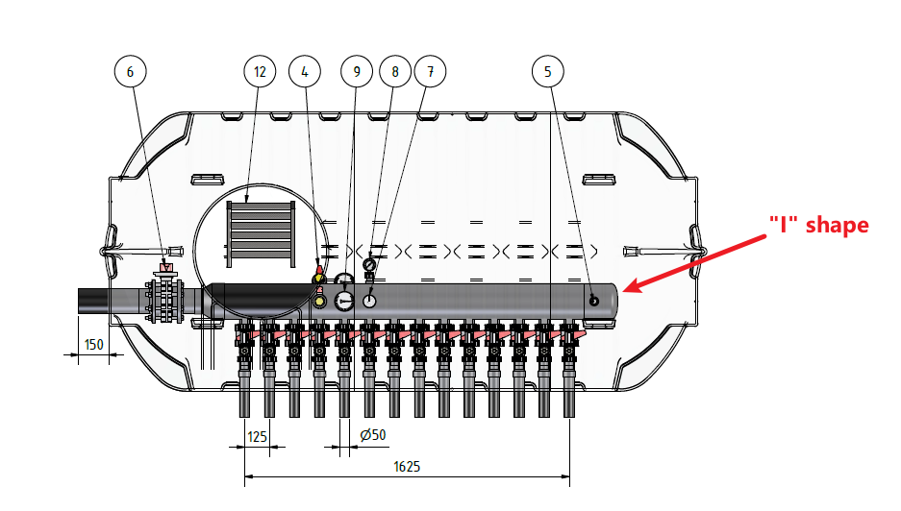

If the same chamber from on top, would be made as a “U” shape, the calculation will be a bit more complicated.
Here we have to differentiate between to options:
- The easy way would be, that 10 probes will be on one side and the other 10 probes would be on the other side.
Then the formular would change to this (see red marking)

“= (Number of probes – 1) * 2 * distance of probes * 2 + addition left side + addition right side”

- It gets more complicated if our customer wants to have the “U” shape like in the picture below. Here we don’t have the same amount of probes on both sides. Therefore to make it easier also in our ERP system, I would use the same formular, as it would be the same amount of probes on both sides.

“= (Number of probes – 1) * 2 * distance of probes * 2 + addition left side + addition right side”
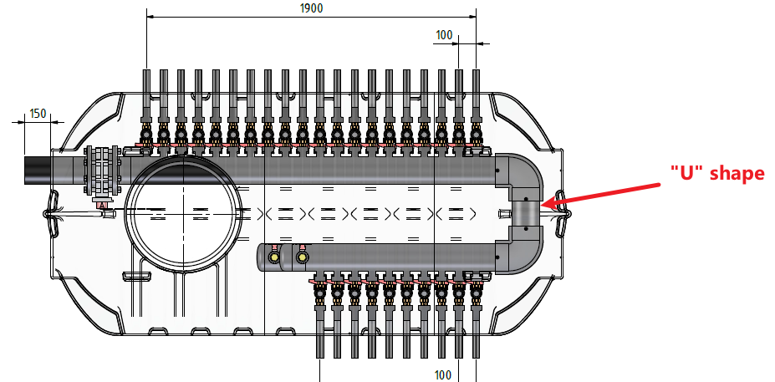

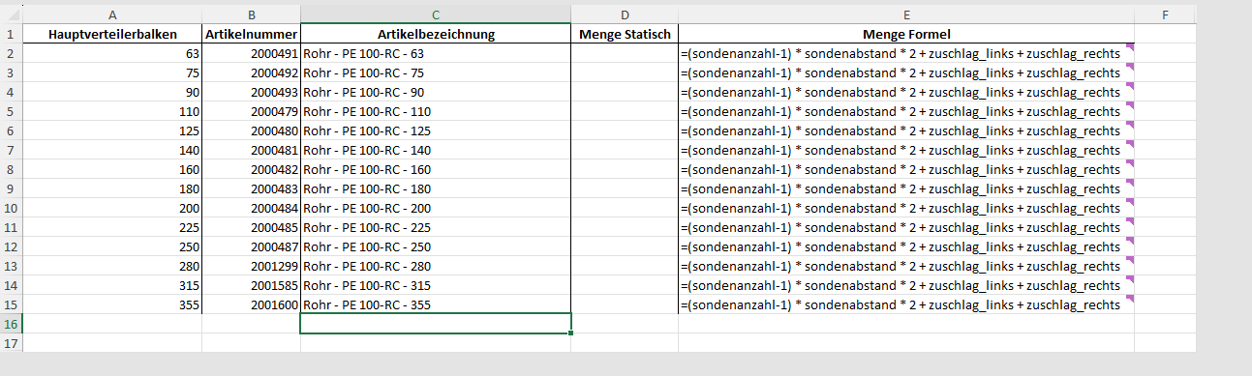
- Tab – „Sondenabstaende“

This Tab needs to be in the UI. The user must choose what type of “Sondenabstand” is necessary (see purple marking in 4th Screenshot)

Here we define what the distance of the probes (in German: Sonde) are.
- Dependency (Sondenabstand): The „HVB“ has a dependence on the distance of the probes. The longer the distance, the longer the HVB. This must be reflected in the BOM configurator.
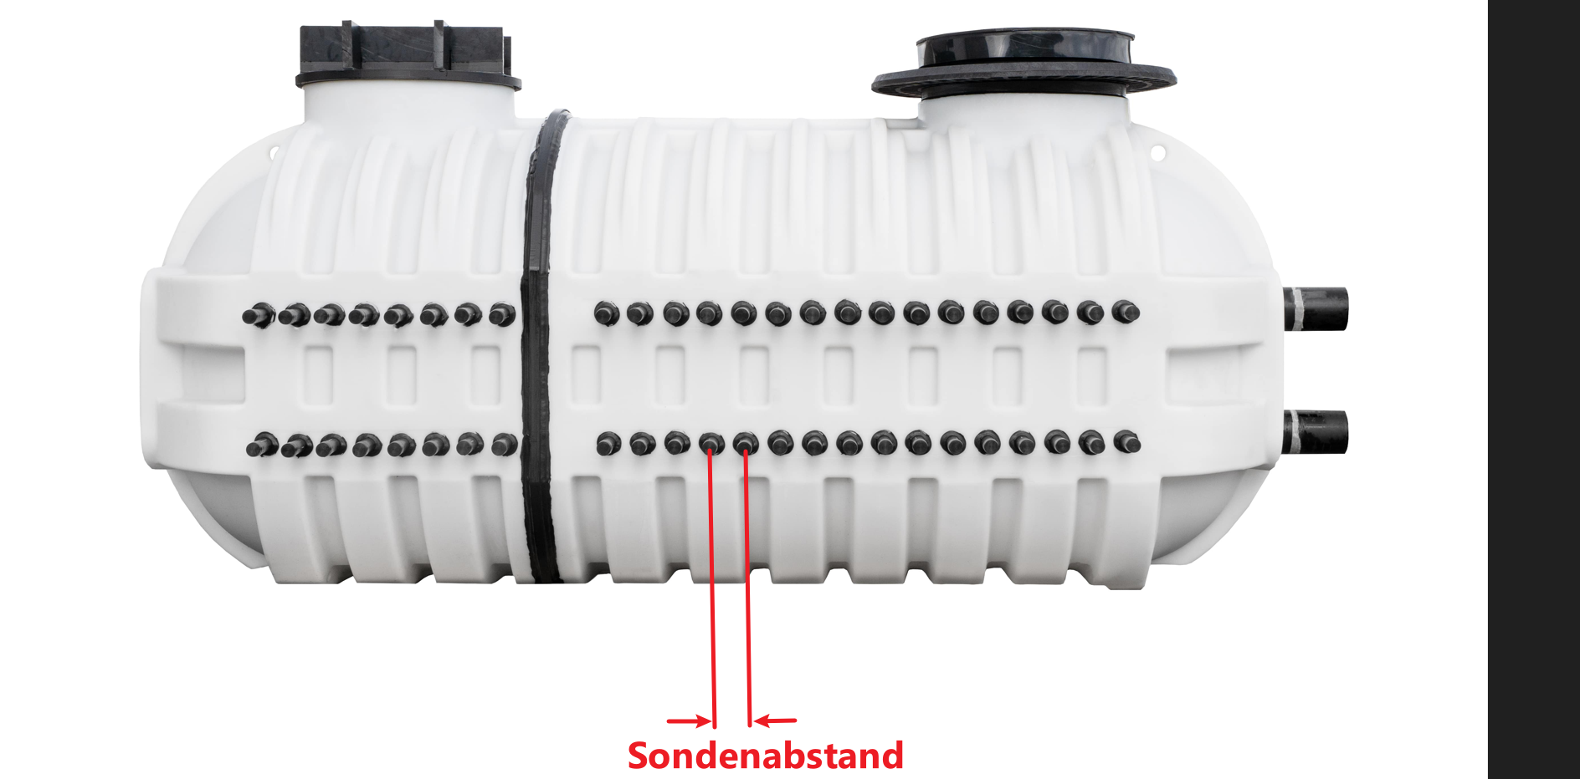

- Dependency (Anschlussart): The “HVB” has a dependence of the way how the probes will be connected to the HVB (Anschlussart). If all probes (for example 10) will be on one side, the HVB will be, with the standard distance of 100 mm, 90 cm long. If the probes will be on 2 sides (5 / 5), the HVB will be 40 cm long. This should be reflected on the BOM configuration

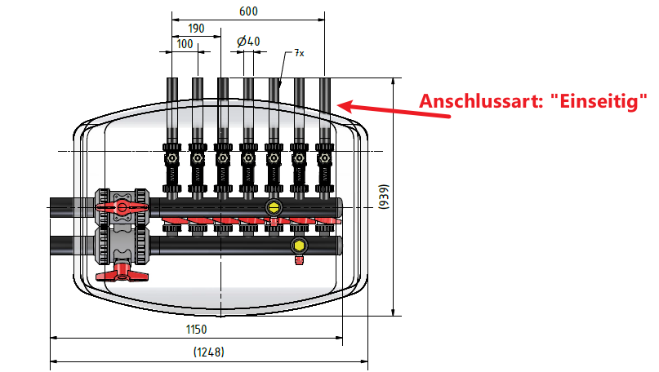

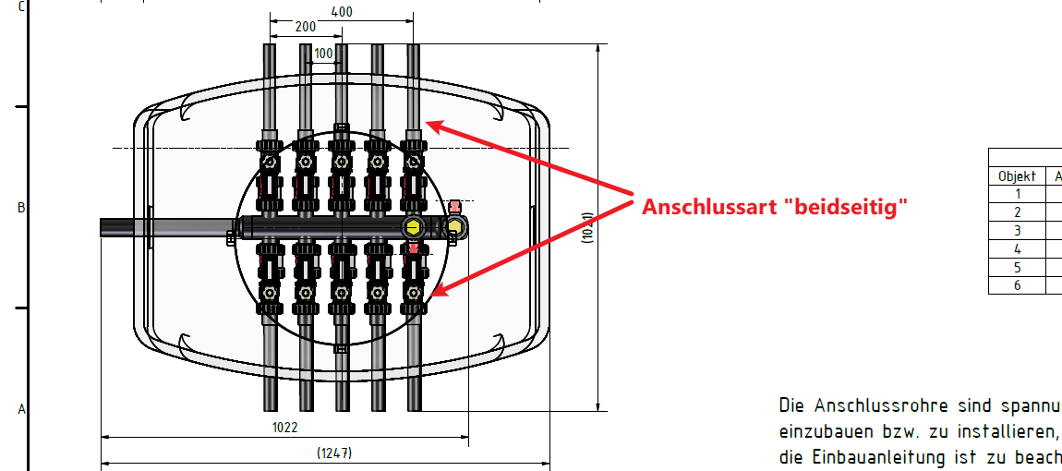

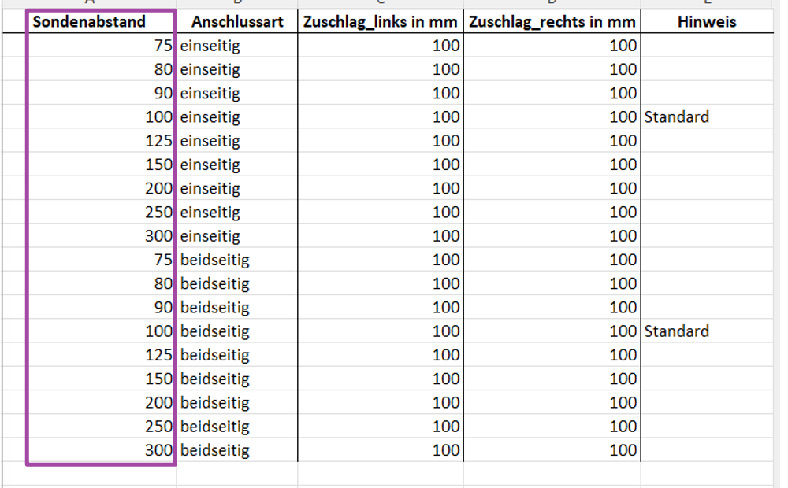
- Tab – „Stumpfschweiß-Endkappen“
This Tab does not need to be in the UI.

That is a main component

If a diameter of HVB is chosen, the same “Stumpfschweiß-Endkappe” diameter is chosen.

There is with two exception always 2 pieces of a kind.

The two exception (purple marked):

“Schacht” (chamber)
Dependency: If any chamber is chosen: With HVB in DA 63 mm we have 1 piece of a short “kurz” version and one piece of a long version. Here we always need from both 1 piece.

Verteiler
Dependency: If “Verteiler” is chosen: Two times the article 2000569 must be selected.
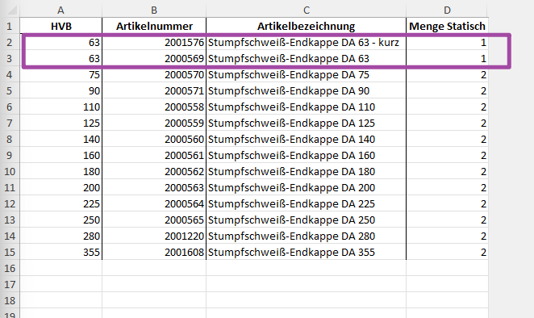
- Tab – „WPA“
This Tab needs to be in the UI. The user must choose what type of “WPA” is necessary (see purple column). That is the diameter which needs to be chosen for the diameter of the heating pump

That is a main component

What needs to be chosen is just the “Durchmesser WP”. It can be the same diameter as the “HVB”, or a smaller diameter.
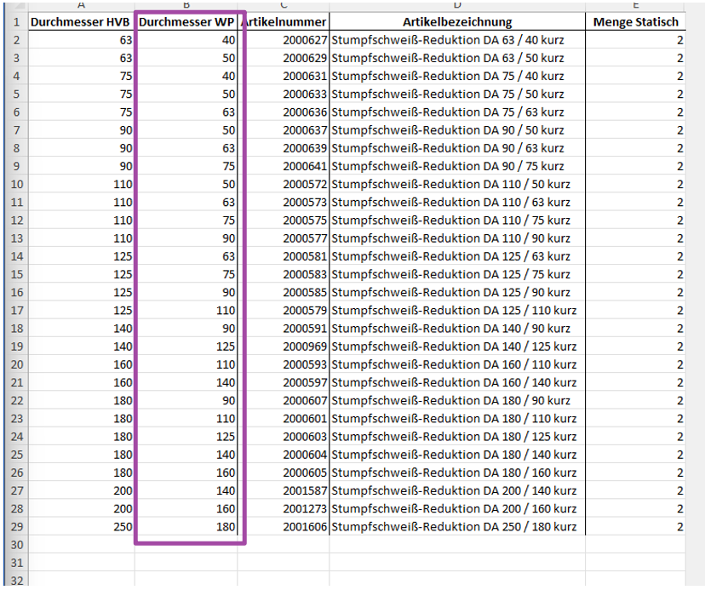
- Tab „WP-Verschlusskappen“
This Tab does not need to be in the UI.

That is a main component

If the “WPA” is chosen, it is automatically 2 pieces for the same diameter for the “WP-Verschlusskappen” chosen. Example: If “WPA” is 90 mm, 2 pieces 90 mm “WP-Verschlusskappen” must be selected.

We just have WP-Verschlusskappen up to 110 mm. We do not have bigger diameters. Nevertheless please program it that way, that we can add bigger diameters for the future.
Note: The Artikelbezeichnung says: “Sondenverschlusskappe“ but that is just to make it easier with our supplier.

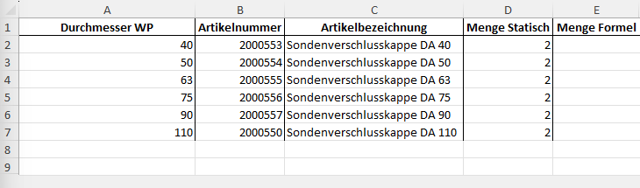
- Tab – “Kugelhähne”
This Tab needs to be in the UI. The user must choose what type of “Kugelhahn” is necessary.

Name of Selection in the user interface: “Kugelhahn”.

The user should select in the UI what Kugelhahn is necessary: (DN25/DA32, DN32/DA40, DN40/DA50, DN50/DA63)

Kugelhahn (from now ball valve) Diameter 32 mm (DN 25 / DA 32)
This ball valve has 6 different articles.

Quantities + Explanation
- Article 2000852 = One piece per probe

- Article 2001167 = Two pieces per probe

- Article 2001179:
  - Dependency: This part is just used for a HVB with a diameter of DA 63 mm
  - If dependency applies: One piece per probe

- Article 2001177:
  - Dependency: This part is just used for probes with a diameter of DA 40 or DA 50 mm
  - If dependency applies: one piece per probe

- Article 2001178:
  - Dependency: This part is for HVB and probes.
    - First Dependency: Probes for DA 32 mm
    - If dependency applies: One piece per probe

    - Second Dependency: HVB used for every diameter but not 63 mm
    - If dependency applies: One piece per probe

- Article 8000415
  - Dependency: This part is just used for probes with a diameter of DA 50 mm
  - If dependency applies: one piece per probe

Kugelhahn (from now ball valve) Diameter 40 mm (DN 32 / DA 40)
This ball valve has 3 different articles.

Quantities + Explanation
- Article 2000819
  - Dependency: This part is for HVB and probes.
    - First Dependency: Probes for DA 40 or 50 mm
    - If dependency applies: One piece per probe

    - Second Dependency: HVB used for every diameter
    - If dependency applies: One piece per probe

- Article 2001286
  - Dependency: See article 2000819
  - Two pieces per probe

- Article 8000416
  - Dependency: This part is just used for probes with a diameter of DA 50 mm
  - One piece per probe

Kugelhahn (from now ball valve) Diameter 50 mm (DN 40 / DA 50)
This ball valve has 2 different articles.

Quantities + Explanation
- Article 2000821
  - Dependency: This part is used for all HVB from 90 to 355 mm and just for probes 50 mm.
  - One piece per probe

- Article 2000791
  - Dependency: See article 2000821
  - Two piece per probe

Kugelhahn (from now ball valve) Diameter 63 mm (DN 50 / DA 63)
This ball valve has 2 different articles.

Quantities + Explanation
- Article 2000820
  - Dependency: This part is used for all HVB from 110 to 355 mm and just for probes 63 mm.
  - One piece per probe

- Article 2000793
  - Dependency: See article 2000820
  - Two piece per probe

- Tab – “DFM”
This Tab needs to be in the UI. The user must choose what type of “DFM” is necessary.

Name of Selection in the user interface: “Durchflussarmatur”.

For plastic DFM: The drop-down menu should have the following for different selections: 2-12, 8-28, 5-42 and 35-70
For brass DFM: The drop-down menu should have the following for different selections:

We have different kind of flowmeters: Plastic-Flowmeters (P-DFM) and Brass-Flowmeters (B-DFM).

Plastic DFM
There are 4 types of plastic flowmeters (P-DFM): 2-12, 8-28, 5-42 and 35-70 l/min. All plastic flowmeters have the same additional articles (2001167, 2001179, 2001177, 2001178) with the same quantities.

Quantities:
- Flowmeter (2-12, 8-28, 5-42 and 35-70) = number of probes

- Article 2001167 = twice the number of probes

- Article 2001179
  - Dependency: This part is just used for a HVB with a diameter of HVB of 63 mm
  - If dependency applies: One piece per probe

- Article 2001177
  - Dependency: This part is just used for probes with a diameter of DA 40 or DA 50 mm
  - If dependency applies: One piece per probe

- Article 2001178
  - Dependency: This part is for HVB and probes.
    - First Dependency: Probes for DA 32 mm
    - If dependency applies: One piece per probe

    - Second Dependency: HVB used for every diameter but not 63 mm
    - If dependency applies: One piece per probe

- Article 8000415
  - Dependency: This part is just used for probes with a diameter of DA 50 mm
  - If dependency applies: one piece per probe

Brass DFM
There are a lot of types of brass flowmeters. This will be one of the components, where we need a smart possibility, to add later more articles and “sub-articles” with the according dependencies (for HVB and probes)

HC VTR 20
Main component: 2000129 Quantity = amount of probes
Sub-components:
- 2000048
  - Dependency: This part is for HVB and probes (DA 32 or DA 50)
    - First Dependency: probes for DA 32 mm
    - If dependency applies: two piece per probe (1 x HVB and 1 x probe)

    - Second Dependency: probes for DA 50 mm
    - If dependency applies: two piece per probe (1 x HVB and 1 x probe)

- 2000050
  - Dependency: This part is for HVB and probes (DA 40)
    - Dependency: probes for DA 40 mm
    - If dependency applies: two piece per probe (1 x HVB and 1 x probe)

- 8000415
  - Dependency: This part is just used for probes with a diameter of DA 50
  - If dependency applies: one piece per probe (1 x for probe)

- 2000908 Quantity = 1 piece per HC VTR 20

HC VTR 25
Main component: 2000130 Quantity = amount of probes
Sub-components:
- 2000047
  - Dependency: This part is for HVB and probes (DA 32)
    - Dependency: probes for DA 32 mm
    - If dependency applies: two piece per probe (1 x HVB and 1 x probe)

- 2000049
  - Dependency: This part is for HVB (all diameters) and probes (DA 40 or DA 50)
    - First Dependency: probes for DA 40 mm
    - If dependency applies: Two piece per probe (1 x HVB and 1 x probe)

    - Second dependency: Probes for DA 50 mm
    - If dependency applies: One piece per probe (1 x for HVB side)

- 2000766
  - Dependency: This part is just used for probes with a diameter of DA 50
  - If dependency applies: one piece per probe (1 x for probe side)

- 2000908 Quantity = 1 piece per HC VTR 25

HC VTR 32
Main component: 2000132 Quantity = amount of probes
Sub-components:
- 2000765
  - Dependency = This part is for HVB and probes
    - First Dependency: probes for DA 40
    - If dependency applies: One piece per Probe (1 x for probe side)

    - Second dependency: Probes for DA 50 mm
    - If dependency applies: One piece per probe (f1 x or HVB side)

- 2000051
  - Dependency = This part is just used for probes with a diameter of DA 50
  - If dependency applies: one piece per probe (1 x for probe side)

- 2000908 Quantity = 1 piece per HC VTR 32

HC VTR 40
Main component: 2000133 Quantity = amount of probes
Sub-components:
- 2000810 Quantity = 2 pieces per HC VTR 40
- 2000765
  - Dependency = This part is for HVB and probes
    - First Dependency: probes for DA 40
    - If dependency applies: One piece per Probe (1 x for probe side)

    - Second dependency: Probes for DA 50 mm
    - If dependency applies: One piece per probe (1 x for HVB side)

- 2000051
  - Dependency = This part is just used for probes with a diameter of DA 50
  - If dependency applies: one piece per probe (1 x for probe side)

- 2000908 Quantity = 1 piece per HC VTR 40

IMI STAD A 20
Main component: 2001596 Quantity = amount of probes
Sub-components:
- 2000048
  - Dependency: This part is for HVB and probes (DA 32 or DA 50)
    - First Dependency: probes for DA 32 mm
    - If dependency applies: two piece per probe (1 x HVB and 1 x probe)

    - Second Dependency: probes for DA 50 mm
    - If dependency applies: two piece per probe (1 x HVB and 1 x probe)

- 2000050
  - Dependency: This part is for HVB and probes (DA 40)
    - Dependency: probes for DA 40 mm
    - If dependency applies: two piece per probe (1 x HVB and 1 x probe)

- 8000415
  - Dependency: This part is just used for probes with a diameter of DA 50
  - If dependency applies: one piece per probe (1 x for probe side)

IMI STAD A 25
Main component: 2001267 Quantity = amount of probes
Sub-components:
- 2000047
  - Dependency = This part is used for HVB (all diameters) and probes with a diameter of DA 32
  - If dependency applies: Two pieces per IMI STAD A 25 (1 x HVB and 1 x probes)

- 2000049
  - Dependency = This part is used for HVB (all diameters) and probes with a diameter of DA 40 or DA 50 mm
  - If dependency applies: Two pieces per IMI STAD A 25 (1 x HVB and 1 x probes)

- 2000766
  - Dependency = This part is just used for probes with a diameter of DA 50
  - If dependency applies: One piece per IMI STAD A 25 (1 x for probes)

IMI STAD A 32
Main component: 2001272 Quantity = amount of probes
Sub-components:
- 2000765
  - Dependency: This part is used for HVB (all diameters) and probes with a diameter of DA 40
  - If dependency applies: Two pieces per IMI STAD A 25 (1 x HVB and 1 x probes)

- 2000051
  - Dependency = This part is just used for probes with a diameter of DA 50
  - If dependency applies: One piece per IMI STAD A 32 (1 x for probes)

IMI TA-Compact P 25
Main component: 2001738 Quantity = amount of probes
Sub-components
- 2000047
  - Dependency = This part is used for HVB and probes with a diameter of DA 32
  - If dependency applies: Two pieces per IMI STAD A 25 (1 x HVB and 1 x probes)

- 2000049
  - Dependency = This part is used for HVB (all diameters) and probes with a diameter of DA 40
  - If dependency applies: Two pieces per IMI STAD A 25 (1 x HVB and 1 x probes)

- 2000766
  - Dependency = This part is just used for probes with a diameter of DA 50
  - If dependency applies: One piece per IMI STAD A 25 (1 x for probes)

- Tab – “Sondengrößen-Sondenlänge”

This Tab needs to be in the UI. The user must choose what diameter of “Sondengröße” is necessary. That is the diameter which needs to be chosen for the diameter of the probes as well as the length of the probe.

Name of Selection in the user interface:
- “Sondengröße” (DA 25, 32, 40, 50 or 63 mm).
- Sondenlänge (“Type in field” where any number is possible. The data can be any number and must be in meters “m” (e.g. “0,3 m”)

This is a permanently living Tab. The user must fill in, for each product (and we have here ten’s of thousands) what the diameters and length of probes are, depending on what “Schachttyp” is needed in a database.

In the user interface the user selects the size of the probes (DA 25, 32, 40, 50 or 63 mm). If the “Schachttyp” is not defined yet in the database, there should come a pop-up Window, saying that this “Schachttyp” is not yet defined in the database. Then there should be two possibilities:
- The user can say directly in the pop-up Window (or in a different Window), what the length will be. And if the user does not know it
- He should be able to say, what the length will be approximately. If possible such a “Schachttyp” must then be marked, so that the user must deliver the length of probes afterwards.

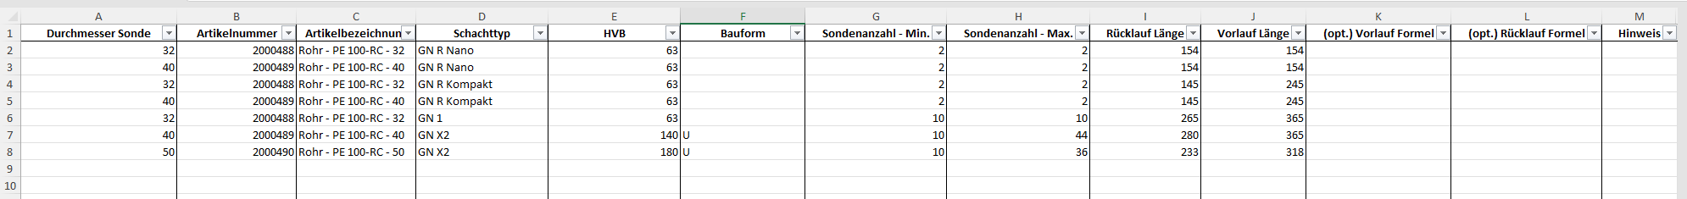

- Sondenverschlusskappe
This Tab does not need to be in the UI.

This is to be handled the same way as the “WP-Verschlusskappen” from point 8.
Quantity: two times the number of probes (10 probes = 20 “Sondenverschlusskappe”)
Diameter: Same diameter as for the probes (“Sondengröße”)
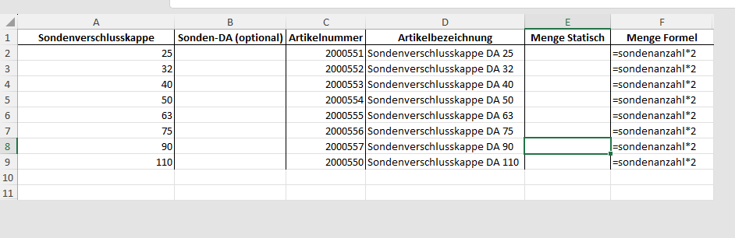

- Entlüftung
This Tab does not need to be in the UI.

Besides article numbers 2000815 and 2001177 all parts are always the same.

- Article 2000815:
  - Dependency: Is just used for HVB DA 63 mm
  - If dependency applies: two pieces

- Article 2001177
  - Dependency: Is used for all HVB but not DA 63 mm
  - If dependency applies: two pieces

