Advanced Penetration Testing Engineer- Hands On
CYBERSECURITY PROJECT
ON
Vulnerability Assessment & Penetration Testing
Batch 14 | Instructor: Rashadul Islam

Student Name | Samia Salam Oishee
Student ID | 2023000000145
Date | 18.5.2026
Instructor | Rashadul Islam
Lab Setup | Kali Linux + Metasploitable 2 on Host-Only Network
VA Tool | Nessus Essentials (free) – running on Kali Linux
Date of Submission | 18.5.2026
Time Allowed | 3 Days

SECTION A: VULNERABILITY ASSESSMENT

VA Task 1: Configure and Run a Nessus Scan

Scan Name you gave it | Samia
Target IP entered | 192.168.28.129
Scan Policy used | Basic Network Scan
Date & time scan started | 18.5.2026 8:01
Date & time scan completed | 18.5.2026 8:20
Total scan duration (approx.) | 19-20 min

Critical | High | Medium | Low | Informational
11 | 7 | 24 | 9 | 142
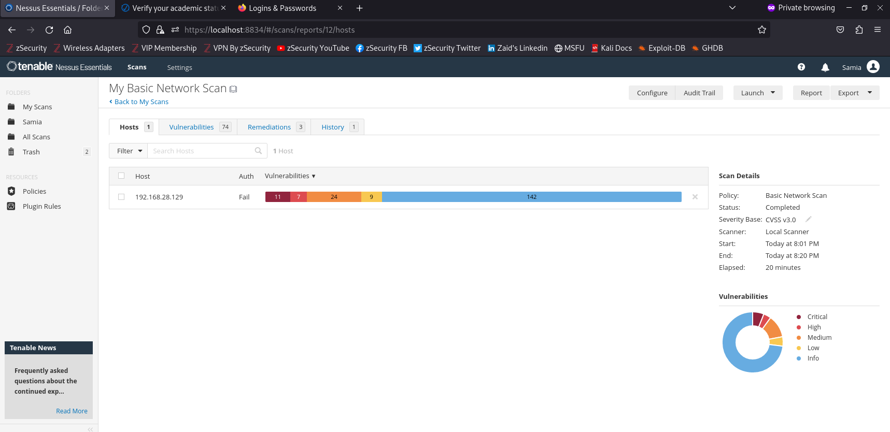

VA Task 2: Analyse Nessus Findings

Vulnerability Name | Unreal IR Cd Backdoor Detection
Severity Level | Critical
CVE Number | CVE-2010-2075
Affected Port / Service | TCP
What does this vulnerability mean? | The FTP service contains a malicious backdoor vulnerability. An attacker can remotely access the system without valid credentials.
What could an attacker do with it? | An attacker can gain shell access to the target machine. They may steal data or fully control the system.
Fix / Recommendation | Upgrade vsftpd to a secure version and disable vulnerable FTP services.
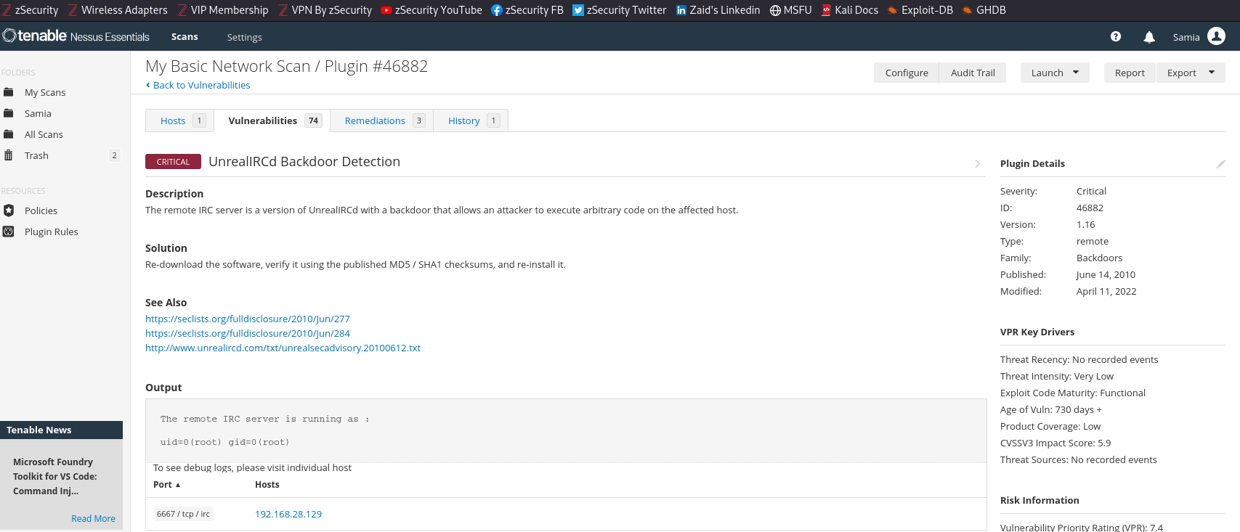

Vulnerability Name | SSL Anonymous Cipher Suites Supported
CVE Number | CVE-2007-1858
Affected Port / Service | 25 / tcp / smtp
Brief Explanation | (1–2 sentences)
Fix / Recommendation
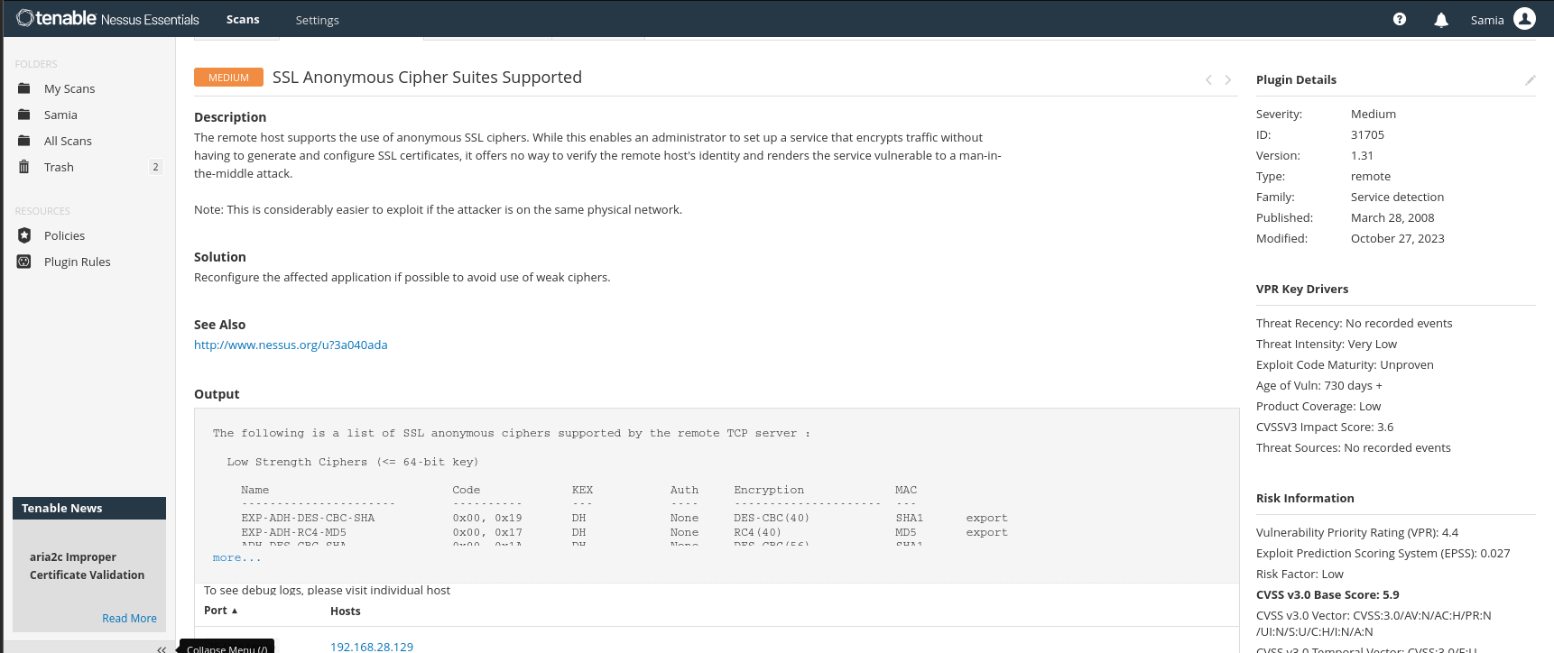

- In your own words, explain the difference between a Vulnerability Assessment and a Penetration Test.

A Vulnerability Assessment identifies and lists security weaknesses in a system. A Penetration Test actively exploits vulnerabilities to determine real-world impact. VA focuses on detection, while PT focuses on exploitation and proof of risk.

TESTING

PT Task 1: Exploitation with Metasploit

 | Target Service | Port | Metasploit Module
A | vsftpd 2.3.4 (FTP backdoor) | 21 | exploit/unix/ftp/vsftpd_234_backdoor
B | Samba (SMB) | 445 | exploit/multi/samba/usermap_script

My choice (circle or write A or B): ___A____

- Did the exploit succeed? Describe what happened in 2–3 sentences:
Yes, the exploit successfully opened a remote shell on the target machine. I gained unauthorized access through the vulnerable FTP service.

- What user account did the shell give you access as (from the whoami output)? Why does this matter?
The shell provided root access, which gives full administrative control over the system. An attacker could completely compromise the machine.

PT Task 2: Write a Short Penetration Test Report | [20 marks
What you need to do:
Fill in the finding report card below for the exploit you just performed. This is the kind of report a real penetration tester would write for a client.

Finding Title | vsftpd 2.3.4 Backdoor Remote Command Execution
Severity | critical
Affected Service & Port | ftp 21
CVE Number | Cve 2011 2533
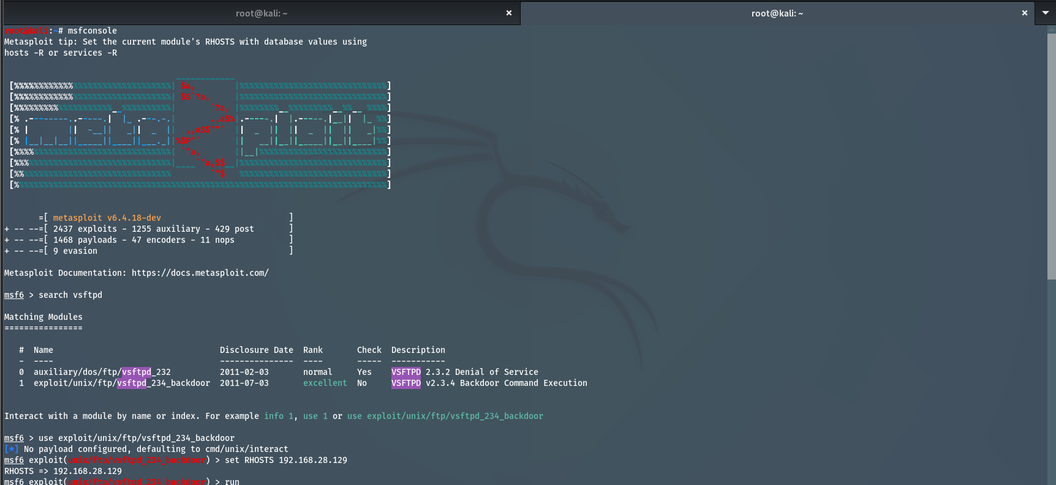
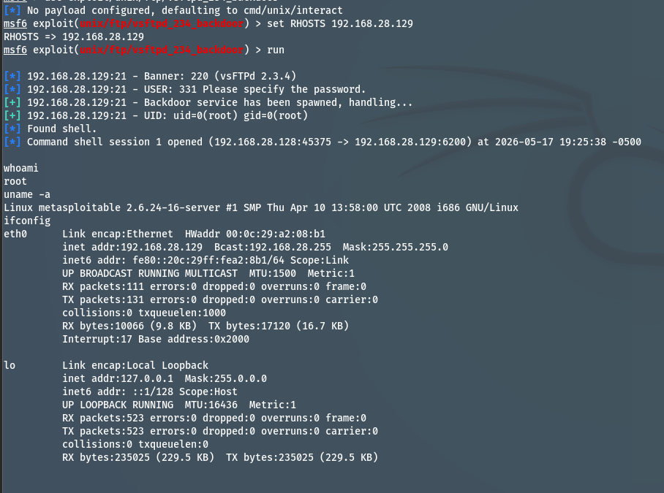

What is the vulnerability?
The installed version of vsftpd contains a backdoor vulnerability that allows remote attackers to gain unauthorized shell access to the server.

How was it exploited?
Metasploit Framework was used to exploit the vulnerable FTP service. After setting the target IP and running the exploit module, a remote shell session was obtained successfully.

What is the impact?
An attacker could fully compromise the system, steal data, install malware, or use the machine for further attacks.

Recommended Fix
Upgrade the FTP service to a secure version, disable unnecessary services, and regularly apply security patches.

