SOLUTIONS & AUTOMATION
UrbanCart
24/7 Voice + Chat Customer Operations Platform

Task 1 — Analyze & Propose the Solution
Field | Detail
Client | UrbanCart • E-commerce • Pakistan
Prepared for | Sarah Malik, Operations Manager
Discovery meeting | 1 September 2026 • BD: Ibrahim Wasiq Qurashi
Prepared by | Solutions & Automation Engineer
Document type | Architecture and solution proposal
Implementation window | Initial working version in 6–8 weeks
Status | Recommended architecture for client review

This proposal analyses the discovery meeting, names the problems that are actually costing UrbanCart customers, and designs an end-to-end system the operations team can run without a developer rewriting prompts every time a PDF changes.

1. Executive summary
UrbanCart already has demand. What it does not have is a single, reliable way to answer customers after hours, keep product and policy answers truthful, capture sales-ready leads, and surface only the work that actually needs a human.
The proposed platform is a conversation layer in front of UrbanCart’s real business data. Customers talk by website chat, WhatsApp, or phone. A Vapi voice agent handles the call. n8n orchestrates every turn: classify intent, look up an order, retrieve policy text, write a lead, or escalate. Answers that depend on catalog or policy are produced only from retrieved documents (RAG). Structured records live in PostgreSQL. Day-to-day work for sales, support and operations lives in Airtable. Documents stay in Google Drive so non-technical staff can update knowledge by dropping a file. Slack is reserved for events that deserve interruption. Notion is the internal operating manual. Zapier covers a small set of business-owned automations that operations can change without touching the core orchestrator.
Design principle
The AI is a receptionist and a knowledge clerk, not a decision-maker. It answers what UrbanCart has published. It collects what sales asked for. It never invents a return window, a price, or a delivery promise. If retrieval is weak or the customer is angry, a human takes over.

What changes for UrbanCart after the first release:
- A customer who messages at 1 a.m. gets a grounded answer or a clear next step, not silence until morning.
- Sales receives one lead record with name, phone, product, budget, city and intent — not a screenshot from three apps.
- Support sees order status without hunting spreadsheets, and is interrupted only for damaged goods, complex refunds, failed automations and high-value buyers.
- When shipping policy changes, operations replaces the file in Drive. The vector index updates. No code change.

2. Current state and key problems

2.1 How UrbanCart works today
UrbanCart sells electronics, accessories, home and lifestyle products through the website, Instagram and WhatsApp. Support answers product, price, stock, delivery and return questions by hand during business hours. Customer data sits in spreadsheets, the store backend and a separate complaints sheet. Leads arrive from several channels and are hard to track. Order status is looked up manually. Policies live in PDFs, Word files and spreadsheets that change often.

2.2 Problems that matter
Problem | Evidence from the meeting | Business cost
After-hours blackout | Night messages wait until the next day | Lost buyers who will not wait
Manual FAQ load | Most product, price, delivery, return questions answered by staff | Support time spent on repeatable work
Hallucination risk | Catalog and policies change; they do not want invented answers | Wrong delivery/return promises damage trust
Lead leakage | Leads arrive in different places; sales starts from zero | Slow follow-up, missed high-intent buyers
Order lookup friction | Agent searches UC-10452 by hand | Longer calls, inconsistent status
No single system of record | Sheets + store + complaints sheet | No management view of customers, leads, tickets
Knowledge update is manual | Someone must update everything when a PDF changes | Stale answers; depends on developers
Escalation is informal | Damaged goods / refunds / anger need a human immediately | Angry customers wait in the same queue as FAQs
Notification noise risk | Team uses Slack and does not want every chat pinged | Alert fatigue if poorly designed

2.3 What success looks like (client words)
- Customers can contact UrbanCart by chat or phone at any time.
- Common questions are answered from actual business information.
- Potential buyers are identified and useful leads reach sales.
- Basic order inquiries are handled without a spreadsheet hunt.
- The team is alerted only when a human is required.
- Management can see what is happening.
- The first version is reliable and expandable — not everything automated on day one.

3. What to automate vs keep under human control
The client was explicit: do not try to solve everything. The split below is the operating contract between the AI and the team.

3.1 Automate in the first release
- Greeting, language detection (Urdu/English mix is common), and intent classification.
- Product availability, price and specification answers drawn from the catalog in RAG + product table.
- Shipping coverage and typical delivery time drawn from the shipping policy (e.g. “Do you deliver to Lahore?”).
- Return window and warranty answers drawn from the current policy documents.
- Simple order status by order ID (example: UC-10452) from PostgreSQL.
- Lead collection to the required minimum fields, with validation.
- Writing conversation summaries, leads, tickets and tasks to the right stores.
- Selective Slack alerts and a Zapier path that creates a dated Drive folder + Notion log for high-priority tickets.
- Knowledge re-ingest when a Drive file is added or replaced.

3.2 Remain under human control
- Damaged product, missing items, and quality disputes.
- Complicated refunds, partial refunds, exceptions to policy.
- Angry, abusive, or legally threatening conversations.
- Price negotiation, custom discounts, bundle deals not in the catalog.
- Payment disputes, COD refusal after dispatch, courier exceptions that need judgement.
- Any question where retrieval confidence is below threshold or documents conflict.
- Publishing a new policy — a person drops the file in Drive and confirms it is the active version.
- Final decision to cancel or replace an order.

3.3 Grey zone — AI prepares, human decides
The agent may collect facts (order ID, photos promised, preferred callback time) and open a ticket with a recommended next step. It must not promise a refund, a replacement, or a delivery date that is not in the retrieved policy or order record.

4. Users, roles and journeys

4.1 Users
Actor | Goal | Primary surface
Shopper / caller | Get a true answer fast, or buy | Website chat, WhatsApp, phone (Vapi)
Sales | See ready-to-buy leads with context | Airtable Leads + Slack #sales-leads
Support | Handle exceptions and order issues | Airtable Tickets + Slack #support-priority
Operations | Keep catalog/policies current, watch failures | Google Drive, Airtable Tasks, Slack #ops-alerts
Management | See volume, conversion, escalations | Airtable dashboards + Notion weekly brief
System (n8n) | Route every turn safely | Webhooks, DB, RAG, notifications

4.2 Customer journeys

Journey A — After-hours product question (chat)
- Customer on WhatsApp: “Is the iPhone 15 available and what is the price?”
- Webhook hits n8n. Intent = product_inquiry. Product resolved against catalog.
- RAG + product table return stock, price, short spec. Answer cites the catalog version.
- Agent asks if they want a sales callback. If yes, Journey C.

Journey B — Policy question (voice or chat)
- “Can I return headphones after 10 days?”
- Intent = policy_question, domain = returns.
- Vector search filtered to return_policy chunks. If the policy says 7 days, the answer is 7 days, with the document name.
- If no chunk clears the score threshold, the agent says it cannot confirm and opens a support ticket.

Journey C — Lead capture
- Customer shows purchase intent (“I want to buy”, “what is your best price”, “please call me”).
- Agent collects: name, phone, product, budget, city, ready-to-buy vs browsing.
- Record upserted in PostgreSQL customers + Airtable Leads. High-value rule fires Slack.
- Sales sees previous conversations on the same phone number — they do not start from zero.

Journey D — Existing order
- “My order UC-10452 hasn’t arrived yet.”
- Intent = order_status. Identity check: order ID + phone (or name + city if ID missing).
- PostgreSQL returns status, last checkpoint, promised window. Simple delay with a known courier scan is answered. “Stuck 8 days, no scan” becomes a ticket.

Journey E — Complaint / escalation
- “The parcel arrived smashed” / raised voice / refund demand outside policy.
- Sentiment + intent = escalate. Agent apologises, stops trying to close the case, captures order ID and callback number.
- P1 ticket in Airtable, Slack to #support-priority, Zapier creates an evidence folder in Drive and a Notion incident line.

5. How customers interact — chat and voice

5.1 Shared conversation contract
Chat and voice use the same brain (n8n + RAG + databases). Only the mouth is different. That keeps answers consistent and avoids two prompt codebases drifting apart.
- Identity: phone number is the primary key on WhatsApp and voice; chat widget may only have a session ID until a phone is given.
- Language: reply in the customer’s language. Urdu, Roman Urdu and English are all expected.
- Honesty: never invent stock, price, delivery days or return windows. Quote the retrieved source or escalate.
- Length: voice answers are short (one idea, then a question). Chat may include a compact spec list.
- Memory: the last 8 turns plus any matched customer/order record are passed into the turn.

5.2 Chat (website + WhatsApp)
Website widget and WhatsApp both POST to the same n8n webhook. WhatsApp is the higher-volume channel today, so the first release treats it as a first-class channel, not an afterthought. Each turn returns a text reply and optional quick-reply chips (Check another product / Track an order / Talk to sales / Talk to support).

5.3 Voice (Vapi)
Vapi is the AI receptionist on the UrbanCart phone number. It is the right tool because it is built for low-latency spoken dialogue, telephony, barge-in, and tool calls — not because a list asked for a voice vendor.
Vapi configuration for UrbanCart:
- System prompt: receptionist for UrbanCart, Pakistan e-commerce. Warm, concise, never invent policy.
- Tools (server URLs pointing at n8n): lookup_product, lookup_policy, lookup_order, create_lead, create_ticket, end_call_summary.
- Start speaking first: “UrbanCart, how can I help you?”
- Silence timeout and max-duration guards so abandoned calls do not hang.
- Escalation tool immediately transfers or leaves a structured voicemail ticket if no agent is on shift.
- After hang-up, Vapi end-of-call report posts transcript + recording URL to n8n for logging.
Voice is worse than chat at long policy quotes. The agent therefore summarises (“Returns are accepted within 7 days if unused and sealed”) and offers to send the same answer on WhatsApp.

6. System architecture
The architecture is a hub-and-spoke model. Customers never talk to five tools. They talk to one conversation layer. n8n is that layer. Everything else is a system of record, a knowledge store, or a notification sink.
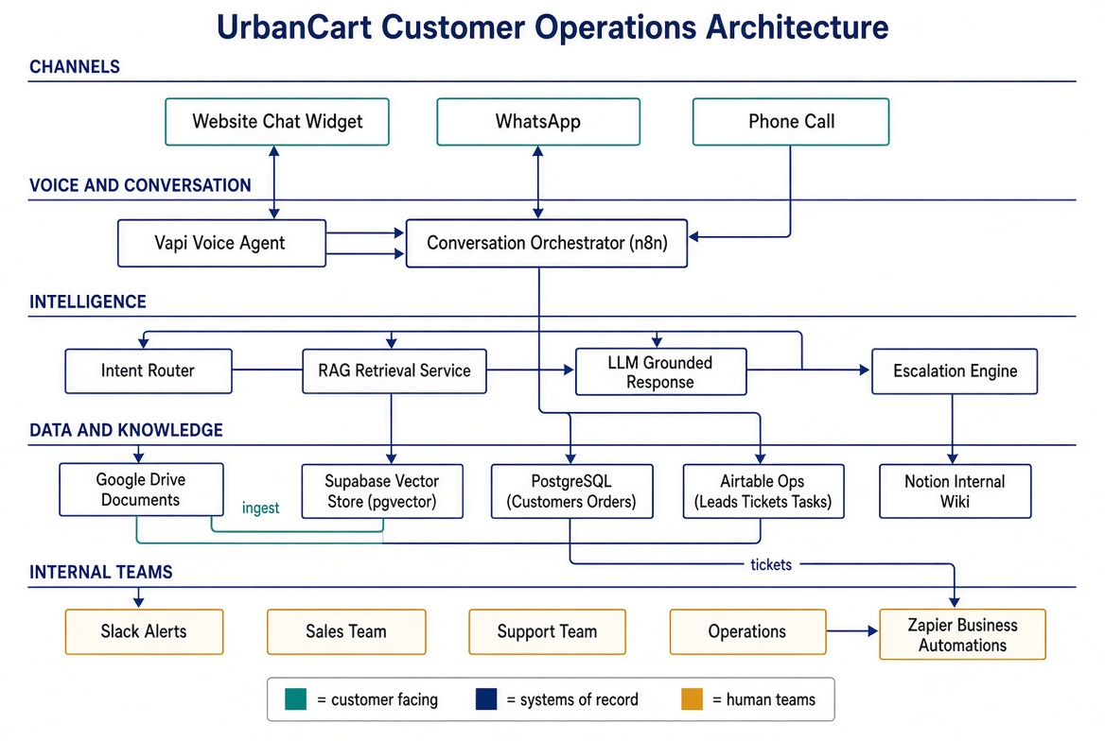
Figure 1. UrbanCart customer operations architecture.

6.1 Request path (one customer turn)
- Channel event arrives (WhatsApp message, chat widget payload, or Vapi tool-call / transcript).
- n8n authenticates the webhook, validates payload, loads or creates a conversation session.
- Customer match: phone → PostgreSQL customers. Attach open tickets and last orders.
- Intent + slots: product_inquiry, policy_question, order_status, lead_capture, complaint, other.
- Branch: structured lookup (order/product table) and/or RAG retrieve.
- Grounded reply generated with source snippets. If confidence is low → escalate path.
- Persist: conversation turn, any lead/ticket/task, audit log.
- Side effects only if rules match: Slack, Zapier hook, Airtable status change.

6.2 Why this shape
- n8n can express the messy real world (if/else, retries, human-in-the-loop) without burying it in application code.
- PostgreSQL holds the records that must be consistent (orders, customers). Airtable holds the records humans live in all day (pipeline, tickets, tasks).
- Supabase gives hosted Postgres + pgvector + auth + storage so RAG and relational data can share one project without standing up a separate vector vendor.
- Drive remains the place non-technical staff already put files. Notion remains the place they already write process. Neither is asked to be the transactional database.

7. Technology roles — why each tool is here
Every item below has a job. If it cannot be justified, it would not be in the build.
Technology | Role in UrbanCart | Why this tool, not a substitute
Vapi | Spoken receptionist on the company phone line: STT, LLM turn-taking, TTS, tool calls into n8n, call recordings. | Built for telephony voice agents. A chat model on a SIP bridge would add latency and custom telephony work UrbanCart does not need in week one.
n8n | System orchestrator. Owns webhooks, intent routing, RAG retrieve/ingest, Postgres and Airtable writes, Slack, error retries, conversation state. | Self-hostable, branching workflows, native HTTP/DB nodes. The place complex support logic should live so it is visible to engineers.
Zapier | Business-owned side workflows. First zap: P1 ticket → dated Drive evidence folder + Notion Incidents row + optional Gmail to ops lead. | Operations can adjust a zap without opening n8n. Keeps “office automation” separate from the conversation brain.
Google Drive | Source of truth for product catalog, shipping, returns, warranty, support guidelines, training docs. Trigger for knowledge refresh. | Staff already produce PDFs, Word and sheets. Drive is the drop-zone; the AI must follow the file, not a hidden copy.
Airtable | Operational workbench: Leads, Tickets, Tasks, Daily snapshot. Views for sales, support, ops, management. | Better than sheets for filtered views and forms; lighter than building an internal app. Humans will actually use this.
Notion | Internal knowledge: how the agent works, escalation playbook, prompt change log, weekly ops brief, incident diary. | Already in use at UrbanCart. Wrong place for order rows; right place for “how we work”.
Slack | Interrupt channel for high-value leads, P1 complaints, failed automations, serious order exceptions. | Already the internal chat. Rules exist so it does not become a transcript dump.
PostgreSQL | System of record for customers, orders, order items, conversation sessions, audit events. | Orders need joins, unique constraints, and status history. Spreadsheets and Airtable are the wrong primary store for that.
Supabase | Hosted backend: Postgres access, pgvector for embeddings, storage for extracted text, service-role APIs used by n8n, optional auth for an internal viewer. | One project covers relational + vector + file artefacts. Avoids a second vector SaaS and a hand-managed Postgres box.
RAG | Ground every catalog/policy/warranty answer in retrieved UrbanCart text. Refuse to answer when retrieval is weak. | The client forbade made-up policy. RAG is the method that makes that promise testable.

n8n vs Zapier
n8n is the backbone: multi-step reasoning, database I/O, RAG, voice tool-calls. Zapier is a side door for operations. Mixing them on purpose prevents the conversation workflow from becoming an unmaintainable zap, and prevents engineers from being called to create a Drive folder.

8. Data architecture — what lives where
Data is split by how it is used, not by which vendor is fashionable. If a sales person must sort and filter it every morning, it is in Airtable. If a wrong duplicate would break an order lookup, it is in PostgreSQL. If a human authored it as a document, it stays in Drive and is projected into the vector store.

8.1 Placement map
Information | System of record | Also projected to | Notes
Customer | PostgreSQL customers | Airtable Leads / Tickets (lookup) | Keyed by phone E.164
Lead | Airtable Leads | Postgres lead_events (audit) | Sales lives here
Product catalog row | Postgres products | Drive catalog file → vectors | Price/stock from table; prose from RAG
Order + items + status | PostgreSQL orders | Airtable Tickets when issue opened | UC-##### is unique
Conversation turns | PostgreSQL conversations / messages | — | Transcript + channel + tokens
Support ticket | Airtable Tickets | Slack, Notion incident if P1 | Human queue
Ops task | Airtable Tasks | Slack if SLA breach | Follow-ups, courier checks
Policy / catalog files | Google Drive | Supabase Storage + pgvector | Versioned by file id + modified time
Embeddings / chunks | Supabase pgvector | — | Never shown raw to staff
Playbooks, runbooks | Notion | — | Not retrieved for customers
Alerts | Slack (ephemeral) | Airtable + Postgres audit | Do not use Slack as storage

8.2 PostgreSQL (via Supabase) — core tables
- customers — id, full_name, phone unique, city, channel_origin, created_at, last_seen_at.
- products — sku, name, category, price_pkr, currency, stock_qty, is_active, warranty_months, updated_at.
- orders — id, order_code unique (UC-10452), customer_id, status, city, courier, promised_by, last_checkpoint, total_pkr, created_at.
- order_items — order_id, sku, qty, unit_price.
- conversations — id, channel (voice|whatsapp|web), customer_id, vapi_call_id, started_at, ended_at, outcome.
- messages — conversation_id, role, text, intent, retrieval_ids[], confidence, created_at.
- lead_events — customer_id, product, budget_pkr, ready_to_buy, airtable_record_id, notified.
- audit_log — actor (agent|n8n|zapier|human), action, payload jsonb.

8.3 Supabase vector schema
- documents — drive_file_id unique, title, doc_type (catalog|shipping|returns|warranty|support|training), version, checksum, ingested_at, is_active.
- chunks — id, document_id, chunk_index, content, token_count, embedding vector(1536), metadata jsonb (heading, page, sku if any).
Match function: cosine similarity over active documents, optional filter on doc_type, return top 6 with score. Training documents are never in the customer-facing filter.

8.4 Airtable bases
- Leads — Name, Phone, Product, Budget (PKR), City, Intent (Ready / Browsing), Source (Voice/WhatsApp/Web), Status, Owner, Postgres customer id, Conversation link, Created.
- Tickets — Priority (P1–P3), Type (Damage / Refund / Anger / Missing knowledge / Order exception), Customer, Order code, Summary, Channel, Status, Assignee, SLA due.
- Tasks — Title, Related ticket/lead, Owner team, Due, Status.
- Daily Ops — Date, chats, calls, auto-resolved %, leads, P1s, ingest jobs, failed jobs. Filled by a scheduled n8n workflow.

8.5 Notion structure
- UrbanCart Agent Operating Manual (what it may and may not say).
- Escalation playbook for support.
- Prompt and tool-schema change log.
- Incidents database (created by Zapier on P1).
- Weekly management brief template.

8.6 Google Drive folders
- /UrbanCart Knowledge/Active — only files in this folder are ingested as live knowledge.
- /UrbanCart Knowledge/Archive — replaced policies, kept for audit.
- /UrbanCart Knowledge/Inbox — drafts; not ingested.
- /UrbanCart Evidence/{ticket-id} — created by Zapier for P1 cases (photos, chat export).

9. RAG design — grounded answers from UrbanCart documents
The client’s example was exact: “Can I return headphones after 10 days?” must be answered from the current return policy, not from a model’s memory of typical e-commerce rules. RAG is how that constraint is enforced.
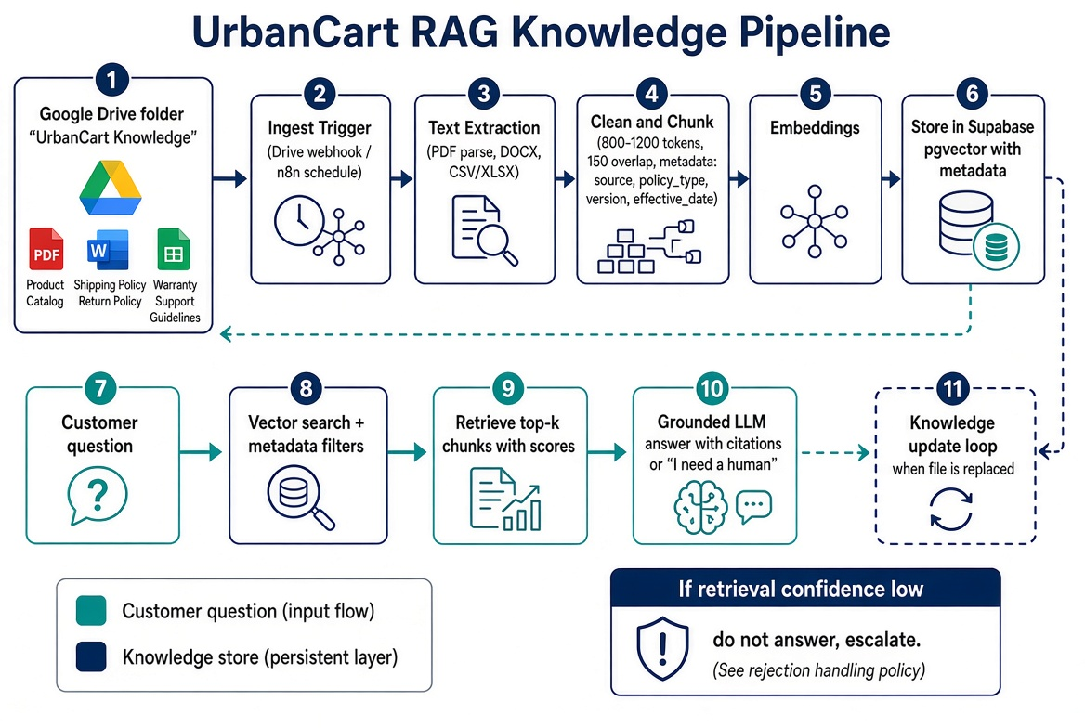
Figure 2. Document ingest and retrieval pipeline.

9.1 Ingestion
- Operations drops or replaces a file in Drive /Active (PDF, DOCX, XLSX/CSV). Folder watch via Drive push notification or n8n polling every 10 minutes in v1.
- n8n ingest workflow records drive_file_id, md5, mime type. If checksum unchanged, stop.
- Text extraction: PDF text layer first; scanned pages go through OCR. DOCX via paragraph extract. Sheets become “SKU | field | value” sentences so embeddings work on tabular catalog rows.
- Cleaning: drop headers/footers, collapse whitespace, keep headings as metadata.
- Chunking: 800–1,200 tokens, 150-token overlap, split on headings where possible. Each chunk stores doc_type, title, heading path, page, file version, effective date if present.
- Embed with a single embedding model (text-embedding-3-small or equivalent). Upsert into chunks. Mark previous chunks for that drive_file_id inactive so old policy text cannot be retrieved.
- Write ingest result to Airtable Tasks (success/fail) and Slack #ops-alerts only on failure.

9.2 Retrieval
- Embed the customer question plus a short rewritten standalone query (“return window for headphones”).
- Filter by doc_type when intent is known (returns → returns + warranty; delivery city → shipping; product spec → catalog).
- Retrieve top 6 by cosine similarity. Keep chunks with score ≥ 0.72 (tune in week 3 against a 40-question gold set).
- If the best score < 0.72, or the top chunks disagree, do not answer from the model prior. Escalate as missing_knowledge.

9.3 Grounded generation
The generator receives: system contract, customer turn, retrieved chunks labelled [S1], [S2]…, and any structured product/order rows. Instructions: answer only with facts present in S* or structured rows; cite the document title in plain language (“according to our Return Policy”); if the user asked for something absent, say so.
Example grounded reply: “Our Return Policy allows unused headphones to be returned within 7 days of delivery, with original packaging. Ten days is outside that window, so I cannot approve a return from here. I can have support call you if you want an exception review.”

9.4 Knowledge updates without developers
Replacing Return_Policy_v4.pdf in /Active is enough. Ingest deactivates v3 chunks. No prompt edit. Notion change-log is updated by the ingest workflow so the team can see “shipping policy refreshed at 14:02, 12 chunks.” Training documents in Drive are tagged doc_type=training and excluded from customer retrieval; they exist so future staff fine-tuning or internal copilots can use them without leaking internal tone rules to shoppers.

9.5 Evaluation
A frozen set of questions from the meeting plus UrbanCart-like variants (Lahore delivery, warranty months, return after 10 days, UC-10452 status, damaged parcel) is run after every ingest. Failures become Airtable Tasks, not silent drift.

10. Voice and chat interaction design

10.1 Intent set (v1)
Intent | Examples | Systems touched
product_inquiry | Is this available? Price? Specs? | products + catalog RAG
policy_shipping | Do you deliver to Lahore? How long? | shipping RAG
policy_returns | Can I return after 10 days? | returns RAG
policy_warranty | Does this have warranty? | warranty RAG + product row
order_status | UC-10452 has not arrived | PostgreSQL orders
lead_capture | I want to buy / call me | Airtable Leads + Slack if high value
complaint | Arrived damaged / I want a refund | Airtable Tickets P1 + Slack + Zapier
handoff_human | Let me talk to someone | Ticket P2 + queue message
smalltalk_other | Hello / thanks | none beyond log

10.2 Voice flow (Vapi → n8n tools)
- Call lands on Vapi number. Agent greets.
- As the user speaks, Vapi streams partial transcripts. When a tool is needed, Vapi POSTs to n8n with tool name + args + call id.
- n8n runs the same functions as chat and returns a short JSON result (not a paragraph of policy). Vapi speaks a compressed version.
- If create_ticket or create_lead is called, n8n writes records before the spoken confirmation so a dropped call does not lose the lead.
- On end-of-call, transcript, recording URL, extracted slots and outcome are stored. If a lead was partial (name + phone only), Airtable status = Incomplete and sales still sees it.

10.3 Chat flow
Identical tool set, longer text allowed, optional “send this on WhatsApp” if the user started on web. Conversation id is reused if the same phone writes later so sales can read prior context.

11. Lead capture
Minimum fields from the meeting: name, phone, product of interest, approximate budget, location, ready to purchase vs only asking.

11.1 Collection rules
- Ask one field at a time on voice; chat may use a short form.
- Validate phone as Pakistan mobile (03XX or +92 3XX). Repeat back the number on voice.
- Budget stored as integer PKR. “Around two lakh” → 200000 with a flag inferred=true.
- If the customer refuses a field, save partial lead rather than looping.
- Deduplicate on phone: update the existing customer and append a lead event. Sales sees history.

11.2 High-value rule (Slack-worthy)
A lead notifies #sales-leads only when at least one is true: ready_to_buy = yes; budget ≥ 100,000 PKR; product is in a “flagship” list (example: iPhone 15). Example payload: “New customer interested in iPhone 15, budget Rs. 200,000, located in Lahore. Ready to purchase. Phone: 03XX. Open in Airtable.”
Browsing questions with no phone number never notify Slack.

12. Existing order retrieval
Orders are not retrieved by RAG. Status is a structured fact. RAG is used only if the customer then asks a policy question about that order (“can I still return it”).
- Primary key: order_code (UC-10452). Secondary: phone last-4 + city if the customer does not have the code.
- Statuses UrbanCart will standardise in Postgres: placed, confirmed, packed, handed_to_courier, in_transit, out_for_delivery, delivered, delayed, returned, cancelled.
- Safe automated replies: current status, last checkpoint city/time, promised window copied from the row, courier name.
- Not automated: changing address after dispatch, claiming non-delivery when status is delivered, COD amount disputes — these open tickets.
- If the order code does not exist: say so, offer to take phone + approximate date, create a P3 lookup task. Do not invent a status.

13. Human escalation
Escalation is a first-class path, not a failure. The client asked for it on damaged goods, complicated refunds, and anger.

13.1 Triggers
- Intent complaint or keywords (damaged, broken, smashed, refund, lawyer, fraud) with negative sentiment.
- Explicit “let me talk to a person”.
- Retrieval miss on a factual question.
- Repeated user correction (“that is not what I asked”) twice in one session.
- Voice: raised energy / barge-in after an answer twice.

13.2 What the agent does
- Stops arguing. Short apology. No further policy debate.
- Collects order code and callback number if missing.
- Creates Airtable Ticket with priority, transcript snippet, channel, recording URL if voice.
- Tells the customer what happens next: “Support has this now. Someone will call / message from UrbanCart during business hours. If this is after hours, you will hear from us after 10:00.”
- Does not promise a refund.

13.3 After-hours vs in-hours
In hours, Slack alert is enough; support claims the Airtable record. After hours, the ticket waits in the P1 view. Optionally Vapi can warm-transfer to a rostered on-call number later; that is a phase-2 toggle, not required for week 8.

14. Internal notifications
Slack must stay quiet. Four event classes only.
Event | Channel | Example
High-value lead | #sales-leads | iPhone 15, Rs. 200,000, Lahore, ready to buy
Serious complaint / P1 | #support-priority | Damaged parcel, UC-10452, voice recording attached
Failed automation / ingest | #ops-alerts | Return policy ingest failed — PDF text layer empty
Important order exception | #support-priority | UC-10452 delayed > promised_by + 48h, customer asked twice

Normal FAQs, browsing chats, and successful RAG answers produce zero Slack messages. They appear only in Airtable Daily Ops counts and Postgres transcripts.

14.1 Zapier workflow (required business automation)
When Airtable Tickets.Priority becomes P1, Zapier:
- Creates Google Drive folder /UrbanCart Evidence/{ticket_id}_{date}.
- Creates a Notion Incidents row: summary, customer phone, order code, link to Airtable, link to Drive folder, owner empty.
- If ticket type is Damage, posts a short checklist comment in Notion (ask for unboxing photo, keep packaging).
This is a real operations workflow, not a toy integration. Support gets a place to drop photos without asking engineering. n8n still creates the ticket; Zapier handles the office paper-trail.

15. Errors and missing information
Situation | System behaviour
Unknown product name | Ask one clarifying question with closest catalog matches. If still unknown, log missing_catalog and offer human follow-up.
Policy not in Drive / low score | Say the information is not in the current documents. Open missing_knowledge ticket. Do not guess.
Order code not found | Confirm spelling (UC vs zero/O). If still missing, P3 task, no fake status.
Invalid phone | Re-ask once. Save partial lead with flag invalid_phone.
Vapi tool timeout | Spoken fallback: “Give me a moment.” Retry once. Then take a callback number and open ops alert.
n8n / Supabase down | Channel-level apology + “please WhatsApp us in 10 minutes.” Page #ops-alerts. Do not leave the customer in a silent loop.
Drive ingest fail | Keep previous active chunks. Slack ops with file name. Never wipe the index on a failed job.
Conflicting chunks (v2 and v3 both active — should not happen) | Prefer newest ingested_at. If still conflicting, escalate rather than pick silently.
Customer switches language mid-call | Follow the latest turn language. Do not force English.
Duplicate Slack risk | Dedupe key = ticket_id or lead_id. One alert per record unless priority increases.

16. Security, reliability, cost, scale
The client listed reliability, security, easy maintenance, reasonable cost, scale, and accurate answers. The architecture answers those constraints as follows.
- Reliability: n8n workflows are idempotent on message_id / call_id. Ingest never deletes old chunks before new ones are active. Voice and chat share tools so a chat outage does not imply a different answer on the phone.
- Security: Service-role keys stay in n8n credentials. Customer PII in Postgres, not in Slack message bodies beyond phone and city. Drive evidence folders are restricted to support group. No training-doc chunks in customer retrieval. Call recordings stored with signed URLs, not public links.
- Easy maintenance: Knowledge updates are a Drive drop. Prompt changes are versioned in Notion. Operations-owned paper-trail lives in Zapier. Engineers touch n8n only for routing logic.
- Cost: Vapi minutes only when people call. Embeddings on policy corpus are small (dozens of documents, not millions). WhatsApp session messages are cheaper than always-on voice. Airtable and Notion seats match the existing team size.
- Scale: Stateless webhooks + hosted Supabase. If WhatsApp volume grows, add n8n workers. Vector table stays tiny at catalog scale. Split read-replicas only if order lookup latency appears — not expected in 6–8 weeks.
- Accuracy: RAG threshold + refusal + gold-question set after every ingest. Structured facts (price, stock, order status) come from tables, not from the LLM.

17. Implementation plan (6–8 weeks)
The client asked for a working first version, then expansion. The plan below is that first version.
Week | Outcome
1 | Workshops: finalise intents, order statuses, high-value lead rule, Slack channels. Stand up Supabase project, Drive folders, Airtable bases, Notion manual skeleton. Seed 20 sample products and 10 orders including UC-10452.
2 | n8n conversation webhook + intent router + Postgres customer/order lookup. Chat sandbox working on web.
3 | Drive ingest + chunk + embed + retrieve. Gold set of policy questions passing. Refusal path live.
4 | Vapi assistant on a test number. Tools wired to the same n8n functions as chat. Call recording stored.
5 | Lead capture + Airtable + high-value Slack. Ticket + escalation path. Zapier P1 → Drive folder + Notion incident.
6 | WhatsApp channel, error handling, Daily Ops rollup, management views. Internal training in Notion.
7 | UAT with Sarah’s team on five scripted scenarios (product, policy, order, lead, damage). Fix retrieval misses.
8 | Soft launch on WhatsApp + voice overflow after hours. Runbook signed off. Backlog for phase 2 (warm transfer, Instagram DM, Urdu TTS polish, courier API).

Out of scope for v1 (deliberate): Instagram comment automation, payment capture on the call, courier API write-backs, full bilingual TTS studio voices, customer-facing app. These expand later on the same data model.

18. Risks and how the design absorbs them
Risk | Mitigation
Stale catalog in Drive vs live store stock | Price/stock answered from Postgres products; RAG used for prose specs. A nightly sheet→Postgres sync can be added without changing the agent.
WhatsApp template / session constraints | Session replies for open conversations; any proactive sales ping stays a human/Zapier decision.
Voice mishears order codes | Confirm UC- plus digits one by one. Fall back to phone lookup.
Staff dump drafts into /Active | Inbox vs Active folders. Only Active is ingested. Ingest posts the file name to ops.
Slack noise creeps back | Four event types only; coded in n8n, not left to individual taste.
Over-automation of refunds | Refund language is on the forbidden list in the system prompt and in the evaluator.

19. Demonstration scenarios for Task 2
The build will be shown end-to-end on these UrbanCart-realistic paths. Each path must leave a visible trail across the stack.
- Product inquiry (chat): “Is the iPhone 15 available and what is the price?” → catalog/table answer → no Slack.
- Policy (voice or chat): “Can I return headphones after 10 days?” → return policy chunk → grounded refusal of 10-day return if policy is 7.
- Delivery: “Do you deliver to Lahore and how long?” → shipping policy.
- Order: “My order UC-10452 hasn’t arrived yet.” → Postgres status sentence.
- Lead: caller wants iPhone 15, budget Rs. 200,000, Lahore, ready to buy → Airtable lead + Slack #sales-leads.
- Complaint: “The parcel arrived damaged.” → P1 ticket, Slack #support-priority, Zapier Drive folder + Notion incident. Agent does not approve a refund.
- Knowledge update: replace Return Policy in Drive → ingest job → same 10-day question now follows the new window.
- Failure: unreadable PDF ingest → previous policy remains active, #ops-alerts notified.

20. Recommendation
Build the platform as specified. It matches what Sarah asked for in the room: 24/7 coverage, answers from UrbanCart’s own files, organised leads and tickets, quiet Slack, and a first version that can ship in 6–8 weeks without pretending the AI is the support manager.
The conversation brain is n8n. The voice mouth is Vapi. The truth for policies is Drive + RAG on Supabase. The truth for orders is PostgreSQL. The place people work is Airtable. The place people write process is Notion. The interrupt wire is Slack. The office side-door is Zapier.
If UrbanCart accepts this proposal, Task 2 implements these workflows, seeds representative documents and orders, and runs the eight demonstration scenarios above.

End of Task 1 proposal
Prepared for UrbanCart discovery follow-up. Architecture is a recommendation; implementation details (exact embedding model, WhatsApp provider, Vapi voice) can be fixed in week 1 without changing the data split or the automate-vs-human contract.

