https://www.caida.org/catalog/datasets/passive_dataset_download/
https://data.caida.org/datasets/passive-2019/
Index of /datasets/passive-2019/equinix-nyc/20190117-130000.UTC
equinix-nyc.dirA.20190117-125910.UTC.anon.pcap
equinix-nyc.dirA.20190117-130000.UTC.anon.pcap
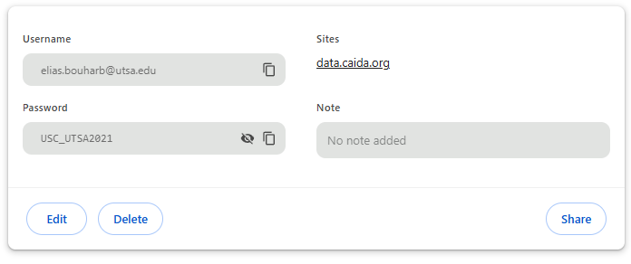
https://mawi.wide.ad.jp/mawi/samplepoint-F/2024/
https://mawi.wide.ad.jp/mawi/samplepoint-F/2024/202403151400.html
https://mawi.wide.ad.jp/mawi/samplepoint-F/2024/202410251400.html

