My topology
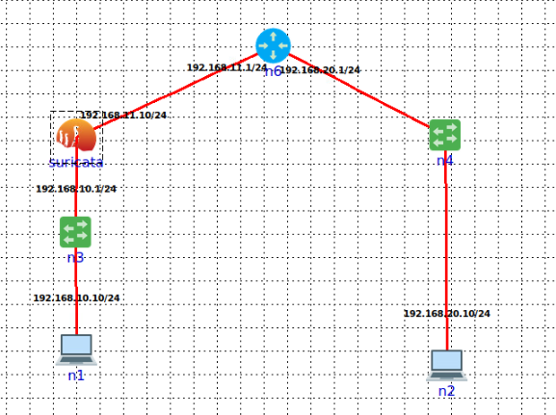
Set the default gateway in suricata to be the ip of the router
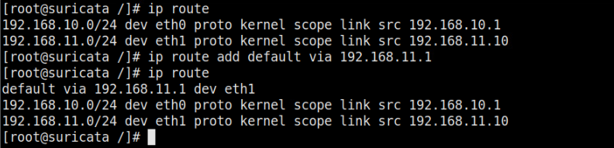
Add in the router a static route to the network 10 that was not discovered
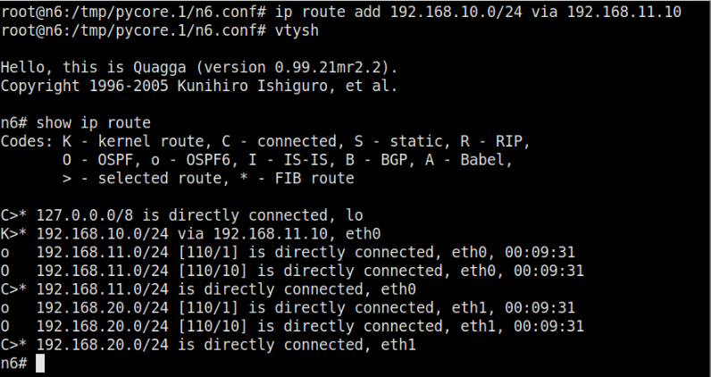
Let suricata forward the packets to a certain queue
Start suricata
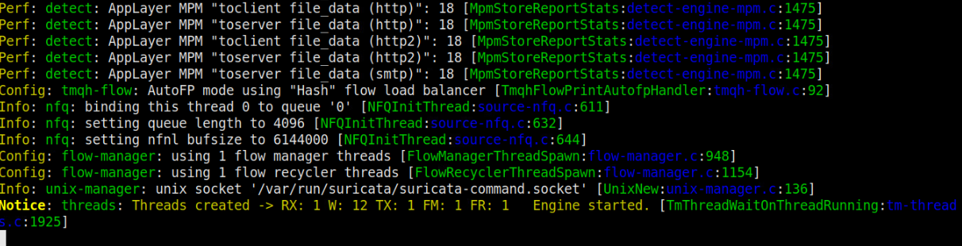

Open the suricata.yaml file (main file containing the configuration)
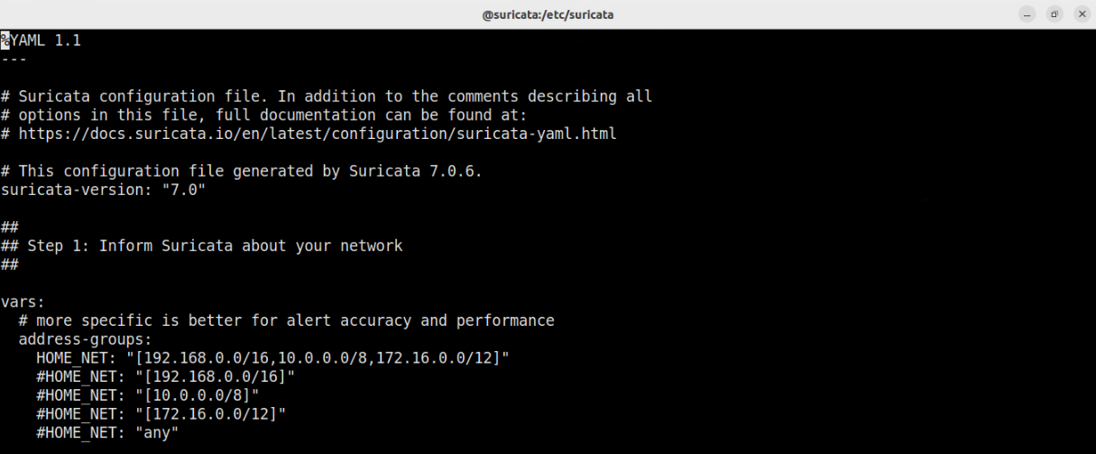
Inspect the loaded rules
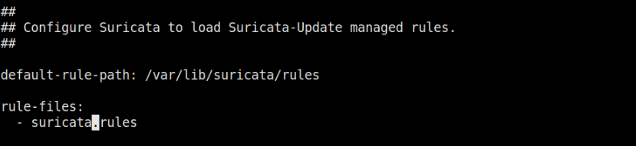
Comment suricata.rules and add myrules.rules instead.
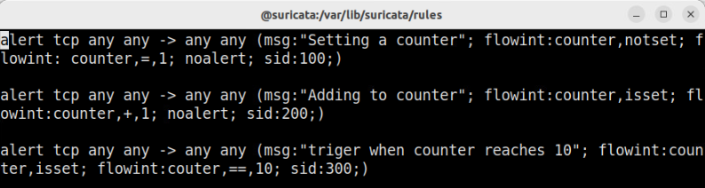
Run suricata
From h2 run a hh.py code
Inspect logs
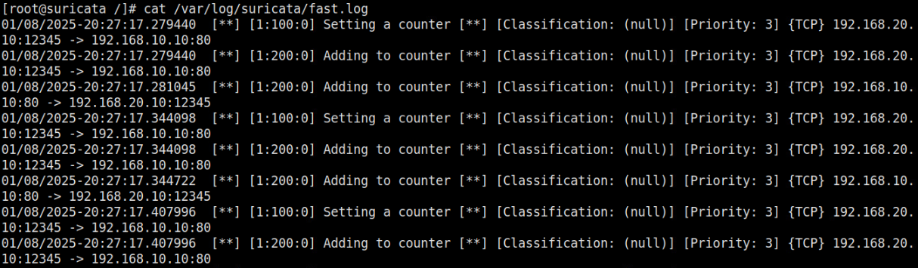

On fabric
https://www.virtono.com/community/tutorial-how-to/how-to-install-suricata-on-ubuntu-22-04/
https://docs.suricata.io/en/suricata-7.0.2/install.html
https://github.com/OISF/suricata
suricata rules were not found:
https://docs.suricata.io/en/suricata-6.0.0/rule-management/suricata-update.html

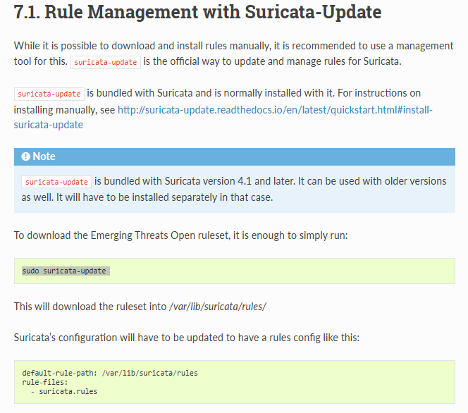
Edit interface suricata.yaml
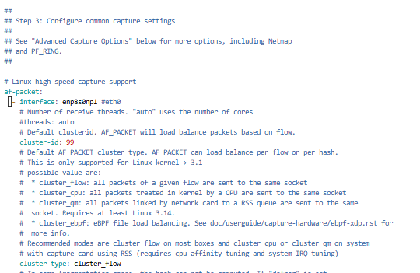
Edit default rules directory:
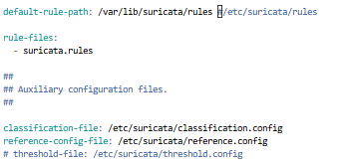
Command to run : sudo suricata -vvvv -c /etc/suricata/suricata.yaml -i enp8s0np1

