It looks like the file x.txt wasn't uploaded yet. Could you upload it so I can run the optimization using your data?
Once uploaded, I'll:
- Read the data into a list x
- Optimize the parameters a and k to minimize the objective:
Optimization Problem
Objective function (cost):
MAE(a,k)=1N∑i=1N∣x^i−xi∣+1a\text{MAE}(a, k) = \frac{1}{N} \sum_{i=1}^{N} |\hat{x}_i - x_i| + \frac{1}{a}MAE(a,k)=N1​i=1∑N​∣x^i​−xi​∣+a1​
where x^i\hat{x}_ix^i​ is the predicted value using a sliding window of size kkk
Decision variables:
  - a∈(0,1)a \in (0, 1)a∈(0,1): Sensitivity factor (continuous)
  - k∈Z,k>3k \in \mathbb{Z}, k > 3k∈Z,k>3: Sliding window size (integer)
Constraints:
  - 0<a<10 < a < 10<a<1
  - k>3k > 3k>3
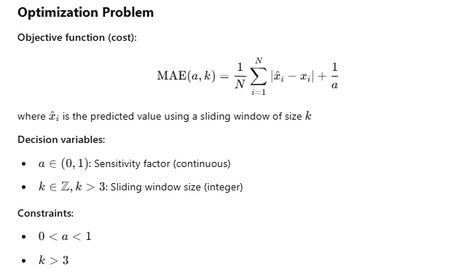
How Differential Evolution Works (Intuitively)
It’s an evolutionary algorithm — inspired by biological evolution and natural selection. Here's a breakdown of its steps:
1. Population Initialization
- Instead of starting with a single guess (like minimize() does), it starts with a population of candidate solutions.
- Each candidate is a pair: [a, k] (floating-point values within your bounds).
2. Mutation
- For each candidate (called a "target"), the algorithm picks three other distinct candidates from the population.
- It creates a mutant vector by combining those three, using a formula like:
mutant=x1+F⋅(x2−x3)\text{mutant} = x_1 + F \cdot (x_2 - x_3)mutant=x1​+F⋅(x2​−x3​)
where FFF is a mutation factor (e.g. 0.5–1.0).
3. Crossover
- The mutant is mixed with the original candidate to create a trial solution.
4. Selection
- If the trial solution performs better than the original candidate (i.e., lower error), it replaces it.
- Otherwise, the original candidate stays.
5. Repeat
- This process is repeated for many generations, gradually improving the population until convergence.

✅ Why It Worked Better Than minimize()
- minimize() is local: it starts from one point (e.g., k=5) and looks for a local improvement — it can get stuck.
- differential_evolution is global: it explores the entire search space and avoids getting stuck in local minima.
- Also, it's robust with mixed variable types (like a continuous and k integer-rounded).

🔧 Important Parameters
- mutation: controls exploration vs exploitation
- popsize: number of candidate solutions
- maxiter: how many generations to run
- strategy: how mutation is performed (e.g., 'best1bin' is commonly effective)

