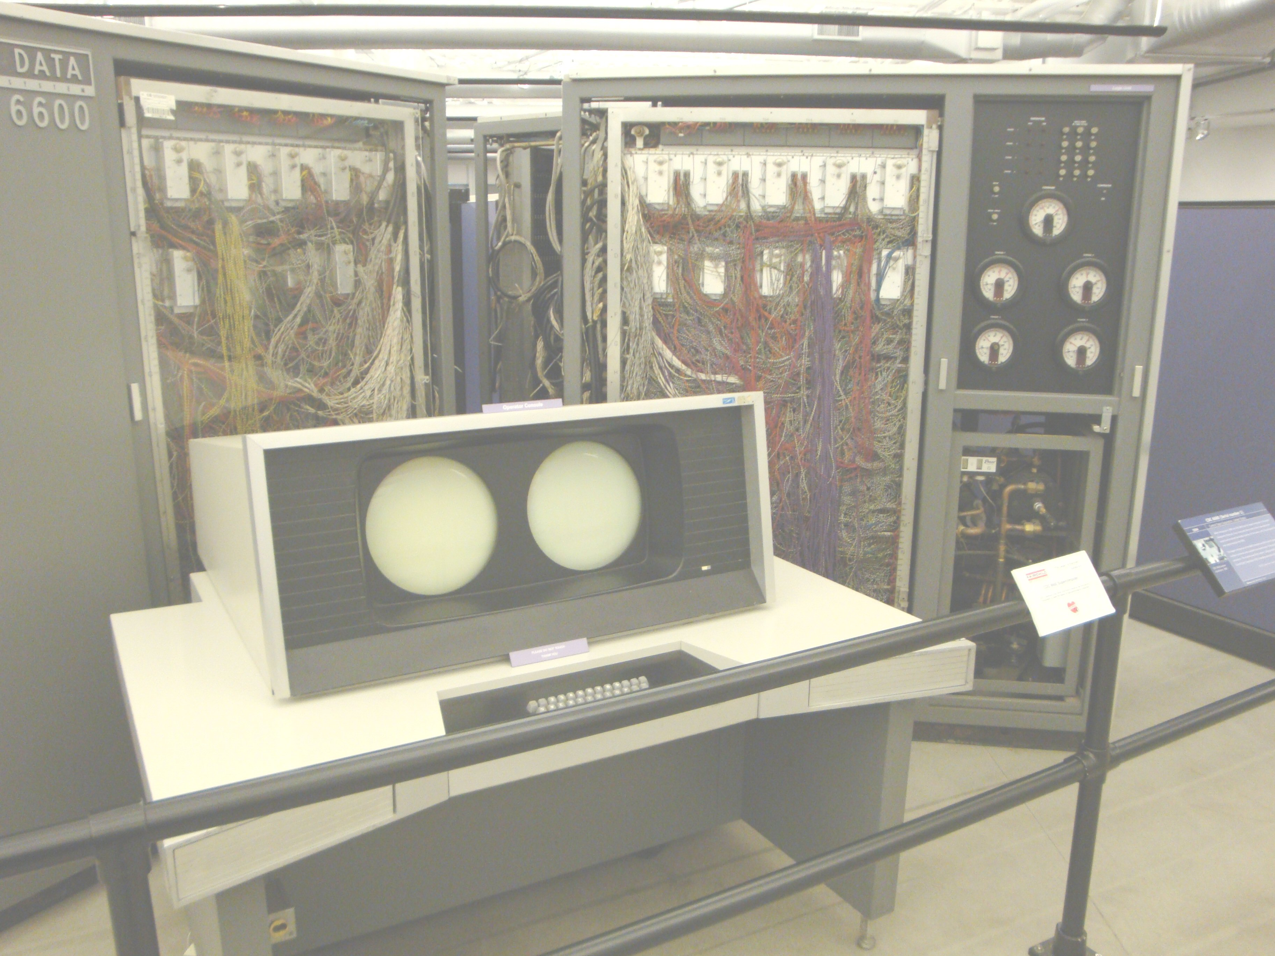
IP Pascal
Language Manual
Moore/CAD
IP Pascal Language Manual
Moore/CAD
Version 2.0

