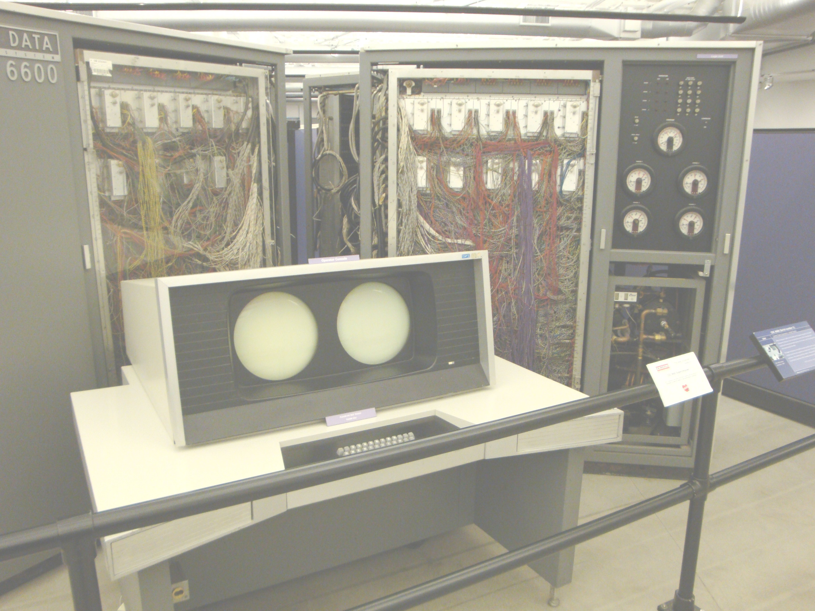
The Language Pascaline
Report Version 0.2

The Language Pascaline: Report Version 0.2

