Word 2007 hint/coolstuff/issues page

Contains a few hints, features and issues I have found interesting. Your mileage may vary.

Options
Under the nameless word “button” at upper left, find word options.

Add back missing toolbar features
Some of the things that they hid under the “word button” can be brought back to the toolbar, under options->customize. Buttons that can be added back include print, print preview, open file, new file, etc.

Backup files
Word can generate a .bak file, check options->advanced->always create backup copy.

Text area
Word can show you the actual area you are writing in, with options->advanced->show text boundaries. This draws a dotted line around the “active area” on the page, and means you are not clicking uselessly on white space trying to select things. The box does not print.

Crop marks
Don’t work properly in Word. They are in the printed area.

Save as text 1
When doing “save as text format”, checking the “allow character substitution” lets word substitute dumb things like backwards double quotes with normal quotes.

Save as text 2
Don’t check the “add line breaks”, as it breaks up table rows into separate lines.

Save as .pdf
Save as .pdf file is an add-on, by Microsoft here:
http://www.microsoft.com/downloads/details.aspx?FamilyId=F1FC413C-6D89-4F15-991B-63B07BA5F2E5&displaylang=en

Macro development tab
If you use Macros, checking options->popular->show developer tab is useful.

Formatting check
Word can flag odd formatting issues in the doc, like using hand applied formatting when a style would do the same thing, with options->advanced-mark formatting inconsistencies.

Print odd page sizes centered
If you select a page size smaller than the actual print page size, it centers it on the page horizontally, but not vertically. If you want it centered, print in .pdf form, then print from Adobe reader, which does not suffer braindamage.

Styles then format
Word styles wipe out other formatting, so the proper order is to apply styles, then change the formatting as desired. Otherwise you will be redoing your formatting work quite a bit. Remember, a style is a collection of attributes that can be set individually on every paragraph, or even sometimes every character, in the document.

Follow vs. keep lines together
When trying to keep word from breaking up a table across multiple pages, use right click->paragraph->line and page breaks, and check either “keep with next” or “keep lines together”. Despite the names, “keep with next” really means to keep groups of paragraphs together, and “keep lines together” really means to keep lines in a paragraph together. If it all needs to stay on the same page, you need both.
When you keep a group of paragraphs together, select all but the last paragraph, then apply “keep with next”. If you select the last one, it really means “keep these paragraphs together with the next one you didn’t really want”.

Macro buttons
Are easy to create, and give you another way to add top toolbar buttons back. Under view->macros, perform a record, then assign to a button on that same menu, then modify the button to have a meaningful icon. Perform a series of commands, then stop record.

Macros as Swiss army knife
Macros are written in Visual Basic, and can do anything in word. Although certainly learning yet another programming language, especially one that is such a complete mess, is a giant pain, Microsoft MVPs all know how to create word macros. It divides the pros from the riff-raff.

“corrupted” outlines and tables of contents
The outline, as shown by the document map and inserted with the table of contents, can appear to suddenly include lots of lines of text that should not be there, including text with style “normal“. After a lot of online research, this is apparently not a bug but a “feature”. Word searches the document looking for things to include in the outline, and therefore the table of contents, and it appears to run this search anytime a major layout change is made in the document. This “feature” has been there for 10 years or more.
There are three workarounds for the problem.
- Never use or activate document map mode. I have not tried this, since I find the document map essential.
- Try not to make layout changes. Select a multilevel list when you start the document, and don’t change it.
- You can fix the bad outline entries.
For the last, the procedure is:
- Open the document map
- Select an entry that should not be there.
- Find the style that is indicated.
- Right click on the style, and click on “select all N instances”. Note on a big document, this can take a (very) long time.
- Right click on the document, and select paragraph.
- Change the “outline level” to “body text”.

This will remove all the bad entries from the outline. Then save the document.
Note that modifying the style itself will accomplish nothing. The style itself is not the problem, the problem is that word as flipped the outline attribute on all of the entries with that style. Hence, you can use the style to select them all, but you must modify all of the entries themselves.
My way of dealing with this is to use multilevel listing (1.1.1 format), which makes it obvious what is or is not correct to have in the outline/table of contents. If it does not have a number in front, it is wrong.

Making Appendixes
If you want to create appendixes like:
A
A.1
A.1.2
Etc, this can be done, but there is no inherent built in way to do this. It can be done, but it is very easy to get wrong and hard to undo the damage of doing it wrong. Because it is a layout change, it is best to start with a blank page, but it can be done on an active document, it will just be a layout change, and may mess up your table of contents (see last item).
- Select multilevel lists for the document, if you have not already.
- Select the first header you want for the appendix.
- Click multilevel list->define new multilevel list. This will show you from 1 to 9 list formats.
- Pick one, usually 7, as the place you want to start appendix headers. The reason why is that you only have 9 headers to use (remember word is not really designed for appendixes). So this gives you from 1 to 6 as normal headings, and from 7 to 9 as appendix headings. Select that heading.
- Select number style, A, B, C. This is the only time you will select this! The other headers remain number styles. When you do this, you will see an A at the end of the format string in the “enter formatting for number” box.
- Get rid of all the garbage to the left of A.
- Go to the next list, say 8.
- You will find it has A.1 at the end. Get rid of the garbage to the left of A.
- Repeat for the 9th level.

This process is easy to get wrong just by doing things or missing steps. You must do it exactly as specified, and be ready to discard the document if it is not correct.
- You MUST have selected the first appendix header.
- You MUST modify the headers in order, say 7 to 9. The headers are based on each other, and if you modify header 7, it will affect headers 8 and 9.
- If you have an existing document, and change from numbered lists to appendix lists, the list won’t be right until you have all of the headers, even the sublevel headers, fixed. Word interprets having mixed list headers, like going from header 7 back to header 2 as you restarting the list from the top. This can create some really mysterious errors until you fix up all of the headers.
- If you don’t have a header 7 in the styles, don’t worry. The next style after the top number you have is created when you use it. So using style 5, say, will create style 6. Just keep selecting a higher style until they all get created, 1 to 9. The creation of new headers will stop at 9.

Tables are better than a sharp stick in the eye
Anytime you are trying to arrange things in terms of columns, it is usually easier to use a table, since that is what a table is, multicolumn data.

Setting specific tabs beats lots of tabs
If you are trying to arrange printout across the page and using a lot of tabs to do it, a better way is to design your own tab stops. Select everything you want to lay out, then set as many tabs as you want columns on the ruler, accuracy does not matter at first. Then, you can move the tabs and watch the text move with the tab.

Making a table out of text
Making tables from arbitrary text is easy. In fact, it is easier than trying to reformat a table by adding rows and columns, which takes a specific menu driven operation.
So creating a table can be done by:
- Set your tab stops for the columns (as for last item).
- Lay out the table with tab stops.
- When it looks right, select all the text, and select insert->convert text to table. Make sure “separate text at tabs” is selected. Voila! A table.

Note: if you are trying to convert text to table, and it gives you too many collums, you may have extra tabs in your doc that don’t show up normally (remember that tabs don’t show if you are already at the tab stop). Use the trick in the last section about setting your own tab stops, and it will reveal where the tabs are, and show you a rough outline of the table before you make it a table.

Impressing managers people with nonsense
Microsoft has made it incredibly easy to produce meaningless but impressive diagrams, clip art and charts. You just select from them using insert->illustrations, then fill out the blanks.

Producing really impressive user guides about Windows
If you want to show users how to do something with a program in Windows, put your program window in whatever state you want, then press alt->print screen. This copies the contents of the selected window to the clipboard, then paste. For example, here is the page I am typing:
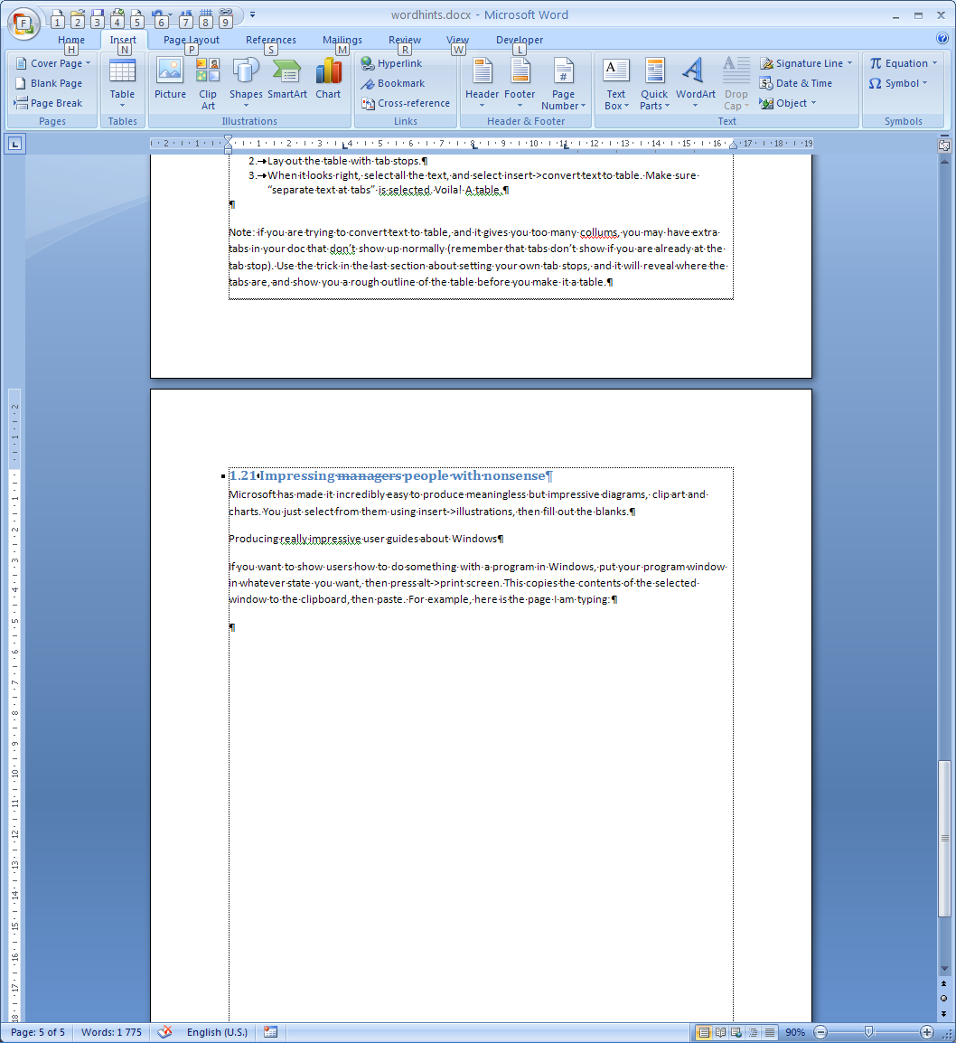
Then you can resize it.

