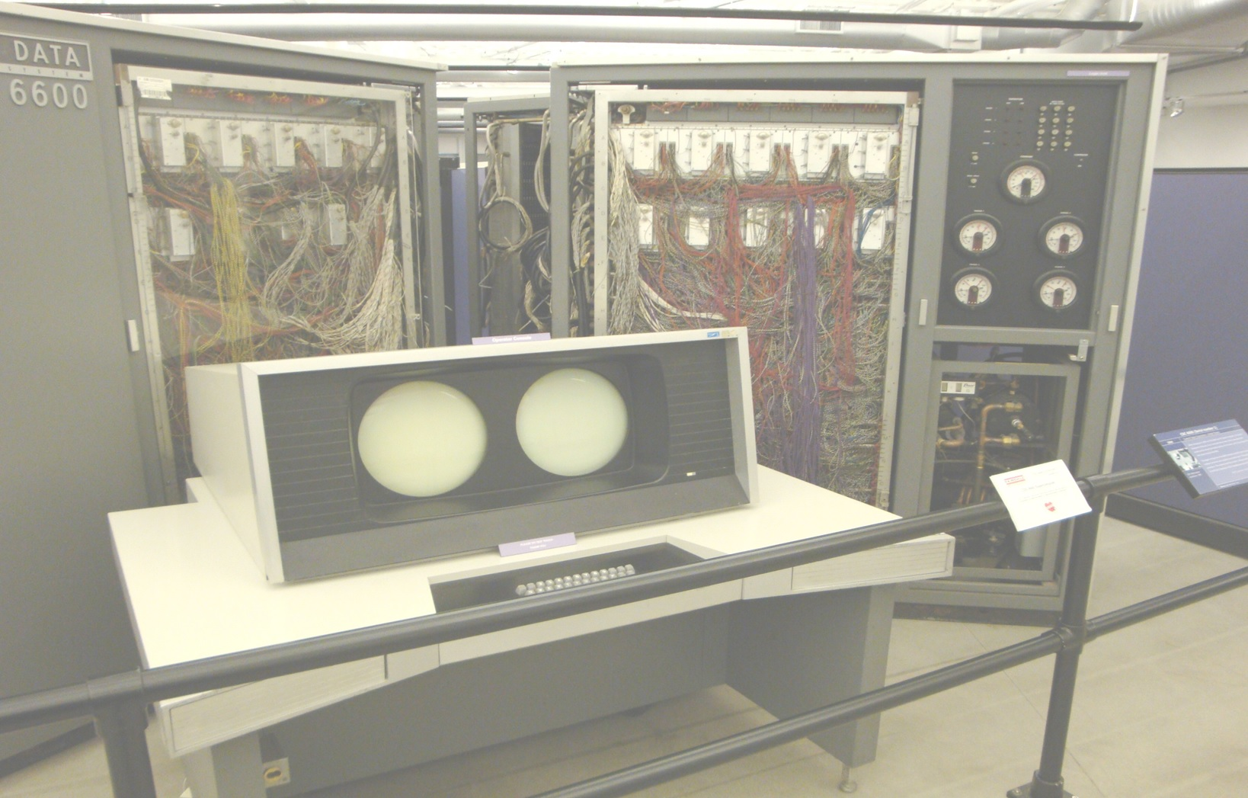
The Pascaline Computer Language
Scott A. Franco
Version 0.4
Scott A. Franco
The Pascaline Computer Language

