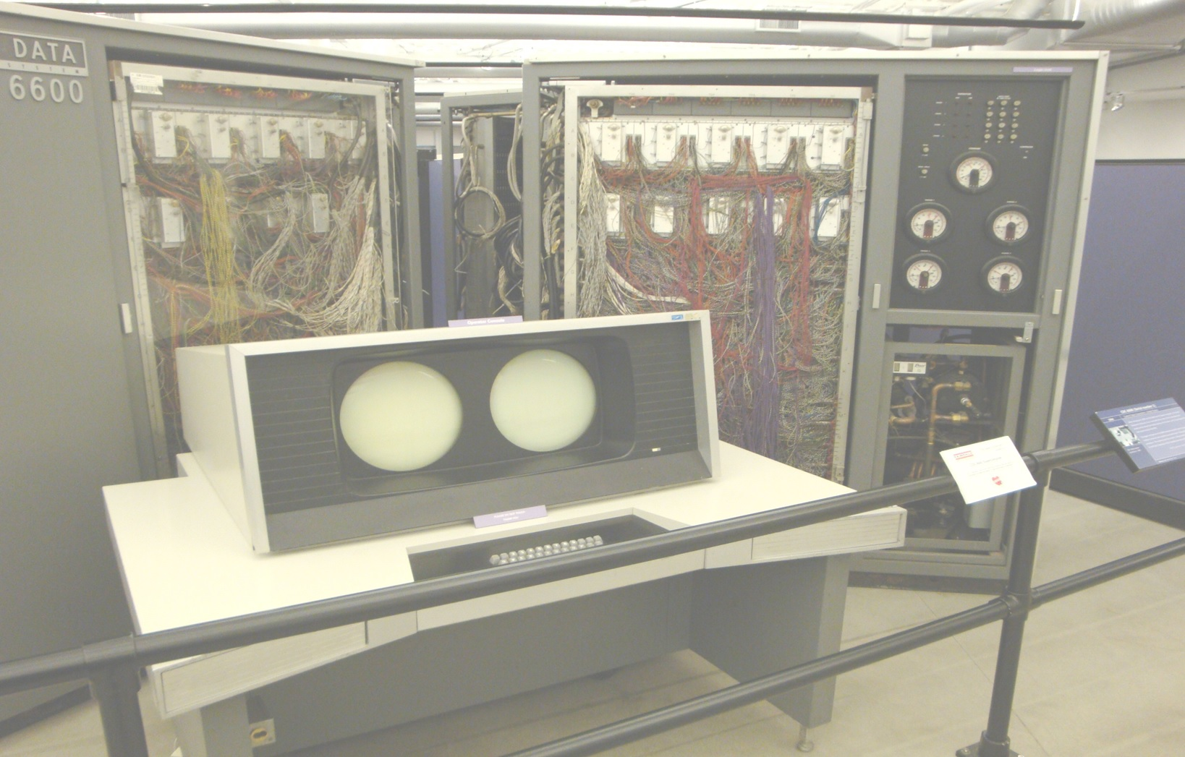
The Pascal-P6 Compiler Version 0.3
Scott A. Franco
The Pascal-P6
Compiler
Version 0.3
Scott A. Franco

