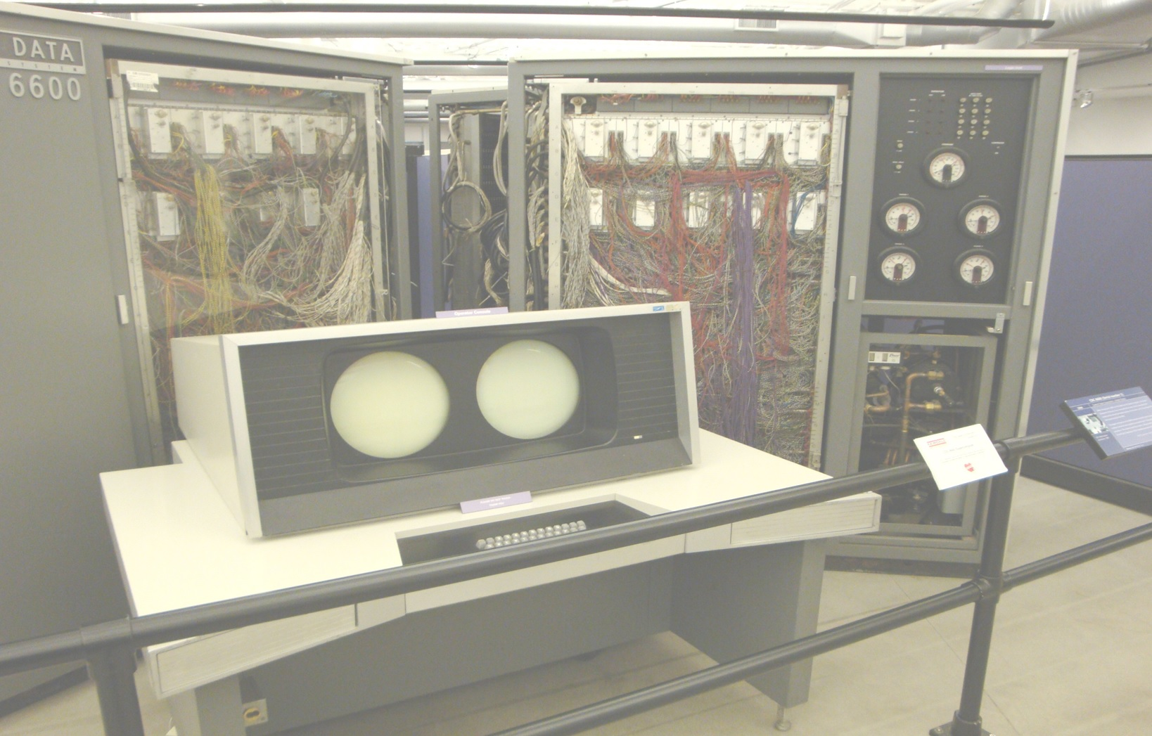
Petit-Ami Toolkit
Scott A. Franco
Petit-Ami Toolkit
Version 0.1
Version 0.1
Scott A. Franco

