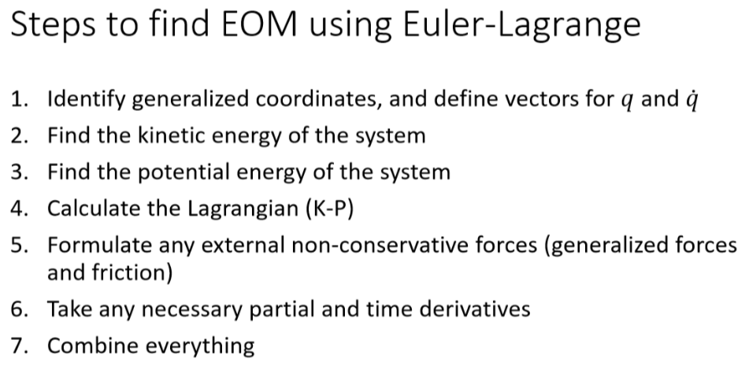
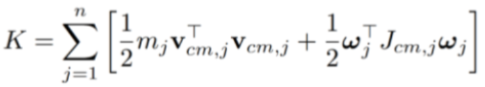
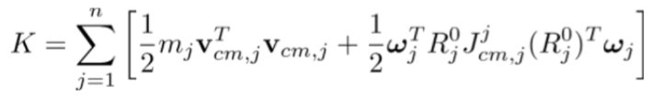
Can get velocities from derivative of angle or position (often qdot)
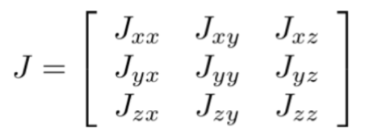
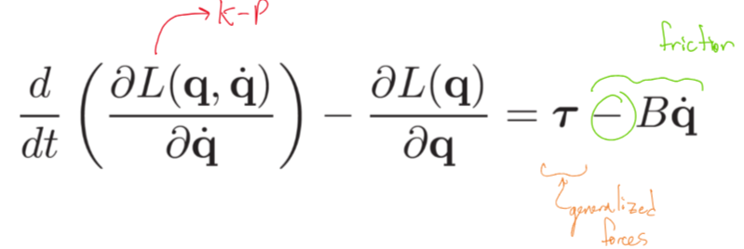
Minus for friction is often unnecessary. Just written to imply acting against motion.
Generalized forces, Q, where r is distance from fixed reference frame to where force is applied:
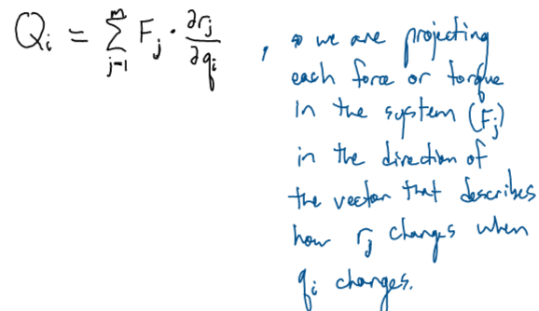
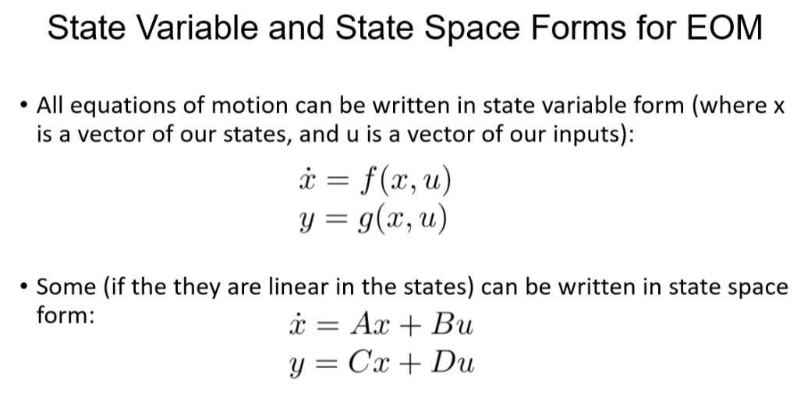

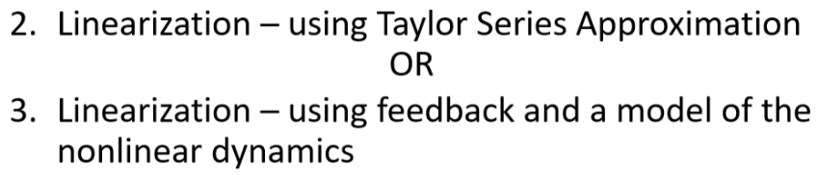
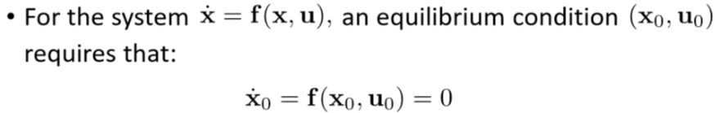
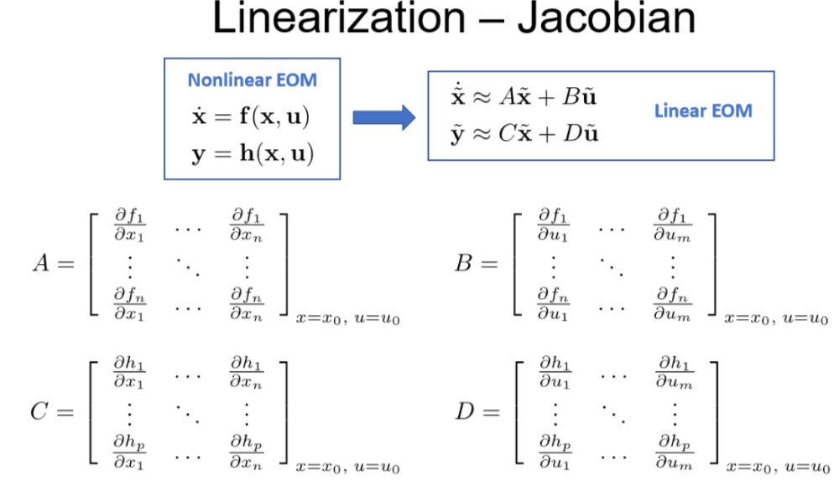
x_tilde = x – x_eq
F = (F_fl or F_eq) + F_ctrl
Feedback linearization only works if there is a force in the same row as the non-linearity.
Know how to go from time domain to laplace domain for transfer functions.
State space laplace xform:
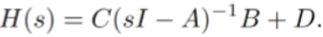
Where the ith column represents the ith generalized force (input, tau) and the ith row represents the ith output (y)
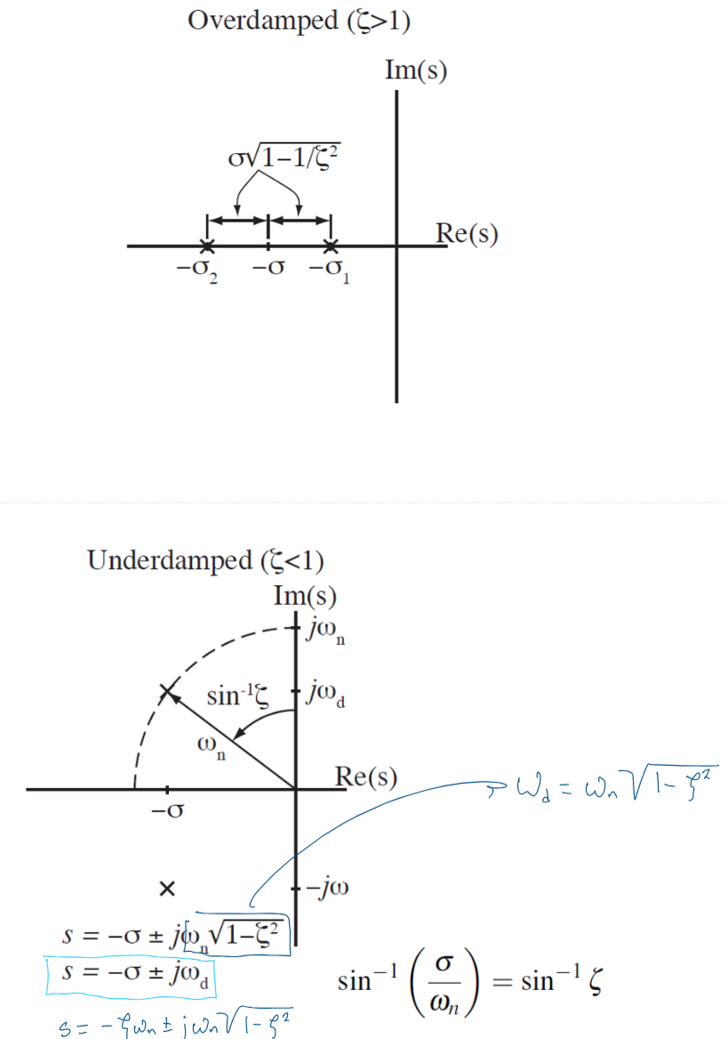
P control:

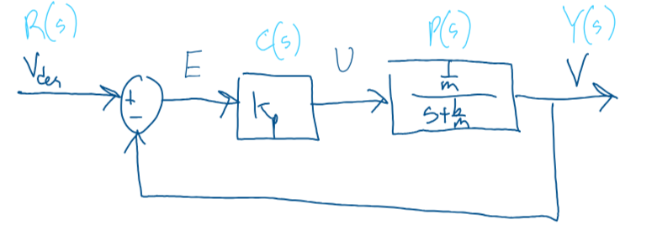
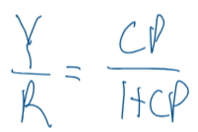
PD Control:
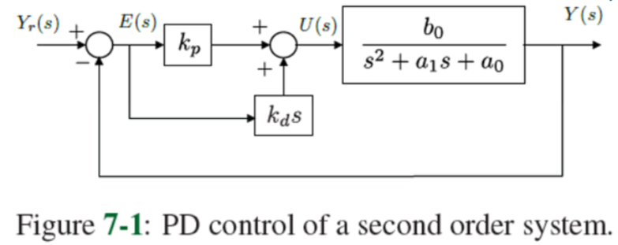
Modified PD Control:
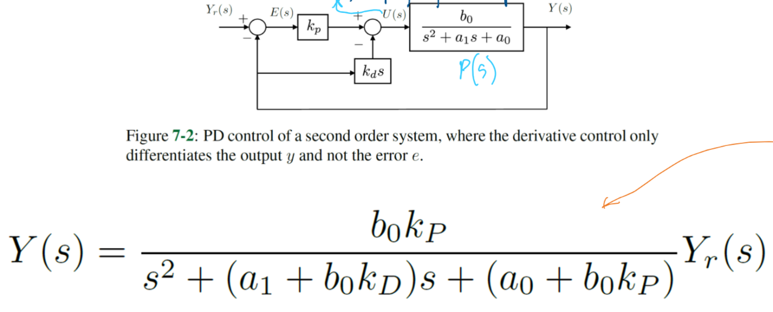
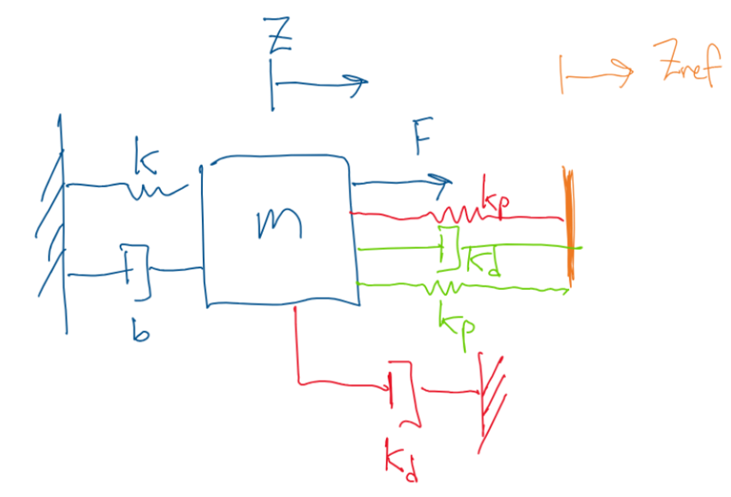

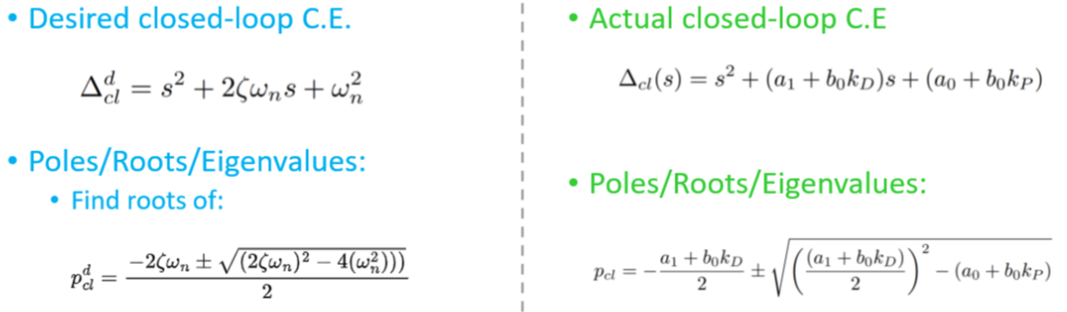

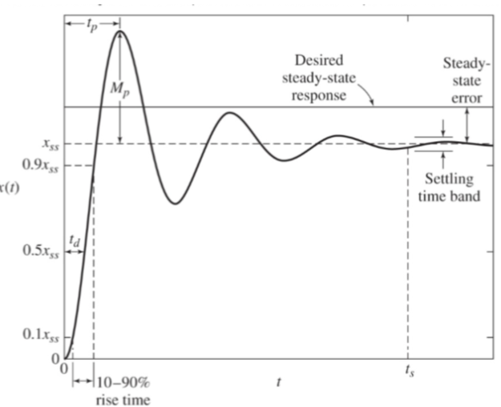
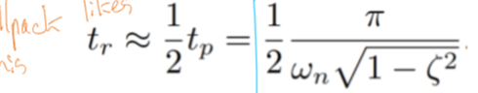
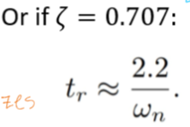
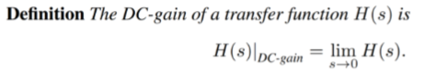

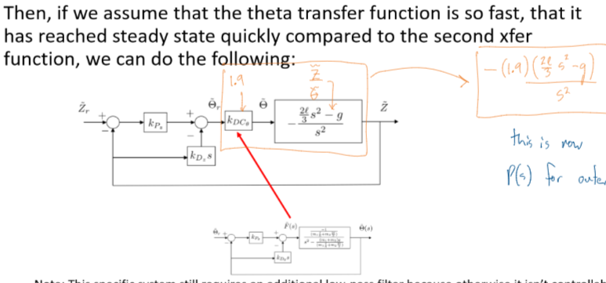
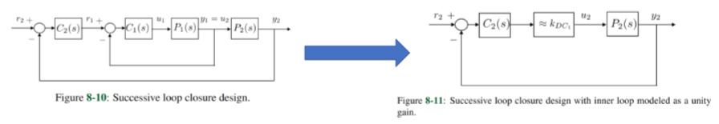
Final Value Theorem:
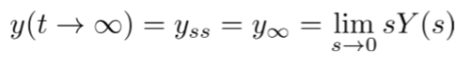
Making sympy symbols
a, b = sp.symbols("a b")
c_f = sp.symbols("c_f", cls=sp.Function) # dependent variables
c = c_f(t)
sp.Matrix([[a], [b], [c]])
sp.Integer(3)
sp.Rational(1, 2)
sp.pprint(sp.simplify(equation)[0])
np.rad2deg(radians)
np.array([a, b, c])
wn_h = np.pi / (2*tr_h*np.sqrt(1 - zeta_h**2))
alpha0_h = wn_h**2
alpha1_h = 2* zeta_h * wn_h
self.kp_h = (alpha0_h - a0_h) / b0_h
self.kd_h = (alpha1_h - a1_h) / b0_h
F_tilde = self.kp_h * error_h - self.kd_h * hdot
p_c_dot = p_c.diff(t)
equilibrium = [(z_v, 0.0), (h, 0.0), (theta, 0.0), (zd, 0.0), (hd, 0.0), (thetad, 0.0), (F, g*(m_c+2*m_r)), (tau, 0.0)]
A_lin = sp.simplify(A.subs(equilibrium))
full_eom = EL_case_studyE - RHS
# solving for highest order
result = sp.simplify(sp.solve(full_eom, (zdd, hdd, thetadd)))
zdd_eom = sp.simplify(result[zdd])
hdd_eom = sp.simplify(result[hdd])
thetadd_eom = sp.simplify(result[thetadd])
I = sp.eye(A_lin.shape[0])
H = C @ (s * I - A_lin).LUsolve(B_lin) + D

