

TECHNICAL REPORT

Subject: PM5560 Visual Data Representation

Third Party Disclaimer

The content of this document is not intended for the use of, nor is it intended to be relied upon by any person, firm, or corporation, other than the client and Team Power Solutions. Team Power Solutions denies any liability whatsoever to other parties for damages or injury suffered by such third party arising from use of this document by them, without the express written authority of Team Power Solutions and our client. This document may be subject to further restrictions imposed by the contract between the client and Team Power Solutions and these parties permission must be sought regarding this document in all other circumstances. This document is privileged and may not be used in any manner directly or indirectly detrimental to Team Power Solutions. This document is for the confidential use of the addressee only. Any retention, reproduction, distribution or disclosure to parties other than the addressee is prohibited without the express written authorization of Team Power Solutions.

**Table of Contents**

1. Introduction 3

2. Pre-Setup 3

3. Set-Up 3

3.1. Set-up the meter webpage and DeviceLogExport.exe file 3

3.2. Set-up the PostgreSQL local database 6

3.3. Set-up the datascript.exe files 7

3.4. Set-up the graphscript.exe files 7

4. Ready-to-Use 7

1. Introduction

This document is intended to describe how to use the PM5560 data visual representation tool. This tool consists of three main executable files (.exe) including ***DeviceLogExport***, ***datascript***, and ***graphscript***. The DeviceLogExport file listens on HTTP (443) port to receive the data log from the meter’s webpage and store it based on the scheduled time frequency in the server path for the meter. The datascript file will read the recently exported .csv file based on Date modified into a Pandas DataFrame. Using Pandas DataFrame, it will then convert the data values into the correct format. It will then export this correctly formatted data values into the Postgres. The graphscript file will fetch the data from the Postgres and store it in Pandas DataFrame. Using the Pandas DataFrame, it will then plot the graphs.

1. Pre-Setup

Please ensure that the following ports are open:

HTTP Port 443

Port 5436

1. Set-Up
   1. Set-up the meter webpage and DeviceLogExport.exe file

Follow the steps as detailed below to set-up the meter webpage and DeviceLogExport.exe file:

1. Use an Ethernet cable to connect the computer to one of the meter’s Ethernet port. Refer to the video “Add PM5561 to ION Setup Via Ethernet” (<https://www.youtube.com/watch?v=ItIrCdtBICw>) from 0:40 to 1:35 minutes for instructions on how to connect the meter and computer via ethernet cable.
2. Refer to the “Accessing the meter webpages” instructions (pages 37 and 38) under the Meter webpages section of the PM5500 User Manual. Ensure to fulfill instructions 1 to 4.
3. Complete all the instructions mentioned under the section “Setting up device log exports using the webpages” page 87 of the PM5500 User Manual. To configure the HTTP parameters as appropriate, please refer to the next step.
4. Refer to the PM5500 Datalog Export Tool documentation created by Schneider Electric and follow the instruction carefully written in the document. This documentation and tool can be found at <https://www.se.com/ww/en/faqs/FA341563/>.
5. Open Task scheduler and create a new task to run the DeviceLogExport.exe file daily. Follow the steps as detailed below:
   1. 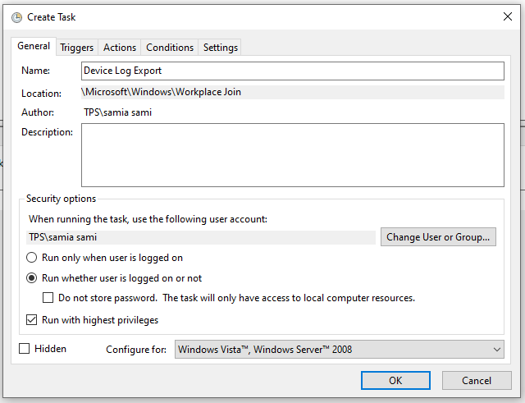In Security options under General tab, select “Run whether user is logged on or not” and “Run with highest privileges” as indicated in the sample is shown below:
   2. Under the Triggers tab, click new and then in the Edit Trigger window make sure that the time is set up such that it will occur before the scheduled time of the daily export in the PM5560 webpage.

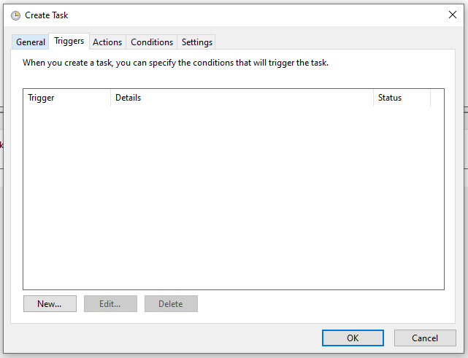

* 1. 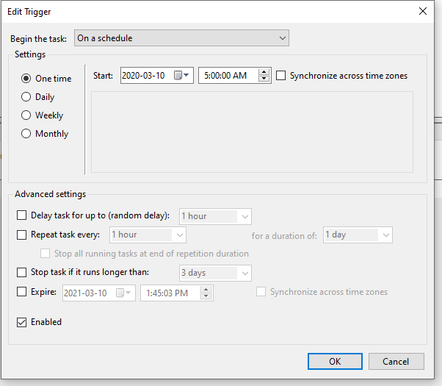Under Actions Tab, select new and then in the Edit Action window select action as “Start a program” and include the file path of the DeviceLogExport.exe script.
  2. 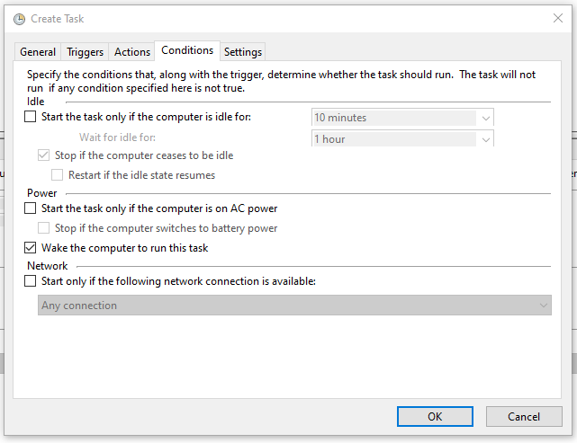Under Conditions Tab, select the following parameters as indicated below:
  3. Under the Settings Tab, select the following parameters as indicated below:

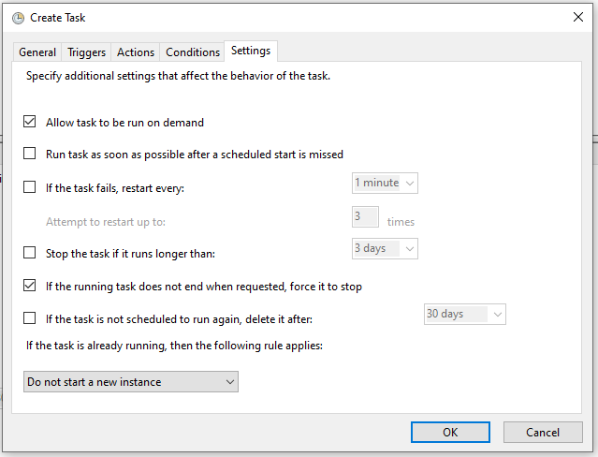

**Note that this is a one-time set-up and once it is done, there is no need to do it again unless the power meter is removed. In that case, please connect the meter with the computer again and then do a manual export to ensure that Datalog Export Tool is properly setup.**

* 1. Set-up the PostgreSQL local database

Follow the steps as detailed below to set-up the PostgresSQL local database:

1. Install PostgresSQL with the instructions found at <https://www.postgresqltutorial.com/install-postgresql/>. In step 7, enter the port (5436) for PostgreSQL.
2. Install pgAdmin 4 (Windows) recent package found at <https://www.pgadmin.org/download/pgadmin-4-windows/>
3. Connect to the PostgresSQL Database Server via pgAdmin application by following the instructions under “Connect to PostgreSQL database server using pgAdmin” found at <https://www.postgresqltutorial.com/connect-to-postgresql-database/>. In step 4, ensure that the hostname is localhost, the default password is teampower, the username is postgres, and the port is 5436.

**Note that this is a one-time set-up and once it is done, there is no need to do it again in the same system.**

* 1. Set-up the datascript.exe files

Follow the steps as detailed below to set-up the datascript.exe file:

1. Download and extract the “datascript.exe” file from compressed file folder “datascript” in C:\Softwares\DeviceLogExporter-V2\DeviceLogs
2. Open Task scheduler and create a new task to run the datascript.exe file daily. Follow the steps as indicated in Set-up the meter webpage and DeviceLogExport.exe file step 5. In the Edit Trigger window make sure that the time is set up such that it will occur after the scheduled time of the daily export in the PM5560 webpage.

**Note that this is a one-time set-up and once it is done, there is no need to do it again in the same system.**

* 1. Set-up the graphscript.exe files

Follow the steps as detailed below to set-up the graphscript.exe file:

Download and extract the “graphscript.exe” file from compressed file folder “graphscript” in C:\logs\DeviceLogExporter-V2\DeviceLogs

**Note that this is a one-time set-up and once it is done, there is no need to do it again in the same system.**

1. Ready-to-Use

All the basic set-up guidelines are fulfilled by now. You can now run the graphscript.exe file to view the meter data in a visual format.

Follow the steps as detailed below to view the graph after running the graphscript.exe file:

1. 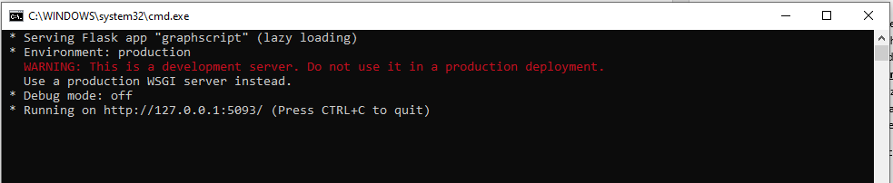After running the file, a command prompt window like the one shown below will appear:
2. Copy and paste the HTTP link shown in this command prompt (<http://127.0.01:5039/>) on an internet browser and hit Enter key to view the graphs.