**Power BI Assignment 2 SOLUTION**

1. Explain the advantages of Natural Queries in Power BI with an example.

Natural Queries in Power BI refer to the ability to use natural language to ask questions and retrieve data insights from datasets and reports.

ADVANTAGES:

1. **User-friendly interface**: Natural Queries make Power BI more accessible to non-technical users who may not be familiar with SQL or other query languages.
2. **Faster insights**: By using natural language, users can quickly ask questions and get instant responses or visualizations. This eliminates the need to write and run complex queries, saving time and enabling faster decision-making.
3. **Increased interactivity**: Natural Queries promote a more interactive and conversational experience with user data.
4. **Enhanced data exploration**: With Natural Queries, users can explore data more dynamically and intuitively.

For example, assume the user wishes to analyze a sales dataset and wants to explore the sales performance of a particular product. Instead of writing a complex query, they can simply use a natural language query like "What were the sales of Product X in the last quarter?"

Power BI will understand this query, interpret it, and generate relevant visualizations like a line chart or table for Product X.

1. Explain Web Front End (WFE) cluster from Power BI Service Architecture.
2. The power-BI service architecture is based on two clusters – Web Front End (WFE) and Back End cluster.
3. WFE manages the initial connection and authentication to the power-BI service and once authenticated, the back end handles all subsequent user interactions.
4. The WFE cluster uses Azure AD to authenticate clients and provide tokens for subsequent client connections to the Power BI service.
5. Power BI uses the Azure Traffic Manager (Traffic Manager) to direct user traffic to the nearest data center.
6. The traffic Manager directs requests using the DNS record of the client attempting to connect, authenticate, and download static content and files.
7. Power BI uses the Azure Content Delivery Network (CDN) to efficiently distribute the necessary static content and files to users based on geographical locale.
8. The Web Front End cluster interacts with other components of the Power BI Service architecture, such as the Data Backend, Query Backend, and Dataset Cache.

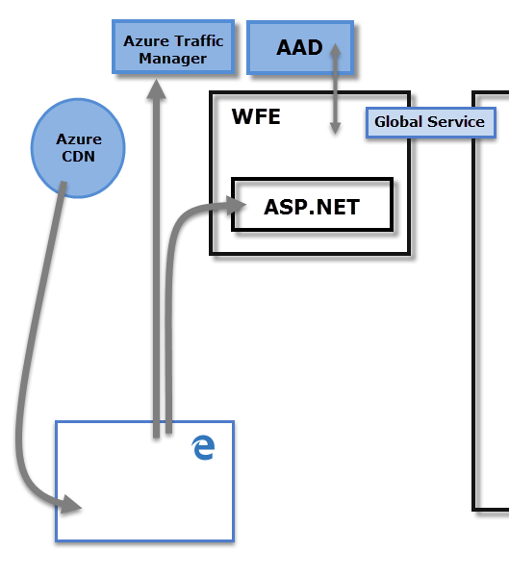

1. Explain Back End cluster from Power BI Service Architecture.
2. The Back End cluster is a core component that handles data processing, data storage, and other backend operations required to support the Power BI service.
3. It plays a vital role in managing and serving data to the front-end components like the Web Front End cluster and ensures the overall functionality and performance of the Power BI service.
4. The Back-End cluster determines how authenticated clients interact with the Power BI service.
5. The Back-End cluster manages visualizations, user dashboards, datasets, reports, data storage, data connections, data refresh, and other aspects of interacting with the Power BI service.
6. The Gateway Role acts as a gateway between user requests and the Power BI service.
7. Users don't interact directly with any roles other than the Gateway Role. Azure API Management eventually handles the Gateway Role.

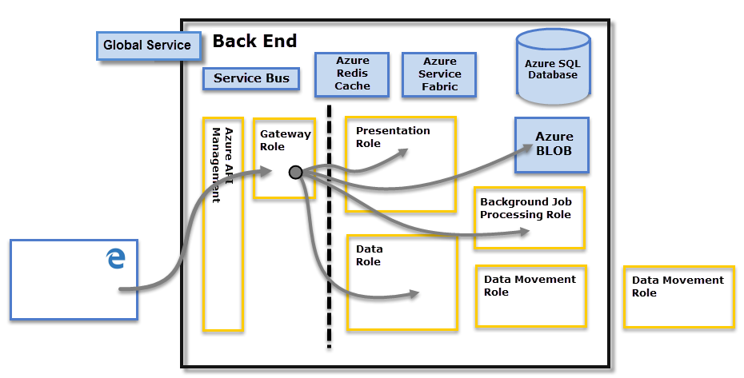

1. What ASP.NET component does in Power BI Service Architecture?
2. In the Power BI Service architecture, ASP.NET components play a crucial role in handling web server functionality and facilitating the communication between the user interface and backend services.
3. ASP.NET is a web development framework provided by Microsoft, and it is utilized within the Power BI Service to build and manage web applications.
4. ASP.NET component within the Web Front End cluster parses the token to determine which organization the user belongs to and then consults the PBI global service.
5. The Web Front End specifies to the browser which back-end cluster houses the organization’s tenant.

5. Compare Microsoft Excel and PowerBi Desktop on the following features:

Data Import

Data transformation

Modeling

Reporting

Server Deployment

Convert Models

Cost

1. **DATA IMPORT**

* Excel allows users to import data from various sources such as CSV, databases, web pages, and other Excel workbooks. Importing data requires manual steps or using add-ins like Power Query.
* Power BI Desktop offers a wide range of built-in data connectors that allow users to import data from multiple sources, including databases, files, online services, and cloud platforms. It provides a more streamlined and intuitive experience for data import.

1. **DATA TRANSFORMATION**

* Microsoft Excel is not efficient in handling big data and only handles a certain amount of information.
* Power BI can connect a large number of data sources. So, it is very much faster to transform information into insights.

1. **MODELING**

* Microsoft Excel can work on simple and structured data models.
* Power BI is ideal for building complex data models easily.

1. **REPORTING**

* Microsoft Excel is ideal for creating reports in tabular format. So, it creates simple and less attractive reports than those of Power-BI.
* Power-BI is creating tabular reports that are more limited. So, it creates more beautiful, personalized, attractive, and interactive reports which can be present in the dashboard.

1. **SERVER DEPLOYMENT**

* Microsoft Excel is On-Premises or hosted cloud.
* Power-BI is a cloud service.

1. **CONVERT MODELS**

* Excel models can be used within Power BI Desktop, allowing you to leverage existing Excel data models in Power BI reports.
* Power BI Desktop models can be imported into Excel, enabling the reuse of Power BI data models within Excel workbooks.

1. **COST**

* Excel is included in the Microsoft Office suite, which is available through various pricing plans based on licensing models (one-time purchase or subscription-based).
* Power BI Desktop is a free tool provided by Microsoft, allowing users to create and publish reports without any additional cost. However, advanced features and collaboration capabilities may require a Power BI Pro or Premium subscription.

6. List 20 data sources supported by Power BI desktop.

1. Excel workbook
2. CSV (Comma-separated values) file
3. SharePoint Online list
4. SQL Server database
5. Oracle database
6. MySQL database
7. PostgreSQL database
8. IBM DB2 database
9. Sybase database
10. Teradata database
11. Salesforce
12. Dynamics 365
13. Google Analytics
14. SharePoint Server
15. Azure SQL Database
16. Azure Data Lake Storage
17. Azure Blob Storage
18. Azure Cosmos DB
19. Hadoop Distributed File System (HDFS)
20. Web data sources (via web connectors, APIs, or HTML scraping)