

Umar Ahmad / Samiullah Butt / Ashfaq Ahmad
22i-1743 / 22i-1663 / 22i-1616
CY-D
SSD Project

Threat Modeling Toolkit for Developers – Automated
STRIDE/DREAD Analysis

Contents
1. Project Overview 3
1.1 Introduction 3
1.2 Project Objectives 3
1.3 Team Structure and Contributions 3
1.4 Key Features Implemented 3
1.5 Technologies Used 4
2. Functional and Non-Functional Requirements 4
3.THREAT MODELING 5
4. PROJECT UI SCREENSHOTS 7
5. Testing & Validation 13
6. Conclusion 18

1. Project Overview

1.1 Introduction
ThreatModelX is an automated threat modeling toolkit designed to streamline security analysis during the software development lifecycle. Traditional threat modeling requires specialized security expertise and manual effort, often resulting in inconsistent analysis or being skipped entirely due to resource constraints. ThreatModelX addresses this gap by automatically generating STRIDE/DREAD threat analyses from design artifacts, enabling developers to identify and prioritize security vulnerabilities early in the development process.

1.2 Project Objectives
The primary objectives of ThreatModelX are to:
- Automate STRIDE/DREAD threat analysis from design artifacts
- Reduce manual security assessment effort and expertise requirements
- Provide actionable security insights through risk scores and mitigation recommendations
- Enable seamless integration into CI/CD pipelines for continuous security assessment
- Foster security-by-design practices within development teams

1.3 Team Structure and Contributions
- Ashfaq Ahmed (22i-1616) - Developed the parsing engine, threat analysis module, and core automation features
- Sami Ullah Butt (22i-1663) - Defined STRIDE/DREAD templates, validated threat generation accuracy, and developed mitigation strategies
- Umar Ahmad (22i-1743) - Conducted comprehensive testing, developed documentation, and implemented CI/CD integration

1.4 Key Features Implemented
- Multi-format input support (PlantUML, Source Code, IaC configurations)
- Automated system model generation from design artifacts
- STRIDE-based threat categorization
- DREAD risk scoring and prioritization
- Interactive web-based interface
- Comprehensive threat reports with annotated diagrams
- CI/CD pipeline integration capabilities

1.5 Technologies Used
- Backend: Python with Flask
- Frontend: html, css, javascript
- Parsers: PlantUML parser, OpenAPI/Swagger parser, Terraform/CloudFormation parsers
- Security Frameworks: STRIDE, DREAD
- CI/CD Integration: GitHub Actions/Jenkins hooks
- Reporting: JSON/YAML processing, diagram annotation libraries

2. Functional and Non-Functional Requirements
Functional Requirement (FR) | Security Non-Functional Requirement (NFR)
FR1: User can upload UML, source code, or architecture files for analysis. | NFR1: All uploads are transmitted over HTTPS and validated using secure filename handling and extension whitelisting.
FR2: System parses input files and converts them into an internal threat model representation. | NFR2: Only authorized roles may modify threat data, with all admin actions logged for accountability.
FR3: The Threat Analysis Engine automatically identifies threats using STRIDE and calculates DREAD scores. | NFR3: Secure authentication is enforced using password hashing, MFA (TOTP), and role-based access control.
FR4: The system generates detailed security reports. | NFR4: Sensitive data such as MFA secrets and reports is encrypted at rest using AES-256.
FR5: Users can integrate ThreatModelX with CI/CD pipelines (e.g., GitHub, Jenkins). | NFR5: The dashboard enforces session timeout, CSRF protection, no-cache headers, and input sanitization against XSS.
FR6: The system allows secure login and role-based access (Admin, Analyst). | NFR6: APIs use JWT-based authentication with role claims, expiry, and rate limiting for secure automated access.
FR7: Users can view dashboards and visualize threats and mitigations.
FR8: The system provides APIs for automation and integration

3.THREAT MODELING
The result for threat modeling is as follows:

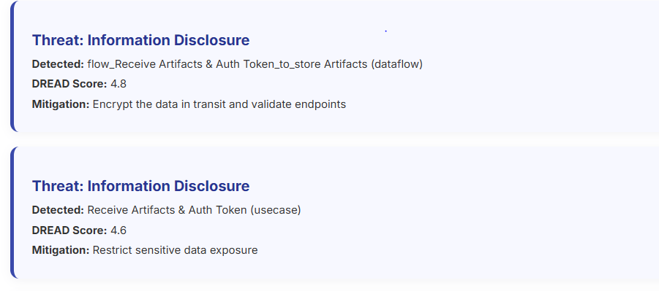
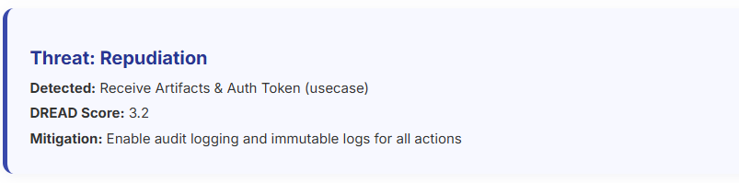
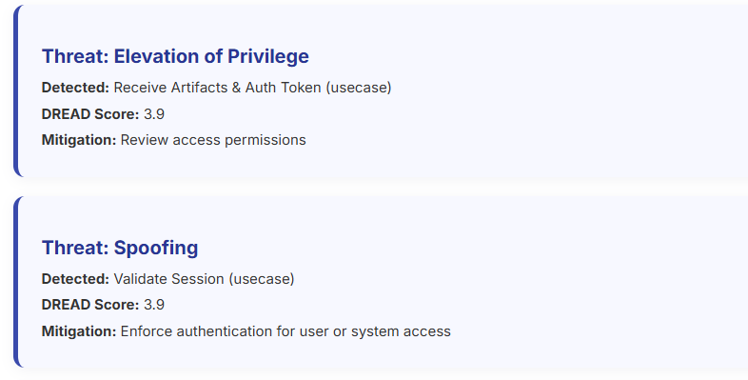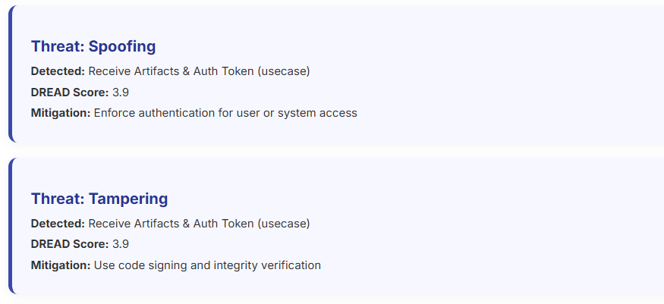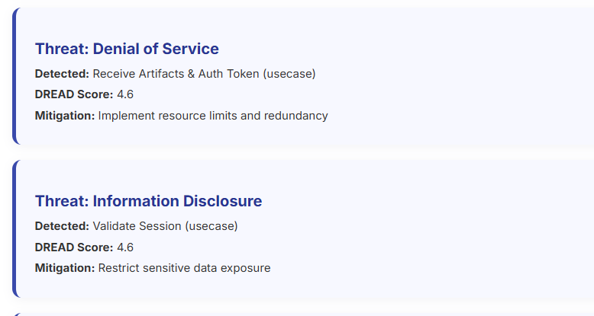

PROJECT UI SCREENSHOTS
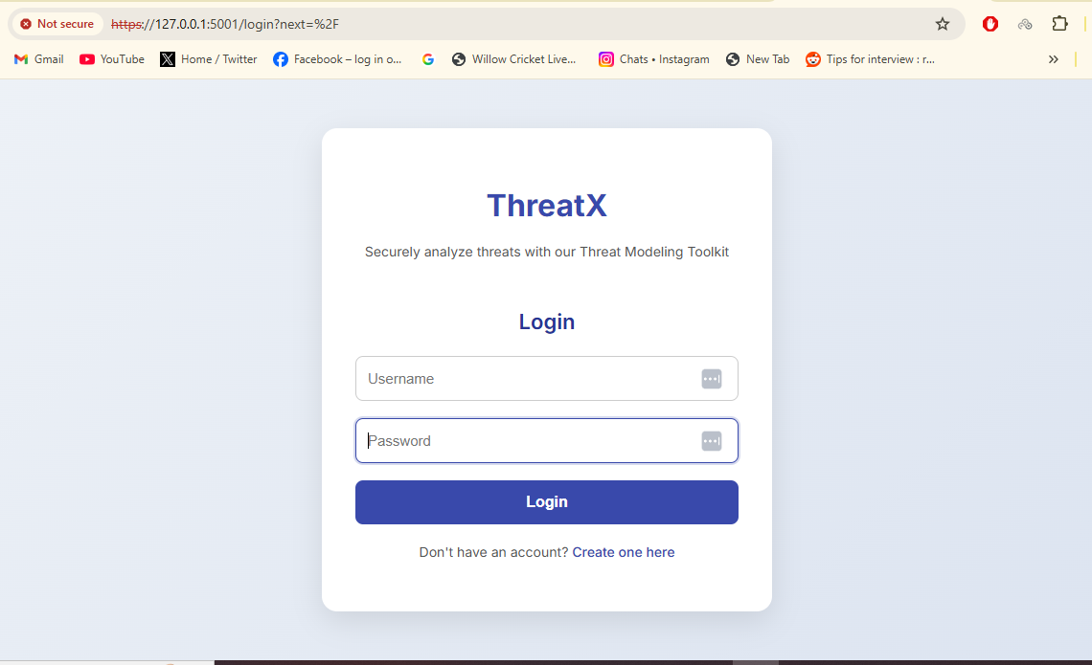
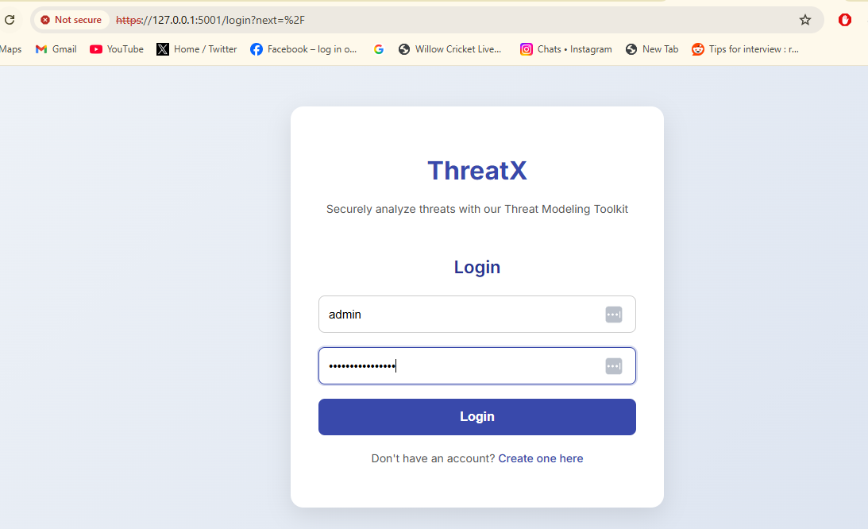
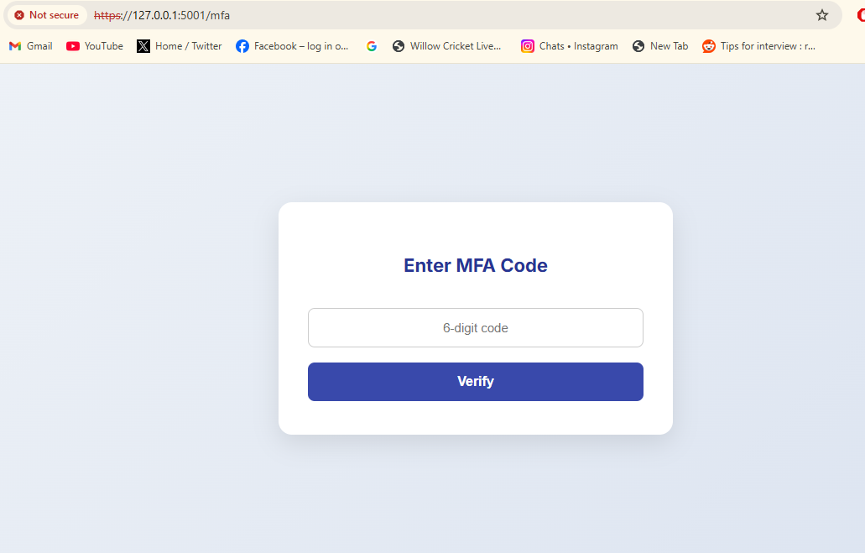
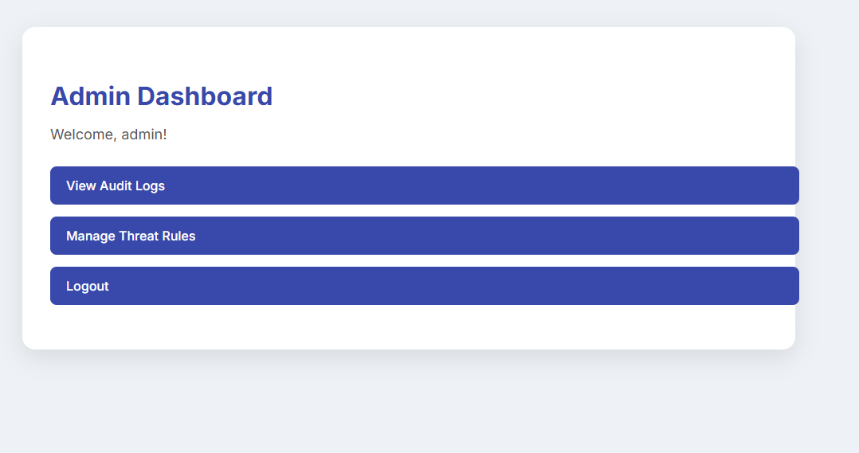
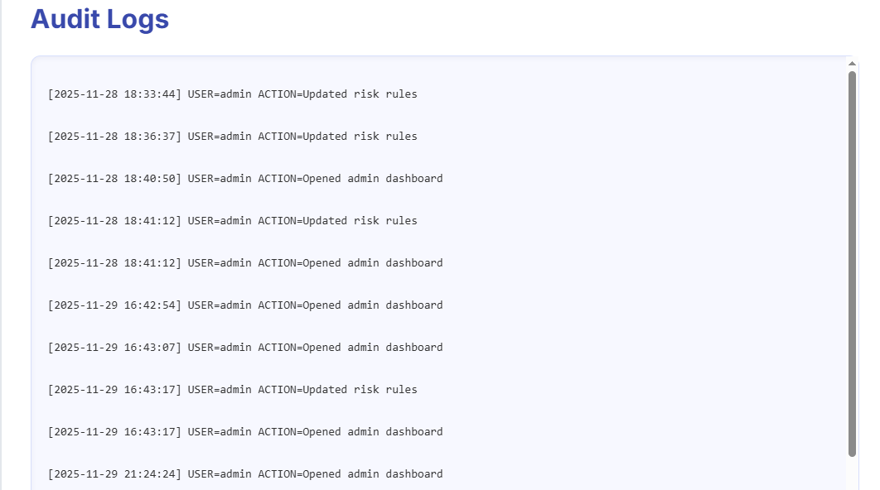
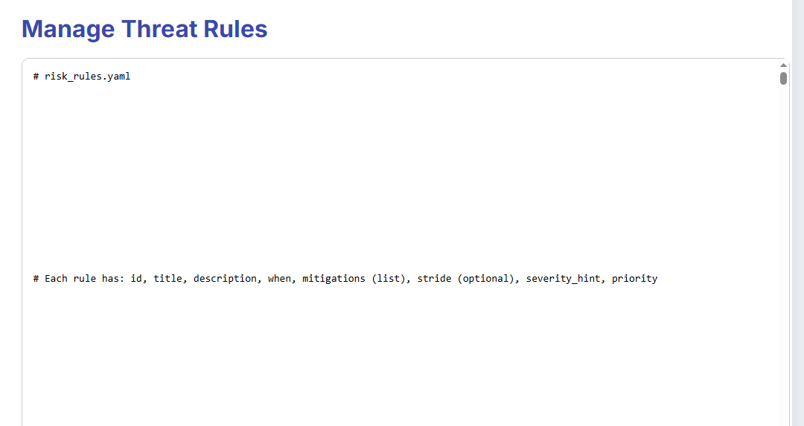
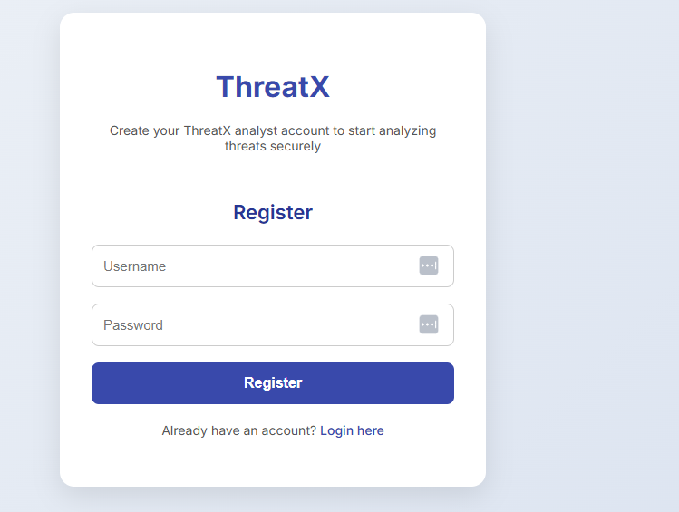
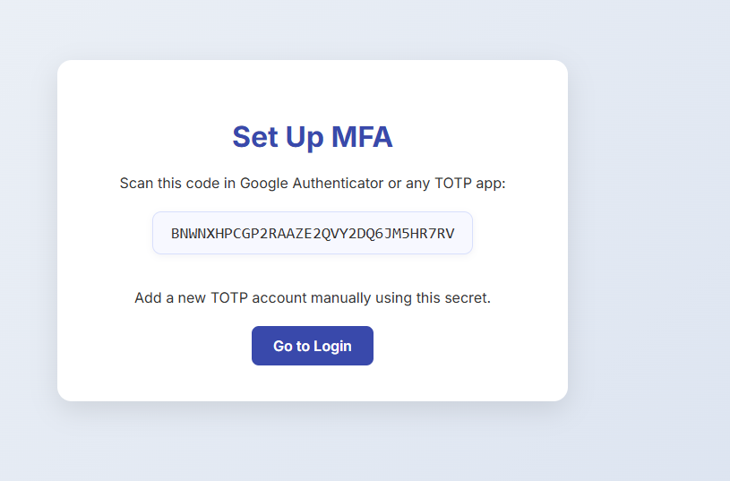
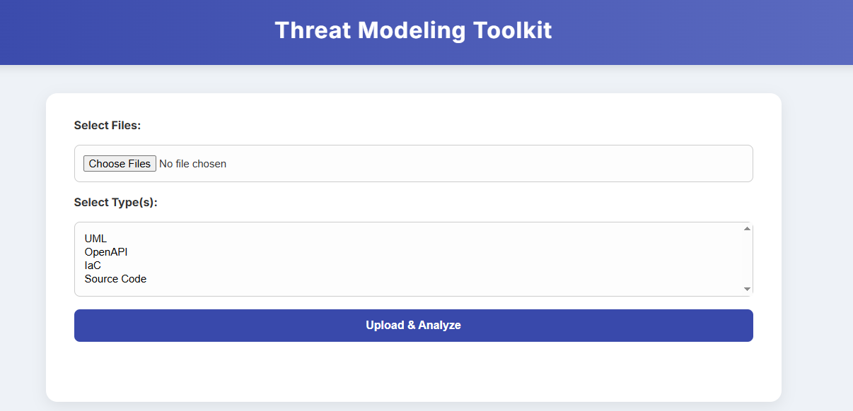
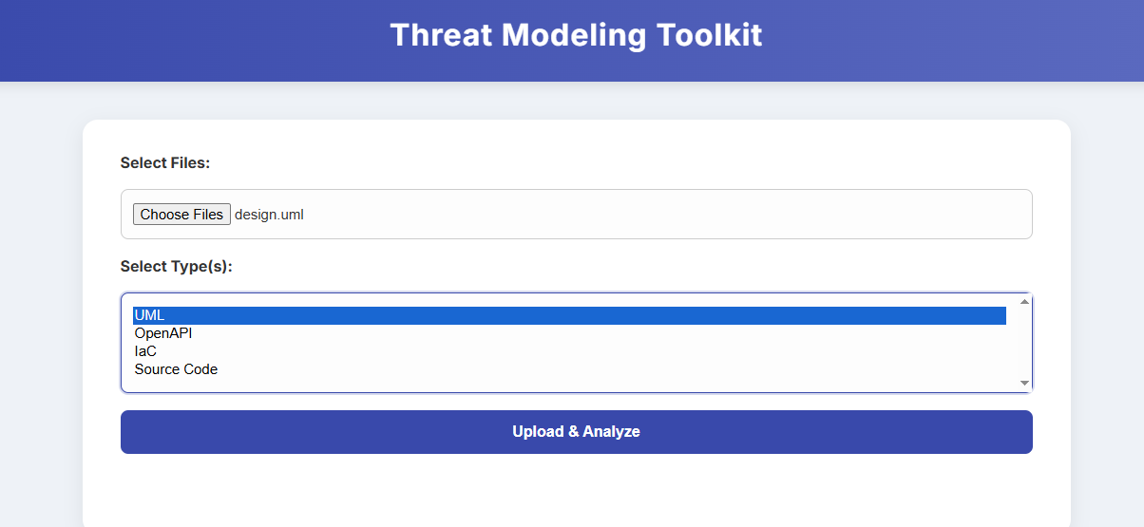
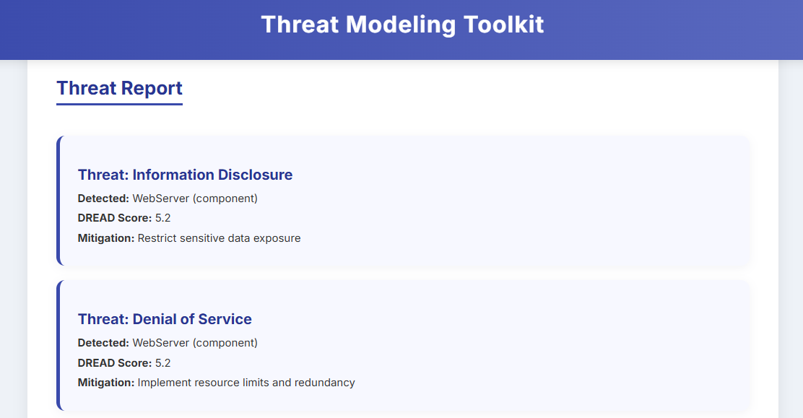
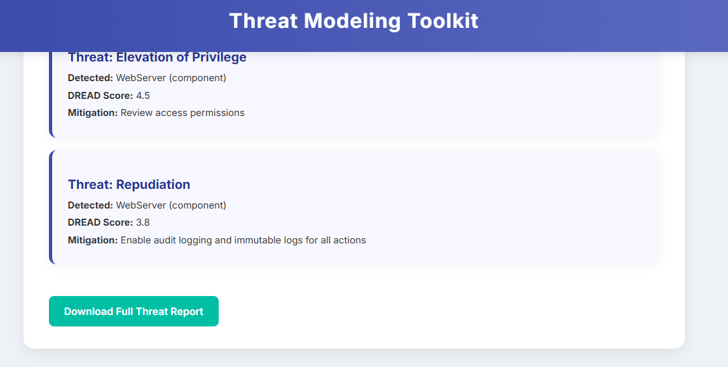

Testing & Validation
5.1 Security Testing
Test 1 — SQL Injection
Goal: Ensure user login/register is protected against SQLi.
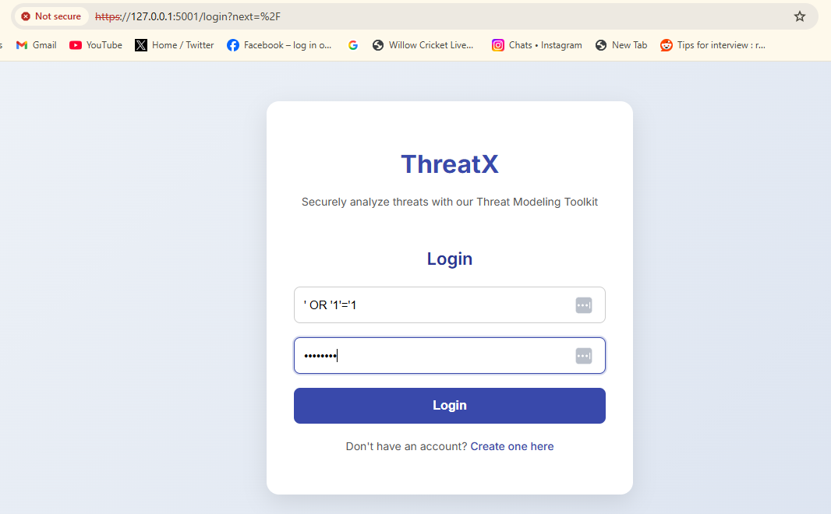
Result:
All SQL injection attempts failed because queries use parameterized statements (? placeholders in SQLite).
Test 2 — XSS in Uploaded Files
Goal: Ensure malicious filenames or text in uploaded files cannot execute scripts.
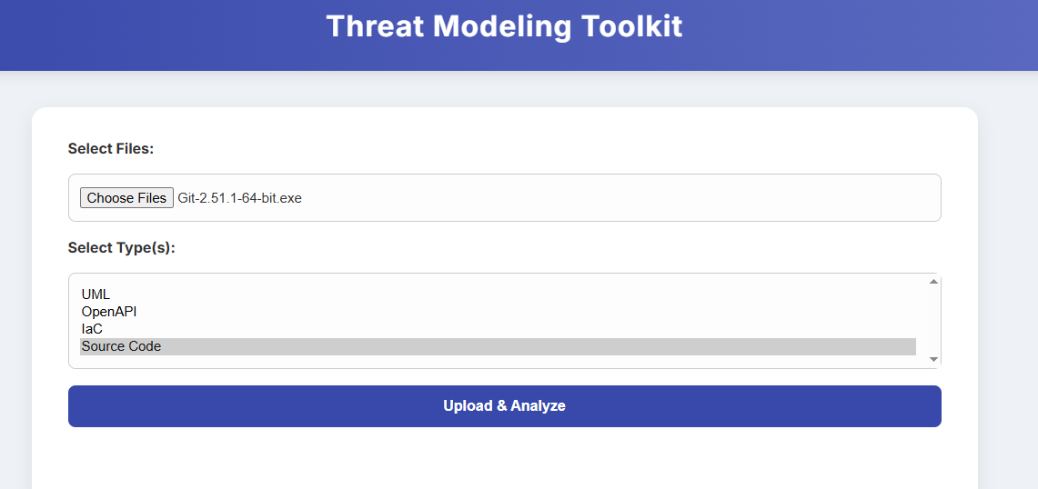
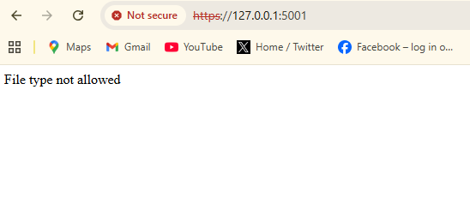
Result:
Files rejected due to extension validation (allowed_file()), and secure_filename() sanitizes names.
Test 3 — CSRF Protection
Goal: Verify CSRF token validation works.
Method: Submitted POST requests without sending CSRF token.
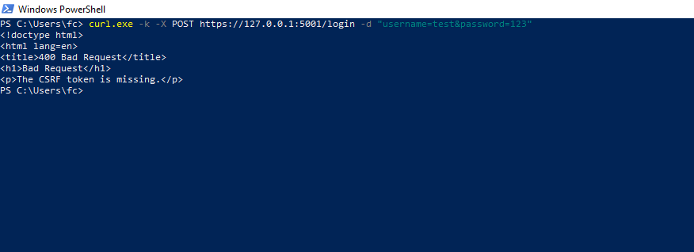
Result: Server returned 400 Bad Request.

Test 4 — Authentication & Session Security
Goal: Ensure back-button cannot reopen protected pages after logout.
Method: Log out → Press browser “Back”.
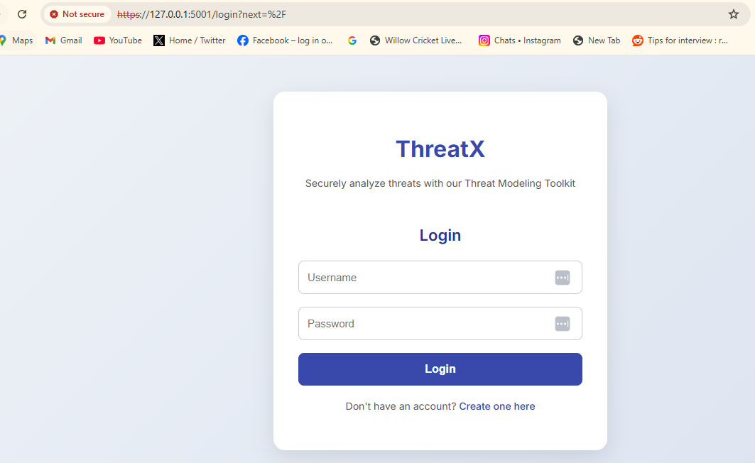
Result: Cache headers (no-store) prevent reloading private pages.
5.2 Functional Testing
Login + MFA Flow
- Registered a user
- Logged in
- Entered 6-digit TOTP
- Verified redirect to dashboard
File Upload & Threat Detection
- Uploaded UML / OpenAPI / IaC files
- Parser correctly converted input
- ThreatEngine returned threats
Admin Panel (RBAC)
- Analyst cannot access /admin/settings
- Admin can
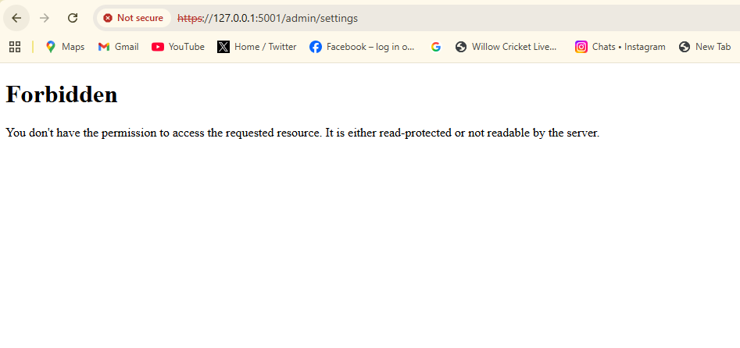
5.3 SAST Implementation (Static Code Analysis)
Tool Used: Bandit (Python Security Scanner)
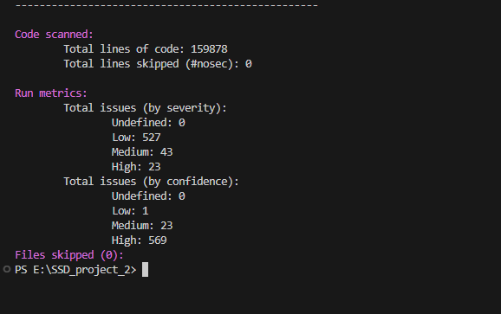
Critical Findings:
Issue | Bandit ID | Fix
Hard-coded secrets | B105 | Removed, replaced with env vars
Insecure temp file usage | B108 | Disabled direct file execution
Missing input validation | B301 | Added file extension validation

6. Conclusion
ThreatModelX demonstrates how automation can significantly improve secure software design. It eliminates manual errors, increases consistency, enables early detection of vulnerabilities, and supports modern DevSecOps practices.
The toolkit proves that automated threat modeling is:
- Faster
- More accurate
- Scalable
- Enterprise-ready

