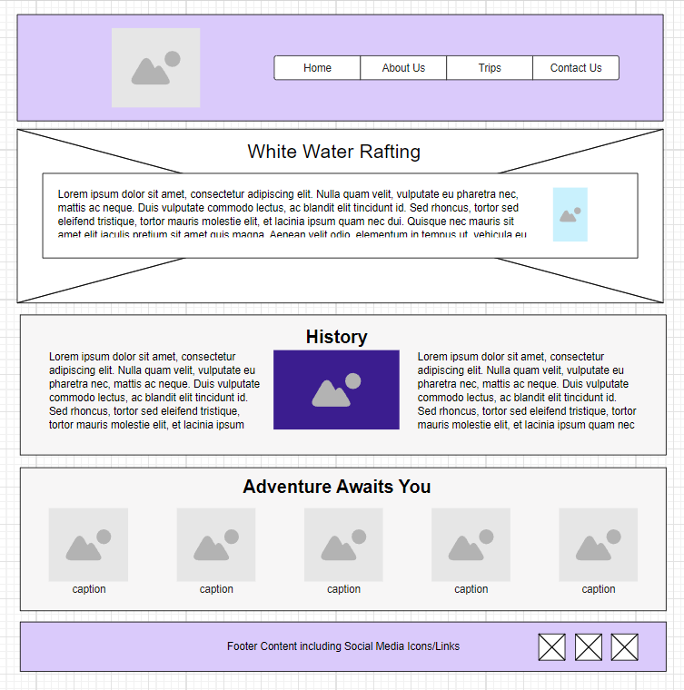

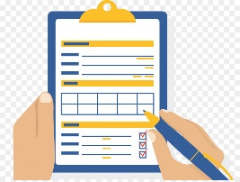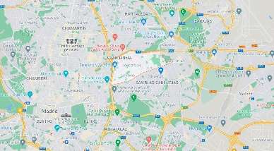

We are a family, and we want you in our family!

Our Staff

Our Staff

Our Staff

Our Staff

Our Staff

Email:

Phone Number:

Adress: