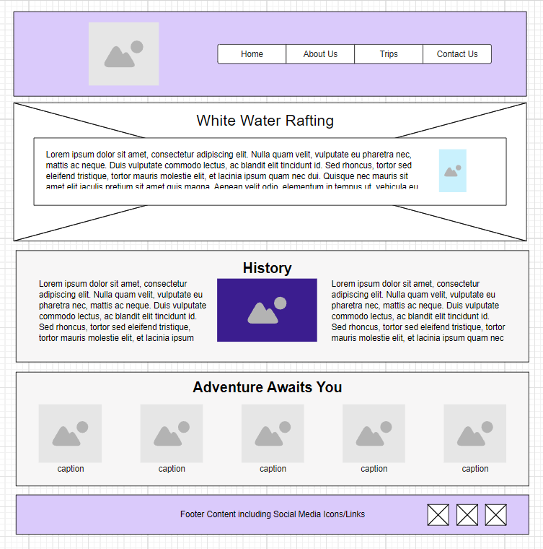

Wave  
Zone Rafting

**CALL TO ACTION BUTTON**

The best in Bolivia



Description (Offerings)

Description (Purpose)

Experiences



Comment and opinion

Comment and opinion

Comment and opinion