AI Usage DISCLOSURE FORM

1. Team Details
Team Name: HackHustlers
Project / Product Name: DuplexFlow AI
Organization / Institution (if any): SRM Institute of Science and Technology, Kattankulathur, Chennai
Submission Date: September 30, 2026

2. AI Usage Declaration
Did your team use any Artificial Intelligence (AI) in developing this project? Yes / No
Yes

3. Purpose of AI Usage ( Brief Details)
Idea generation / brainstorming : Yes, System architecture and FDB-v3 multi-step workflow design
Code generation or assistance : Yes, FastAPI routing, LiveKit agent worker setup, and Next.js UI integration
UI / UX design : Yes, Tailwind CSS styling layouts for the Live Studio and Telemetry Dashboard
Content creation : Yes, Documentation and README synthesis
Data analysis : Yes, Benchmark evaluation telemetry processing
Testing / debugging : Yes, Resolving Python tool registry execution errors and WebRTC async loops
Other : Yes, Utilizing Google Gemini Realtime API for multimodal voice generation

4. Feature Origin Classification ( Please add/delete based on the number of the feature)
1. Feature Name : Real-Time Full-Duplex Voice Agent
- Self-Generated/AI-Generated/Both : Both
- Description ( include AI tools/platform Used, prompt used , Output Summary, Modification) : Implemented using LiveKit Agents framework and Google Gemini Realtime API (gemini-2.5-flash). Used AI code generation prompts to structure asynchronous WebRTC audio streams, speech-to-speech event listeners, and robust fallback handling for interrupted turns.

2. Feature Name : Multi-Domain Tool Execution & Telemetry
- Self-Generated/AI-Generated/Both : Both
- Description (include AI tools/platform Used, prompt used , Output Summary, Modification) : Developed multi-step tool execution pipelines across travel, banking, real estate, and retail. AI-assisted code was used to construct mock database states and sync real-time IPC tool inspection logs (/api/live-logs) with the frontend.
3. Feature Name: FDB-v3 Benchmark Telemetry Dashboard
- Self-Generated/AI-Generated/Both: Both
- Description (include AI tools/platform Used, prompt used, Output Summary, Modification): Built using Next.js, Recharts, and Tailwind CSS. AI assistance was utilized to structure interactive evaluation graphs tracking reasoning latency, turn-taking stability, and domain pass rates.

5. Ethical & Compliance Confirmation
AI usage complies with guidelines and policies. Yes
No proprietary or copyrighted data misused. I Agree

6. Declaration & Sign-Off
Name of Team Representative: Aarushi Srivastava
Role: AI and Backend Developer
Signature:
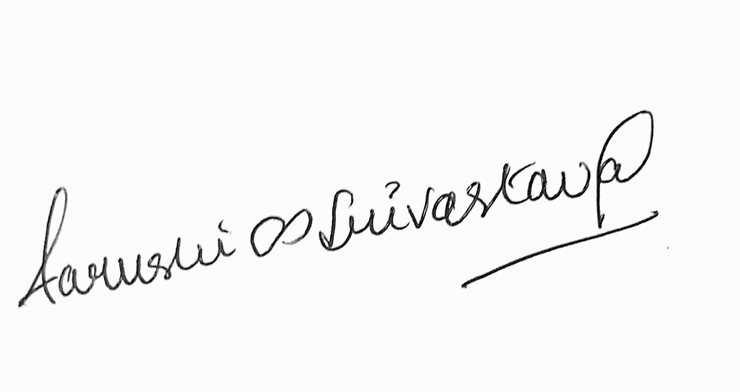
Date: September 30, 2026

