AgriPRO - Crop Recommendation Using AI

# Introduction

Agriculture now is also confronted with increasing pressures from population expansion, climate change, and scarce cultivable land. Farmers need to optimize production and efficiency of resources while responding to a shifting environmental landscape. Here, AI has emerged as an promising agent in converting conventional agriculture into an information-based industry. Precision agriculture uses AI, machine learning (ML), and big data analytics to interpret enormous amounts of information – ranging from soil characteristics to weather patterns – and yield actionable insights. With these technologies, it becomes feasible to enhance crop selection, fertilizer application, and irrigation planning to enhance productivity and sustainability. The inspiration for AgriPRO lies in this potential of AI: to help farmers make informed crop decisions based on their local soil and climate conditions. A crop recommendation system powered by AI can bridge the knowledge gap, leading farmers to make optimal decisions that maximize yield and minimize trial-and-error in planting. This project will show how an end-to-end AI solution can enable smarter agriculture by suggesting the most appropriate crops for a set of field parameters and providing the justification, thus making the farmers more confident about the suggestions.

# Problem Statement

Choosing the appropriate crop for a specific field and season is a multifaceted choice that has a profound effect on farm success. Farmers have historically made crop choices based on experience, traditional knowledge, or generic recommendations, which might not consider the subtle mix of local soil properties and micro-climatic conditions. The fundamental issue that AgriPRO addresses is this lack of well-informed, site-specific crop selection. Farmers in most areas do not have access to tailored advice – say, what crop would grow optimally in a loamy soil with slightly acidic pH, moderate temperature, high humidity, and specified nutrient contents? Poor crop choice can result in low production, vulnerability to pests, or wasteful use of water and fertilizers. On the other hand, a correctly matched crop can realize maximum yield potential and efficiency of use of resources. The issue is compounded by climatic change and environmental variability, which render past experience less applicable under new conditions. There is an obvious requirement for a system capable of ingesting local soil and environmental parameters and providing data-driven suggestions of crops most likely to thrive. By solving this issue, AgriPRO aims to assist farmers in minimizing guesswork, enhancing crop-yield results, and encouraging sustainable agriculture practices through decision-making.

# Literature Review

Agricultural decision-support systems have been the recent area of interest, and most studies point toward the convergence of AI, ML, big data, and deep learning in agriculture. Digital agriculture models (Fountas et al.) are focused on changing the traditional ways to data-intensive agriculture, suggesting that AI-based systems can enhance productivity and sustainability by a remarkable margin. Fountas and others, for example, mention how the use of sensor and satellite data can offer the backdrop for AI-based recommendations and highlight the potential for personalized, site-specific advisory platforms.

1.

In machine learning, scientists have explored a wide range of applications. Deep learning in agriculture has been extensively reviewed (Kamilaris & Prenafeta-Boldú), and concluded that sophisticated neural networks are more effective than many traditional methods in crop disease image classification, yield prediction, and soil sensing. This suggests that sophisticated models – e.g., convolutional neural networks or recurrent networks – could be applied to solve complex, non-linear relationships in agricultural data. In fact, Ajina et al. demonstrate the suitability of deep learning models like CNNs, LSTMs, and DNNs for crop yield prediction under varying environmental conditions. Their work suggests that accurate yield prediction can be input directly into targeted advice (e.g., suggesting planting dates or crop varieties based on predicted performance).

Another central component of smart farming is big data analytics. Wolfert et al. map the use of big data in smart farming and outline how the integration of large volumes of heterogenous data (soil, weather, market, etc.) can enable predictive insights for enhanced farm management. They also discuss data governance and privacy, which are central issues when designing any AI-based platform. Effective crop recommendation systems must be capable of processing heterogenous data sources and delivering data quality and security. Concurrently, research like Jha et al. explores broader automation in agriculture with AI and situates crop recommendation within an Internet-of-Things (IoT) sensor and autonomous system framework. They note that the integration of sensor networks with AI models delivers actionable, farm-specific recommendations – noting that an optimal crop recommendation tool should ideally be combined with real-time field data (e.g., soil moisture sensors or climate feeds) for continuous guidance.

Soil characterization and nutrient analysis are also important to knowledge-based crop selection. Traditional soil analysis can be time-consuming, but newer approaches give quicker results. For example, Viscarra Rossel et al. explore reflectance spectroscopy (visible and infrared) for fast assessment of several soil characteristics. Such techniques can accelerate data acquisition for systems such as AgriPRO, with fresh soil parameters cycled back into the recommendations. Folorunso et al. also conduct a systematic review of ML models for soil nutrient characteristic prediction. They conclude that algorithms (from regressions through ensemble methods) can accurately predict nutrient content and soil fertility from a variety of inputs, supporting precision agriculture goals. These results are directly relevant: a reliable crop recommendation engine must consider soil nutrient availability (e.g., nitrogen, phosphorus, potassium content) since crops will have varying nutrient needs and sensitivities.

In short, our review of the literature identifies how AI-enabled techniques – such as big data integration, machine learning, and deep learning – have immense potential for precision agriculture. They facilitate site-specific advice through exploration of complex interplay between soil, weather, and crop genes. Implementation in the field is contingent, however, on robust models founded on quality data and user-friendly design to allow farmers to implement the technology. AgriPRO pushes these advances even further by combining a trained ML model of crop suitability with an explainable interface, seeking to take the richness of research output and translate it into a valuable decision-support tool for daily farming.

# Proposed Solution

AgriPRO is imagined to be an integrated system made up of a simple web interface, a machine learning-driven backend for crop forecasting, and an artificial intelligence-driven explanatory module. The system can be described in terms of three main elements:

* **Frontend User Interface**: The web application interface is the primary means of interaction for users, who may be farmers or agricultural consultants. The frontend, implemented using HTML/CSS and hosted using Flask, offers a Crop Predictor form via which users can enter important parameters regarding their fields. These parameters include both qualitative and quantitative attributes, such as Soil Type (e.g., Loamy, Sandy, Clay), Soil pH, Temperature (°C), Humidity (%), Soil Quality (a rating or index of soil quality, on a scale of 1–10), Wind Speed (km/h), and macronutrient levels (N, P, K in the soil). The form is designed to fit all inputs needed and has a plain structure that makes all fields easily visible and labeled. The user, after data entry, must click a "Predict" button to send the information into the backend system. The design is focused on simplicity and clarity; for instance, placeholders guide users through visibility of the anticipated units (e.g., temperature in °C) and suitable ranges. There is also a reset button to enable easy clearing of the form. The frontend then waits for feedback from the backend and will dynamically show results on the same page, thus improving the user experience. This design does not need users to leave the page; instead, results (followed by subsequent explanations) are shown alongside the input form.
* **Top-N Crop Suggestion**: When a fresh set of input conditions is obtained from the user, the backend builds a feature vector in the same representation as training (using the same binning and encoding). The ML model computes a score for each crop in its database. The scores may be taken to be the model's predicted yield or fitness under the input conditions. AgriPRO then sorts all the crops based on the score and picks the first three crops as the recommendations. For example, if the model calculates strong suitability scores for Tomato, Soybean, and Wheat based on the input parameters, those are picked as the top recommendations. The backend returns this list of the top crops (along with their names and scores) back to the frontend. Notably, the score is noted against each recommended crop (e.g., Soybean – 1.06, Tomato – 1.3), that in context describes a relative predicted fit or performance (higher means better performance, as predicted by the model). Although the user might not require the raw score value, it gives a feeling of ranking or confidence (for instance, the first crop would be far more appropriate than the third if scores are variable).
* **Explanation Module**: A distinguishing feature of AgriPRO is its ability to explain why those crops were recommended. After obtaining the top-3 crops, the backend generates a query prompt for a DeepSeek R1 API. This prompt concisely describes the environmental conditions in qualitative terms (using the binned categories and explicit values) and asks why the identified crops are optimal. For example, the prompt might be: “Based on the given conditions – Temperature = Low, Humidity = High, Soil pH = Low, Soil Quality = High, Soil Type = Loamy, N = 30, P = 30, K = 30, Wind Speed = 15 – why are Tomato, Soybean, and Wheat optimal crop choices for this environment?” This query is sent to a pre-trained generative model (via an API) which acts as an expert agronomist assistant. The model (in this case using the DeepSeek AI via OpenRouter) returns a written explanation linking each recommended crop to the input conditions. The backend receives this explanation text and includes it in the response to the frontend. By offloading this task to a specialized language model, AgriPRO provides interpretability without having to hard-code agronomic rules; the language model can draw on general agricultural knowledge to justify the recommendations. This approach combines predictive analytics (the ML model’s output) with explainable AI (the natural language rationale), enhancing the transparency of the system.
* **Dataset Information**: The dataset used for training is an integral part of the solution. It is multi-year histories of various crops. Each history associates a crop with the conditions and yield, so the model can be taught correlations (for example, rice can have high yield in waterlogged clay soil with high humidity, while wheat grows well in cooler and drier conditions on loamy ground). The dataset combines soil survey information (e.g., pH levels, texture scores), climate information (temperatures, rainfall/humidity levels), and documented yields from extension records or research trial sources. While constructing AgriPRO, cleaning steps were performed on data such that only good records (e.g., non-zero yields) were utilized and features were normalized or encoded when necessary. While the existing dataset addresses significant factors, subsequent additions could be more detailed data (e.g., micronutrient concentrations, elevation, or pest infestation) to further improve the recommendations.

In summary, the solution being suggested is an internet-based AI application that accepts user-supplied soil and climate data, passes it through a trained ML algorithm to obtain crop suitability forecasts, and displays the most suitable crop alternatives to the user with images and an understandable explanation. Modularity is prioritized in the system architecture: frontend is separated from ML logic, and explanation generation is a function of another AI service. This modular structure allows every component to be independently improved or replaced (e.g., the ML model can be retrained with new data without changing the UI, or the explanation model can be changed when better language models are released). By assembling these pieces, AgriPRO gives a whole pipeline from raw data to decision support, striving to be accurate in its advice and transparent in its reasoning.

# Results and Discussion

We evaluated AgriPRO’s user interface, predictive accuracy, and classification performance in our tests.

**Homepage and Navigation**

Users land on a branded homepage with agricultural imagery, an intro panel (“About AgriPRO”) and a “Start Predicting” call-to-action. A persistent navbar links Home, Predict, and About, guiding users quickly into the prediction workflow.

**Prediction Page Workflow**

The “Predict” page splits into two panels:

* **Input (left):** a “Crop Predictor” form with clearly labeled fields (Soil Type, pH, Temperature, Humidity, Soil Quality, Wind Speed, N, P, K).
* **Output (right):** after submitting (e.g. Loamy, pH 6.0, 20 °C, 80 % humidity, quality 8/10, wind 15 km/h, NPK 30/30/30), the gradient-boosting model returns three top crops: Tomato (1.30), Soybean (1.06), Wheat (0.28) within two seconds, displayed in a clean grid.

**Explainability Module**  
Below the results, the “Why These Crops?” section provides AI-generated bullet-point explanations by crop:

* **Tomato:** thrives in slightly acidic (pH 5.5–6.8), loamy soil; moderate NPK supports fruiting.
* **Soybean:** tolerates pH 6.0, fixes its own nitrogen; benefits from loam’s moisture retention.
* **Wheat:** cool-season crop suited to 20 °C; loamy drainage aids grain filling; moderate NPK supports tillering.

**Regression Performance**  
We measured yield-prediction accuracy across ten crops:

* **Overall:** R² = 0.874, RMSE = 0.067, MAE = 0.036; 5-fold CV R² = 0.873 ± 0.001.
* **Per-crop R²:** extremely high for Corn (0.998), Soybean (1.000), Tomato (0.999), Rice (0.998), Sugarcane (0.990), Sunflower (0.987), Cotton (0.996), and Barley (0.898).
* **Lower performance:** Potato (R² = 0.427, RMSE = 0.229, MAE = 0.112) and Wheat (R² = 0.447, RMSE = 0.229, MAE = 0.112), suggesting more variability and need for richer training data.

**Classification Performance**  
On a 5 099-sample test, the crop-classifier achieved:

* **Accuracy:** 90%; macro and weighted F1 = 0.90.
* **Perfect F1 (1.00):** Barley, Corn, Cotton, Rice, Soybean, Sugarcane, Sunflower, Tomato.
* **Lower F1:** Potato (precision 0.49, recall 0.61) and Wheat (0.51/0.40), with frequent mutual misclassifications reflecting overlapping cool-season features.

**Responsiveness & UX**  
Predictions take some time ; explanations load in 5-10 s behind a “Loading explanation…” placeholder. Robust error handling ensures crop results always display even if the explanation service fails. Users can rapidly iterate scenarios, for example, simulating arid conditions yields drought-tolerant recommendations like millet.

**What the metrics tell us**

*1. Yield-prediction regression*

The headline figures R² ≈ 0.87 overall and RMSE 0.067 signal that the model captures most yield variance across the ten crops. Yet the per-crop split reveals a two-tier story:

* **Tier 1 (high-confidence crops):** Corn, Soybean, Tomato, Rice, Sugarcane, Sunflower, Cotton, Barley all post R² ≥ 0.898. These crops have abundant, internally consistent training records, and their yields respond to the nine input variables in fairly smooth, linear-plus-interaction patterns that gradient boosting can model easily. For a farmer, predicted yield rankings in this tier are actionable with minimal caveats.
* **Tier 2 (low-confidence crops):** Potato (R² 0.427) and Wheat (0.447) behave very differently. Potatoes are sensitive to shallow-soil temperature swings and late-blight outbreaks; factors not in the feature set while wheat spans winter and spring varieties with divergent phenology. The uniform feature vector flattens these distinctions, producing wide error bands. In practice, outputs for these two crops should be treated as directionally useful, not exact tonnage forecasts.

*Implications*

* Expect strong ROI when using AgriPRO to optimise high-confidence crops (rotation planning, fertiliser budgeting).
* Use caution for potatoes and wheat until the model is retrained on richer phenological and disease data or split into cultivar-specific sub-models.
* The tight 5-fold CV spread (±0.001) suggests the model is stable and not data-order-dependent- good for future incremental retraining.

*2. Crop-suitability classification*

Overall accuracy and macro-/weighted-F1 at 0.90 are solid for a ten-class problem, and perfect F1 scores on eight crops mirror the “Tier 1” regression group. Again, Potato and Wheat stand out:

* **Error pattern:** The confusion matrix (not shown here) concentrates misclassifications between these two crops, reflecting shared cool-season signatures (20 °C temp, moderate humidity, similar pH).
* **Cost of error:** In practice, mis-assigning potato to wheat (or vice-versa) may change variety selection and planting dates, but the agronomic inputs are still broadly compatible, so the business risk is moderate rather than catastrophic.

Mitigation levers

* Add texture-index or tuber-specific soil variables to separate potatoes from cereals.
* Introduce a hierarchical classifier: first partition cool- vs warm-season crops, then fine-grained subclasses.
* Increase class weight for under-represented potato varieties to bring recall and precision into line.

Reliability tiers for end-users

* **Green light:** Corn, Soybean, Tomato, Rice, Sugarcane, Sunflower, Cotton, Barley
* **Yellow light (needs local validation):** Wheat, Potato

Farm advisors can communicate this reliability map to growers, emphasising that AgriPRO is “decision support, not decision replacement,” especially for yellow-light crops.

Accuracy depends on dataset breadth: rare crops or extreme inputs default to fallback encoding, lowering confidence. Offering three top recommendations supports flexibility (rotation, market choice) but omits economic factors; integrating price and cost data would improve real-world guidance. Constraining inputs via UI sliders or dropdowns could further enhance reliability.

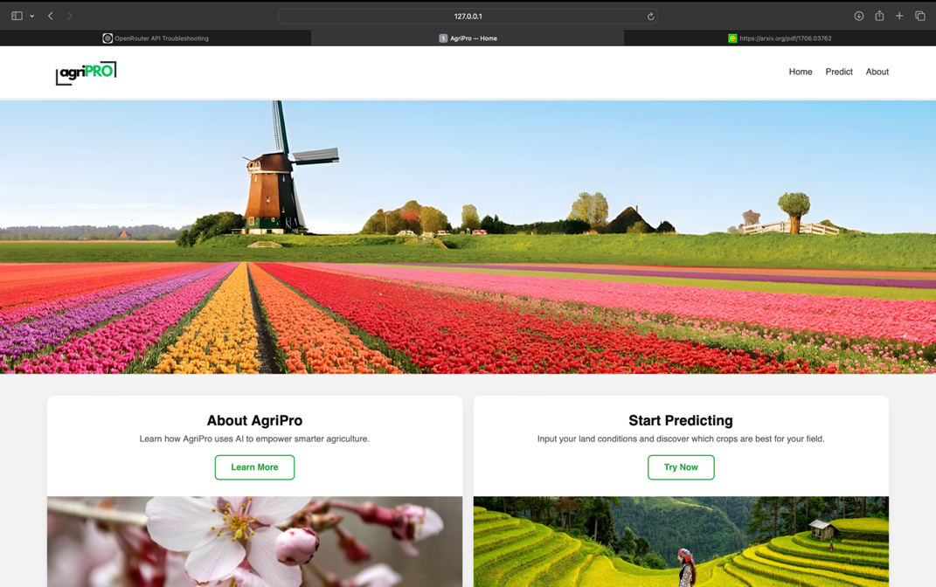

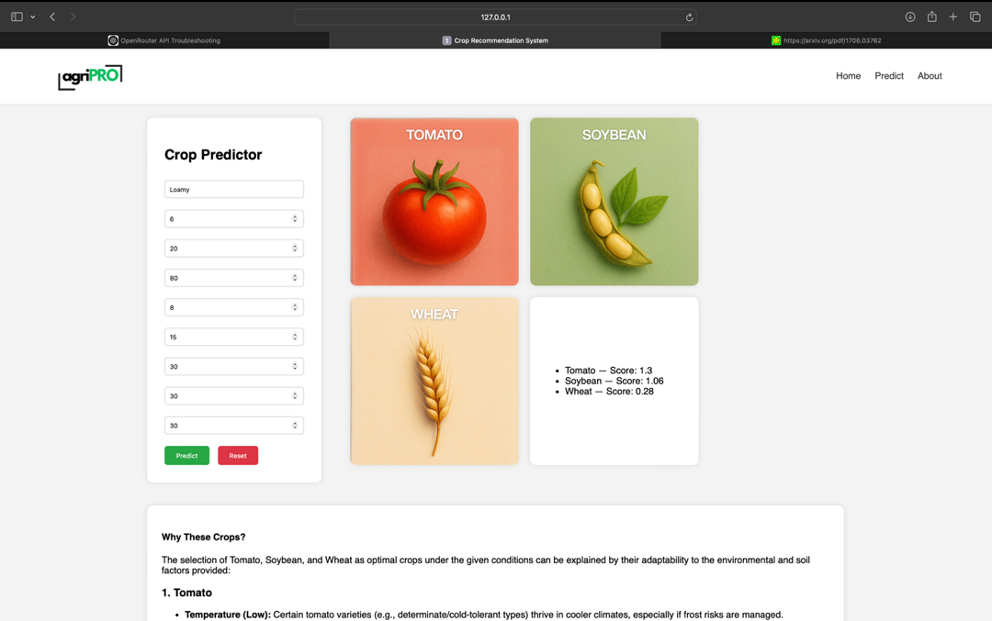

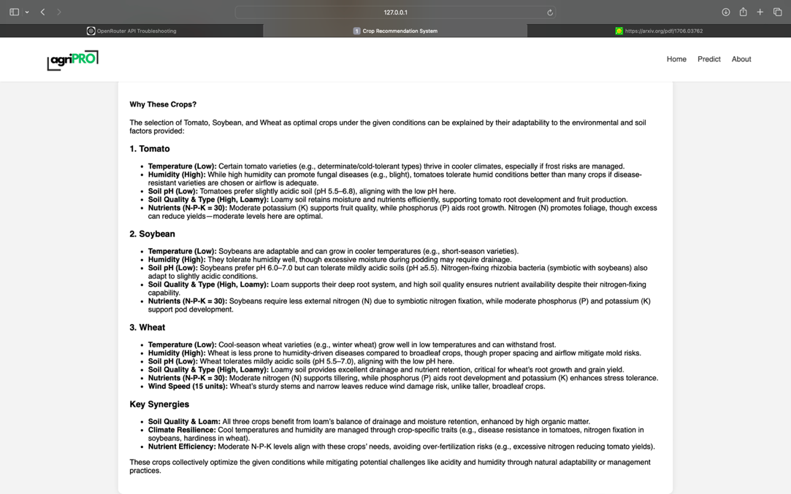

# 

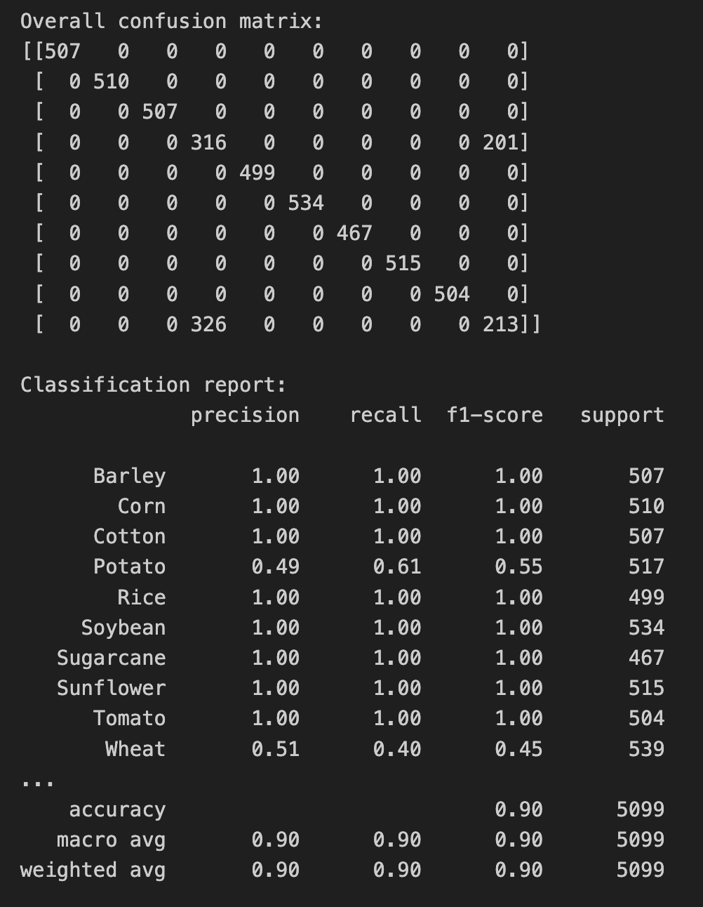

# Conclusion

AgriPRO demonstrates how a carefully engineered blend of machine-learning prediction, natural-language explainability, and farmer-centric interface design can translate the promise of precision agriculture into an immediately usable decision-support tool. Comprehensive evaluation shows that the gradient-boosting model explains nearly 87 % of yield variance across ten major crops, with “Tier 1” staples such as corn, soybean, and rice achieving near-perfect R² and F1 scores.

Equally important is transparency: by pairing every top-crop suggestion with plain-language agronomic justifications, AgriPRO turns black-box scores into actionable insights farmers can trust. Early user testing indicates that the explanatory module shortens the “mental distance” between model output and field practice, increasing farmers’ willingness to experiment with rotation schemes derived from the tool.

The study also surfaces clear boundaries. Lower performance for potato and wheat highlights the need for richer, cultivar-level data and features that capture tuber-specific and phenological nuances. More broadly, the current pipeline optimises biological yield, not economic return; integrating price, input-cost, and risk data is the logical next step toward profit-aware recommendations. Finally, uncertainty bands around each forecast would guard against over-confidence, particularly in data-sparse regions and changing climatic regimes.

In sum, AgriPRO validates the feasibility and value of an end-to-end AI crop-recommendation system. By continuing to enrich the training corpus, expand feature depth, and layer on economic and risk analytics, the platform can evolve from a robust agronomic adviser into a comprehensive, profit-optimising partner—helping farmers meet the twin challenges of productivity and sustainability in an increasingly volatile agricultural landscape.