FreelanceHub
A Full-Stack Freelancing Platform
Node.js + Express + React Application
Individual Final Project
July 2026

1. Project Overview
FreelanceHub is a full-stack freelancing platform that connects employers with freelancers. Employers can post job listings, review applications from freelancers, and manage contracts. Freelancers can browse job openings, apply with their resumes and cover letters, and track their application status. The platform includes a role-based access control system with three tiers: Admin, Employer, and Freelancer, each with appropriate permissions.
The application was built as an individual final project for the Web Programming II course, demonstrating proficiency in full-stack development with Node.js, Express.js, React, and SQLite.
2. Features
The FreelanceHub platform includes the following features:
- User Authentication: Registration and login system with JWT-based authentication using access and refresh token rotation.
- Role-Based Access: Three user roles (Admin, Employer, Freelancer) with role-based authorization guards on every endpoint.
- Job CRUD: Employers can create, read, update, and delete job listings with title, description, budget range, category, and deadline.
- Job Search & Filters: Freelancers can browse jobs with keyword search, category filtering, budget range, and status filters.
- Application System: Freelancers can apply for jobs with their name, resume/CV upload (PDF, DOC, DOCX), and cover letter.
- Application Management: Employers can review applications, view attached resumes, and accept or reject candidates.
- Contract Management: Accepted applications automatically create contracts. Employers can mark contracts as completed or terminated.
- Reviews & Ratings: Freelancers and employers can leave ratings and reviews for completed contracts.
- In-App Notifications: Bell icon with unread count badge and dropdown showing recent notifications. Auto-polling every 30 seconds.
- Admin Dashboard: Site-wide statistics, user management (view/delete), job management (view/update status), category CRUD.
- Responsive Design: Mobile-responsive layout with clean typography using Playfair Display and Plus Jakarta Sans fonts.
- Staggered Animations: Fade-in animations with staggered delays for a polished user experience.
3. Technologies Used
The following technologies and tools were used in the development of FreelanceHub:
Technology | Purpose
Node.js | JavaScript runtime for building the server
Express.js | Web application framework for routing and middleware
React (Vite) | Frontend library for building the user interface
React Router v6 | Client-side routing for the React frontend
SQLite | Lightweight relational database (file-based)
Sequelize ORM | Object-relational mapping for database interactions
JWT (jsonwebtoken) | Token-based authentication with access and refresh tokens
bcryptjs | Password hashing for secure authentication
Morgan + Winston | HTTP request logging and structured application logging
express-validator | Input validation and sanitization on every endpoint
Multer | File upload handling for resumes (PDF, DOC, DOCX)
express-rate-limit | Rate limiting (1000 req/15min dev, 100 production)
Axios | HTTP client for API calls from the frontend
4. System Architecture
FreelanceHub follows a Model-View-Controller (MVC) architecture pattern adapted for a decoupled frontend and backend:
Backend (Controller + Model): Express.js handles incoming HTTP requests, processes them through middleware (authentication, authorization, validation, rate limiting), matches routes to controllers, and returns JSON responses. Sequelize ORM manages database models and interactions with SQLite.
Frontend (View): React renders the user interface in the browser. The frontend communicates with the backend exclusively through RESTful API calls using Axios.
Middleware Stack: Custom middleware handles JWT verification (auth guard), role-based access control (role guard), input validation (express-validator), file upload processing (multer), error handling, and request logging.
Request-Response Flow
1. Client sends HTTP request to the Express server
2. Request passes through middleware stack (rate limiter, logger, body parser, auth guard)
3. Router matches the request to the appropriate controller
4. Controller validates input, processes business logic, and queries SQLite via Sequelize
5. Controller sends JSON response back to the client
6. React frontend processes the response and updates the UI
5. Database Design
The database uses SQLite with six main tables. The schema is designed to normalize data while maintaining efficient query performance through strategic indexing.
Users Table
Stores user account information:
Column | Type | Description
id | INTEGER PRIMARY KEY AUTOINCREMENT | Unique user identifier
name | TEXT NOT NULL | User's full name
email | TEXT UNIQUE NOT NULL | User's email (used for login)
password_hash | TEXT NOT NULL | Bcrypt-hashed password
role | TEXT CHECK(role IN (...)) | User role: employer, freelancer, or admin
avatar | TEXT | Optional profile image URL
bio | TEXT | Optional user biography
skills | TEXT (JSON array) | Array of skills (for freelancers)
created_at | DATETIME | Account creation timestamp
Categories Table
Column | Type | Description
id | INTEGER PRIMARY KEY AUTOINCREMENT | Unique category identifier
name | TEXT NOT NULL | Category display name
slug | TEXT UNIQUE NOT NULL | URL-friendly slug
description | TEXT | Category description
created_at | DATETIME | Creation timestamp
Jobs Table
Column | Type | Description
id | INTEGER PRIMARY KEY AUTOINCREMENT | Unique job identifier
employer_id | INTEGER FK users.id | The employer who posted the job
category_id | INTEGER FK categories.id | Job category
title | TEXT NOT NULL | Job listing title
description | TEXT NOT NULL | Detailed job description
budget_min | REAL | Minimum budget
budget_max | REAL | Maximum budget
deadline | TEXT (DATE) | Application deadline
status | TEXT CHECK(status IN (...)) | open, in_progress, completed, cancelled
created_at | DATETIME | Listing creation timestamp
Applications Table
Column | Type | Description
id | INTEGER PRIMARY KEY AUTOINCREMENT | Unique application identifier
job_id | INTEGER FK jobs.id | The job being applied to
freelancer_id | INTEGER FK users.id | The applicant
name | TEXT NOT NULL | Applicant's name
resume_url | TEXT | Resume/CV file path
cover_letter | TEXT NOT NULL | Cover letter content
status | TEXT CHECK(status IN (...)) | pending, accepted, rejected
created_at | DATETIME | Application timestamp
Contracts Table
Column | Type | Description
id | INTEGER PRIMARY KEY AUTOINCREMENT | Unique contract identifier
job_id | INTEGER FK jobs.id | The related job
employer_id | INTEGER FK users.id | The employer
freelancer_id | INTEGER FK users.id | The freelancer
application_id | INTEGER FK applications.id | The originating application
start_date | DATETIME | Contract start date
end_date | DATETIME | Contract end date
status | TEXT CHECK(status IN (...)) | active, completed, terminated
created_at | DATETIME | Creation timestamp
Notifications Table
Column | Type | Description
id | INTEGER PRIMARY KEY AUTOINCREMENT | Unique notification identifier
user_id | INTEGER FK users.id | The recipient
type | TEXT NOT NULL | Notification type
message | TEXT NOT NULL | Notification message
link | TEXT | Optional link to related resource
read | INTEGER (0/1) | Read status (default 0 = false)
created_at | DATETIME | Creation timestamp
Reviews Table
Column | Type | Description
id | INTEGER PRIMARY KEY AUTOINCREMENT | Unique review identifier
contract_id | INTEGER FK contracts.id | The reviewed contract
reviewer_id | INTEGER FK users.id | The reviewer
reviewee_id | INTEGER FK users.id | The person being reviewed
rating | INTEGER CHECK(1-5) | Star rating
comment | TEXT | Review comment
created_at | DATETIME | Review timestamp
Entity Relationships
- A User (employer) has many Jobs (one-to-many)
- A User (freelancer) has many Applications (one-to-many)
- A User has many Contracts as employer or freelancer (one-to-many)
- A User has many Notifications (one-to-many)
- A User has many Reviews as reviewer or reviewee (one-to-many)
- A Job belongs to an Employer and has many Applications (one-to-many)
- A Job has one Category (many-to-one)
- A Job has one Contract (one-to-one)
- An Application belongs to a Job and a Freelancer (many-to-one)
- An Application creates one Contract when accepted (one-to-one)
- A Contract has many Reviews (one-to-many)
- Foreign keys enforce referential integrity with CASCADE deletes
Entity-Relationship Diagram
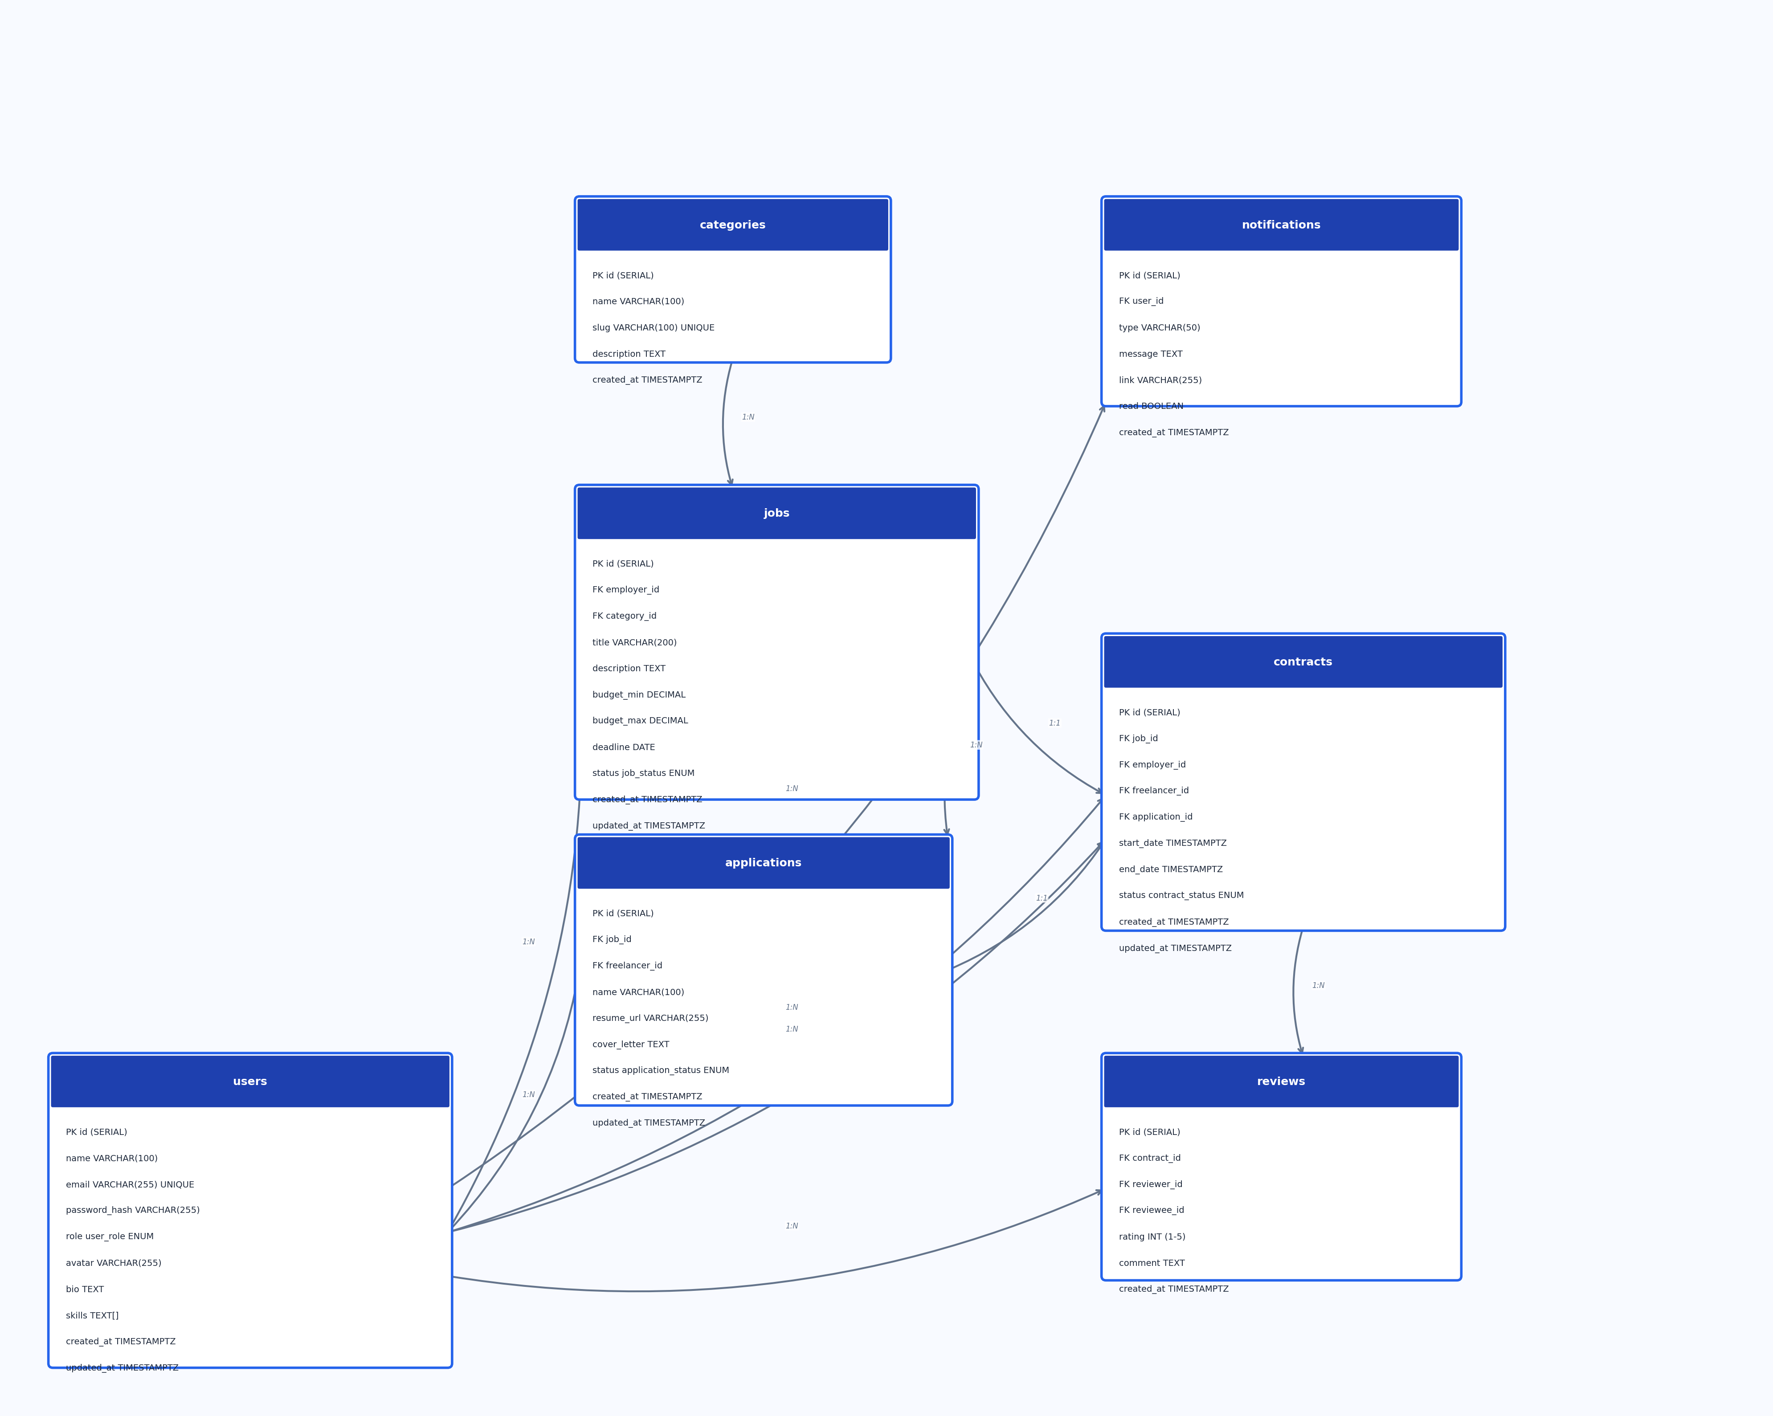
Figure 1: FreelanceHub Database Entity-Relationship Diagram
6. Installation & Setup
Prerequisites
- Node.js (v16 or higher)
- npm (comes with Node.js)
Step-by-Step Installation
1. Clone the repository: git clone <repository-url> && cd freelance-platform
2. Backend setup: cd backend && npm install
3. No database server needed. SQLite creates the database file automatically.
4. Run the schema: sqlite3 database.sqlite < database/ddl.sql
5. Seed sample data: npm run seed
6. Configure environment variables in the .env file (see .env.example)
7. Frontend setup: cd frontend && npm install
8. Start the backend: cd backend && npm run dev (runs on port 5000)
9. Start the frontend: cd frontend && npm run dev (runs on port 3000)
10. Open http://localhost:3000 in a browser
7. Usage Guide
For Freelancers
- Register a new account with the "freelancer" role
- Browse job listings on the home page or use the Browse page with filters
- Click on a job to view details, requirements, and budget
- Apply for a job with your name, resume/CV upload, and cover letter
- Track application status from the My Applications page
- View active contracts from the dashboard
- Receive notifications when applications are accepted
For Employers
- Register a new account with the "employer" role
- Post a new job listing with title, description, category, and budget
- View and manage your job listings from the dashboard
- Review applications from freelancers with attached resumes
- Accept or reject applications to create contracts
- Manage active contracts (mark as completed or terminated)
- Leave reviews for completed contracts
For Admins
- Login with the admin account (admin@example.com / admin123)
- View site-wide statistics on the admin dashboard
- Manage users (view details and delete accounts)
- Manage jobs (view and update status)
- Manage categories (create and delete)
Notifications
- The bell icon in the navbar shows an unread count badge
- Click the bell to view recent notifications in a dropdown
- Employers are notified when freelancers apply to their jobs
- Freelancers are notified when their applications are accepted
- Notifications auto-poll every 30 seconds
8. API Endpoints
Authentication
Method | Endpoint | Description | Auth
POST | /api/auth/register | Register new user | No
POST | /api/auth/login | Login | No
POST | /api/auth/refresh | Refresh tokens | No
GET | /api/auth/me | Get current user | Yes
Jobs
Method | Endpoint | Description | Auth | Role
GET | /api/jobs | List open jobs | No | -
GET | /api/jobs/:id | Get job details | No | -
POST | /api/jobs | Create job | Yes | employer
PUT | /api/jobs/:id | Update job | Yes | employer
DELETE | /api/jobs/:id | Delete job | Yes | employer
GET | /api/jobs/my | Get my jobs | Yes | employer
Applications
Method | Endpoint | Description | Auth | Role
POST | /api/applications/jobs/:jobId | Apply for job | Yes | freelancer
GET | /api/applications/my | My applications | Yes | freelancer
GET | /api/applications/jobs/:jobId | Job applications | Yes | employer
PATCH | /api/applications/:id/accept | Accept application | Yes | employer
Contracts
Method | Endpoint | Description | Auth
GET | /api/contracts | List my contracts | Yes
GET | /api/contracts/:id | Get contract details | Yes
PATCH | /api/contracts/:id/status | Update contract status | Yes
Reviews
Method | Endpoint | Description | Auth
POST | /api/reviews/contracts/:contractId | Create review | Yes
GET | /api/reviews/users/:userId | Get user reviews | No
Admin
Method | Endpoint | Description | Auth
GET | /api/admin/stats | Dashboard stats | Yes
GET | /api/admin/users | List all users | Yes
DELETE | /api/admin/users/:id | Delete user | Yes
GET | /api/admin/jobs | List all jobs | Yes
PATCH | /api/admin/jobs/:id/status | Update job status | Yes
9. Concepts Implemented
This project demonstrates the following concepts covered in the course and beyond:
- Express Server Setup: A fully configured Express server with middleware, routing, error handling, static file serving, and CORS.
- RESTful API Design: Modular route organization using Express Router, separated by domain (auth, jobs, applications, contracts, reviews, admin, notifications).
- Middleware Usage: Custom middleware for JWT authentication, role-based authorization, input validation, file upload handling, rate limiting, and error handling.
- JWT Authentication: Access tokens (15min) and refresh tokens (7d) with rotation for secure session management.
- Role-Based Access Control: Three-tier RBAC (admin, employer, freelancer) with guards on every protected endpoint.
- CRUD Operations: Complete Create, Read, Update, Delete operations for jobs. Create, Read, Update for applications and contracts.
- Database Integration: Full SQLite integration using Sequelize ORM with model associations and parameterized queries.
- File Uploads: Resume/CV upload handling using multer with file type validation (PDF, DOC, DOCX), size limits, and organized storage.
- Input Validation: Every endpoint validated and sanitized using express-validator to prevent injection attacks and malformed data.
- Rate Limiting: Configurable rate limiting with express-rate-limit (1000 requests per 15 minutes in development, 100 in production).
- Logging: Morgan for HTTP request logging and Winston for structured application logging with daily file rotation.
- React Frontend: Component-based architecture with React Router v6, protected routes, auth context, and Axios interceptors for token refresh.
- Password Hashing: Secure password storage using bcryptjs with salt rounds.
- Responsive Design: Mobile-responsive CSS layout with custom properties, CSS animations, and staggered fade-in effects.
10. GitHub Repository
The project source code is hosted on GitHub. The repository contains a complete commit history showing incremental development progress with descriptive commit messages.
[Link to GitHub Repository]
11. Conclusion
FreelanceHub successfully demonstrates a full-featured full-stack web application using Node.js, Express.js, React, and SQLite. The project implements all required concepts including authentication, authorization, JWT token management, password hashing, logging, and RESTful API design.
The platform goes beyond the course material by implementing refresh token rotation, role-based access control, rate limiting, input validation on every endpoint, file uploads, and a polished frontend experience with staggered animations and responsive design.
The project is well-documented, thoroughly structured with clean MVC separation, and ready for presentation and defense.

