Bank Customer Churn Prediction – ISOM 835 Individual Term Project
Name: Samuel Quartey
A. Executive Summary
Customer churn represents a unique operational and financial challenge for banks through operational and financial losses. It costs the bank much less to keep existing customers than to acquire them; therefore, predicting churn must be a focus for banks to remain competitive and ultimately profitable. Many banks are moving away from general marketing plans to more strategic and data-driven methods to increase customer loyalty and long-term profitability, to remain competitive in an increasingly competitive industry.
In this project, I apply predictive analytics and machine learning techniques, using historical data to identify which customers may leave a bank. I have used an actual, real-world data set consisting of 10,000 customers to conduct exploratory data analysis, data preprocessing, and training predictive models to identify those customers and learn what drives them to leave.
In this project, I developed and test two classification models: Logistic Regression & Random Forest. Logistic Regression is a viable model for this analysis due to its strong baseline for interpretability; however, Random Forest allows the identification of more accurate patterns in the data due to its ability to capture complex and non-linear relationships. The Random Forest model also provides significantly better recall and ROC-AUC performance scores, thus performing better at identifying which customers are most at risk for attrition.
Primary drivers of churn that were identified through the analysis include age, activity status, location, balance, and number of products used as a bank customer. With this information, banks will be able to create more focused retention strategies, increase engagement with customers, and decrease revenue losses because of customer attrition.

B. Introduction & Business Context
In the context of financial services companies, retaining customers is critical to long-term survival and success. When customers leave, it means that financial services companies will not only lose revenue on the transactions, but also should their customers but also future opportunities related to lending, investment opportunities, and other fees associated with cross-selling products and services to the customer. Further, replacing lost customers carries costs incurred because of financial services company.
Technological advances in predictive analytics, machine learning, and other technologies have created opportunities for financial services companies to identify customers likely to leave the company before the customer leaves. Financial services companies can identify patterns and behaviors that indicate a greater likelihood of a customer leaving the company than other customers using analysis of historical customer data.
This project will use predictive analytics to examine the issue of financial services companies losing customers. The dataset utilized for this analysis is available from Kaggle and is based on the demographic, financial, and behavioral information of 10,000 customers. Whether a customer has left the financial services company is the target variable for this analysis.
The primary objective of this analysis will be to develop accurate predictive models and use the results for the analytics to provide actionable insights for improving customer engagement, retention programs, and product design.

C. Business Problems and Research Questions
This project addresses several business problems that are commonly faced by banks:
First, how can banks identify customers that will likely leave? Proactive retention strategies can be put in place before customers leave. With the ability to identify when a customer will leave, banks can minimize the amount of revenue they lose as well as enhance their customer's experience.
Second, what are the demographic, financial, and behavioral characteristics that are the strongest drivers of customer churn? By understanding the strongest factors driving customer deactivation, banks are then able to more effectively segment their customer base and therefore personalize their efforts for retention.
Third, how can predictive analytics and machine learning models help provide banks with the necessary tools to create data-driven strategies for retaining customers and improving both long-term value and profitability?

D. Exploratory Data Analysis
An exploratory data analysis (EDA) helped better understand the structure, distribution and relationships within the data set. The data set has 10,000 observations with both numerical and categorical variables.
From our analysis of the target variable, we found an imbalance between the number of customers who remained with the bank versus those who churned. This class imbalance is crucial when assessing the performance of models, especially for accuracy and recall.
An analysis by geography indicated customers in Germany are churning at significantly greater rates than customers in France and Spain. This implies that there may be market or regional factors affecting customer behavior.
In addition, from our analysis by age that older customers may be more likely to churn due to life cycle changes or changing financial needs. In addition, we found that inactive customers also have a higher chance of churning compared to active customers; engagement is therefore very important.
Finally, the patterns of customer use and balance influenced churn. Higher balance of customers and customers with certain products had a greater chance of leaving the bank, and from our correlation heat map, we observed moderate correlation between numeric variables, but no evidence of significant multicollinearity.
Using visual exploratory Data Analysis (EDA), we will explore the structure, patterns and relationships within the Bank Customer Churn dataset with the objective of identifying patterns to inform decision-making within an organization.
Each figure below highlights a specific aspect of customer behavior and its relationship with churn. All visualizations are interpreted in the context of business decision-making.
The distribution of the Target variable (Exited).
In Figure 1 below, we will see a significant class imbalance between those customers who remained with the bank compared to those customers who churned. We can see a vast majority of customers did not churn, which means the dataset is imbalanced. As a result of the imbalanced dataset, certain types of evaluation metrics may be especially helpful in assessing the utility of predictive models, specifically Recall.

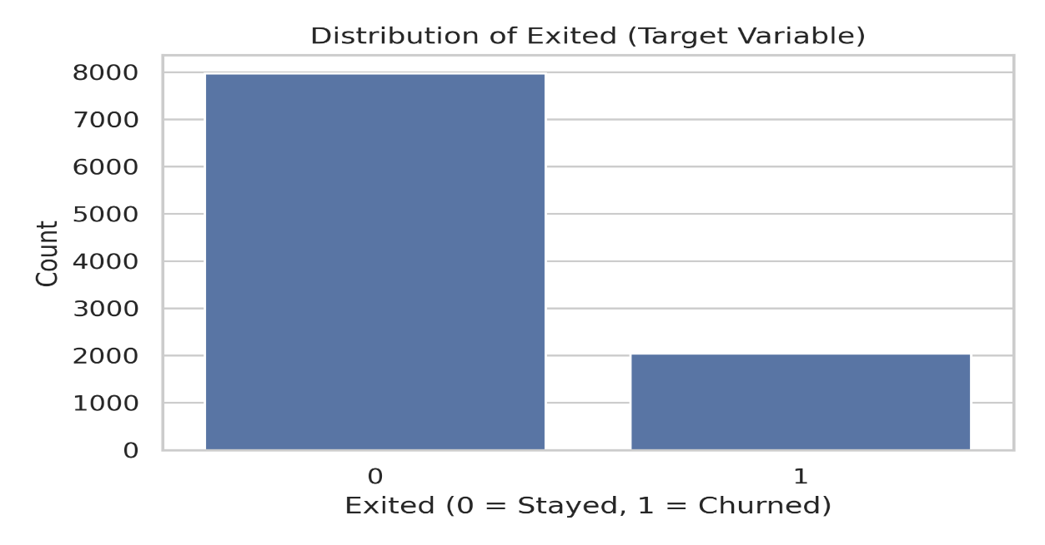
Figure 1: Distribution of Churn (Exited)
Customer Churn by Geography
We will examine customer churn based on a geographical breakdown of customers; thus, Figure 2 will provide insight regarding geographical differences in customer behavior. Based on the visualizations, we can infer that customers living in Germany have much higher churn rates than customers residing in France and Spain. This infers that there may be certain regional or market factors driving customer churn
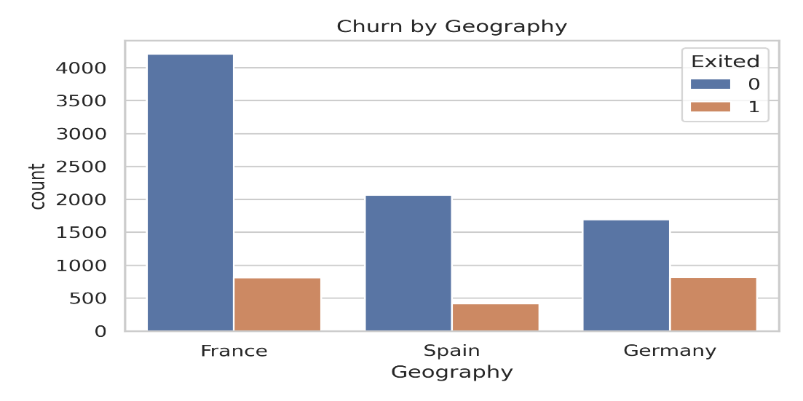
Figure 2: Customer Churn by Region
Age Distribution by Churn Status
We explores the relationship between customer age and churn status.Customer age and churn status are related, as seen in Figure 3. Older customers are more likely to churn than younger customers (age tends to be a predictor of churn). The age of the customer indicates the customer’s changing life cycle needs and how they interact with the bank.
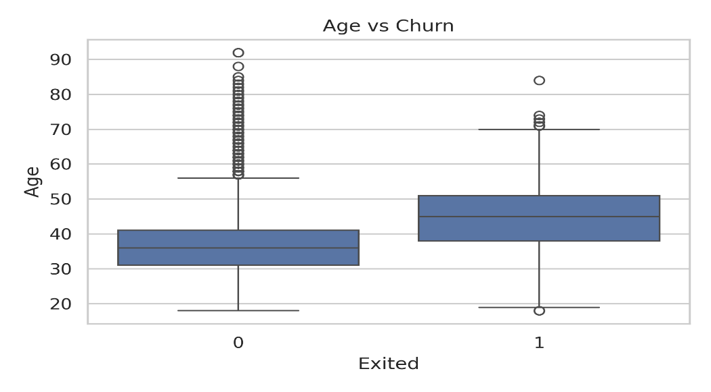
Figure 3: Customer Age and Churn
Customer Churn by Gender
Churn Behaviour by Gender - Figure 4 visually represents churn behaviour among both genders, indicating that while both genders retain a significant number of customers, the female customer has a higher total churn count than the male customer. This suggests that there may be a difference in churn behaviour based on gender.
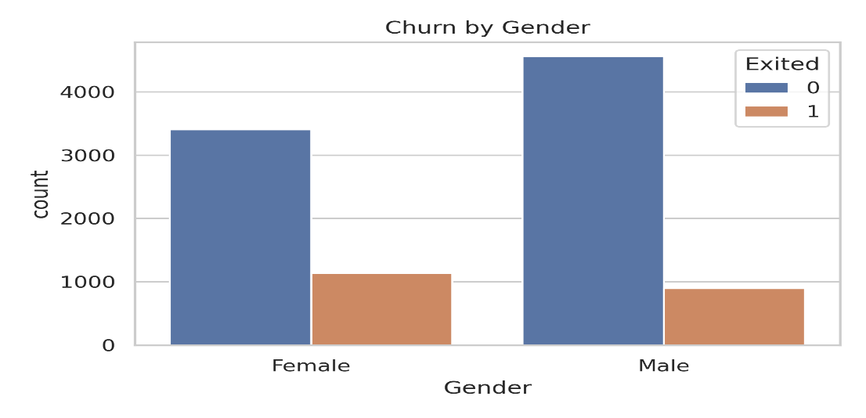
Figure 4: Customer Churn by Gender
Histograms of Numeric Features
Figure 5 shows the histogram of the important numerical characteristics of the customer: age, credit score, balance, period with the bank (tenure), amount of products owned, and estimated salary. These charts will be useful to evaluate skewness, spread, and possible outliers events before building the predictive model.
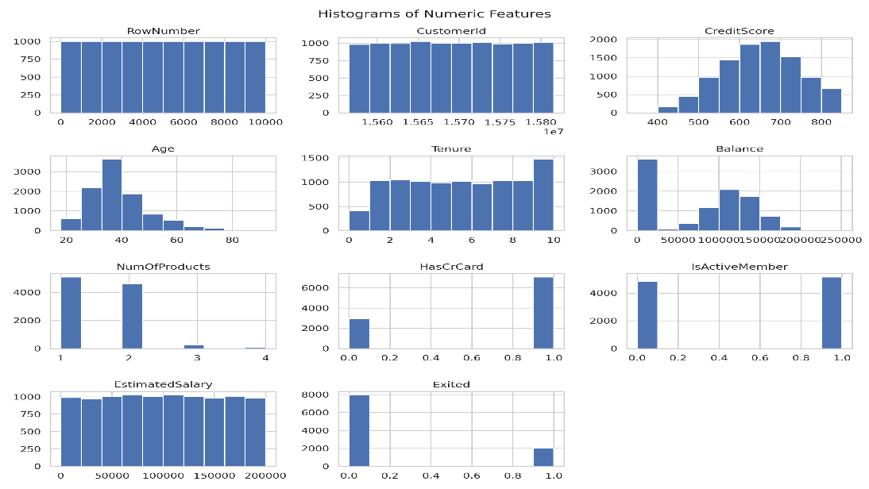
Figure 5: Histograms of Numeric Features

Boxplots of Important Numerical Variables
Figure 6 presents boxplots for different numerical features including age, balance, credit score, and estimated salary. There are a lot of outliers for balance and estimated salary indicating a need for developing predictive models that will work well with non-traditional (non-normal) distributions of data.
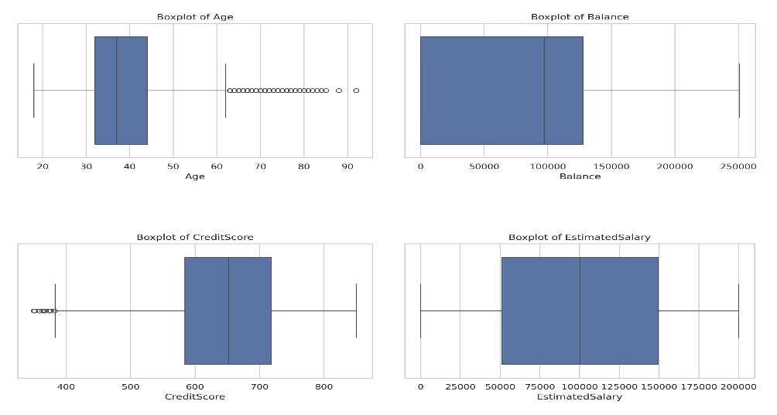
Figure 6: Boxplots of Important Numerical Variables

Correlation Heatmap of Numeric Features
Figure 7 is a correlation heatmap representing numeric features, allowing the possibility of identifying the relationships and multicollinearity between them. As illustrated in the heatmap, there are some moderate relationships between numeric variables but no evidence of serious multicollinearity. This allows for the use of both Logistic Regression and Random Forest models for the prediction of churn.
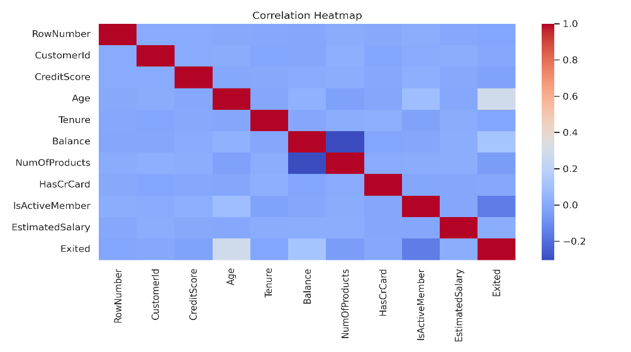
Figure 7: Correlation Heatmap of Numeric Features
E. Methodology
The process of preparing the data for analysis included eliminating the non-informative identifiers (Row Number, Customer Id, and Surname) that contributed nothing towards building a predictive model.
Converting the categorical variables (Geography and Gender) to a numerical format through One-Hot Encoding allowed us to incorporate these variables in our models. All numerical features were standardized so that they could be meaningfully compared against one another.
The dataset was divided into two parts: a training set and a test set. To maintain the same churn distribution within both subsets, stratified sampling was used. In using this method, both data sets maintained an accurate representation of the original data.
We selected two models for further exploration. Logistic Regression was chosen as a baseline model because of its simplicity and ease of interpretation. Random Forest was chosen as a more sophisticated model because it can model non-linear relationships and capture feature interactions.
To determine which model performed best, we used several performance metrics: Accuracy, Precision, Recall, F1-Score, Confusion Matrix, and ROC-AUC. By combining these measures in one document, we were able to evaluate the overall performance of each model relatively equally.

F. Results & Model Comparison
The Logistic Regression model produced a reasonable level of overall accuracy when predicting customer churn; however, due to the class imbalance problem associated with binary classifications that include rare events, it did not perform as well in correctly identifying customers who had churned.
Overall, the Random Forest model outperformed the Logistic Regression model across numerous evaluation metrics, especially in terms of recall and ROC-AUC, indicating that the Random Forest model is more effective at predicting which customers are likely to churn.
The feature importance analyses from Random Forest indicated that Age, is Active Member, geography, Germany, balance, and number of products were the most important factors for predicting churn. These findings were confirmed during the exploration data analysis.
Random Forest was selected as the final model for predicting customer churn due to its overall predictive performance and ability to account for complex relationships between variables.
This section presents model evaluation visualizations that support the comparison of Logistic Regression and Random Forest performance.
Logistic Regression Confusion Matrix
The confusion matrix associated with Logistic Regression below shows a fairly accurate model, but it indicates that the model does not do a good job of identifying churned customers.
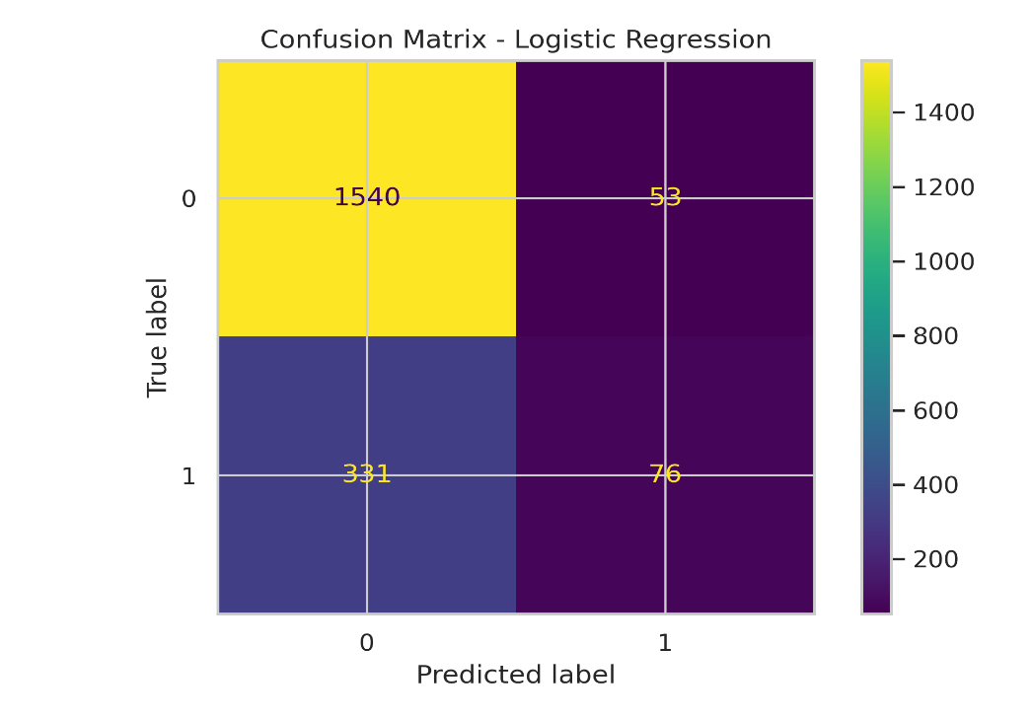
Random Forest Confusion Matrix
The confusion matrix for Random Forest below shows a far improved ability to identify churned customers which gives a better sense of the recall rate and performance of this model compared to Logistic Regression.
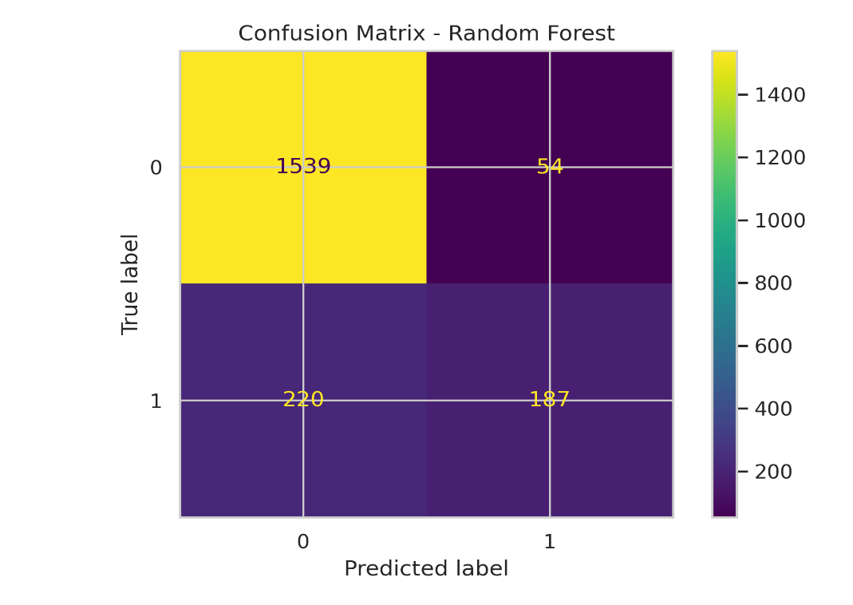
Random Forest ROC Curve
The ROC Curve shows a high area under the curve (AUC) number where the Random Forest model demonstrates strong discriminative ability.
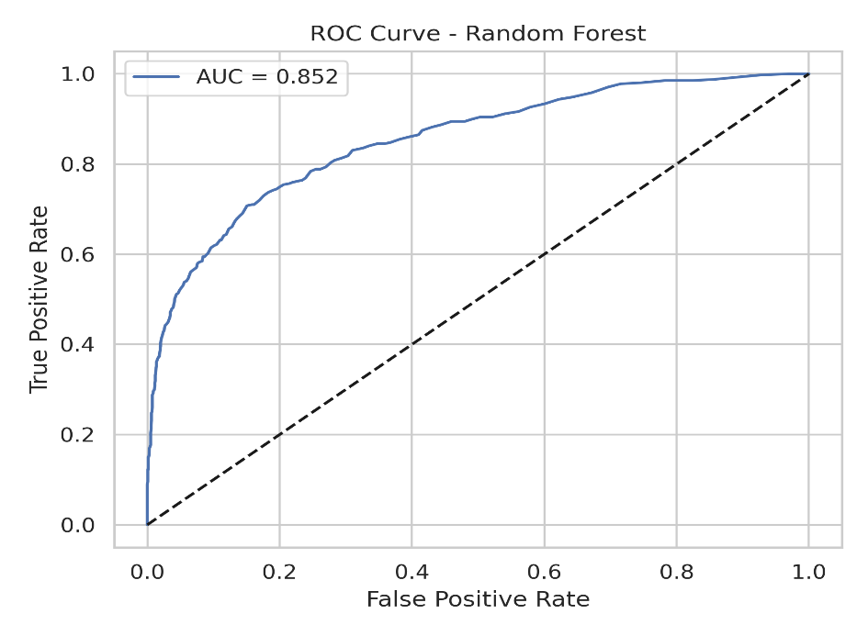

Feature Importance of Random Forest Model
The analysis of feature importance shows that Age, is active Member, geography, Germany balance, and number of products are the best indicators for churn.
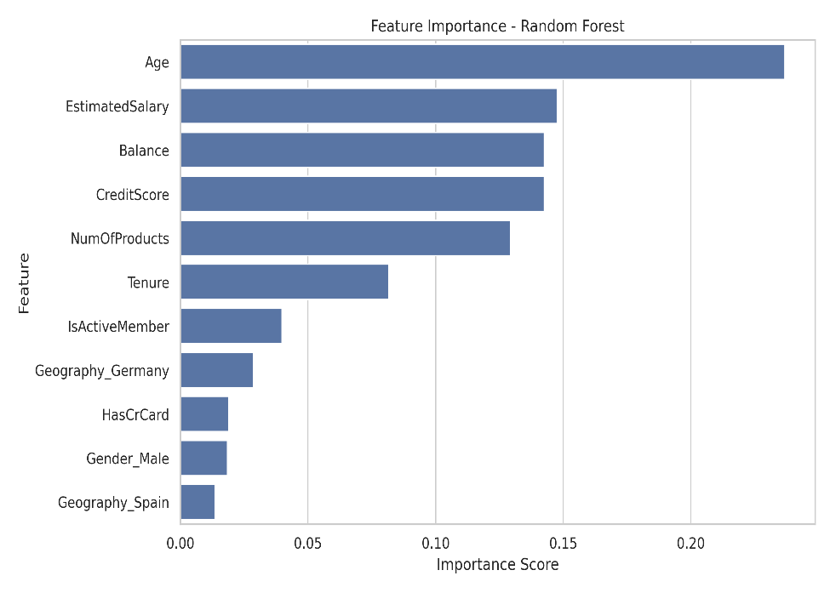

G. Business Insights & Recommendations
The analysis presents several valuable insights for businesses. Retention strategies should focus on older customers and meet their unique financial needs/preferences.
Inactive customers are high-risk and should be reached out with personalized communications, incentive offers, and/or digital engagement efforts.
Market-specific churn drivers need to be explored further for customers in Germany. Differences between regions may require dedicated region-specific strategies.
Proactive relationship management will create a more favorable outcome for high-balance customers, as their potential churn may represent a substantial loss of revenue.
Banks need to evaluate their product bundling strategies because some bundles have higher churn risks.

H. Ethics & Responsible AI
Within financial services, there are ethical considerations that affect the application of machine learning. To avoid generating discriminative results based on sensitive information (such as gender or location), machine learning models should be designed and deployed in a manner that does not allow such discrimination.
At all times, customer privacy and data security must be maintained; sensitive financial information must be treated in a manner that conforms to data protection regulations.
Additionally, the model’s output must be clear and easily interpretable to help build trust and confidence among users and stakeholders.
Predictive analytics should be used to improve customer experience and keep customers loyal, not restrict access.

I. Conclusion & Future Work
This study has shown how predictive analytics and machine learning techniques can solve the problem of banking customer attrition. The Random Forest model provides valuable information about the factors that influence customer attrition. Future studies could address the classification bias of oversampling, experiment with different models like XGBoost, and/or include time and/or behaviorally based data. Overall, this case study provides excellent support for a data-driven banking strategy for retaining customers.

