Customer Churn Prediction Using Machine Learning Techniques

Abstract
This study explores customer churn prediction using machine learning techniques. The primary objective is to identify customers who are likely to leave a service based on historical data. Various preprocessing techniques and classification algorithms were applied to improve prediction accuracy. The results demonstrate that machine learning models can effectively support decision-making in customer retention strategies.

Introduction
Customer churn refers to the phenomenon where customers stop doing business with a company. Predicting churn is crucial for organizations as retaining existing customers is often more cost-effective than acquiring new ones. This study uses a dataset containing customer information to build predictive models that identify potential churners.

Dataset Description
The dataset consists of approximately 3,500 records with multiple features describing customer demographics, behavior, and service usage. The target variable indicates whether a customer has churned. The dataset includes both numerical and categorical variables.

Attributes:
To build a great model we need do some important work for building a great Model. Let`s talking about that,
- Dataset Loading
- Exploratory Data Analysis
- Data Cleaning
- Data Visualization
- Encoding
- Train Test Split
- Scaling
- Train Model
- Test Model
- Prediction
- Model Evaluation
- ML Algorithm

- Data Loading
On that particular part, we basically import or dataset and then extract the dataset using pandas. This is the most important part to building a ML model.
- Exploratory Data Analysis
Exploratory Data Analysis (EDA) is the initial step in any data science or machine learning project. It involves analyzing and understanding the dataset before building predictive models.
The main objective of EDA is to explore the structure, patterns, and relationships within the data. This helps in identifying important features, detecting missing values, and understanding the overall distribution of the dataset.
In this project, EDA was performed using the following techniques:
- Data Overview: Functions like df.head() and df.info() were used to understand the structure and data types of the dataset.
- Statistical Summary: df.describe() was applied to analyze key statistical measures such as mean, standard deviation, minimum, and maximum values.
- Missing Value Analysis: Checked for null or missing values using df.isnull().sum().
- Data Visualization: Graphs such as histograms, count plots, and box plots were used to
For this dataset we use
- head()
- tail()
- Info()
- Describe()
- Corr
- Shape
- Column

- Data Cleaning
Data cleaning is a crucial step in the data preprocessing phase, where inconsistencies, errors, and missing values in the dataset are handled to improve data quality.
In this project, several data cleaning techniques were applied to ensure the dataset was accurate and suitable for model training:
- Handling Missing Values: Missing or null values were identified using df.isnull().sum() and handled appropriately by either removing or imputing them.
- Removing Duplicates: Duplicate records were checked and removed to avoid bias in the model.
- Fixing Inconsistent Data: Irregular or invalid entries (such as unknown or placeholder values) were replaced with appropriate categories (e.g., replacing unexpected values with "Others").
- Data Type Correction: Columns were converted to appropriate data types where necessary to ensure proper analysis and modeling.
- Outlier Handling: Extreme values were identified using statistical methods and visualizations, and treated if necessary to prevent distortion in model performance.
These data cleaning steps helped improve the reliability and consistency of the dataset, leading to better model performance and more accurate predictions.
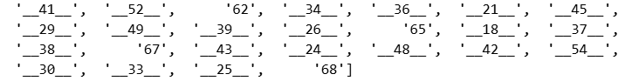
During the data cleaning process, it was observed that several numerical columns contained inconsistent and improperly formatted values such as __41__, __52__, __34__, etc. These values were stored as strings with additional unwanted characters, making them unsuitable for analysis and model training.
To address this issue, the following steps were performed:
- Pattern Identification: Irregular patterns in the data (extra underscores and string formatting) were identified.
- Data Cleaning: Unnecessary characters were removed using string manipulation techniques.
- Data Conversion: The cleaned values were then converted into proper numeric format (integers or floats).
- Validation: The dataset was rechecked to ensure all values were correctly formatted and consistent.
This process ensured that all numerical features were in a usable format, which is essential for accurate statistical analysis and machine learning model performance.
- Data Visualization
Data visualization is an essential part of Exploratory Data Analysis (EDA), used to understand patterns, trends, and relationships within the dataset. It helps in making data more interpretable and supports better decision-making.
In this project, various visualization techniques were applied:
- Count Plot: Used to visualize the distribution of categorical variables and understand the frequency of different categories.
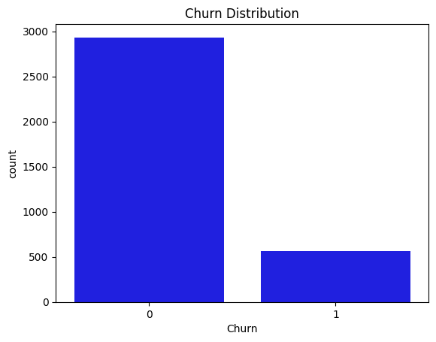
- Scatter Plot: Applied to identify relationships and correlations between numerical variables.
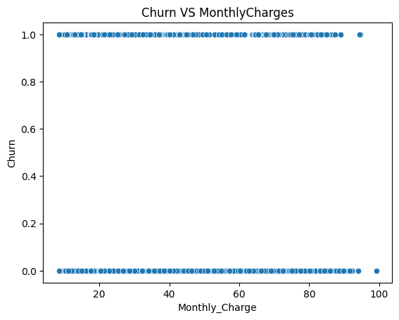
- Bar Plot: Used to compare values across different categories and summarize key insights.
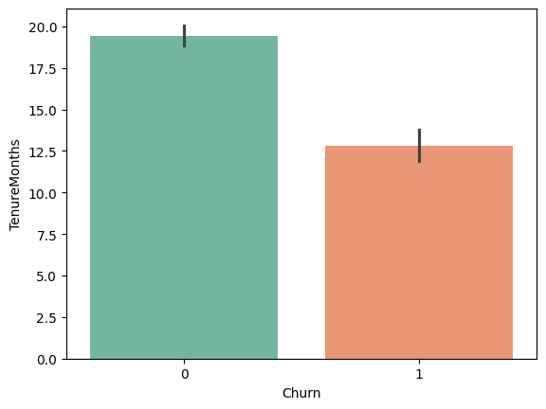
- Box Plot: Helped in detecting outliers and understanding the spread and distribution of numerical data.
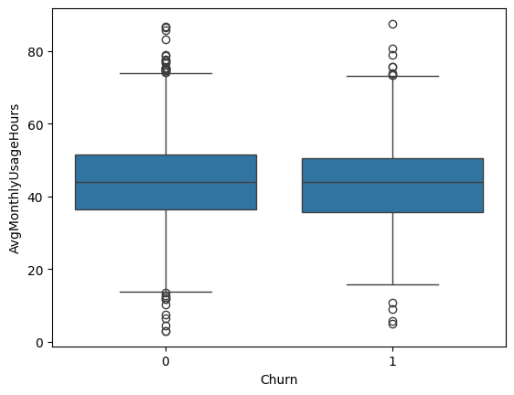
- Histogram Plot: Used to analyze the distribution and frequency of numerical features.
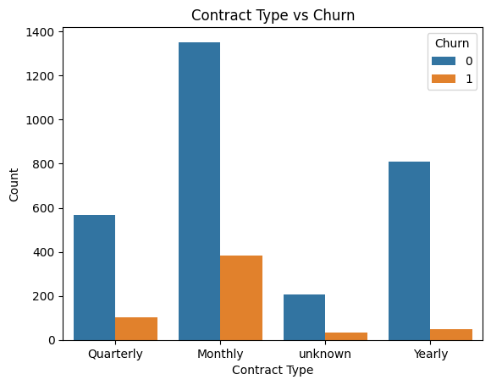
- Heatmap: Applied to visualize correlations between variables, helping to identify strong positive or negative relationships.
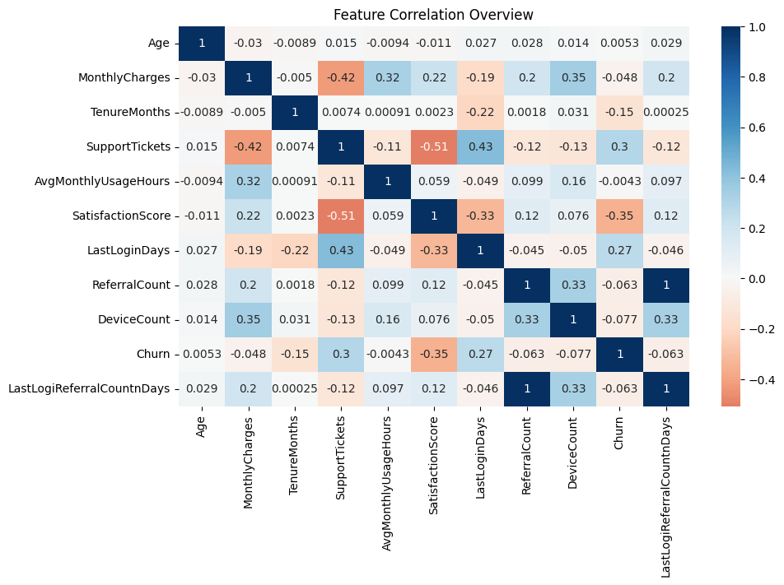
- KDE Plot (Kernel Density Estimation): Used to understand the probability density and distribution shape of continuous variables.
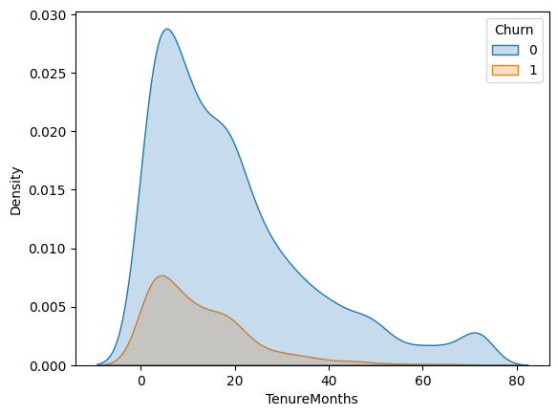
These visualizations provided valuable insights into the dataset, such as identifying trends, detecting anomalies, and understanding feature relationships, which ultimately improved the data preprocessing and model performance.

- Encoding
In this project, categorical variables were transformed into numerical format using One-Hot Encoding to make them suitable for machine learning algorithms.
- One-Hot Encoding: Categorical features were converted into multiple binary (0/1) columns, where each category is represented as a separate feature. This prevents the model from assuming any ordinal relationship between categories.
Before using encoding
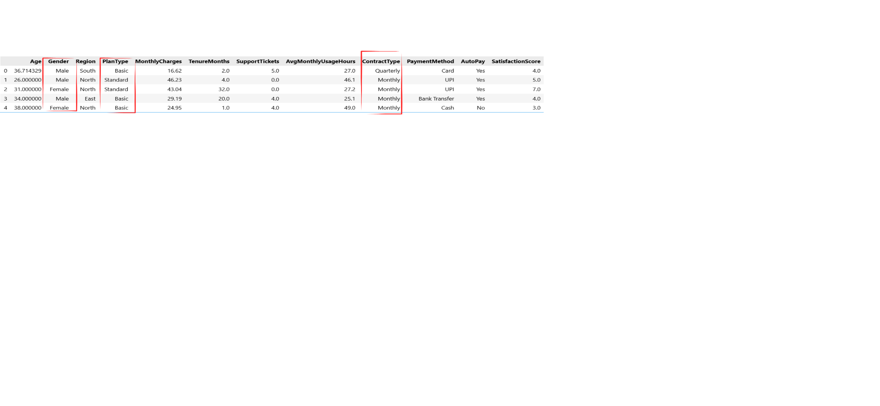
After using Encoding
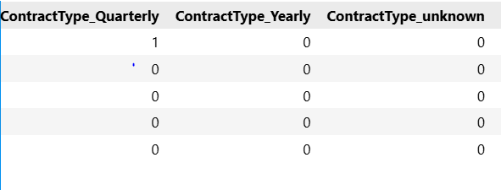

- Type Casting: After encoding, the resulting boolean values were converted into integer format (0 and 1) to ensure compatibility with machine learning models and maintain consistency in the dataset.
This approach allowed the model to effectively interpret categorical data without introducing bias or incorrect assumptions about the relationships between different categories.
- Feature and Target Splitting
In this project, the dataset was divided into two parts: features (X) and target variable (y). The feature set (X) contains all the independent variables used for prediction, while the target variable (y) represents the output to be predicted, which is customer churn in this case. This separation is a fundamental step in machine learning, as it allows the model to learn the relationship between input features and the target outcome.

- Train Test Split
After separating the features (X) and target variable (y), the dataset was divided into training and testing sets using the train-test split technique.
- Training Set: Used to train the machine learning models, allowing them to learn patterns from the data.
- Testing Set: Used to evaluate the performance of the trained models on unseen data.
In this project, a standard split ratio was applied (e.g., 80% training and 20% testing) to ensure a balanced evaluation.
This step is essential to prevent overfitting and to assess how well the model generalizes to new, unseen data.
- Feature Scaling
In this project, feature scaling was applied to numerical variables using the StandardScaler technique to improve model performance.
- Standard-Scaler: This method standardizes numerical features by transforming them to have a mean of 0 and a standard deviation of 1. It helps ensure that all features are on a similar scale, which is particularly important for distance-based algorithms such as KNN and SVM.
- Selected Features: Scaling was applied only to relevant numerical columns, including Age, MonthlyCharges, TenureMonths, SupportTickets, AvgMonthlyUsageHours, SatisfactionScore, LastLoginDays, ReferralCount, and DeviceCount.
- Training and Testing Separation: The scaler was fitted only on the training data and then applied to both training and testing sets. This prevents data leakage and ensures that the model generalizes well to unseen data.
By applying feature scaling, the model was able to learn more effectively from the data, leading to improved accuracy and stability.
- Model Training and Evaluation
he dataset was used to train the machine learning model, and its performance was evaluated on both training and testing data to assess its effectiveness.
- Training Score: 0.874
- Testing Score: 0.85
The training score indicates how well the model has learned from the training data, while the testing score reflects its performance on unseen data.
The results show that the model performs consistently on both training and testing datasets, with only a small difference between the two scores. This suggests that the model is not significantly overfitting and is able to generalize well to new data.
Overall, the model demonstrates good predictive performance and reliability, making it suitable for identifying patterns such as customer churn and supporting data-driven decision-making.
- Model Evaluation
To assess the performance of the machine learning models, several evaluation metrics were used. These metrics provide a comprehensive understanding of how well the model performs on the dataset.
- Accuracy Score:
Accuracy measures the overall correctness of the model by calculating the proportion of correctly predicted instances out of the total observations. It provides a quick overview of model performance.
- Classification Report:
The classification report includes key metrics such as precision, recall, and F1-score. These metrics help evaluate the model’s performance in terms of correctly identifying positive and negative classes, especially in cases of imbalanced data.
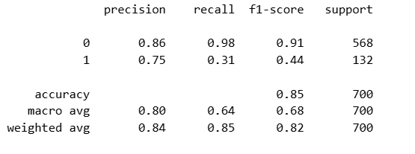

Classification Report Analysis
The classification report provides detailed insights into the model’s performance across both classes: non-churn (0) and churn (1).
For the non-churn class (0), the model performs exceptionally well, with a precision of 0.86, recall of 0.98, and F1-score of 0.91. This indicates that the model is highly effective at identifying customers who are not likely to churn.
However, for the churn class (1), the performance is significantly weaker. While the precision is moderate at 0.75, the recall is very low at 0.31, resulting in an F1-score of 0.44. This means that the model fails to identify a large portion of actual churn customers.
This imbalance suggests that the model is biased toward predicting non-churn cases and struggles to detect churn effectively. In a business context, this is a critical limitation, as missing churn customers can lead to potential revenue loss.
Although the overall accuracy of 0.85 appears strong, it does not fully reflect the model’s weakness in identifying churn cases. Therefore, improving recall for the churn class should be a priority to enhance the model’s effectiveness in real-world applications.

- Confusion Matrix:
The confusion matrix provides a detailed breakdown of prediction results, showing true positives, true negatives, false positives, and false negatives. It helps in understanding the types of errors made by the model.
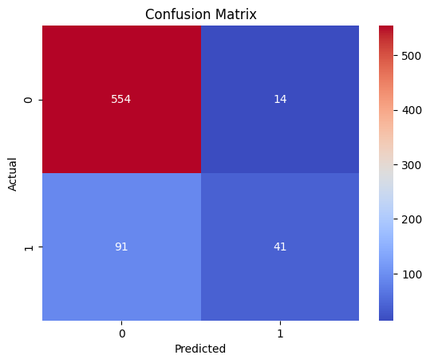

Confusion Matrix Analysis
The confusion matrix provides a detailed evaluation of the model’s prediction performance.
- True Negatives (TN): 554 instances were correctly predicted as non-churn.
- True Positives (TP): 41 instances were correctly identified as churn.
- False Positives (FP): 14 instances were incorrectly predicted as churn.
- False Negatives (FN): 91 instances were incorrectly predicted as non-churn.
The model performs well in identifying non-churn customers, as indicated by the high number of true negatives and low false positives. However, a significant number of false negatives suggests that the model is missing many actual churn cases.
This is a critical issue in a business context, as failing to identify churn customers can lead to potential revenue loss. Therefore, improving recall for the churn class should be a priority to better detect high-risk customers.
Overall, while the model demonstrates good accuracy, further optimization is needed to enhance its ability to identify churn customers effectively.
- Cross-Validation Score:
Cross-validation was used to evaluate the model’s stability and robustness. By splitting the data into multiple folds, the model was trained and tested several times, ensuring consistent performance across different subsets of the data.
- ROC-AUC Score:
The ROC-AUC score measures the model’s ability to distinguish between classes. A higher AUC value indicates better classification performance and stronger separability between positive and negative classes.
Analysis:
Accuracy_Score | 0.85
Mean CV score | 0.8674
Roc_auc | 0.851
The model was evaluated using multiple performance metrics to ensure its effectiveness and reliability.
- Accuracy Score: The model correctly predicts 85% of the instances, indicating strong overall performance.
- Mean Cross-Validation Score: The cross-validation score is slightly higher than the test accuracy, showing that the model performs consistently across different subsets of the data. This indicates good stability and low risk of overfitting.
- ROC-AUC Score: The ROC-AUC score demonstrates that the model has a strong ability to distinguish between churn and non-churn customers.
Overall, the model shows good generalization and stability, making it suitable for predicting customer churn. However, further improvements can be made to enhance the detection of churn customers and reduce false negatives.
By using these evaluation techniques, the model’s performance was thoroughly validated, ensuring reliability and effectiveness in predicting outcomes such as customer churn.

- Model Comparison Analysis
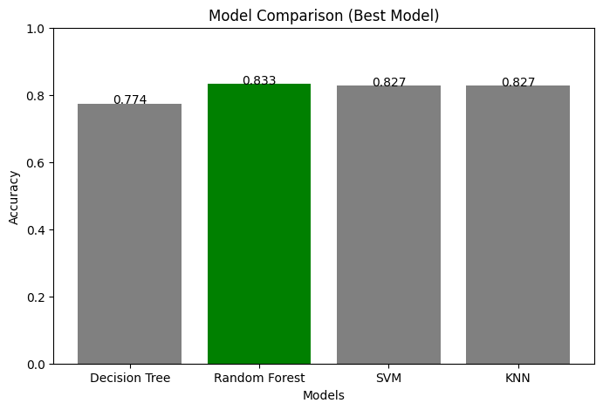
A comparison of multiple machine learning models was performed based on their accuracy scores, including Decision Tree, Random Forest, Support Vector Machine (SVM), and K-Nearest Neighbors (KNN).
Among all the models, Random Forest achieved the highest accuracy score of 0.833, making it the best-performing model in this project. This is likely due to its ensemble nature, which combines multiple decision trees to improve predictive performance and reduce overfitting.
SVM and KNN also demonstrated strong performance, each achieving an accuracy score of 0.827. Their results are close to Random Forest, indicating that they are also reliable models for this dataset.
On the other hand, the Decision Tree model showed the lowest accuracy at 0.774. This may be due to its tendency to overfit the training data when used as a single model.
Overall, while all models performed reasonably well, Random Forest was selected as the best model due to its slightly higher accuracy and better generalization capability.

Conclusion and Business Recommendation
In this project, multiple machine learning techniques were applied to predict customer churn and identify high-risk customers. Through data preprocessing, feature engineering, and model evaluation, a reliable prediction system was developed.
Among the tested models, Random Forest performed the best in terms of accuracy and overall stability. The model demonstrated good generalization, as indicated by consistent training, testing, and cross-validation scores. Additionally, the ROC-AUC score confirmed that the model has a strong ability to distinguish between churn and non-churn customers.
However, the analysis also revealed a key limitation: the model struggles to effectively identify churn customers, as indicated by the low recall score for the churn class. This suggests that some high-risk customers may go undetected, which could lead to potential business loss.
To address this issue, further improvements can be made by optimizing the model for recall, applying class balancing techniques, or adjusting the decision threshold.
From a business perspective, the model can be used to identify high-risk customers based on predicted churn probability. These customers can be targeted with retention strategies such as personalized offers, discounts, improved customer support, and engagement campaigns.
Overall, this project demonstrates how machine learning can be effectively used to support data-driven decision-making and improve customer retention strategies.

