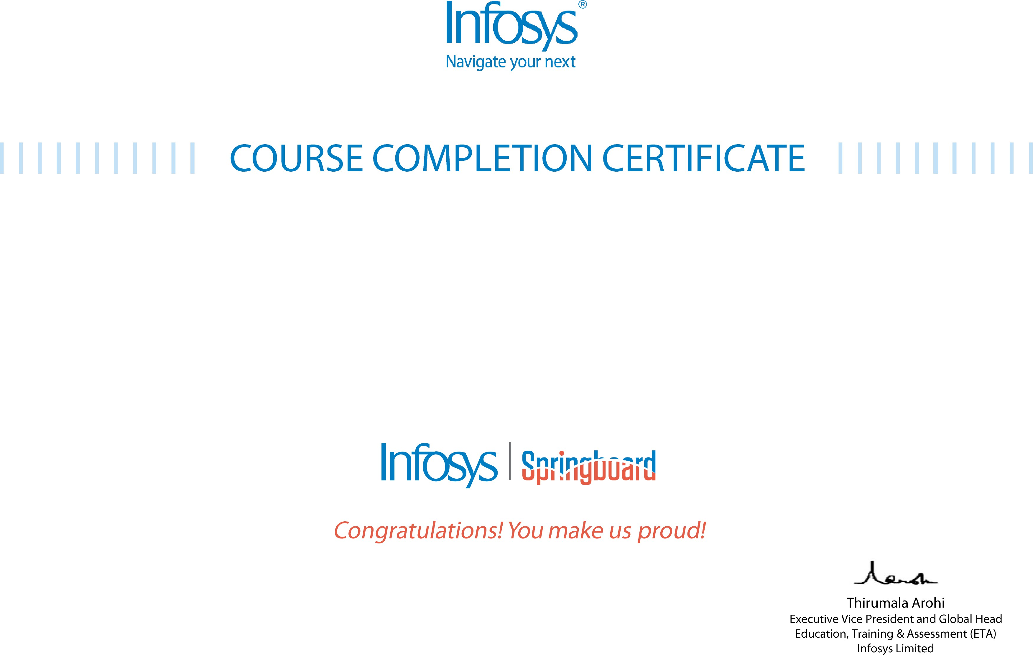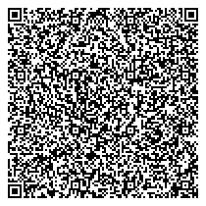

# The certificate is awarded to

mohammed mohammed

# for successfully completing the course

**Agile Scrum in Practice**

# on June 13, 2025

Issued on: Friday, June 13, 2025

To verify, scan the QR code at [https://verify .onwingspan.com](https://verify.onwingspan.com/)