Ideas for location website:

* Add map + location of houses in the map.
* 3 categories / buy a home – sell a home – rent a home

Website font, shape, template:

- name of the website / ideas:

- shape:

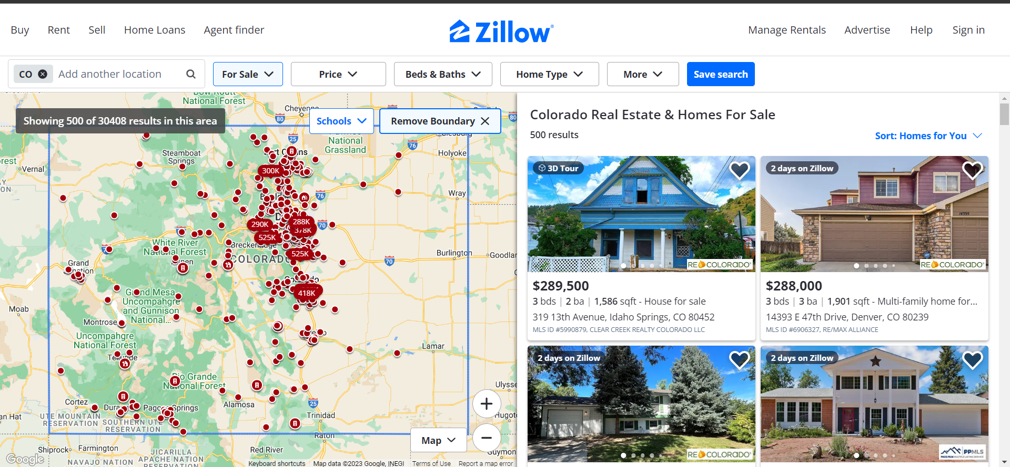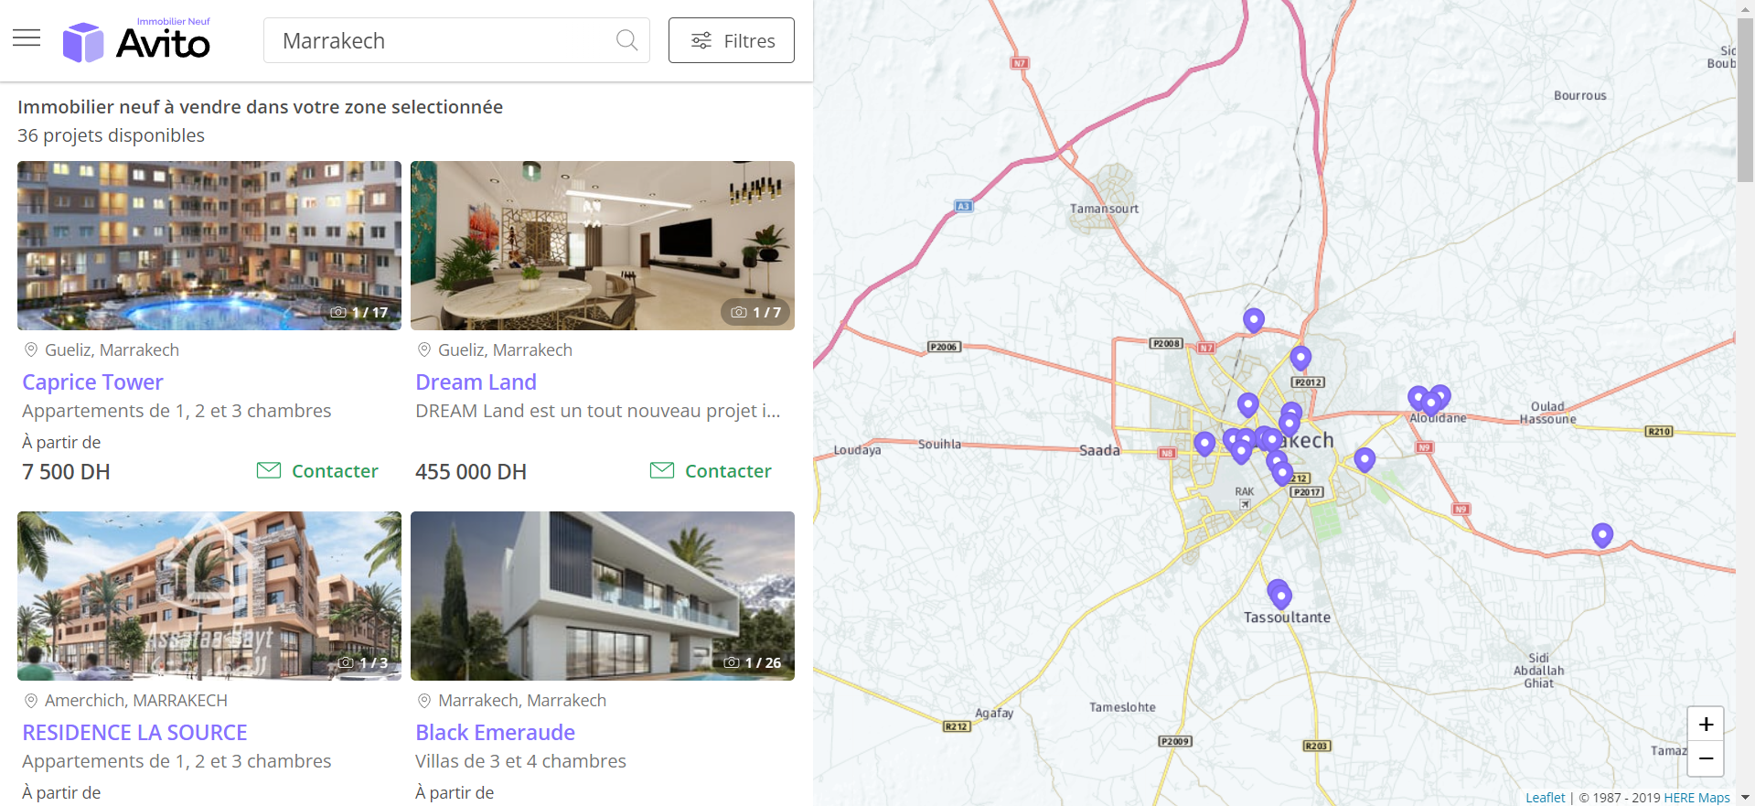

Tools for creating the website:

- webscrape : facebook marketplace, avito (https://immoneuf.avito.ma/fr/), booking

Making money process:

- ads mainly (tiktok , facebook )

- do the transaction online (no need for physical confrontation)