**Batch T7**

**Practical No.**

**Title of Assignment**

**Student Name: Shreyash Patil**

**Student PRN: 22510039**

**Code:**

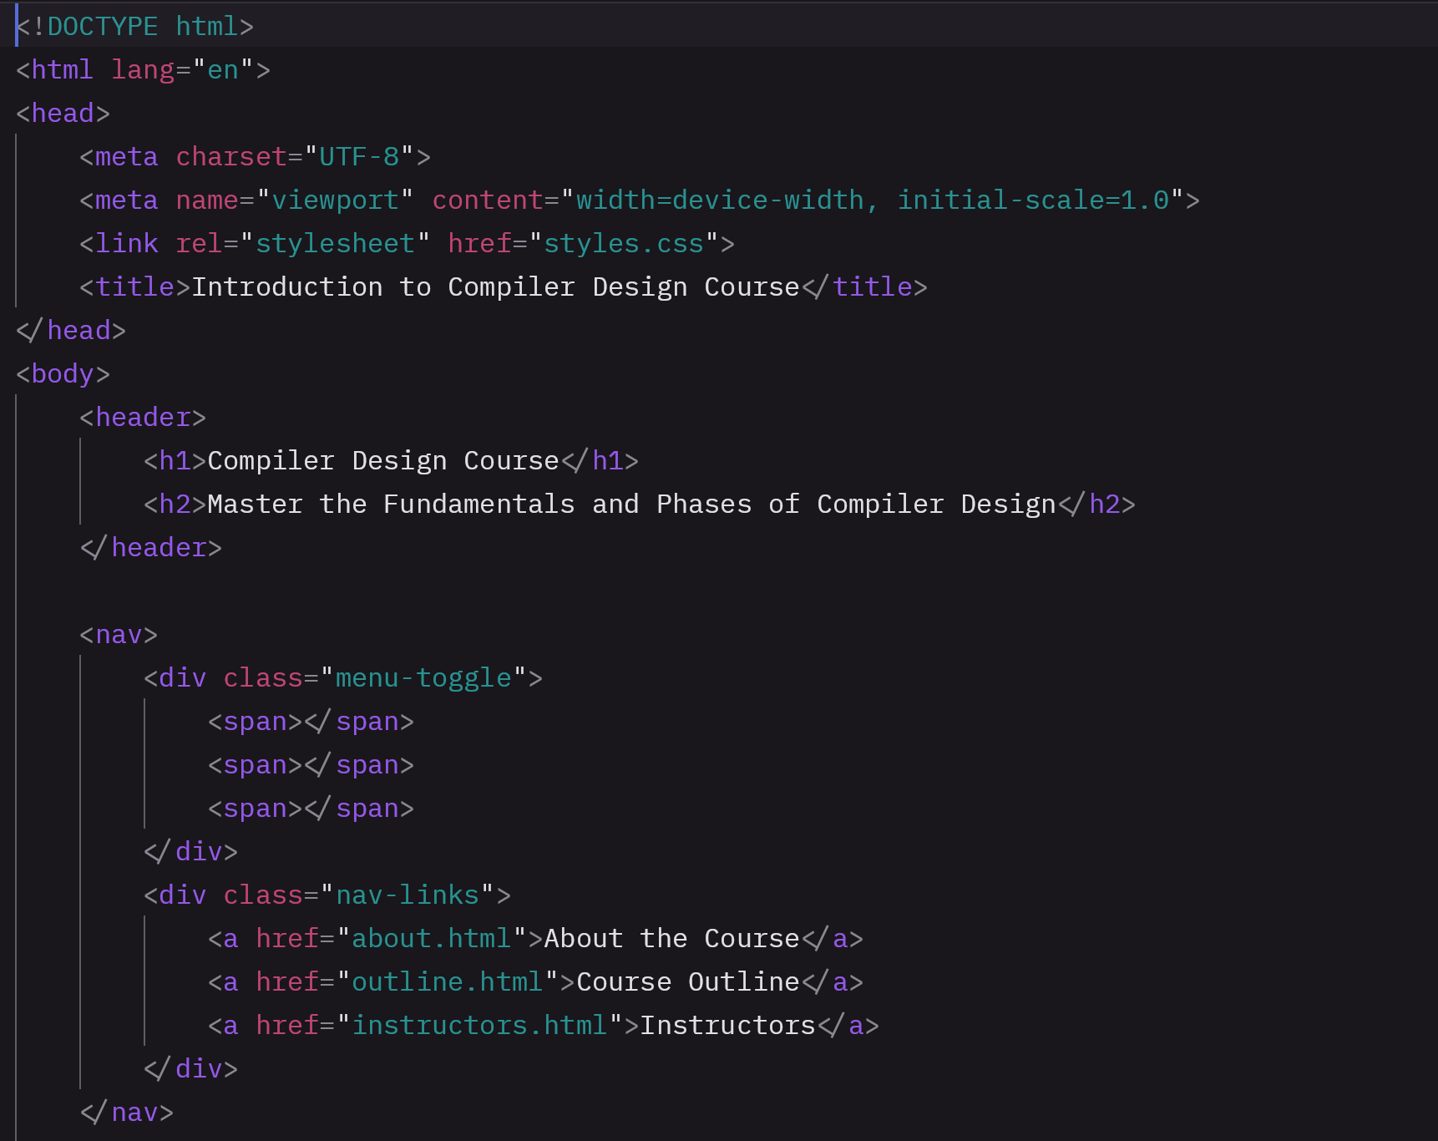 **Output:**

