

END SEMESTER ASSESSMENT (ESA) B.TECH. CSE(AI&ML)
III SEMESTER

UE25CS251A
DIGITAL LOGIC AND COMPUTER DESIGN LABORATORY

PROJECT REPORT
ON
“SERIAL 2’S COMPLEMENTER USING A SHIFT REGISTER AND A FLIP-FLOP”

SUBMITTED BY
NAME SRN
- Samiksha P PES2UG25AM228
- Thaaswika Peddinti PES2UG25AM284
- Thanmayi Nayak K PES2UG25AM285
- VS Kingslin Abhishek PES2UG25AM291

AUGUST – DECEMBER 2026
DEPARTMENT OF CSE(AI&ML)
ELECTRONIC CITY CAMPUS,
BENGALURU – 560100, KARNATAKA, INDIA

TABLE OF CONTENTS
Sl.No | TOPIC | PAGE No
 | PROBLEM STATEMENT | 3
 | CIRCUIT DIAGRAM | 5
 | FSM  (only if Applicable to assigned project) | 6
 | LITERATURE SURVEY  (Brief Description of the concept behind the project executed) | 7
 | MAIN VERILOG CODE | 8
 | TEST BENCH FILE | 9
 | SCREEN SHOTS OF THE OUTPUT | 10
 | REFERENCES  (Links to sites, papers or other referred material) | 11

PROBLEM STATEMENT
Problem Statement (Project 10)
Design and implement a Serial 2’s Complementer with a shift register and a flip-flop. The binary number is shifted out from one side and its 2’s complement is shifted into the other side of the shift register.
Objectives
• Design a synchronous bit-serial circuit that converts an N-bit binary number into its 2’s complement, one bit per clock cycle.
• Use a right-shift register for storage and a single D flip-flop (the “flag”) to remember whether the first ‘1’ has already been shifted out.
• Model the design in Verilog HDL, verify it with a self-checking test bench and show that the register holds the correct 2’s complement after N clock cycles.
Specification
Signal | Dir. | Description
clk | in | System clock; all registers update on the rising edge
rst | in | Synchronous reset (clears register, flag, counter, done)
load | in | Loads data_in into the shift register and clears the flag
data_in[N-1:0] | in | Number to be complemented (N = 8 by default, parameterised)
data_out[N-1:0] | out | Shift register contents; equals the 2’s complement once done = 1
serial_out | out | Bit shifted out of the register (LSB first)
serial_in | out | Complemented bit shifted into the MSB end
flag | out | Flip-flop output: 1 after the first ‘1’ has been shifted out
done | out | Goes high after N shift cycles

CIRCUIT DIAGRAM

The circuit consists of an N-bit shift register (N = 8 shown), one XOR gate, one OR gate and a D flip-flop. The bit leaving the register (b0) is XOR-ed with the flag to give the bit entering at the MSB end (b7). The OR gate sets the flag permanently once a ‘1’ has been shifted out.
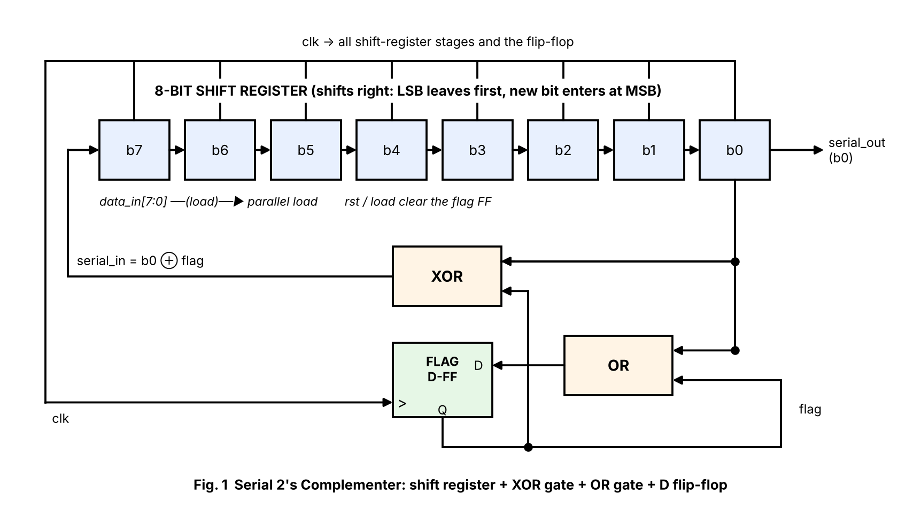
Fig. 1 – Block / gate-level diagram of the Serial 2’s Complementer
Working
• Load: The 8-bit number is loaded in parallel (load = 1) and the flag flip-flop is cleared.
• Shift: On every clock edge the register shifts right. serial_in = b0 ⊕ flag enters at b7 and flag ← flag + b0 (OR).
• Rule: Until the first ‘1’ appears the flag is 0, so bits pass unchanged; the first ‘1’ is also passed unchanged (the flag is still 0 while it is being shifted out). After that the flag is 1 and every remaining bit is inverted.
• Result: After N = 8 clock pulses the original number has been completely shifted out and the register holds its 2’s complement. done goes high.
Truth table | b0 (x) | flag | serial_in (y) | next flag
 | 0 | 0 | 0 | 0
 | 1 | 0 | 1 | 1
 | 0 | 1 | 1 | 1
 | 1 | 1 | 0 | 1

FSM
The control behaviour is a two-state Mealy machine. The state is the value stored in the flag flip-flop; the input x is the bit shifted out (b0) and the output y is the bit shifted in (serial_in).
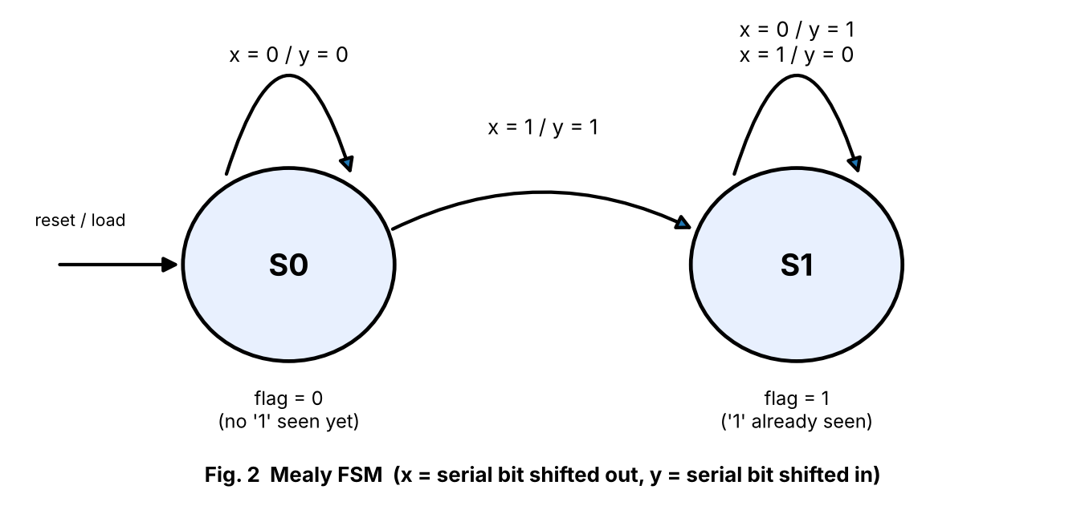
Fig. 2 – Mealy state diagram of the Serial 2’s Complementer
Present state | x = 0 | x = 1
S0 (flag = 0) | S0 / y = 0 | S1 / y = 1
S1 (flag = 1) | S1 / y = 1 | S1 / y = 0

S0 is the reset/load state. The machine leaves S0 when the first ‘1’ is shifted out and stays in S1 for the rest of the word.

LITERATURE SURVEY
2’s complement representation
The 2’s complement of an N-bit number A is 2ᴺ − A, obtained by inverting all bits (1’s complement) and adding 1. It is the standard way of representing signed integers in digital systems because addition and subtraction can then be performed with the same adder hardware, and zero has a single representation.
Serial method
Adding 1 to the inverted number makes the carry ripple through the trailing 1’s of the inverted word, i.e. through the trailing 0’s of the original word, and stop at the first ‘1’. This leads to a simple rule that is easy to realise serially, starting from the LSB: copy every bit up to and including the first ‘1’, then invert every bit after it. Example: 0101 1000 → 1010 1000.
Hardware building blocks
• Shift register: A chain of D flip-flops sharing one clock. In a right-shift register each bit moves one position per clock; the LSB leaves at one end and a new bit enters at the MSB end. After N clocks a bit-serial operation has processed the whole word.
• D flip-flop: Stores one bit of state. Here it records that the first ‘1’ has passed and is set by flag ← flag OR b0.
• XOR gate: Inverts the bit conditionally: b0 ⊕ 0 = b0 (copy), b0 ⊕ 1 = b0’ (invert).
Advantages
A bit-serial complementer needs only N + 1 flip-flops and two gates and has no carry chain, so its area and critical path are independent of the word length. The price is latency: N clock cycles per word. Bit-serial arithmetic is used where area and power matter more than speed, for example in DSP data paths and small controllers.
Worked example (N = 8, input 0101 1000)
Clock | Register b7…b0 | b0 (out) | flag before | serial_in
0 | 01011000 | 0 | 0 | 0
1 | 00101100 | 0 | 0 | 0
2 | 00010110 | 0 | 0 | 0
3 | 00001011 | 1 | 0 | 1
4 | 10000101 | 1 | 1 | 0
5 | 01000010 | 0 | 1 | 1
6 | 10100001 | 1 | 1 | 0
7 | 01010000 | 0 | 1 | 1
8 | 10101000 | – | – | –

MAIN VERILOG CODE:
// Serial 2's Complementer using a Shift Register and a D Flip-Flop
// The number is shifted out LSB first; its 2's complement is shifted in at the MSB end.
// Rule: copy bits up to and including the first '1', invert every bit after it.
module serial_twos_comp #(parameter N = 8) (
input clk,
input rst, // synchronous, active high
input load, // load parallel data into the shift register
input [N-1:0] data_in,
output [N-1:0] data_out, // shift register contents (2's complement after N clocks)
output serial_out,// bit shifted out (LSB of original number)
output serial_in, // bit shifted in (complemented bit)
output reg flag, // flip-flop: 1 once the first '1' has been seen
output reg done
);
reg [N-1:0] sr;
reg [$clog2(N+1)-1:0] cnt;

assign serial_out = sr[0];
assign serial_in = sr[0] ^ flag; // XOR with flag: pass until first 1, invert after
assign data_out = sr;

always @(posedge clk) begin
if (rst) begin
sr <= {N{1'b0}};
flag <= 1'b0;
cnt <= 0;
done <= 1'b0;
end else if (load) begin
sr <= data_in;
flag <= 1'b0;
cnt <= 0;
done <= 1'b0;
end else if (!done) begin
sr <= {serial_in, sr[N-1:1]}; // shift right, new bit enters at MSB
flag <= flag | sr[0]; // flip-flop sets after first 1 leaves
cnt <= cnt + 1'b1;
if (cnt == N-1) done <= 1'b1;
end
end
endmodule

TEST BENCH FILE:
`timescale 1ns/1ps
module tb_serial_twos_comp;
parameter N = 8;
reg clk = 0, rst = 1, load = 0;
reg [N-1:0] data_in;
wire [N-1:0] data_out;
wire serial_out, serial_in, flag, done;
integer i, errors = 0;
reg [N-1:0] expected;

serial_twos_comp #(N) dut (.clk(clk), .rst(rst), .load(load), .data_in(data_in),
.data_out(data_out), .serial_out(serial_out), .serial_in(serial_in),
.flag(flag), .done(done));

always #5 clk = ~clk;

task run(input [N-1:0] val);
begin
data_in = val; load = 1; @(posedge clk); #1; load = 0;
wait (done); #1;
expected = (~val) + 1'b1;
if (data_out === expected) $display("PASS: in=%b (%0d) 2's comp=%b expected=%b", val, val, data_out, expected);
else begin $display("FAIL: in=%b out=%b expected=%b", val, data_out, expected); errors = errors + 1; end
@(posedge clk);
end
endtask

initial begin
$dumpfile("wave.vcd"); $dumpvars(0, tb_serial_twos_comp);
#12 rst = 0;
run(8'b0000_0000);
run(8'b0000_0001);
run(8'b0101_1000);
run(8'b1010_1100);
run(8'b1000_0000);
run(8'b1111_1111);
run(8'b0011_0110);
for (i = 0; i < 6; i = i + 1) run($random);
if (errors == 0) $display("ALL TESTS PASSED"); else $display("%0d TEST(S) FAILED", errors);
$finish;
end
endmodule

SCREEN SHOT OF THE OUTPUT:
Simulation was run with Icarus Verilog. The test bench checks 13 input patterns (corner cases 0, 1, 128, 255 plus random values) against (~in + 1) and prints PASS/FAIL.
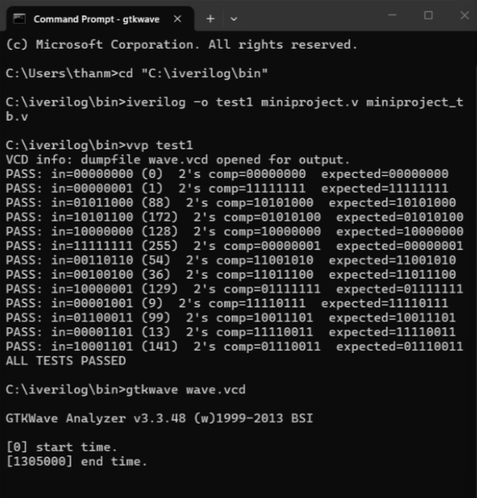
Fig. 3 – Simulation console output (all tests pass)
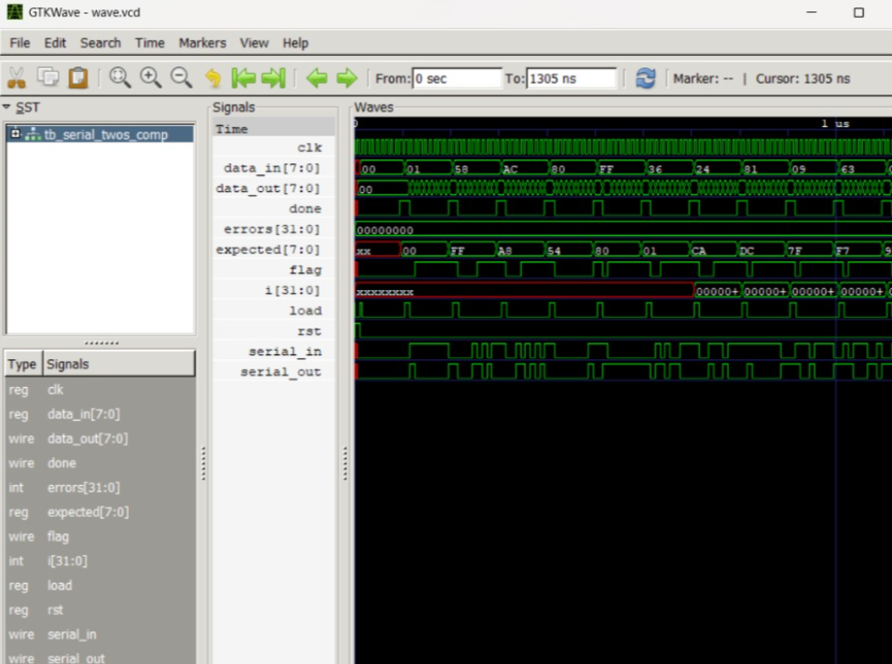
Fig. 4 – Waveform for input 01011000: the register shifts right and ends at 10101000

REFERENCES
[1] M. Morris Mano and Michael D. Ciletti, Digital Design: With an Introduction to the Verilog HDL, Pearson.
[2] Stephen Brown and Zvonko Vranesic, Fundamentals of Digital Logic with Verilog Design, McGraw-Hill.
[3] Samir Palnitkar, Verilog HDL: A Guide to Digital Design and Synthesis, Prentice Hall.
[4] Two’s complement – https://en.wikipedia.org/wiki/Two%27s_complement
[5] Shift register – https://en.wikipedia.org/wiki/Shift_register
[6] Icarus Verilog simulator – https://steveicarus.github.io/iverilog/
[7] PES University, UE25CS251A Digital Logic and Computer Design Laboratory – course material.

