**Q.3. Generate a model for an Insurance company to hold information on the insurer's vehicle, and create a chart of monthly, yearly, and qtrly premiums based on no. of years of insurance where in each year, the value of the vehicle depreciates by 7%.**

**CODE:**

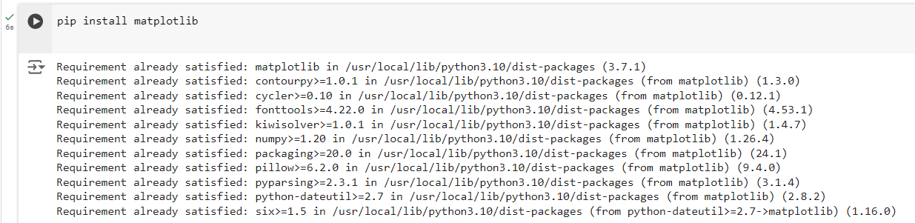

This is a command that installs the `matplotlib` library, which is a Python library used for creating static, animated, and interactive visualizations and plots.

The `Vehicle` class models the depreciation of a vehicle's value over time. It takes two parameters during initialization: the vehicle's initial value and its annual depreciation rate. The class includes a method `depreciated_value`, which calculates the vehicle's value after a given number of years by applying the depreciation rate for each year, effectively reducing the value exponentially over time.

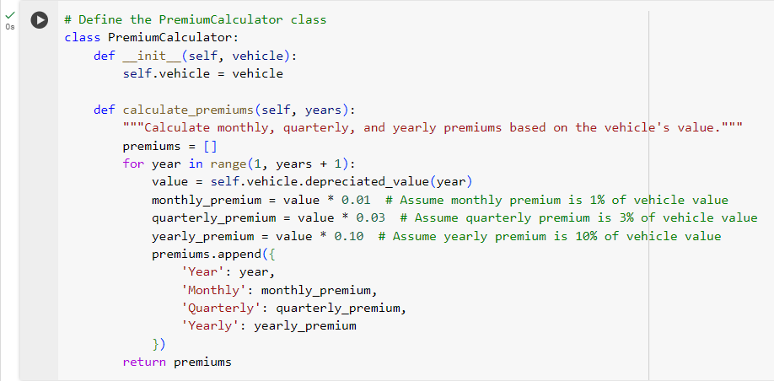

The `PremiumCalculator` class calculates insurance premiums based on a vehicle's depreciating value. It takes a `Vehicle` object during initialization and has a `calculate_premiums` method that computes the monthly, quarterly, and yearly premiums for each year over a specified number of years. The premiums are calculated as percentages (1%, 3%, and 10%) of the vehicle's value for the respective periods and are returned as a list of dictionaries, each containing the premiums for a given year.

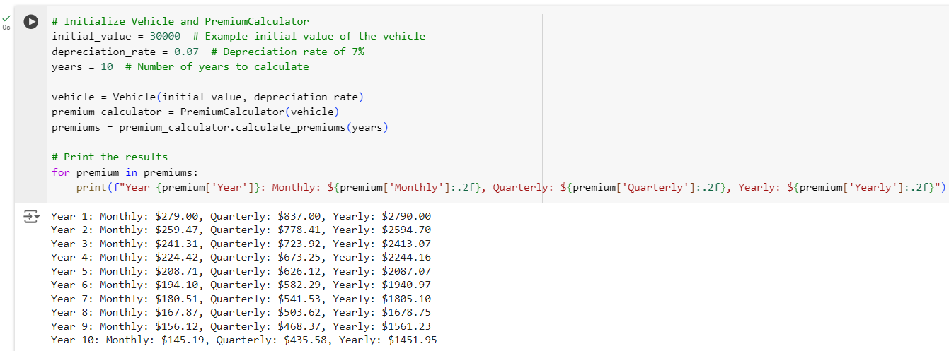

This code initializes a `Vehicle` with an initial value of $30,000 and a depreciation rate of 7%. It then creates a `PremiumCalculator` object for that vehicle and calculates the insurance premiums for 10 years. The monthly, quarterly, and yearly premiums are printed for each year, where the premiums are a percentage of the vehicle's depreciated value (1%, 3%, and 10% respectively). **The results are formatted to show two decimal places for each premium.**

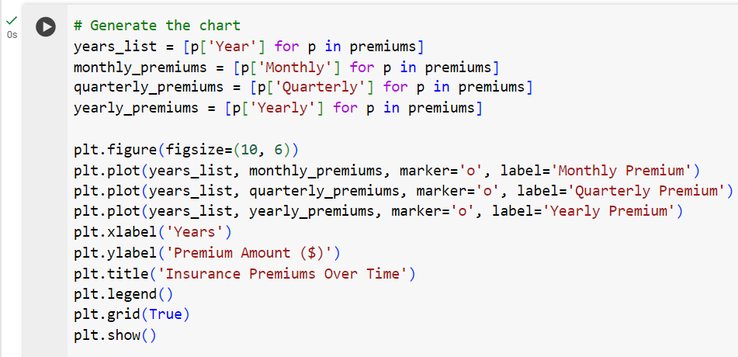

**OUTPUT:** The above code generates a line chart showing how the monthly, quarterly, and yearly insurance premiums change over time based on the vehicle's depreciation. It uses `matplotlib` to plot the premiums for each year, with separate lines for monthly, quarterly, and yearly premiums. The x-axis represents the number of years, and the y-axis shows the premium amounts in dollars. The chart includes markers, labels, a legend, and a grid for clarity, displaying how the premiums decrease as the vehicle depreciates over time.

