A MINI PROJECT REPORT

**On**

**<Design and implementation of staff members availability using RFID technology>**

**Submitted by**

**Ayaz Khan Samiksha Gupta**

**Roll No: 161500154 Roll No:161500478**

**Shivangi Tripathi Zaved Alam**

**Roll No:161500278 Roll No:161500646**

**To**

**<Dr. Debjani Ghosh>**

Department of Computer Engineering & Applications

**Institute of Engineering & Technology**



**GLA University**

**Mathura- 281406, INDIA**

**December, 2018**

**Department of Computer Engineering & Applications**



**GLA University, Mathura**

**17 km. Stone NH#2, Mathura-Delhi Road, P.O. – Chaumuha, Mathura – 281406**

***Declaration***

*We hereby declare that the work which is being presented in the Mini Project “****Design and implementation of Staff Members availability using RFID Technology”,*** *in partial fulfillment of the requirements for Mini-Project LAB, is an authentic record of our own work carried under the supervision of* ***Dr. Debjani Ghosh, Assistant professor, GLA University, Mathura****.*

**Name of Students with signature**



**Department of Computer Engineering & Applications**

**GLA University, Mathura**

**17 km. Stone NH#2, Mathura-Delhi Road, P.O. – Chaumuha,**

**Mathura – 281406**

**CERTIFICATE**

*This is to certify that the project entitled* ***“Design and implementation of staff Members availability using RFID Technology”*** *carried out in Mini Project – I Lab is a bonafide work done by* ***<Ayaz Khan (161500154), Samiksha Gupta (161500478), Shivangi Tripathi (161500278) and Zaved Alam (161500646)*** *and is submitted in partial fulfillment of the requirements for the award of the degree Bachelor of Technology (Computer Science & Engineering).*

**Signature of Supervisor:**

**Name of Supervisor:**

**Date:**

**ACKNOWLEDGEMENT**

*It gives us a great sense of pleasure to present the report of the B. Tech Mini Project undertaken during B. Tech. Third Year. This project in itself is an acknowledgement to the inspiration, drive and technical assistance contributed to it by many individuals. This project would never have seen the light of the day without the help and guidance that we have received.*

*Our heartiest thanks to* ***Dr. (Prof). Anand Singh Jalal,*** *Head of Dept., Department of CEA for providing us with an encouraging platform to develop this project, which thus helped us in shaping our abilities towards a constructive goal.*

*We owe special debt of gratitude to* ***Dr. Debjani Ghosh,*** *Assistant Professor Department of CEA, for his constant support and guidance throughout the course of our work. His sincerity, thoroughness and perseverance have been a constant source of inspiration for us. He has showered us with all his extensively experienced ideas and insightful comments at virtually all stages of the project & has also taught us about the latest industry-oriented technologies.*

*We also do not like to miss the opportunity to acknowledge the contribution of all faculty members of the department for their kind guidance and cooperation during the development of our project. Last but not the least, we acknowledge our friends for their contribution in the completion of the project.*

Zaved Alam

Samiksha Gupta

Shivangi Tripathi

Ayaz Khan

**Abstract**

Employees, staff members or students in an institute face issues in searching a staff member throughout cabin rooms. Even though one finds a cabin, it isn’t necessary that he/she finds him/her. To address the discussed issues, we propose a solution that can check the availability of a staff member in his/her cabin.

We are using Nodemcu, rfid reader reads the id of the tag and changes the corresponding database in firebase through Nodemcu. The firebase details are presented through an interface on the web. By which one could determine the presence of someone at a required place.

We used low frequency (Passive Tag) RFID tag in our technology which uses radio-frequency electromagnetic fields to transfer information from a tag to RFID reader for identification purposes. Passive tags do not require battery power. They derive power from the electromagnetic field generated from the reader. if an RFID system operates at a lower frequency, it has a slower data read rate, but increased capabilities for reading near or on metal or liquid surfaces. If a system operates at a higher frequency, it generally has faster data transfer rates and longer read ranges, but more sensitivity to radio wave interference caused by liquids and metals in the environment. However technology innovations in recent years have made it possible to use ultra-high frequency RFID systems around liquids and metals.

**Table of Contents**

|  |  |
| --- | --- |
| Declaration | 2 |
| Certificate | 3 |
| Acknowledgments | 4 |
| Abstract | 5 |
| Table of Contents | 6 |
| 1. **Introduction** (This chapter must describe introduction about your project) | **7** |
| 1.1 Motivation and Overview ………………………………........ | 7 |
| 1.3 Objective .………………………………………………….... | 7 |
| 1. **Software Requirement Analysis** | **8** |
| 2.1 Define the problem ………………………………………………….. | 9 |
| 2.2 Define the modules and their functionalities (SRS) ……………..………………………………… | 9 |
| 1. **Software Design** | **10** |
| 3.1 UML Diagram | 10 |
| * 1. Database Diagram | 15 |
| 1. **Implementation and User Interface** | **17** |
| 4.1 Interface Screen | 17 |
| 4.2 Database Screen | 19 |
| **5.References/Bibliography** | **20** |
| 1. **Appendices**   6.1 Coding/Code Templates | **21** |

**1. Introduction**

**Motivation**

Employees, staff members or students in an institute face issues in searching a

staff member throughout cabin rooms. Even though one finds a cabin, it isn’t

necessary that he/she finds him/her. To address the discussed issues, we propose

a solution that can check the availability of a staff member in his/her cabin.

The device can also be used in many ways. One of which is that it could be used to help save the endangered species.

**Objective**

To develop a device by which one could determine the position of a particular object that are in motion. With the help of which we could save our time.

**2. SOFTWARE REQUIREMENT ANALYSIS**

**2.1 Define the problem**

Often this problem occurs in colleges and schools, when need a particular faculty member. We go to the member’s cabin again and again which consumes a lot of time. This device could save our time by giving us a real time status information. The device is capable of maintaining the data and display the results through an interface on web.

It could also be used in many areas/fields. One could use it to tag animals in a forest/at homes. The animals or pets could be tracked in a given range.

This device would prove to be a boon for the Staff and students. RFID cards/tags has a unique id by which we could determine the presence of a particular object in a given area uniquely. We can change the database when RFID tags are sensed in the range and also generate a message/alarm if particular id is present/not present as per needed by using database.

**2.2 Define the modules and their functionalities (SRS)**

**Nodemcu ESP 8266:**

The **ESP8266** WiFi **Module** is a self contained SOC with integrated TCP/IP protocol stack that can give any microcontroller access to your WiFi network. The **ESP8266** is capable of either hosting an application or offloading all Wi-Fi networking **functions** from another application processor.

* **WiFi connection**
* **Firebase connection**
* **mfrc522.PICC_IsNewCardPresent()**
* **mfrc522.PICC_ReadCardSerial()**
* **mfrc522.PICC_DumpToSerial()**

The nodemcu is connected to the MFRC 5266 which reads the RFID tags nearby. The database is changed accordingly.

**Interface:**

A website is designed to display the results (i.e. display the availability status of the staff) to the users.

* Ground_floor.html
* First_floor.html
* Second_floor.html
* Third_floor.html

Link: <http://www.glafacultycheck.ga>

**3. SOFTWARE DESIGN**

**3.1 UML Diagrams**

**3.1.1 Sequence Diagram**

Administrator

System

Database

Enter ID and Password

Verify ID and Password

Display Admin Page

Message 1

Fig 3.4: Sequence Diagram For Admin Login

**3.1.2 Object Diagram**

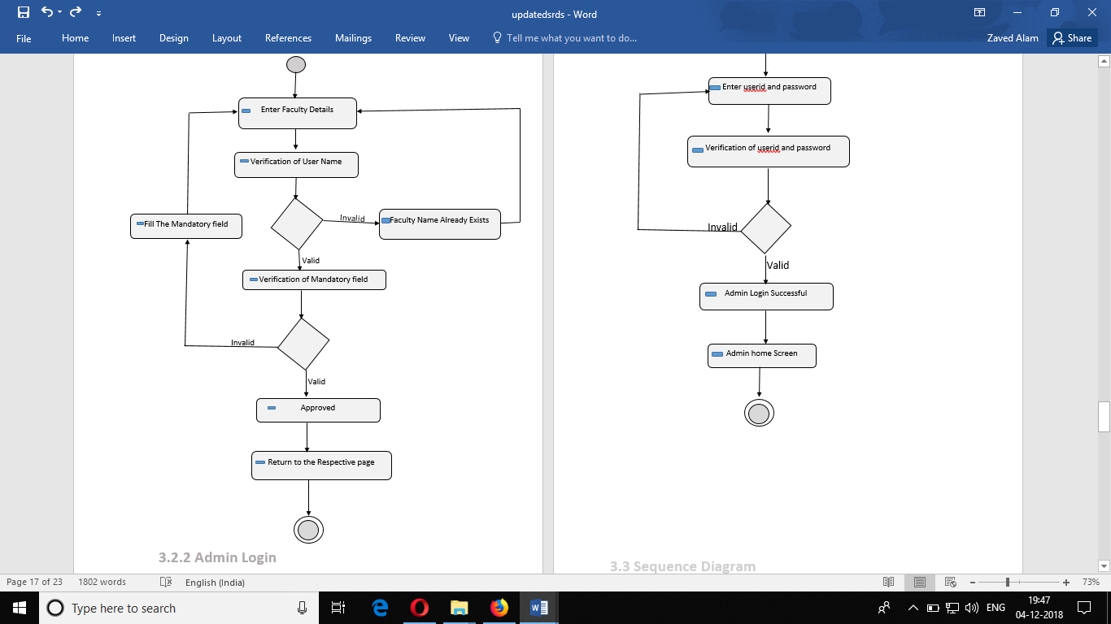

**Fig. Object diagram of faculty registration**

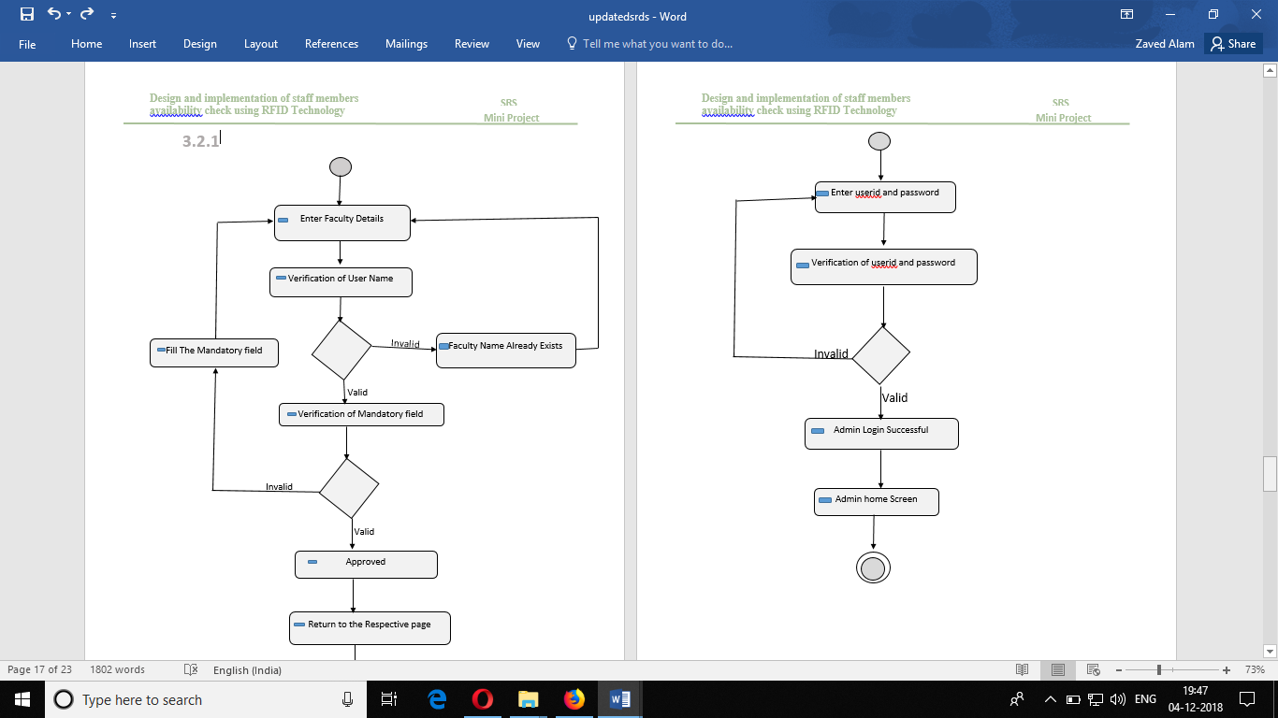

**Fig. Object diagram of admin login**

**3.1.3 Usecase diagram**

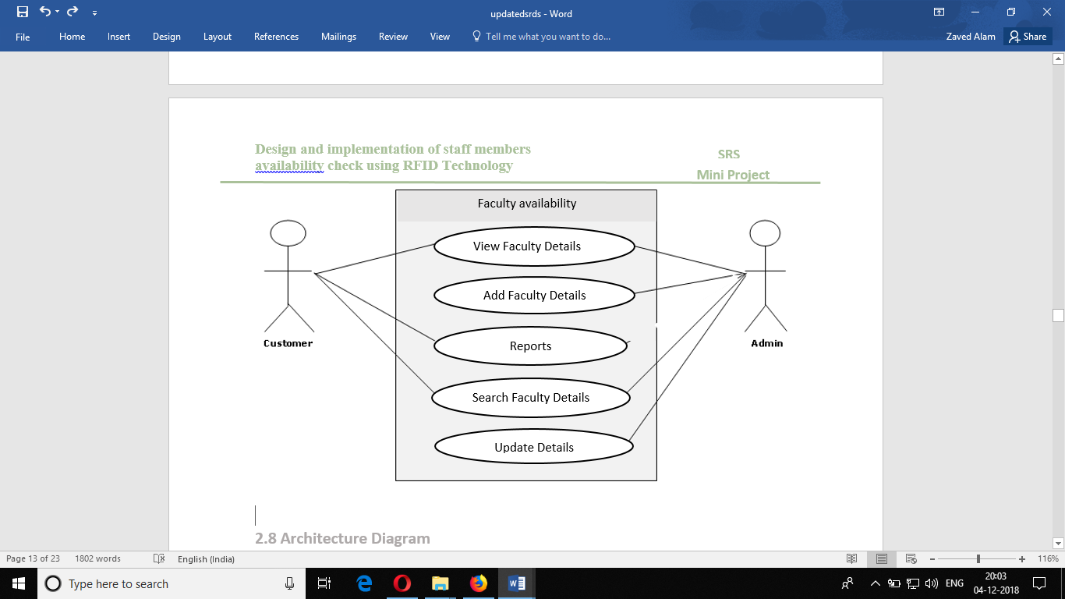

**Fig 2.2 Use Case Model Survey**

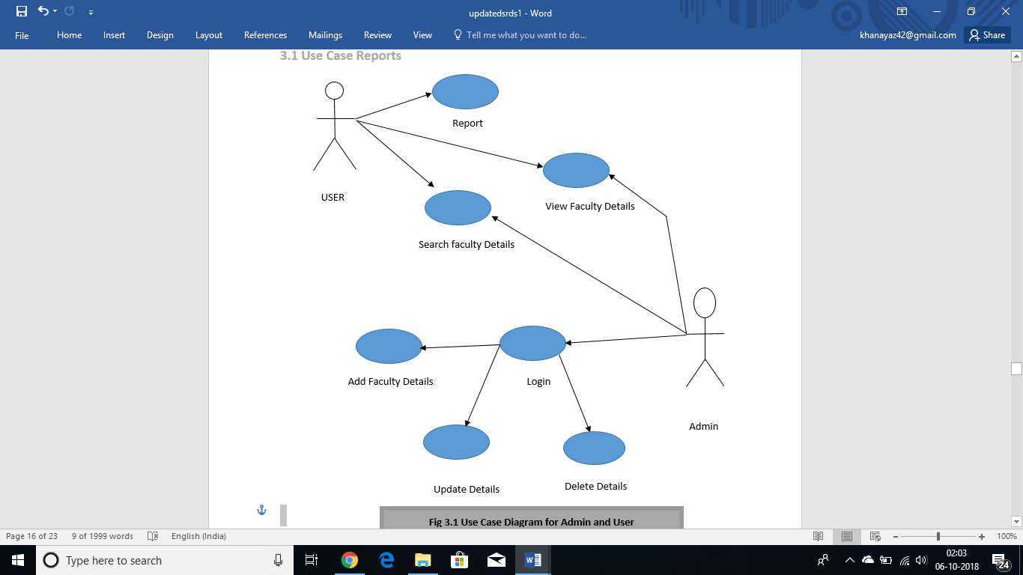

**Fig 3.1 Use Case Diagram for Admin and User**

**3.2 Database design**

**3.2.1 Tables:**

report

Admin_detail

faculty_detail

report

comments

s_no

name

user_id

password

s_no

room_no

name

availability

comments

**3.2.2 ER Diagram:**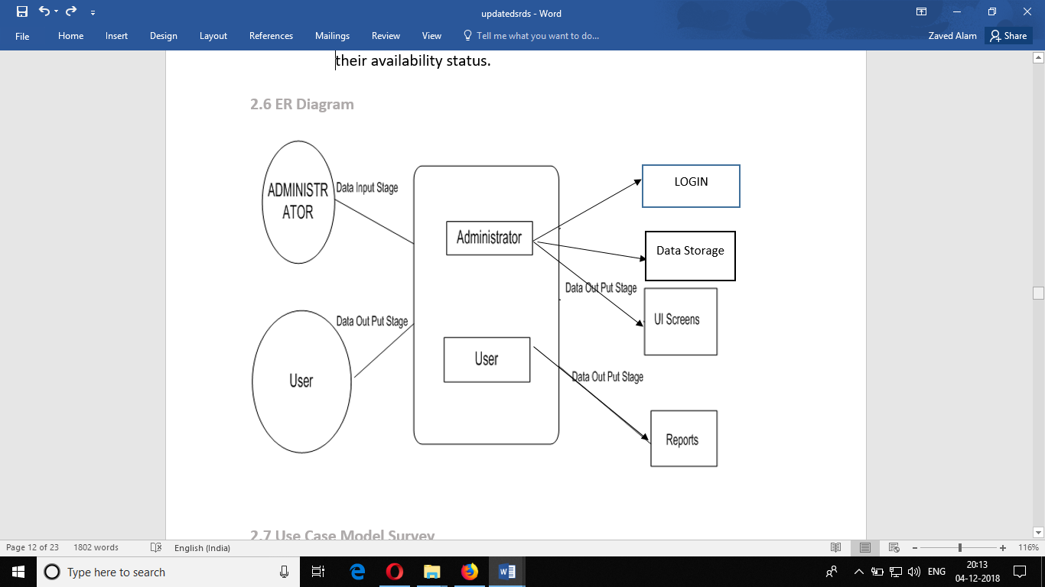

* + 1. **Stored Procedure:**

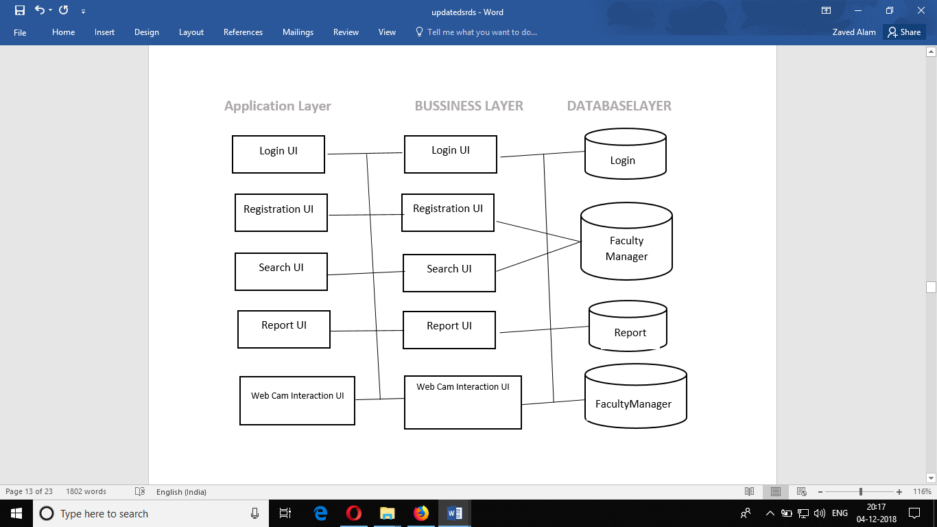

**4. Implementation and User Interface**

**4.1 Interface Screen**

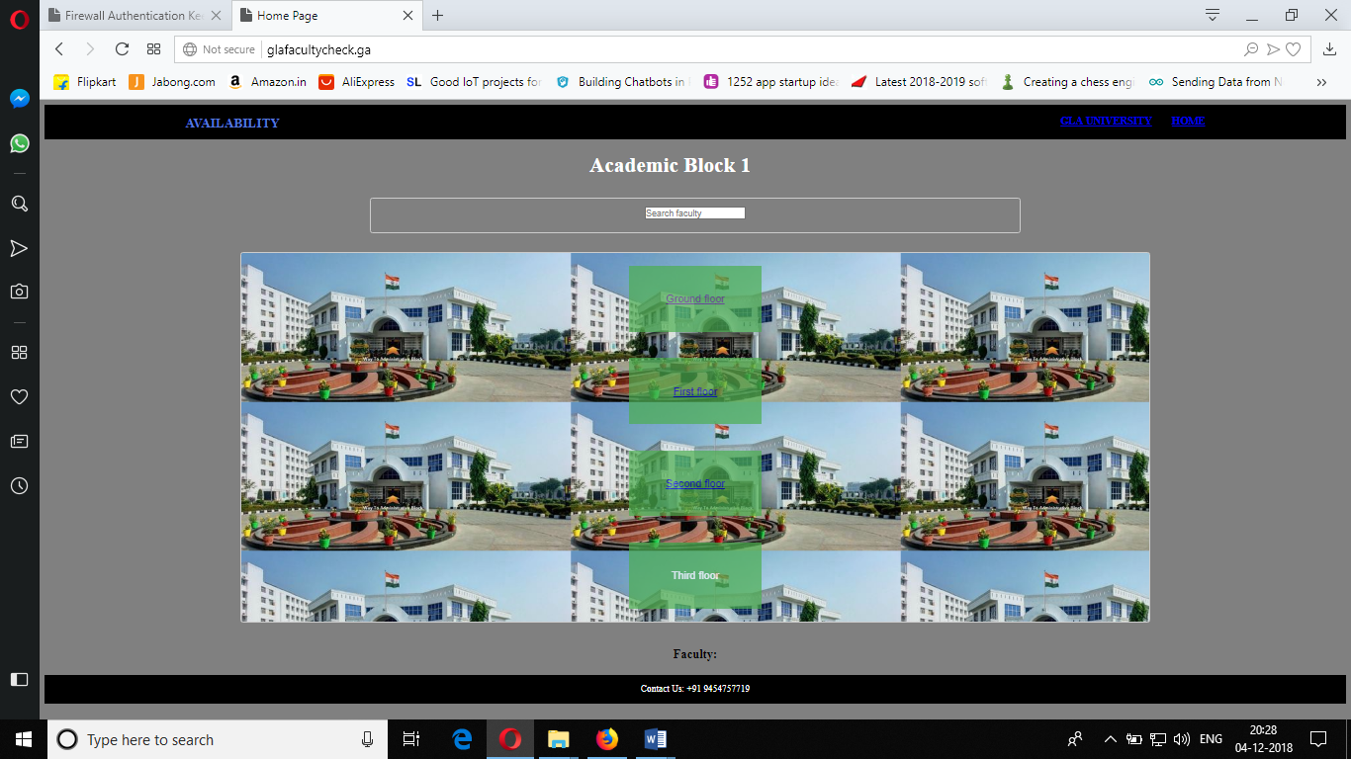

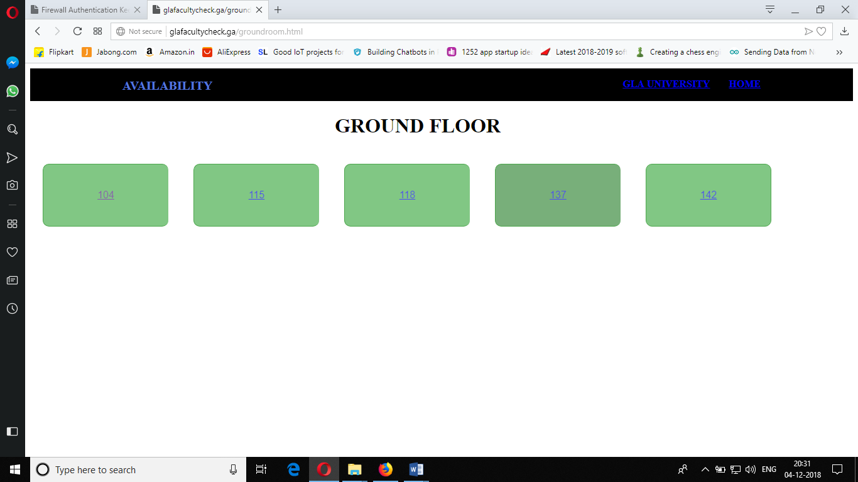

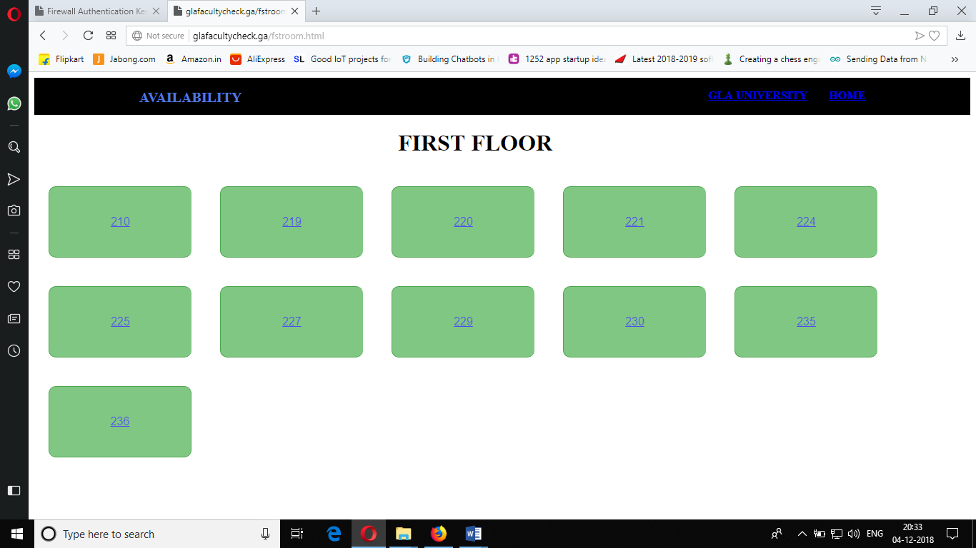

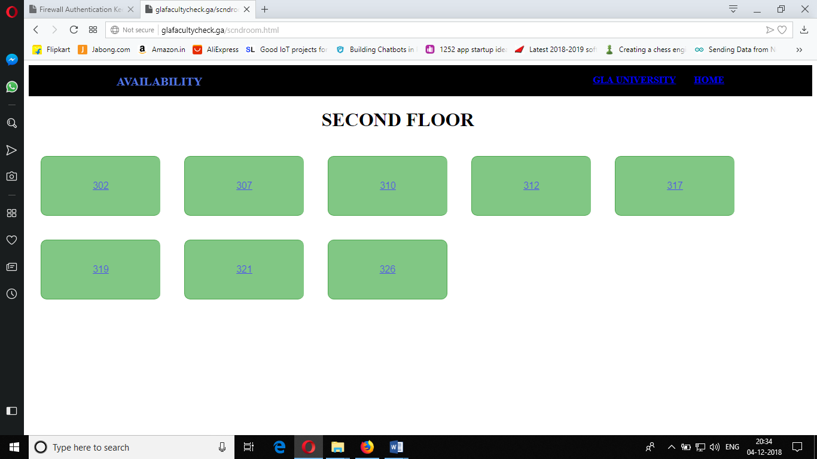

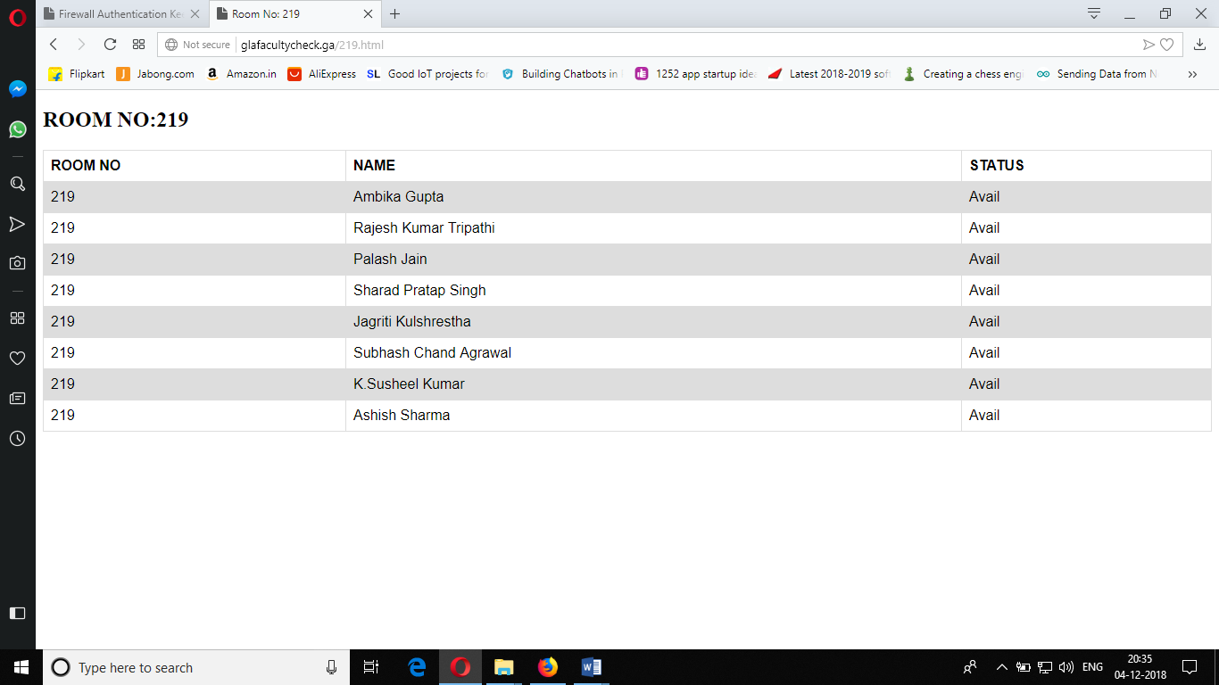

**4.2 Database Screen**

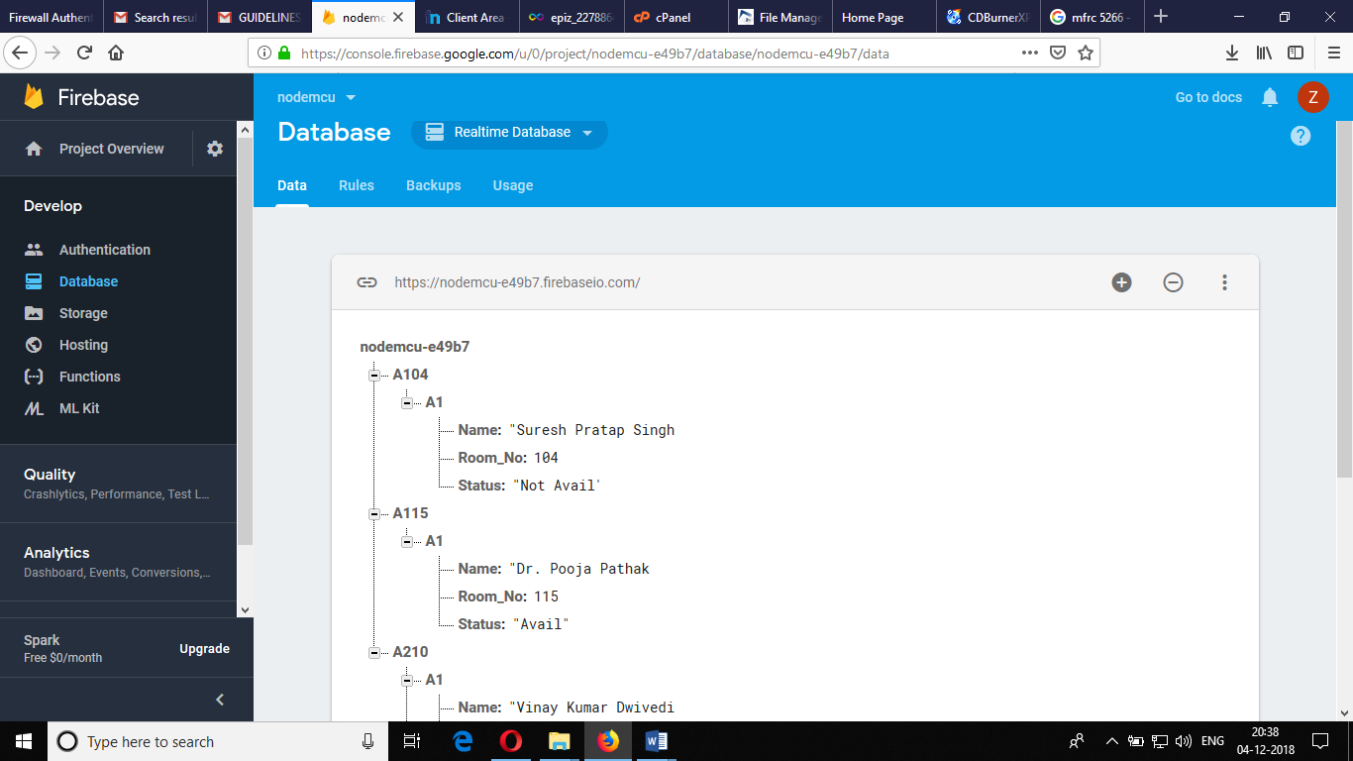

**5. References**

* NodeMCU Development Workshop- Agus Kurniawan
* HTML: [www.W3school.com](http://www.W3school.com)
* PHP: [www.Javatpoint.com](http://www.Javatpoint.com)
* RFID: A Guide to Radio Frequency Identification
* Wikipedia: [www.wikipedia.com](http://www.wikipedia.com)

**6. Appendices**

**6.1 Coding/ Code Templates**

//

// Copyright 2015 Google Inc.

//

// Licensed under the Apache License, Version 2.0 (the "License");

// you may not use this file except in compliance with the License.

// You may obtain a copy of the License at

//

// http://www.apache.org/licenses/LICENSE-2.0

//

// Unless required by applicable law or agreed to in writing, software

// distributed under the License is distributed on an "AS IS" BASIS,

// WITHOUT WARRANTIES OR CONDITIONS OF ANY KIND, either express or implied.

// See the License for the specific language governing permissions and

// limitations under the License.

// FirebaseDemo_ESP8266 is a sample that demo the different functions

// of the FirebaseArduino API.

#include <ESP8266WiFi.h>

#include <FirebaseArduino.h>

// Set these to run example.

#define FIREBASE_HOST "nodemcu-e49b7.firebaseio.com"

#define FIREBASE_AUTH "KiZYJK2IFBukD8V3jwGy9mH9l4It7NycscpOklZ7"

#define WIFI_SSID "Dell.laptop1"

#define WIFI_PASSWORD "1122334455aa"

#include <SPI.h>

#include <MFRC522.h>

#define RST_PIN 5 // Configurable, see typical pin layout above

#define SS_PIN 15 // Configurable, see typical pin layout above

MFRC522 mfrc522(SS_PIN, RST_PIN); // Create MFRC522 instance

int cnt=10;

String strID="";

String cid="8224111699";

String cid1="12811622163";

void setup() {

Serial.begin(9600);

// connect to wifi.

WiFi.begin(WIFI_SSID, WIFI_PASSWORD);

Serial.print("connecting");

while (WiFi.status() != WL_CONNECTED) {

Serial.print(".");

delay(500);

}

Serial.println();

Serial.print("connected: ");

Serial.println(WiFi.localIP());

Firebase.begin(FIREBASE_HOST, FIREBASE_AUTH);

while (!Serial); // Do nothing if no serial port is opened (added for Arduinos based on ATMEGA32U4)

SPI.begin(); // Init SPI bus

mfrc522.PCD_Init(); // Init MFRC522

mfrc522.PCD_DumpVersionToSerial(); // Show details of PCD - MFRC522 Card Reader details

Serial.println(F("Scan PICC to see UID, SAK, type, and data blocks..."));

}

int n = 0;

void loop() {

// Look for new cards

if ( ! mfrc522.PICC_IsNewCardPresent()) {

return;

}

// Select one of the cards

if ( ! mfrc522.PICC_ReadCardSerial()) {

return;

}

// Dump debug info about the card; PICC_HaltA() is automatically called

mfrc522.PICC_DumpToSerial(&(mfrc522.uid));

// set value

// one=database.ref("User");

// one.setString("Status", "Not Avail");

//Firebase.User.setFloat("Status", 289);

// handle error

if (Firebase.failed()) {

Serial.print("setting /number failed:");

Serial.println(Firebase.error());

return;

}

delay(10);

//while (!Serial); // Do nothing if no serial port is opened (added for Arduinos based on ATMEGA32U4)

SPI.begin(); // Init SPI bus

mfrc522.PCD_Init(); // Init MFRC522

mfrc522.PCD_DumpVersionToSerial(); // Show details of PCD - MFRC522 Card Reader details

Serial.println(F("Scan PICC to see UID, SAK, type, and data blocks..."));

for (byte i = 0; i < mfrc522.uid.size; i++){

strID +=mfrc522.uid.uidByte[i];

}

// update value

if(strID==cid){

Firebase.setString("A210/A1/Status", "avail");

Serial.println(strID);

strID="";

// handle error

if (Firebase.failed()) {

Serial.print("setting /number failed:");

Serial.println(Firebase.error());

return;

}

delay(10);}

else{

Firebase.setString("A210/A1/Status", "not_avail");

// handle error

if (Firebase.failed()) {

Serial.print("setting /number failed:");

Serial.println(Firebase.error());

return;

}

delay(10);}

if(strID==cid1){

Firebase.setString("A210/A2/Status", "avail");

Serial.println(strID);

strID="";

// handle error

if (Firebase.failed()) {

Serial.print("setting /number failed:");

Serial.println(Firebase.error());

return;

}

delay(10);}

else{

Firebase.setString("A210/A2/Status", "not_avail");

// handle error

if (Firebase.failed()) {

Serial.print("setting /number failed:");

Serial.println(Firebase.error());

return;

}

delay(10);}

// get value

Serial.print("Status: ");

Serial.println(Firebase.getString("A210/A1/Status"));

Serial.println(cnt);

if(cnt==0){

Serial.println("Reset..");

ESP.restart();

}

cnt--;

delay(50);

}