**Name: Samiksha Dipak Bramhankar (TE-IT)**

**Roll no – 09**

Screenshots:

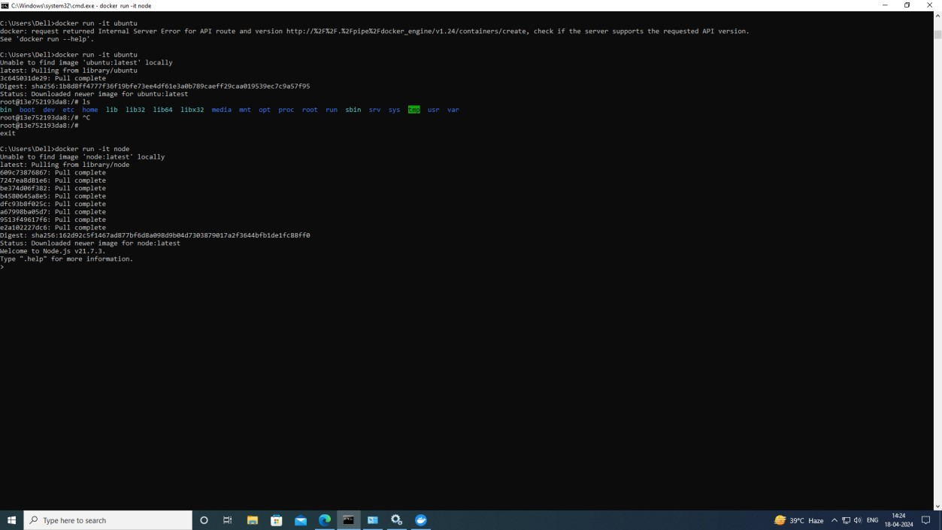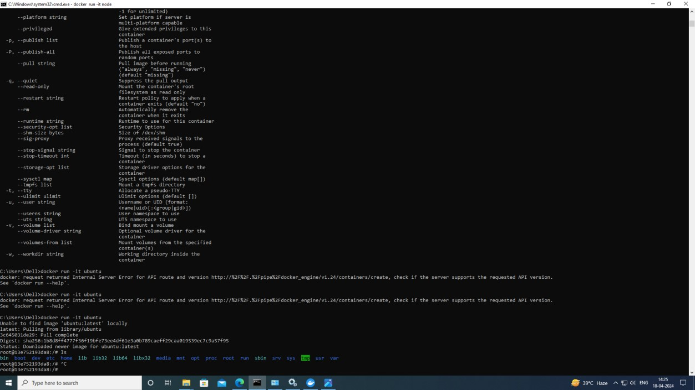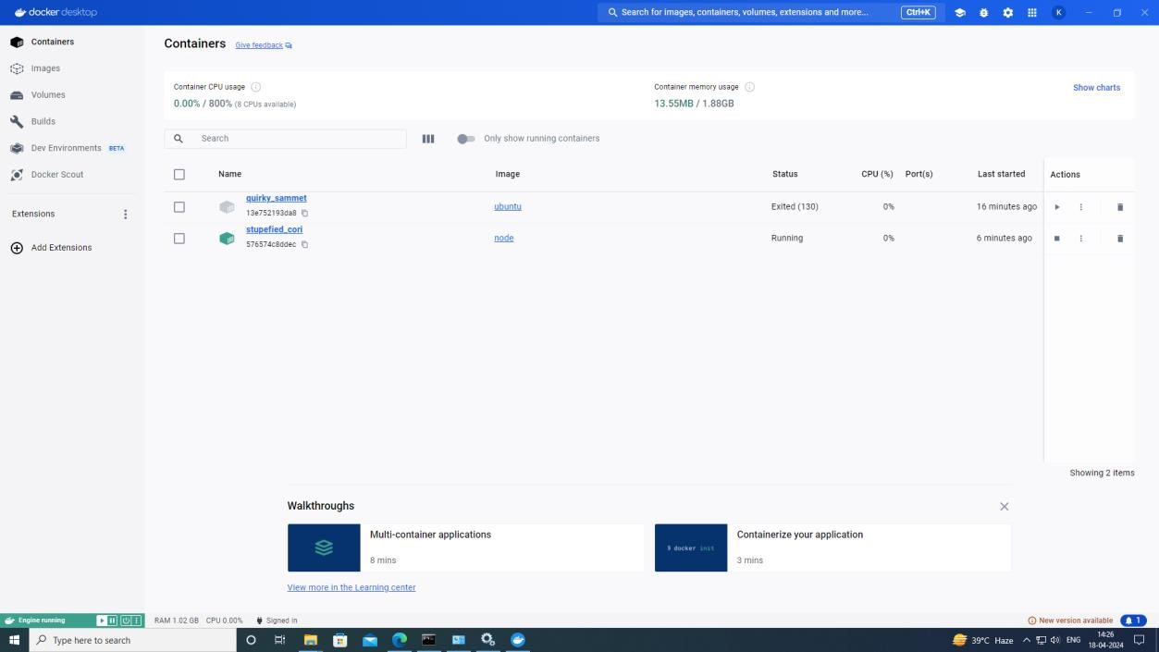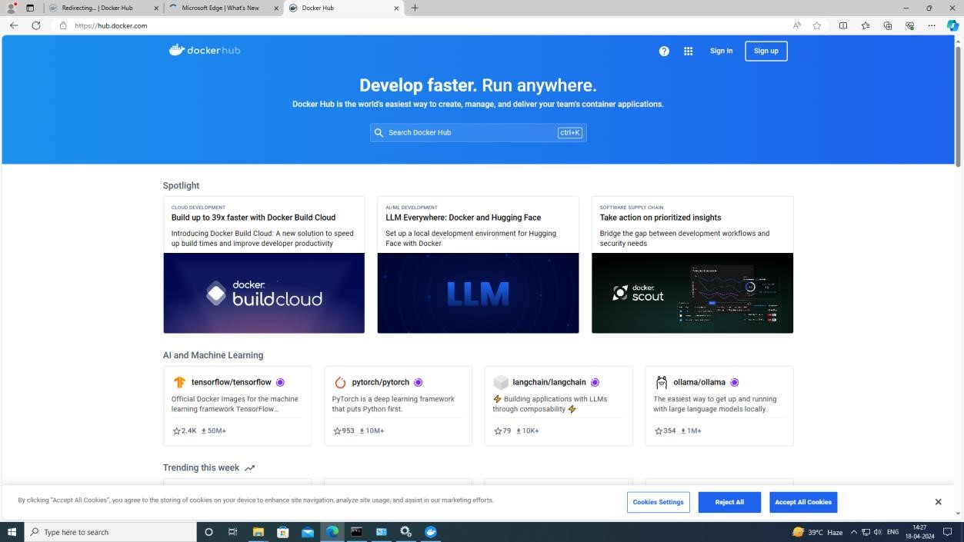

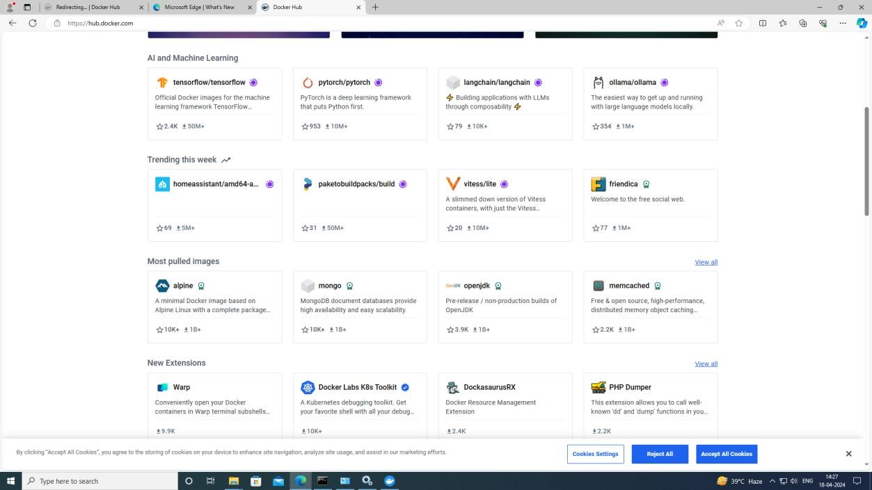

**Theory**: Docker is a platform designed to make it easier to create, deploy, and run applications by using containers. Containers allow a developer to package up an application with all of its parts (such as libraries and other dependencies), ensuring that it will run consistently on any environment. With Docker, developers can build, ship, and run applications anywhere, whether it's on a developer's laptop, on a physical server, or in the cloud. Docker uses containerization technology, which packages an application and its dependencies together into a single unit called a container. These containers are lightweight, portable, and isolated from each other, allowing multiple containers to run on the same machine without conflicts. Some key components of Docker include: Docker Engine: The core of Docker, responsible for creating and managing containers. Dockerfile: A text file that contains instructions for building a Docker image. Docker Image: A lightweight, standalone, executable package that includes everything needed to run a piece of software, including the code, runtime, libraries, and dependencies.Docker Hub: A cloud-based repository where Docker images can be stored, shared, and distributed. Docker Compose: A tool for defining and running multi-container Docker applications using a YAML file. Overall, Docker simplifies the process of building, deploying, and managing applications, making it a popular choice among developers and DevOps teams.