**Software Testing Methods :**

1. White Box Testing

2. Black Box Testing

3. Grey Box Testing

**1.White box testing-**

-White box testing is done by coder because code knowledge is required.

-It is also called as code level testing/unit testing/clear box testing.

-In white box testing whenever coder complete his code writing, he checks or compile code then if any bug found code have to solve it

-coder cannot send code to tested without doing white box testing

-coder check or test mostly positive scenarios only.

-white box testing has purpose to test correctness and completeness of the program.

**2.Black box testing-**

-Black box testing is known system and function testing.

-This testing is done by tester.

-Overall functionality get checked in this type of testing.

-Tester check internal functionality depend upon external functionality.

Example-Tester check whenever data is sign module got entered and users press sign up button,this button is process to store entered data.Tester check whether the data is stored correctly or not.

So here internal functionality is storing of data and external functionality is filling up data in fields and submit buttons process.

-Tester test the positive and negative scenarios.

**Positive scenario means-**

If suppose we have mobile number field with 10 digit functionality then as a tester we will check field functionality by entering 10 digit number whether it works or not.

**Negative scenario means-**

If suppose we have mobile number field with 10 digit functionality then as a tester if we check with 9 digits or less as it should not accept or more than 10 digits.

**Grey box testing:**

-Grey box testing is a combination of both white box and black box.

-To do grey box testing,tester need programming knowledge

-The role of grey box tester is whenever final software is handed over to tester tester check its functionality and if any fault occure in the output of function then tester try to solve that issue by self.So knowledge of coding is required.

like API and database

**Difference: -**

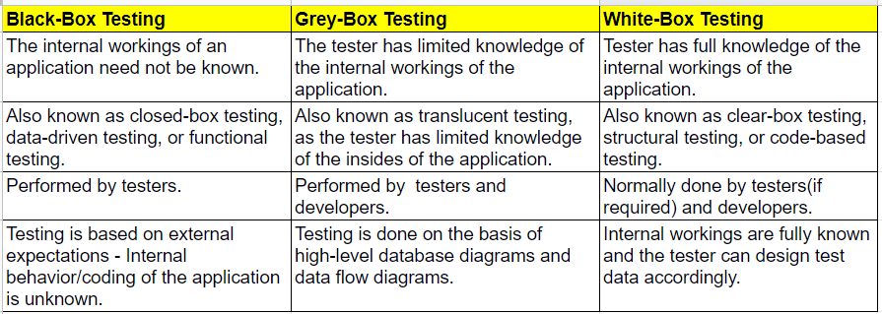

# **Levels of testing and types of testing..**

**Testing Types are**: Functional testing, regression testing, Smoke, Sanity, load and many more...

**Levels Of Testing**

1. Unit Testing

2. Integration Testing

3. System Testing

4. User Acceptance Testing (UAT)

**1.Unit Testing (White box , Clear box , glass box , Structure based)**

A Unit is a smallest testable piece of the software. It means testing a subprogram / module and checking is possible only by programmer.

Unit testing is a white box testing level and is performed at coding level

**Method Used for unit testing**: White Box Testing

**When Unit testing should be done?**

Testing can happen anytime when basic unit of code is ready

Unit testing should be done before Integration testing.

**By whom unit testing should be done?**

Unit testing should be done by the developers and testers (if required).

**Unit Testing Techniques:**

**White Box Testing Techniques/The way which Unit Testing is performed :**

● Statement Coverage - This technique is aimed at exercising all programming statements with minimal tests.

● Branch Coverage - This technique is running a series of tests to ensure that all branches are tested at least once.

● Path Coverage - This technique corresponds to testing all possible paths which means that each statement and branch is covered.

**Unit testing tools available in the market, which are as follows:**

● NUnit

● JUnit

● PHPunit

● Parasoft Jtest

● EMMA

**How to achieve the best result via Unit testing?**

● Naming conventions for unit test cases must be clear and consistent.

● Identified bugs on unit testing must be fixed before next level of SDLC

● Only one code should be tested at one time.

● If there are changes in the code of any module, ensure the unit test is available or not for that module.

**Advantages**

● Unit testing uses a module approach due to that any part can be tested without waiting for completion of another parts testing.

● The developing team focuses on the functionality of the unit.

● Refactoring of code can be possible after a number of days by dev and ensure the module is still working without any defect.

**Disadvantages**

● It cannot identify integration error

● Some Code knowledge required