Normal data I captured in pc named anivrath.csv and tested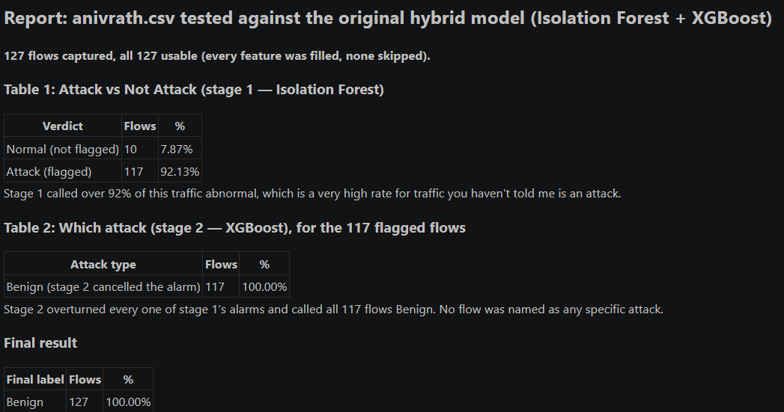

2nd time Normal data I captured in pc named anivrath.csv and tested
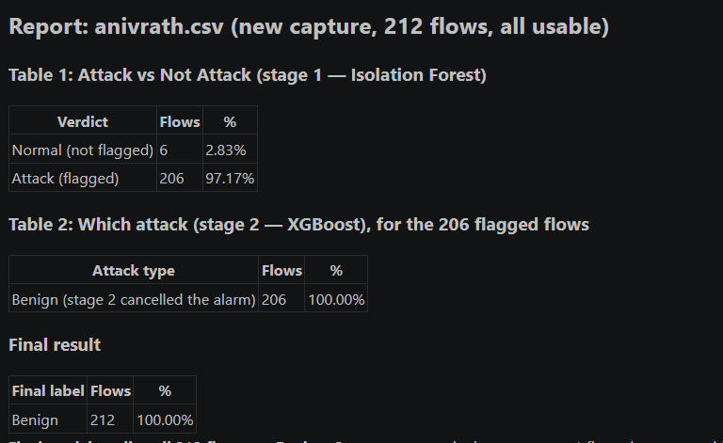
I captured kali to kali attack ssh bruteforce using patator and tested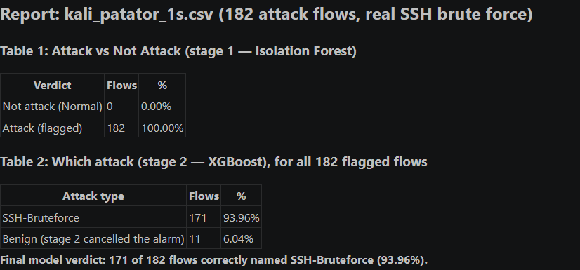

Ssh brute force attack kali to kali using hydra and I used java converter it’s a tool to clean live incoming data and tested
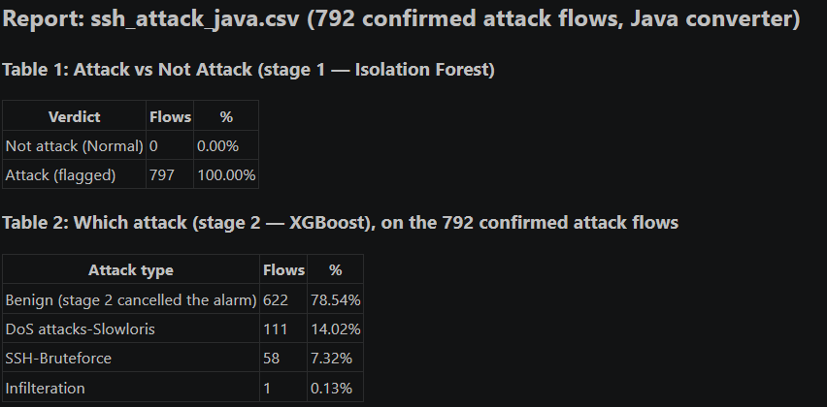

I did kali to kali attack and cleaned it by python convertor and tested
