|  |
| --- |
| **Date / *date*:** 28/02/2023 |
|  |
| **Titre / *Title***: Design Document of Transformer and AC Inductor |
| **Référence / *reference:*** |
| **Rédacteur / *writer***: |
| |  |  | | --- | --- | | **Validation** | **Autorisation** | | Nom:  Date: | Nom:  Date: | |  |  |  |  | | --- | | *Summary:*  This document details the design of Transformer and AC Inductor. | |

**APPROBATION OF DESIGN DOCUMENT (BLANK DOCUMENT)**

|  |  |  |  |
| --- | --- | --- | --- |
|  | NAMES | DATE |  |
| Written | Samiksha Baid | 28/02/2023 |  |
| Checked |  |  |  |
| Quality |  |  |  |
| Customer |  |  |  |

**BLANK DOCUMENT REVISION INDEXES**

|  |  |  |
| --- | --- | --- |
| **Date** | **Modifications** | **Index** |
| 28/02/2023 | First issue | A0 |
|  |  |  |

**DESIGN DOCUMENT APPROVAL**

|  |  |  |  |
| --- | --- | --- | --- |
|  | NAMES | DATE |  |
| Tested by |  |  |  |
| Checked by |  |  |  |
| Approval |  |  |  |
| Customer |  |  |  |

**FILLED DOCUMENT REVISION INDEXES**

|  |  |  |  |
| --- | --- | --- | --- |
| **Date** | **Modifications** | **Updated by** | **Index** |
|  |  |  |  |
|  |  |  |  |
|  |  |  |  |
|  |  |  |  |
|  |  |  |  |

**REFERENCE DOCUMENT LISTS**

|  |  |  |  |  |
| --- | --- | --- | --- | --- |
| **Ref.No** | **Name** | **Descriptions** | **Link/Location** | **Revision** |
| [1] | Magnetics Equation |  | Reference Document: <https://ietresearch.onlinelibrary.wiley.com/doi/epdf/10.1049/iet-cds.2016.0410> |  |
| [2] | Reference Book |  | Transformer and Inductor design Handbook by McLyman |  |
| [3] | Fringing Factor |  | [Evaluating Fringing Effects in Multi-Gapped Toroids - Technical Articles (eepower.com)](https://eepower.com/technical-articles/evaluating-fringing-effects-in-multi-gapped-toroids/) |  |
| [4] | Skin Depth |  | [Skin Depth Calculator (omnicalculator.com)](https://www.omnicalculator.com/physics/skin-depth) |  |
| [5] | Gap Losses |  | Transformer and Inductor design Handbook by McLyman -eq 10-15 |  |
| [6] | Temperature rise |  | [Link](https://elnamagnetics.com/wp-content/uploads/library/TSC-Ferrite-International/Predicting_Temperature_Rise_of_Ferrite_Cored_Transformers.pdf) |  |

Summary

1 Introduction 4

2 Transformer Design 5

2.1 Input, Output and Core parameters for the model 5

2.2 Procedure for designing Transformer 6

2.3 Flow chart 7

3 AC Inductor Design -EE Core only 8

3.1 Input, Output and Core parameters 8

3.2 Procedure for AC Inductor design 9

4 Abbreviations 13

4.1 Common abbreviations: 13

4.2 Transformer abbreviations: 13

4.3 Inductor abbreviations: 14

# Introduction

The following sections in this document contain design of high frequency Transformer and high frequency AC Inductor.

# Transformer Design

## Input, Output and Core parameters for the model

In order to design transformer following are the **major inputs** required for its design.

* Tf_n -Transformer turns ratio, Np/Ns
* Iprms - Primary Winding RMS Current, A
* Isrms - Secondary Winding RMS Current, A
* Vinmax - Maximum Permissible Input Voltage, V
* fs - Switching Frequency, Hz
* Lm_req - Transformer magnetizing inductance, mH

Some **global inputs** are also required which are listed below:

* J - Current Density, 5 A/m^2
* *σ* - Copper resistivity, 1.72E-08 ohm m
* muo - Permeability of free space,1.26E-06 H/m
* K_wdg_fctr - Winding Factor, 2.3
* Relative Core loss coefficient, kW/m^3

And some **core parameters** are required as listed below:

* mur(N97) - Relative Permeability
* Ae - Effective Core Area, mm^2
* le - Effective Flux path length, mm
* AL - Permeance, nH/n^2
* Volume_onestack - Volume of Core, mm^3
* Acw - Window area, mm^2
* ln - Mean length per winding, mm
* Core_L- Core Length, mm
* Core_B- Core Breadth, mm
* Core_W- Core Width, mm

Outputs from the model:

* ifpossible - if 0 then not possible to design transformer with this core,
* Core_Loss - Core loss, Watt
* Core_name -Core selected- A string
* R_pri - Primary wire resistance - mohm
* R_sec - Secondary wire resistance - mohm
* Volume_onestack - Volume of Core - mm^3
* No_of_Stack- Number of Stack
* Bmax - Maximum Flux density, Tesla
* Lm_Obtained - Obtained Magnetizing Inductance, mH
* Np - Primary Turns
* Ns - Secondary turns
* Lg – Air gap, mm

## Procedure for designing Transformer

* 1. The first step is to set number of turns for secondary and Number of stacks for the core. Since this is an iterative approach, it begins by setting these to 1.
 $$N_{s}=1 Num_{Stack}=1$$

 2. Thereafter, find the Primary turns from given transformer turns ratio as below:
 $$N_{p}=N_{s}×Tf_{n}$$

 3. From above obtained turns the required window area needs to be calculated. So, first window area for primary and secondary per turn is calculated using below equation:

$$W_Area_{Pri_pturn}=\frac{I_{prms}}{J}$$

$$W_Area_{Sec_pturn}=\frac{I_{srms}}{J}$$

Using above two total required window area is calculated considering winding factor of 2.3 as below:

* 1. Now from the core parameters check if the core selected has window area greater than the above required one or not. If yes then proceed to next step other wise change the core and start from Step (a).
  2. Now compute maximum Voltsec using below equation:
 $$VoltSec=\frac{V_{inmax}×0.5}{f_{s}}$$

 3. After that assume air gap to be 0 and compute Inductance and Maximum flux density using below equations. (**Note – Equations are written considering airgap. If airgap is put equal to 0 then equations automatically give result for un-gapped core. As introduction of air gap changes the relative permeability of core, the permeability is also updated using below equation.)**

$$μ_{r_wg}=\frac{μ_{r}}{1+\frac{μ_{r}*l_{g}*0.5}{l_{e}}}$$

$$Lm_{Fund}=\frac{N_{p}^{2}×μ_{0}×μ_{r_wg}×Ae×Num_{Stack}}{l_{e}+l_{g}×μ_{r_wg}}$$

$$I_{p}=\frac{VoltSec x 1000}{2×Lm_{Fund}}$$

$$AT_{per_m}=\frac{N_{p}× I_{p} ×1000}{l_{e}+l_{g}×μ_{r_wg}}$$

$$B_{max}=1.5×μ_{0}μ_{r_wg}×AT_{per_m}$$

Maximum flux density has been overestimated by 50% for safety margin.

* 1. After getting Lm and Bmax, compare Lm and Lm_req and if these two deviate from each other by very small amount say L_Error and Bmax is less than say Bmax allowed then the core is final. If core is final then Core loss, primary and secondary winding resistances are calculated as below:
 $$Loss_{Core}=Volume_{1stack}×Num_{Stack}×{10}^{-9}×Relative_Core_loss_CoeffN97×{10}^{3}$$

 $$R_{Pri}=\frac{ρ_{cu}×\left(l_{n}+\left(Num_{Stack}-1\right)×2×Core_{W}\right)×N_{p}×{10}^{6}}{W_Area_{Pri_pturn}}$$

$$R_{Sec}=\frac{ρ_{cu}×\left(l_{n}+\left(Num_{Stack}-1\right)×2×Core_{W}\right)×N_{s}×{10}^{6}}{W_Area_{Sec_pturn}}$$

2. If either of the condition (Flux_density_max<Bmax_allowed && abs(Lm_Fund-Lm)<L_error) is not fulfilled then either of the below steps or both could be taken and repeat procedure from step (b).
     1. Increase Ns by 1
     2. Increase Num_stack by 1

## Flow chart

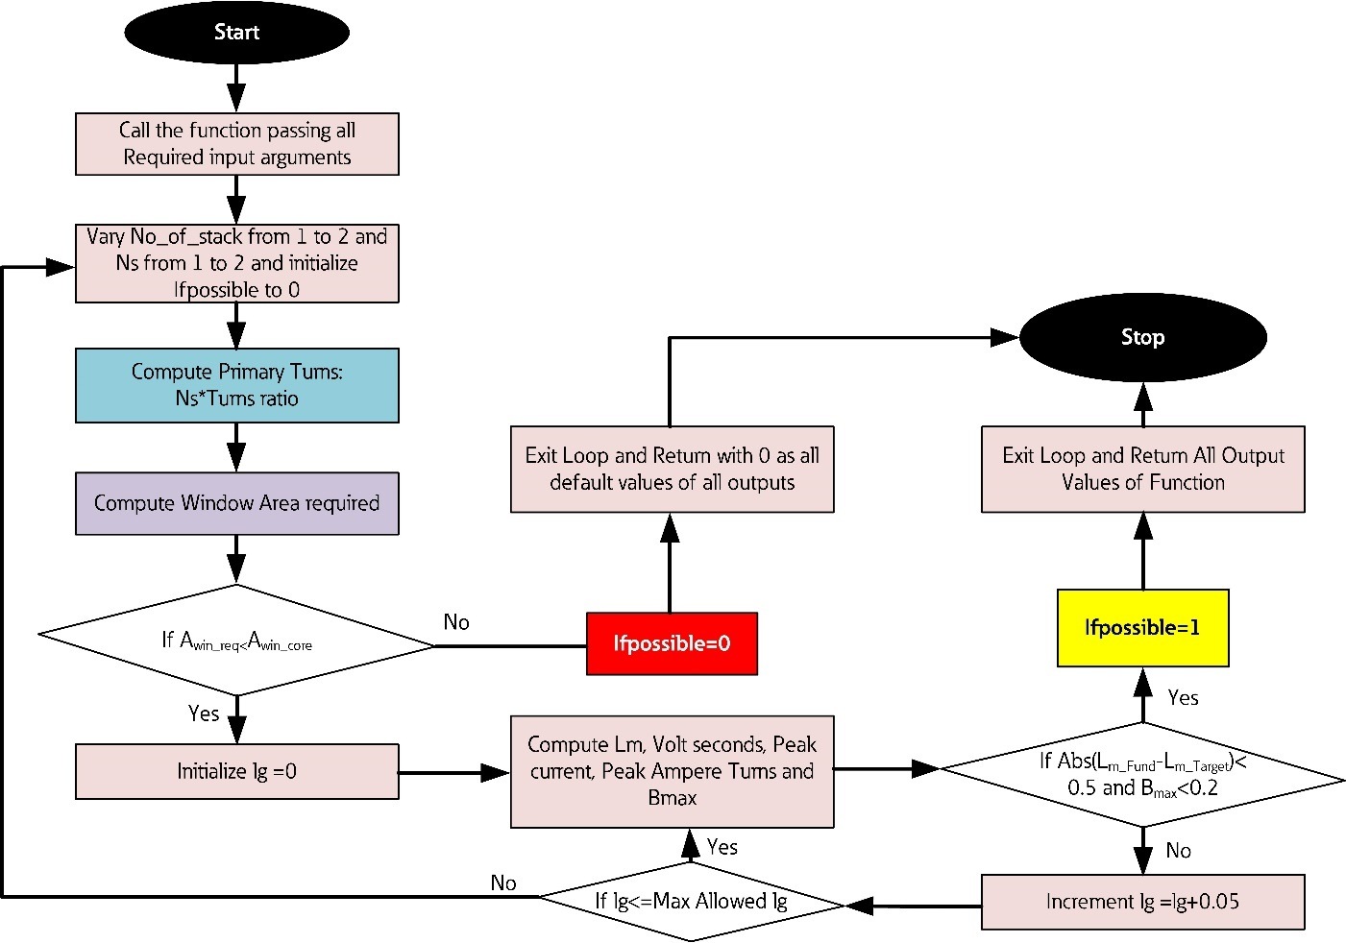

# AC Inductor Design -EE Core only

## Input, Output and Core parameters

In order to design inductor following are the **major inputs** required for its design.

* Curr_Ind_rms - Inductor RMS Current, A
* Volt_ind_rms - Inductor RMS Voltage, V
* fs - Switching Frequency, Hz
* L_Value - Required inductance, uH
* Del_I - Ripple rms current through Inductor, A

Some **global inputs** are also required which are listed below:

* J - Current Density, 5 A/m^2
* *σ* - Copper resistivity, 1.72E-08 ohm m
* muo - Permeability of free space,1.26E-06 H/m
* K_wu - Window utilization Factor, 1/2.5
* Relative Core loss coefficient W/m^3
* Kf - Waveform Factor, 4.44
* Kpf - packing factor, 1.28

And some **core parameters** are required as listed below:

* mur(N97) - Relative Permeability for un-gapped core
* Ae - Effective Core Area, mm^2
* le - Effective Flux path length, mm
* Volume_onestack - Volume of Core, mm^3

All the dimensions as in the figure below are also needed from core datasheet:

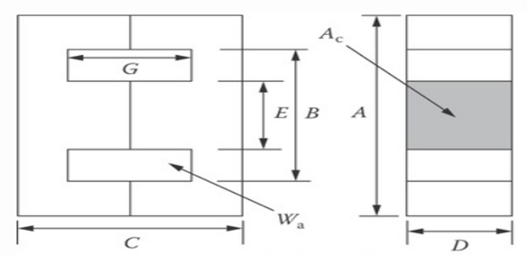

* Core_A -mm
* Core_B – mm
* Core_C -mm
* Core_D -mm
* Core_E – mm
* Core_G -mm

**Outputs:**

* ifpossible - if 0 then not possible to design inductor with this core,
* Core_Loss - Core loss, Watt
* Core_name -Core selected- A string
* R_ac - AC resistance - ohm
* R_dc - DC resistance - ohm
* Volume - Volume of Core - mm^3
* No_of_Stack- Number of Stack
* Bmax - Maximum Flux density, Tesla
* L_Obtained - Obtained Magnetizing Inductance, mH
* N_t - Turns
* lg - airgap, mm

## Procedure for AC Inductor design

* 1. The first step is to calculate the area of cross section of copper, skin Depth, copper strand diameter, number of strands and diameter of bunched litz wire using below equations:
 $$A_{Copp}=\frac{I_{Ind}}{J}$$

 $$D_{Skin_Depth}=1000\sqrt{\left(\frac{ρ_{cu}}{πμ_{cu}μ_{0}f_{s}}\right)}$$

$$d_{Cu}=2*D_{Skin_Depth}$$

$$N_{Strands}=Roundup \frac{A_{Copp}}{π×\frac{{d_{cu}}^{2}}{4}}$$

$$Coat_{t}=0.07×d_{Cu}$$

$$d_{litz}=K_{pf}×\sqrt{N_{Strands}}×\left(Coat_{t}+d_{Cu}\right)$$

2. The next step is to compute the cross-section area of stranded litz wire and the corrected cross section area of copper because of stranding. The equations used for that are as below:
 $$A_{litz}=π\frac{d_{litz}^{2}}{4}$$

 $$A_{Copp_Cor}=N_{Strands}×π\frac{d_{Cu}^{2}}{4}$$

3. Now comes setting number of turns for winding and Number of stacks for the core. Since this is an iterative approach, it begins by setting these to 1.
 $$N_{t}=1 Num_{Stack}=1$$

 4. From the number of turns and cross sectional area of litz wire, required window area can be computed as below:
 $$A_{W_Req}=A_{litz}×N_{t}$$

 5. Using the dimensions of core, the window area can be computed as below:

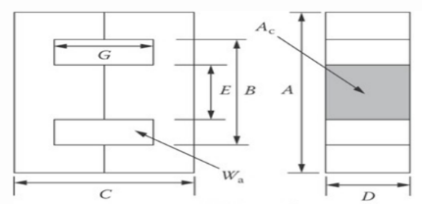

* 1. Available Core window area considering winding factor is then:
 $$A_{cw_Avai}=A_{cw}×K_{wu}$$

 2. Now from the core parameters check if the available window area of selected core is greater than the required one or not. If yes then proceed to next step otherwise change the core and start from Step (c).
  3. Now compute all the core parameters like effective core area, Mean length per turn, Core surface area and copper surface area for temperature computation. Equations used for computing all the above are as below:



* 1. After that assume air gap to be 0 and compute Inductance and Maximum flux density using below equations. (**Note – Equations are written considering airgap. If airgap is put equal to 0 then equations automatically give result for un-gapped core. As introduction of air gap changes the relative permeability of core, the permeability is also updated using below equation.)**

$$μ_{r_wg}=\frac{μ_{r}}{1+\frac{μ_{r}*l_{g}*0.5}{l_{e}}}$$

In case of gapped cores fringing also needs to be considered. Fringing factor is computed as below:

$$K_{Frng_Fctr}=1+\frac{lg}{\sqrt{\left(Ae\right)}}×ln\left(\frac{2×Core_G}{l_{g}}\right)$$

The inductance and flux density are then computed as below:

* 1. If the obtained value of L and the required doesn't deviate much and maximum flux density is well within the defined limit then loop proceeds for further computations. If the criteria not fulfilled then try one or both of the following and repeat from step (d).
     1. Increase N_t by 1
     2. Increase Num_stack by 1
  2. If Criteria for L and Bmax meets then proceed for below computations.
  3. Now number of turns per layer need to be found considering 70% occupancy only as below:
 $$N_{t_perlayer}=\frac{0.7×Core_G}{d_{litz}}$$

 4. From number of turns per layer, total layers required will be computed as below:

$$N_{Layer}=Roundup\left(\frac{N_{t}}{N_{t_perlayer}}\right)$$

Using Number of layers and Q, the ratio of Ac resistance and Dc resistance can be obtained from graph below:

Q in this case is 2 as d is taken to be 2 times of skin depth(see step (a)).

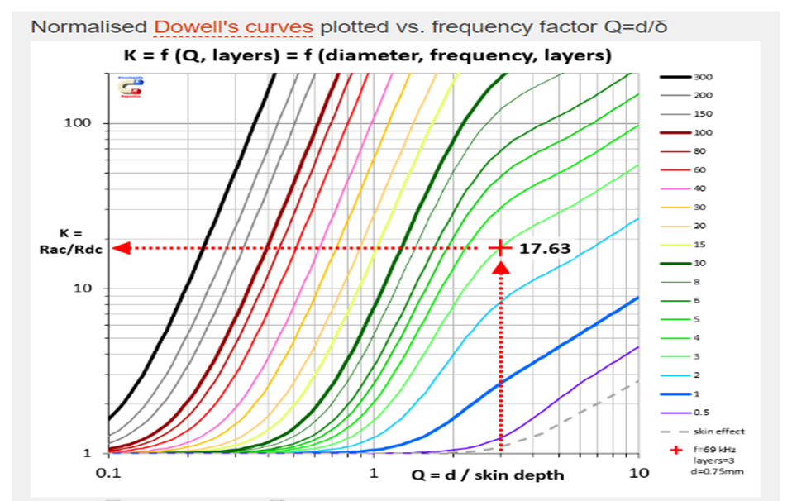

* 1. The DC and AC resistance can then be computed as below:
 $$R_{dc}=\frac{ρ_{cu}×l_{n}×N_{t }×{10}^{3}}{A_{Copp_Cor}}$$

 $$R_{ac}=\frac{R_{dc}K}{N_{Strands}}$$

2. Copper, core and gap losses are then computed as below:
 $$Loss_{Cu}=I_{Ind}^{2}×\left(R_{ac}+R_{dc}\right)$$

 $$Loss_{Core}=Volume_{onestack}×Num_{stack}×K_{core}×{10}^{-9}$$

$$Loss_{gap}={10}^{-2}×0.155×Core_E×l_{g}×f_{s}×{\left(B_{max}/1.5\right)}^{2}$$

$$Loss_{Total}=Loss_{Cu}+Loss_{Core}+Loss_{Gap}$$

3. The temperature rise for core, copper and total are then computed as below:
 $$Core_{T_Rise}={\left(\frac{1000*Loss_{Core}}{A_{Surf_core}/100}\right)}^{0.833}$$

 $$Cu_{T_Rise}={\left(\frac{1000*Loss_{Cu}}{A_{Cu_H}/100}\right)}^{0.833}$$

$$Total_{T_Rise}={\left(\frac{1000*Loss_{Total}}{{(A}_{Surf_core}+A_{Cu_H})/100}\right)}^{0.833}$$

4. If the obtained value of Temperature rise is well within the defined limit then the core is final. If not then try one or both of the following and repeat from step (d).
     1. Increase N_t by 1
     2. Increase Num_stack by 1

# Abbreviations

## Common abbreviations:

$$Num_{Stack} - Number of stacks of core$$

$$J-CurrentDensity,A/mm^{2}$$

$$μ_{0}-Permeability of free space, H/m$$

$$μ_{r}-Relative permeability of ungapped core$$

$$f_{s} - Switching Frequency, Hz$$

$$μ_{r_wg }- Relative permeability of gapped core$$

$$l_{g}- Air gap, mm$$

$$ρ_{cu} - Copper resistivity, Ωm$$

$$l_{e}- Effective Flux path length, mm$$

$$l_{n} - Mean length per turn,mm$$

$$A_{e}-Effective area of core,mm^{2}$$

$$B_{max}- Maximum Flux Density, Tesla$$

$$Loss_{Core} - Core loss, W$$

$$Volume_{1stack}-Volume of core per stack,mm^{3}$$

$$Relative_Core_loss_CoeffN97-Loss coefficient for core loss computation,kW/m^{3}$$

$$A_{cw}-Window area of core,mm^{2}$$

## Transformer abbreviations:

$$N_{s}- Number of secondary winding turns$$

$$N_{p}- Number of Primary winding turns$$

$$Tf_{n}-Transformer turns ratio N_{p}/N_{s}$$

$$W_Area_{Pri_pturn}-Window area for Primary Conductor per turn,mm^{2}$$

$$W_Area_{Sec_pturn}-Window area for Secondary Conductor per turn,mm^{2}$$

$$W_Area_{Total}-Total Window area Required,mm^{2}$$

$$I_{prms} - Primary winding RMS current, A$$

$$I_{srms }- Secondary winding RMS Current, A$$

$$K_{wdg_fctr} - Winding Factor, 2.3$$

$$VoltSec - Voltage Second across Transformer Primary Winding, Vs$$

$$V_{inmax}- Maximum Voltage across Transformer Primary winding, V$$

$${Lm}_{Fund}- Fundamental Inductance obtained, mH$$

$$I_{p} - Peak magnetizing current, A$$

$$AT_{per_m} - Ampere Turn per meter, A/m$$

$$R_{Pri}- Primary winding Resistance, mΩ$$

$$R_{Sec}- Secondary winding Resistance, mΩ$$

## Inductor abbreviations:

$$A_{Copp}-Required Cross-sectional area of copper,mm^{2}$$

$$I_{Ind}- Inductor Rms Current, A$$

$$D_{Skin_Depth}- Skin depth, mm$$

$$μ_{cu}-Copper Relative Permeability$$

$$d_{Cu}- Diameter of one copper strand, mm$$

$$N_{Strands}- Number of strands required$$

$$Coat_{t}- Enamel/Insulation coating thickness on copper strand, mm$$

$K_{pf}- Packing factor$

$$d_{litz}- Outer diameter of bunched litz wire, mm$$

$$A_{litz}-Cross section area of litz wire.mm^{2}$$

$$A_{Copp_Cor}-Corrected cross-sectional area of copper after stranding them,mm^{2}$$

$$A_{W_Req}-Required Window area,mm^{2}$$

$$A_{cw_Avai}-Available Window area considering winding factor,mm^{2}$$

$$K_{wu}- Window utilization factor=1/Winding factor$$

$$A_{Surf_core}-Surface area of Core,mm^{2}$$

$$A_{Cu_H}-Surface area of copper exposed to heat,mm^{2}$$

$$K_{Frng_Fctr}- Fringing Factor$$

$$L_{Fund}- Inductance obtained for chosen core and parameters, H$$

$$N_{t_perlayer}- Number of turns per layer$$

$$N_{Layer}- Number of layers of winding$$

$$R_{dc}- DC resistance of conductor, Ω$$

$$R_{ac}- AC resistance of conductor, Ω$$

$$Loss_{Cu}- Copper Losses, W$$

$$Loss_{Core}- Core Losses, W$$

$$Loss_{gap}- Gap losses,W$$

$$Loss_{Total}- Total losses,W$$

$$Core_{T_Rise}- Temperature rise of core, Degree celsius$$

$$Cu_{T_Rise}-Temperature rise of copper, Degree celsius$$

$$Total_{T_Rise}- Total Temperature rise, Degree celsius$$