Demoblaze Website – Defect Report

Test Environment
OS: | Windows 10 Pro (64-bit)
Browser: | Google Chrome 142.0.7444.134 (64-bit)
Device: | Laptop
Screen Resolution: | 1920 × 1080
Website: | https://www.demoblaze.com/

Test Summary
Functional and UI testing were conducted to verify the modules of the Demoblaze demo application (Login, Signup, Product Display, Add to Cart, Contact Form, and Logout). Testing ensured validation, navigation flow, button functionality, and alert handling across all features.
Defect ID | Defect Title | Severity | Status
D001 | Contact Form – Blank Field Accepted | High | Open
D002 | Add to Cart – Quantity Field Missing | Medium | Open
D003 | Contact Form – Invalid Email Format Accepted | High | Open
D004 | Logout – Alert Message Not Displayed | Low | Open

Issues Found

- Add to Cart – Quantity Field Missing
Issue: No option to modify quantity before checkout.
Impact: Poor user experience; users must repeatedly add the same product.
- Contact Form – Invalid Email Format Accepted
Issue: The contact form accepts invalid email formats (e.g., test@demo). Impact: Leads to incorrect data submission and email failure.

3)Contact Form – Blank Field Accepted

Issue: The Contact Form allows submission with required fields (Name, Email, Message) left blank. No error message is displayed.
Impact: Leads to incomplete data submissions and poor user experience.

4)Logout – Alert Message Not Displayed
Issue: Application logs out silently without confirmation.
Impact: Reduces usability and clarity of session handling.
Screenshots (Sample / Simulated)
Screenshot 1: 1) Add to Cart – Quantity Field Missing

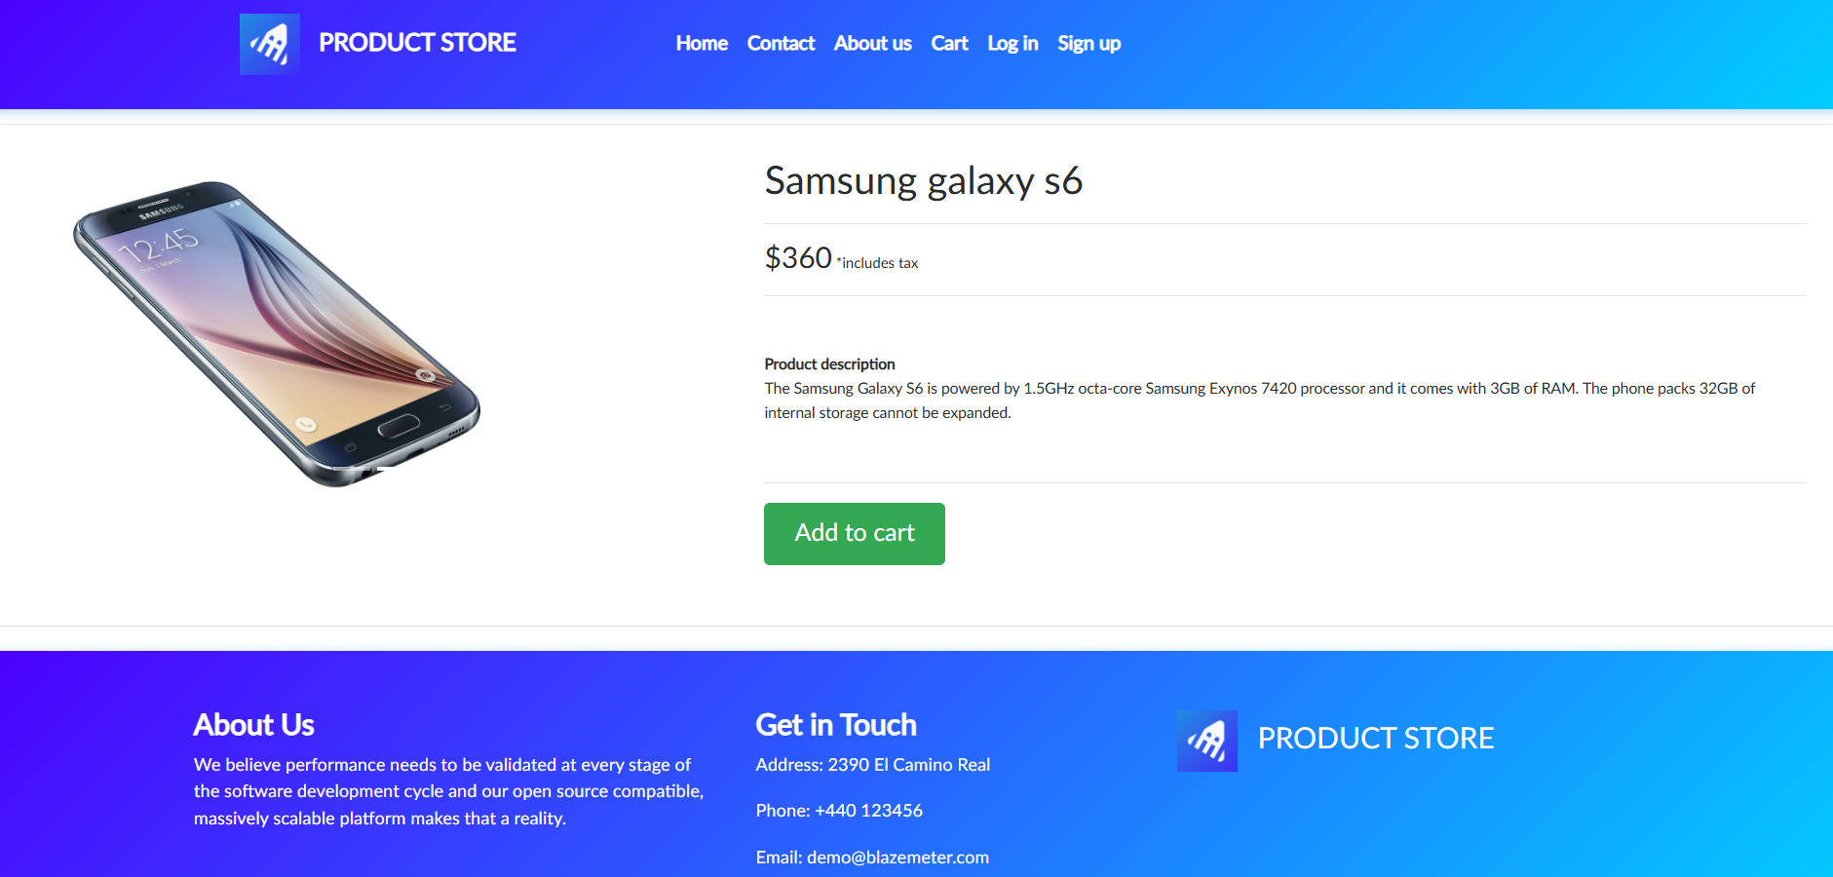

Screenshot 2: 2) Contact Form – Invalid Email Format Accepted

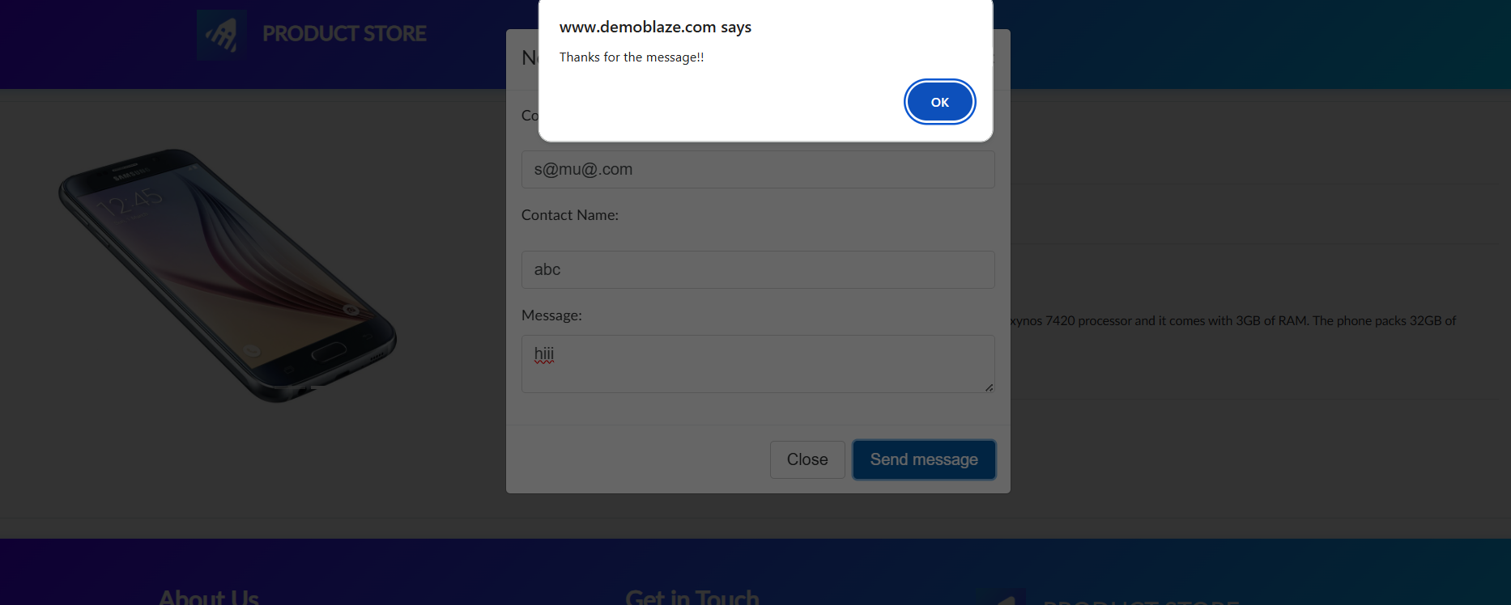

Screenshot 3: 3) Contact Form – Blank Field Accepted
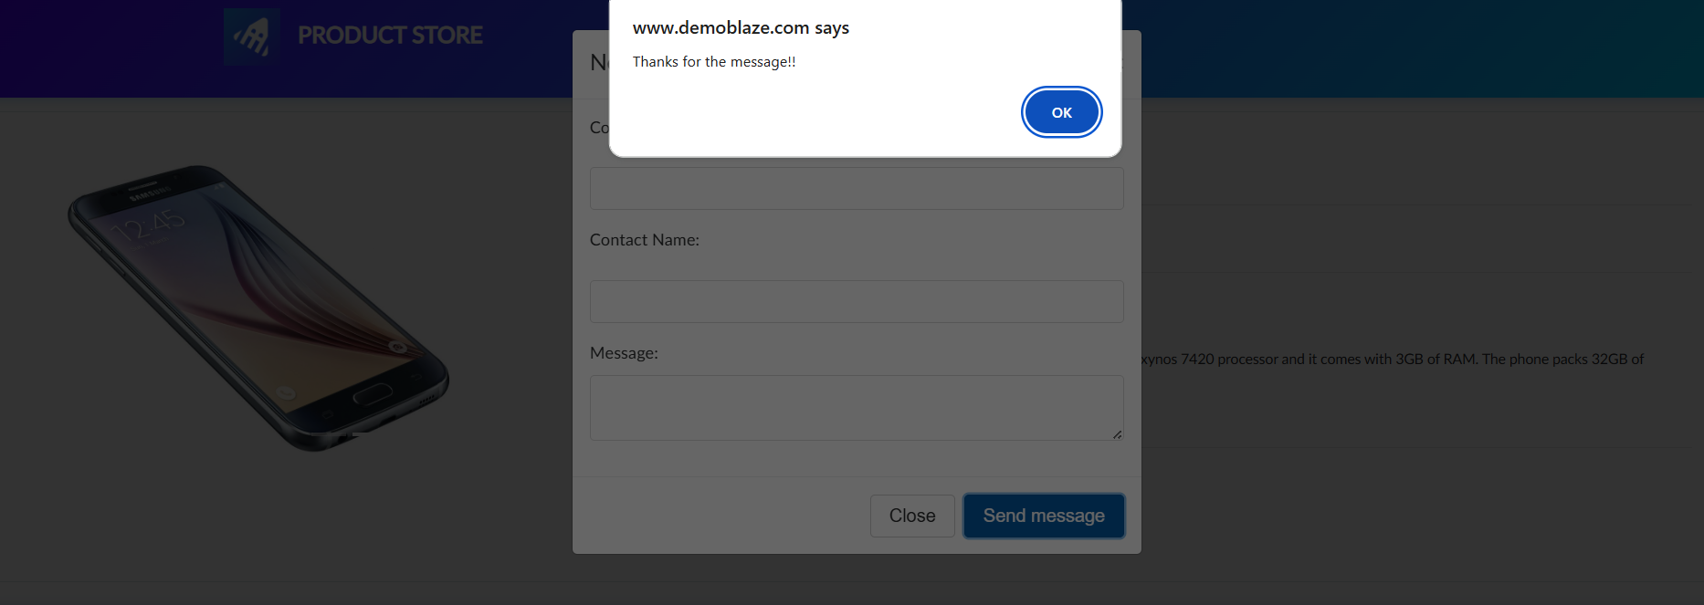

Conclusion
Functional testing of the Demoblaze Website revealed that while most modules function as expected, several usability and validation issues persist. Key problems include missing alerts, poor validation, and UI responsiveness concerns. It is recommended to fix these defects, re-test all forms, and run regression tests before production deployment.

