**CUDA- GPU setup tutorial**

**Requirements:**

* NVIDIA GPU (graphics card) in laptop
* python version 3.8.10 ( its good to remove other python versions and keep the single one i.e. 3.8.10)

**note**: if any issues for 3.8.10, you can go for 3.9 but not above 3.10 version or below 3.8

**Step 1 (downloading cuda toolkit):**

* search for 'download cuda toolkit nvidia' and click on very first link...(cuda toolkit 12.4 update downloads 1)

OR

click on the below link:

<https://developer.nvidia.com/cuda-downloads> 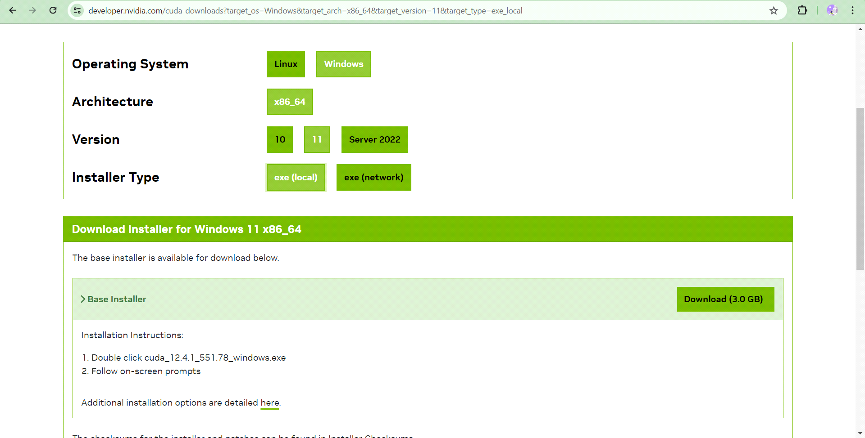

* then select OS->architecture->OS version->installer type to be exe(local)
* click on download (base installer)
* exe file will get downloaded.just proceed and finish the installation
* Make sure you are logged in in NVIDIA,if not then login in NVIDIA ,that, is the last step in installation process itself.

**Note:**

* After installation, ensure that the cuda path is added in the system variables.For that , go to windows search -> search for 'edit the system environment variable'-> 'Environment variables'->check for cuda path as given below.

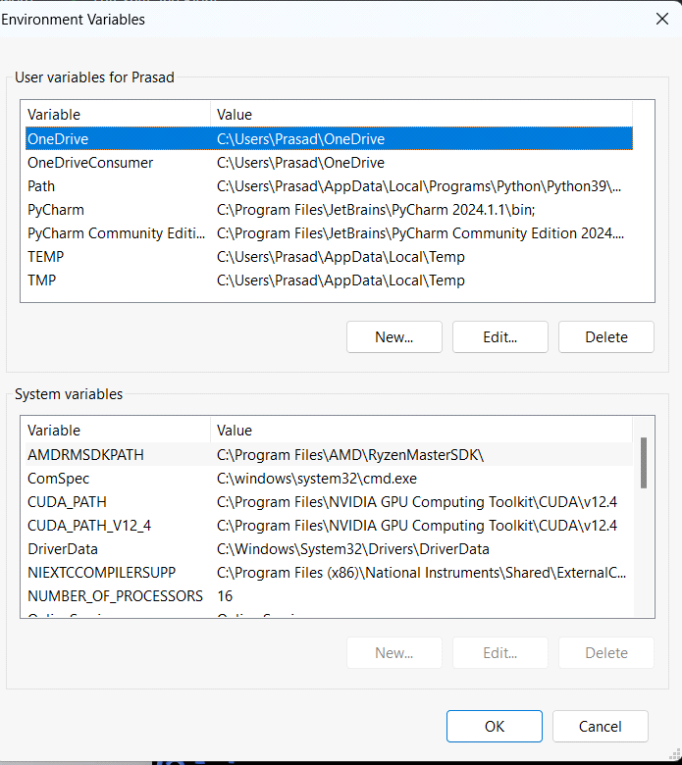

* like above image,you will find the cuda_path in system variables if cuda is properly installed
* If path not found (cuda is not installed properly),add it in system variables, or repeat the above steps from beginning
* likewise ,the python path should also be there in user variables.
* also give prompt in command shell terminal as 'nvcc--version', if error ,then cuda not installed completely

**Step2 (calling the GPU support to pycharm,vscode IDE):**

* setup the IDE (pycharm,vscode,etc) with python version 3.8.10.
* compulsarily install library 'torch' for having GPU support. Make sure that the torch library installed is of GPU version and not for CPU. For that you can also go for following steps:

go to website 'pytorch.org'(https://pytorch.org/) -> scroll down to find link for installation as follows:

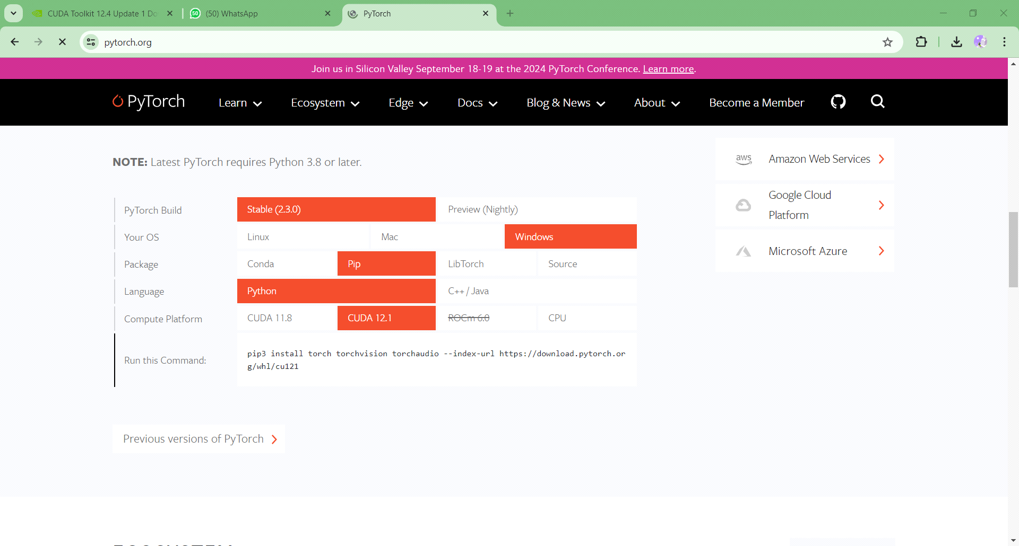

select options according to your system ->'compute platform to be CUDA 12.1'->run the given command in your IDE terminal.

* to check whether cuda available in IDE or not ,run code in pycharm,vscode:print(torch.cuda.is_available), if **true** then installation successfully installed.
* also check the task manager by running any code on GPU.

sample code is provided with tutorial----------------------------------