**Exercise 1: Implementing the Singleton Pattern**

Logger.java

public class Logger {  
  
 private static Logger *instance*;  
  
 private Logger(){  
 System.*out*.println("Logger Instance Created");  
 }  
  
 public static Logger getInstance(){  
 if (*instance*==null){  
 *instance* = new Logger();  
 }  
 return *instance*;  
 }  
  
 public void log(String Message){  
 System.*out*.println("Log: " + Message);  
 }  
}

Main.java

public class Main {  
 public static void main(String[] args){  
 Logger log1 = Logger.*getInstance*();  
 log1.log("This is the first log");  
  
 Logger log2 = Logger.*getInstance*();  
 log1.log("This is the second log");  
  
 if(log1==log2){  
 System.*out*.println("Both logger instances are the same.");  
 }  
 else{  
 System.*out*.println("Different instances!");  
 }  
  
 }  
}

Output:

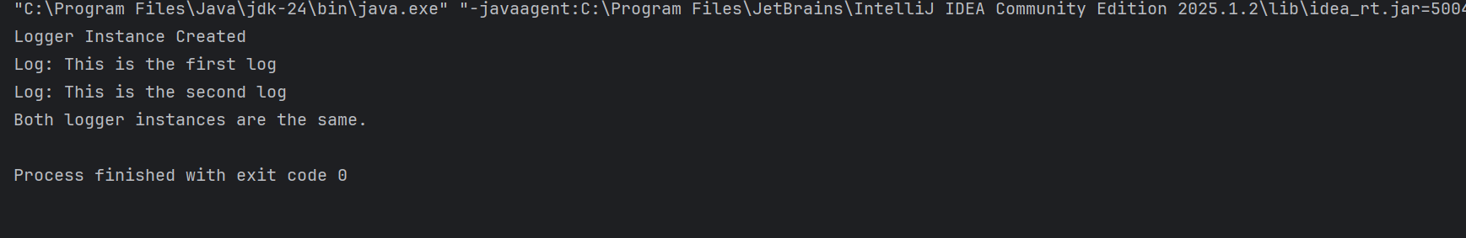

**Exercise 2: Implementing the Factory Method Pattern**

Document.java

public interface Document {  
 void open();  
}

WordDocument.java

public class WordDocument implements Document{  
 @Override  
 public void open(){  
 System.*out*.println("Opening Excel Document...");  
 }  
}

PdfDocument.java

public class PdfDocument implements Document {  
 @Override  
 public void open() {  
 System.*out*.println("Opening PDF Document...");  
 }  
}

ExcelDocument.java

public class ExcelDocument implements Document{  
 @Override  
 public void open() {  
 System.*out*.println("Opening Excel Document...");  
 }  
}

DocumentFactory.java

public abstract class DocumentFactory {  
 public abstract Document createDocument();  
}

WordFactory.java

public class WordFactory extends DocumentFactory{  
 @Override  
 public Document createDocument(){  
 return new WordDocument();  
 }  
}

PdfFactory.java

public class PdfFactory extends DocumentFactory {  
 @Override  
 public Document createDocument() {  
 return new PdfDocument();  
 }  
}

ExcelFactory.java

public class ExcelFactory extends DocumentFactory{  
 @Override  
 public Document createDocument(){  
 return new ExcelDocument();  
 }  
}

Main.java

import javax.print.Doc;  
  
//TIP To <b>Run</b> code, press <shortcut actionId="Run"/> or  
// click the <icon src="AllIcons.Actions.Execute"/> icon in the gutter.  
public class Main {  
 public static void main(String[] args) {  
 DocumentFactory wordFactory = new WordFactory();  
 Document wordDoc = wordFactory.createDocument();  
 wordDoc.open();  
  
 DocumentFactory pdfFactory = new PdfFactory();  
 Document pdfDoc = pdfFactory.createDocument();  
 pdfDoc.open();  
  
 DocumentFactory excelFactory = new ExcelFactory();  
 Document excelDoc = excelFactory.createDocument();  
 excelDoc.open();  
 }  
}

Output:

