**Exercise 1: Setting Up JUnit**

**Step-by-Step Setup:**

1. Create a new Maven Project in IntelliJ.
2. Add JUnit Dependency in your pom.xml:

<dependencies>

<dependency>

<groupId>junit</groupId>

<artifactId>junit</artifactId>

<version>4.13.2</version>

<scope>test</scope>

</dependency>

</dependencies>

1. Create Package and Test Class  
   In src/test/java, create the package in.cognizant.demo  
   → then add a class called SampleTest.

SampleTest.java

package in.cognizant.demo;  
  
import org.junit.Test;  
import static org.junit.Assert.*;  
  
public class SampleTest {  
  
 @Test  
 public void TestSum() {  
 int sum = 2 + 3;  
 *assertEquals*(5, sum);  
 }  
}

Output

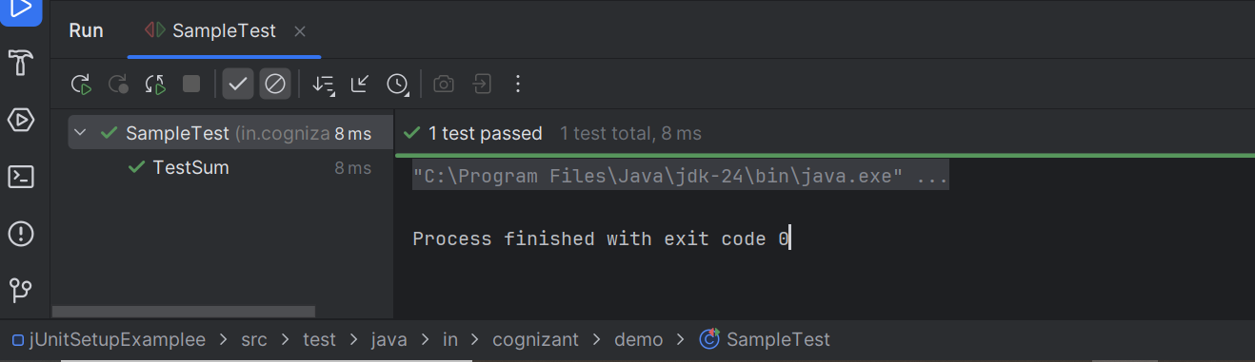

**Exercise 3: Assertions in Junit**

### **Steps Followed:**

1. Create a test class AssertionsTest.java under src/test/java/in/cognizant/demo.
2. Use **JUnit assertions**:
   * assertEquals
   * assertTrue
   * assertFalse
   * assertNull
   * assertNotNull

AssertionsTest.java

package in.cognizant.demo;  
import org.junit.Test;  
import static org.junit.Assert.*;  
  
public class AssertionsTest {  
  
 @Test  
 public void TestAssertions(){  
  
 *assertEquals*(5,2+3);  
  
 *assertTrue*(5 > 3);  
  
 *assertFalse*(5 < 3);  
  
 *assertNull*(null);  
  
 *assertNotNull*(new Object());  
 }  
}

output

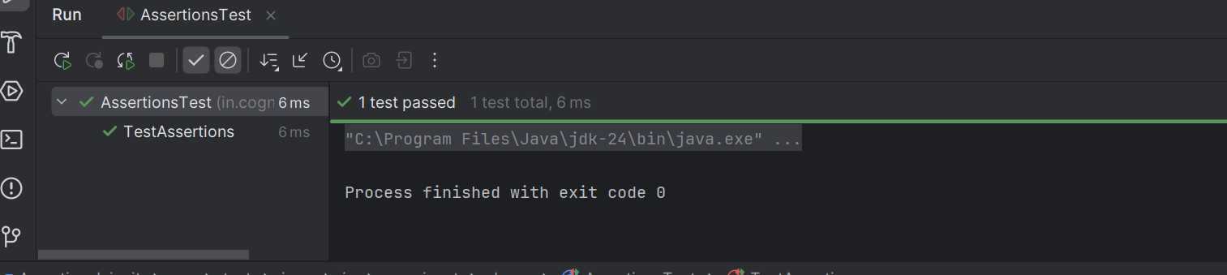

**Exercise 4: Arrange-Act-Assert (AAA) Pattern, Test Fixtures, Setup and Teardown in Junit**

CalculatorTest.java

import org.junit.After;  
import org.junit.Before;  
import org.junit.Test;  
import static org.junit.Assert.*;  
  
public class CalculatorTest {  
 private Calculator calculator;  
  
 @Before  
 public void SetUp(){  
 calculator = new Calculator();  
 System.*out*.println("Setup Complete");  
 }  
  
 @After  
 public void tearDown() {  
 calculator = null;  
 System.*out*.println("Teardown complete");  
 }  
  
 @Test  
 public void testAddition() {  
  
 int a = 5;  
 int b = 3;  
  
 int result = calculator.add(a, b);  
  
 *assertEquals*(8, result);  
 }  
  
 @Test  
 public void testSubtraction() {  
 // Arrange  
 int a = 10;  
 int b = 4;  
  
 // Act  
 int result = calculator.subtract(a, b);  
  
 // Assert  
 *assertEquals*(6, result);  
 }  
}

Calculator.java

public class Calculator {  
  
 public int add(int a, int b) {  
 return a + b;  
 }  
  
 public int subtract(int a, int b) {  
 return a - b;  
 }  
}

output

