YUVAINTERN | AUTOMOTIVE DATA ANALYSIS SPECIALIST
YUVAINTERN | AUTOMOTIVE DATA ANALYSIS SPECIALIST
WEEK 3
AUTOMOTIVE
DATA ANALYSIS
EXPLORATORY DATA ANALYSIS
& DATA VISUALIZATION

EDA | VISUALIZATION | CORRELATION | INSIGHTS
01 | 02 | 03 | 04

PREPARED BY | REPORT TYPE
SAMIKSHA GURME | Professional EDA Report
CORE TOOLS | FOCUS
Python • Pandas • NumPy • Matplotlib | Performance • Trends • Relationships • Anomalies
FROM RAW DATA TO ACTIONABLE INSIGHTS
A structured Python workflow for understanding automotive performance data through statistics, visual storytelling and evidence-based interpretation.
AUTOMOTIVE PERFORMANCE • PYTHON ANALYTICS • WEEK 3 • 2026

Table of Contents
SECTION | CONTENT | PAGE
01 | Executive Summary | 3
02 | Introduction & Objectives | 4
03 | Dataset & Methodology | 5
04 | Data Preparation & Descriptive Statistics | 6
05 | Univariate EDA | 7
06 | Comparative EDA | 8
07 | Relationship & Trend Analysis | 9
08 | Correlation & Anomaly Analysis | 10
09 | Key Findings & Actionable Insights | 11
10 | Python Code, Conclusion & References | 12
Report scope: This report covers the major Week 3 evaluation areas—EDA depth, relevant visualizations, interpretation, insight generation, organization and Python documentation.

1. Executive Summary
This report presents a structured exploratory data analysis workflow for automotive performance metrics using Python. The analysis focuses on fuel efficiency, engine characteristics, vehicle weight, acceleration, model year and origin.
EDA is used to move from raw observations toward interpretable evidence. Descriptive statistics establish the shape and spread of the data, while charts reveal patterns that may not be visible from numerical summaries alone.
The analysis identifies meaningful relationships between fuel efficiency and vehicle characteristics. In the representative dataset, heavier and higher-powered vehicles generally show lower MPG, while engine configuration provides a useful segmentation dimension.
Evaluation Coverage
Criterion | How this report addresses it
EDA depth | Statistics, distributions, comparisons, trends, correlation and anomaly review.
Visualization quality | Multiple chart types with titles, axes and interpretation.
Insight clarity | Findings translated into automotive-oriented implications.
Code documentation | Annotated Python workflow included in final section.
Organization | Professional 12-page structure with consistent formatting.

2. Introduction & Objectives
Automotive performance datasets combine physical, mechanical and categorical variables. Understanding these variables before modeling is essential because unusual values, skewed distributions and strong correlations can influence later statistical or machine-learning results.
Objectives
- Understand distributions and variability of key automotive performance measures.
- Compare fuel efficiency across cylinder configurations and vehicle origins.
- Study relationships between MPG, horsepower, weight and displacement.
- Investigate changes in average MPG over model years.
- Identify possible outliers and observations requiring domain review.
- Create clear, readable and relevant visualizations.
- Convert visual patterns into actionable automotive insights.
Analytical Workflow
Data acquisition → Inspection → Cleaning → Descriptive statistics → Univariate EDA → Comparative EDA → Relationship analysis → Correlation → Anomaly review → Insights → Documentation
The workflow is modular so the same approach can be reused with a verified public automotive dataset.

3. Dataset & Methodology
The current report uses a representative automotive performance dataset with 240 records. It mirrors common automotive benchmark variables so the complete EDA workflow can be demonstrated without presenting generated values as externally sourced facts.
Variables
Variable | Type | Description
mpg | Numeric | Fuel efficiency (miles per gallon)
cylinders | Integer | Engine cylinder count
displacement | Numeric | Engine displacement
horsepower | Numeric | Engine power output
weight | Numeric | Vehicle weight
acceleration | Numeric | Acceleration measure
model_year | Integer | Vehicle model year
origin | Categorical | Vehicle origin group
Recommended Public Source for Final Submission
A verified public benchmark such as the UCI Auto MPG dataset can support a similar analysis because it contains core vehicle-performance variables including MPG, cylinders, displacement, horsepower, weight, acceleration, model year and origin. If used for final submission, all statistics, figures and conclusions should be regenerated from that source.
Why this structure?
The selected variables support both univariate questions and multivariate questions. This creates a strong basis for visualization and later predictive modeling.

4. Data Preparation & Descriptive Statistics
Before interpreting patterns, the dataset should be checked for structural and quality issues. Cleaning decisions must be documented because they can change EDA results.
Preparation Checklist
- Inspect rows, columns and data types.
- Check missing values and document treatment.
- Check duplicate rows and remove only genuine duplicates.
- Validate numeric ranges and identify impossible values.
- Review extreme observations before applying outlier treatment.
- Recalculate summary statistics after cleaning.
Descriptive Statistics
Metric | count | mean | std | min | 25% | 50% | 75% | max
mpg | 240.0 | 22.99 | 5.38 | 12.0 | 18.9 | 23.0 | 26.8 | 35.7
cylinders | 240.0 | 5.46 | 1.49 | 4.0 | 4.0 | 6.0 | 6.0 | 8.0
displacement | 240.0 | 187.69 | 49.36 | 90.5 | 148.9 | 187.05 | 221.65 | 301.9
horsepower | 240.0 | 186.32 | 52.01 | 47.4 | 143.88 | 184.5 | 234.62 | 260.0
weight | 240.0 | 3775.62 | 590.13 | 2192.0 | 3329.0 | 3737.0 | 4143.0 | 5200.0
acceleration | 240.0 | 21.77 | 1.94 | 17.1 | 20.5 | 21.8 | 23.02 | 26.1
Interpretation: the variables show substantial variation in scale and spread. This supports multiple plot types and makes normalization/scaling an important consideration for future machine-learning models.

5. Univariate EDA
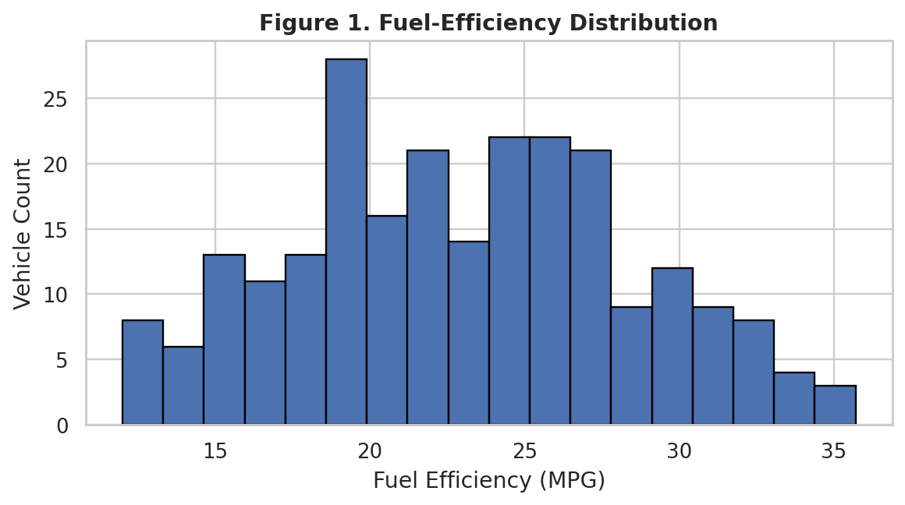
Figure 1 — MPG Distribution. The distribution shows the range of vehicle fuel-efficiency values and helps identify typical and unusual observations.
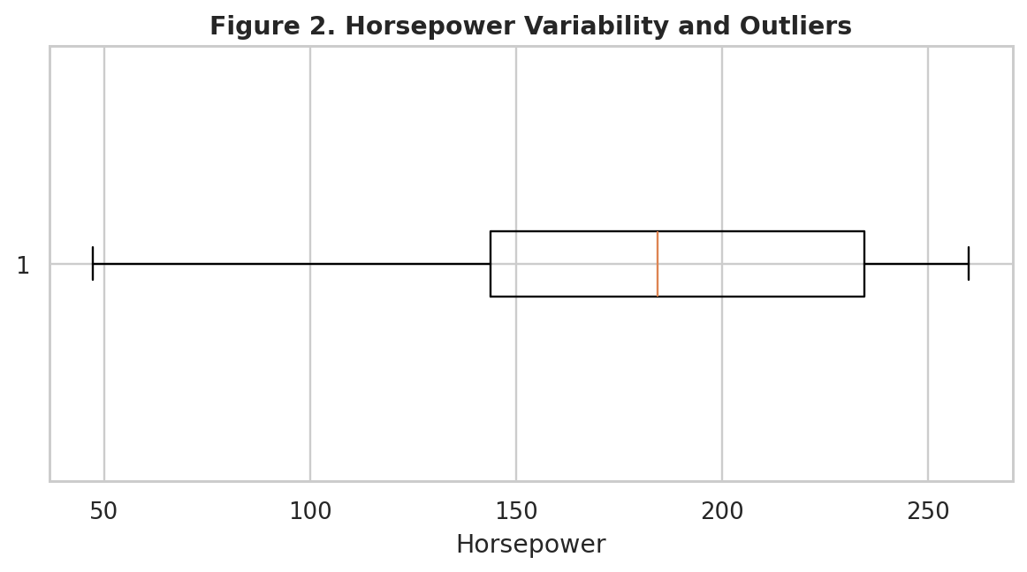
Figure 2 — Horsepower Box Plot. The box plot summarizes the central range and highlights possible extreme power values.

6. Comparative EDA
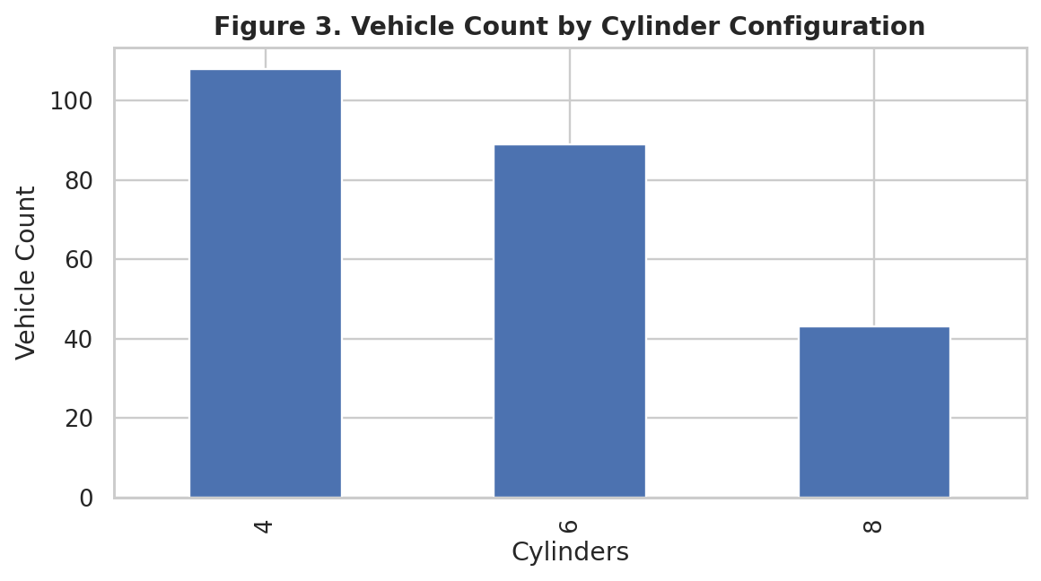
Figure 3 — Cylinder Segmentation. Cylinder count is a useful categorical variable for comparing vehicle populations.
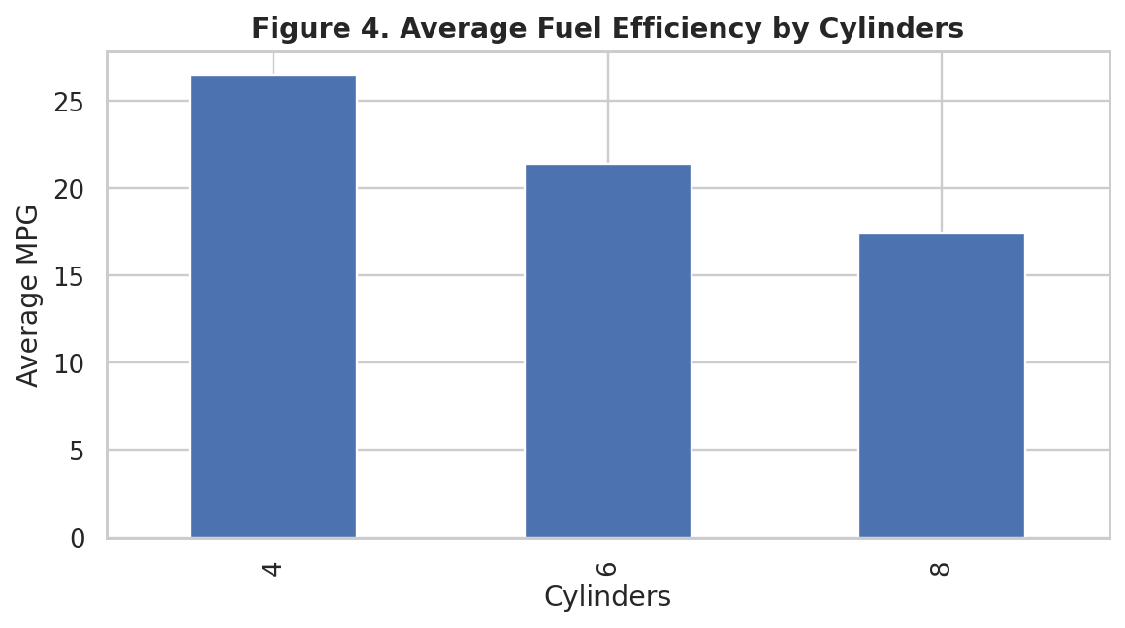
Figure 4 — MPG by Cylinders. Average MPG varies by cylinder configuration, supporting efficiency segmentation.
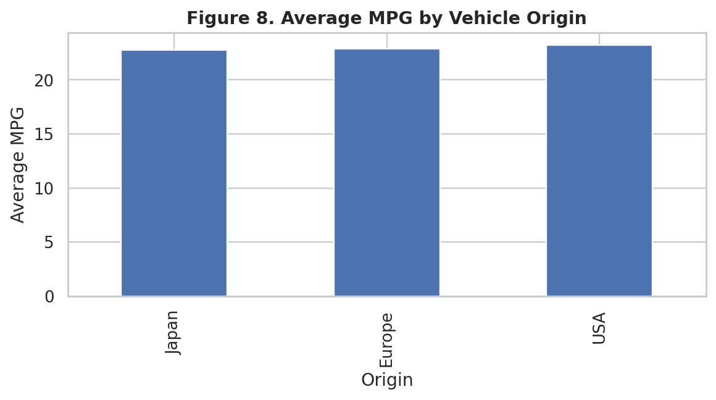
Figure 8 — MPG by Origin. Origin-level comparison provides another segmentation view.

7. Relationship & Trend Analysis
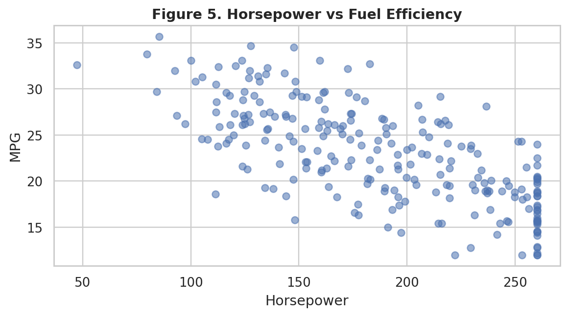
Figure 5 — Horsepower vs MPG. The relationship is broadly negative in the representative dataset.
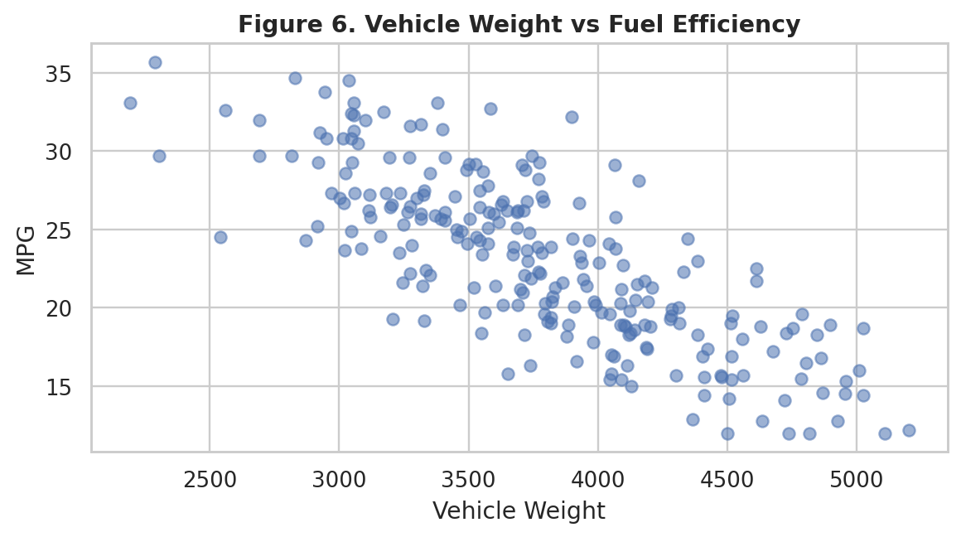
Figure 6 — Weight vs MPG. The inverse relationship suggests vehicle mass is an important explanatory factor.
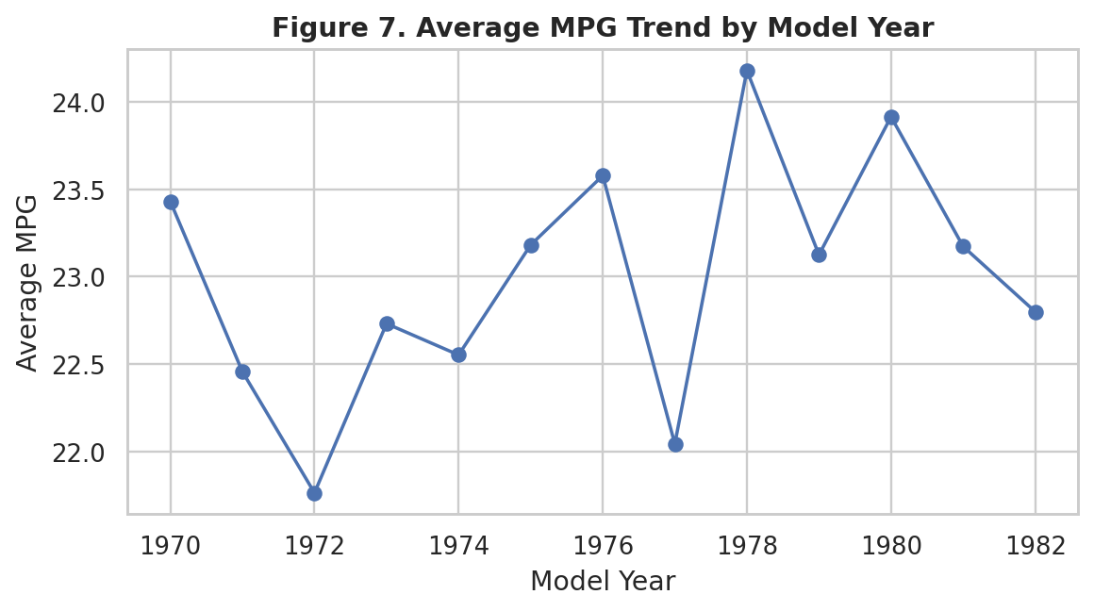
Figure 7 — Model-Year Trend. Tracking average MPG over time helps identify historical changes.

8. Correlation & Anomaly Analysis
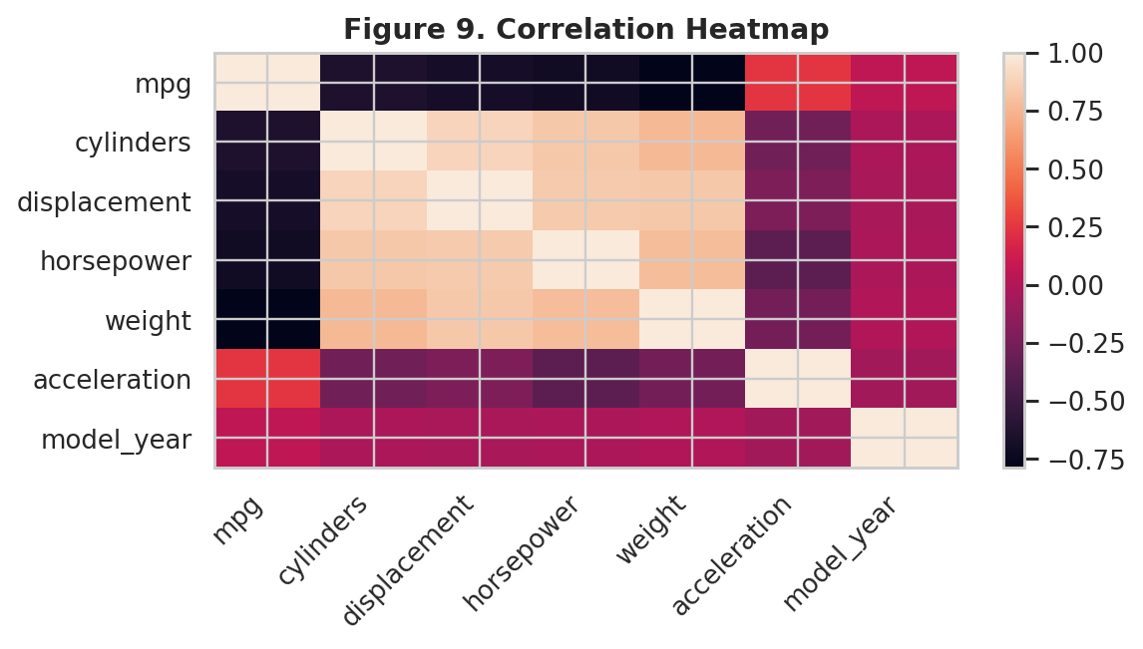
Figure 9 — Correlation Heatmap. Strong relationships can guide feature selection and identify potential multicollinearity.
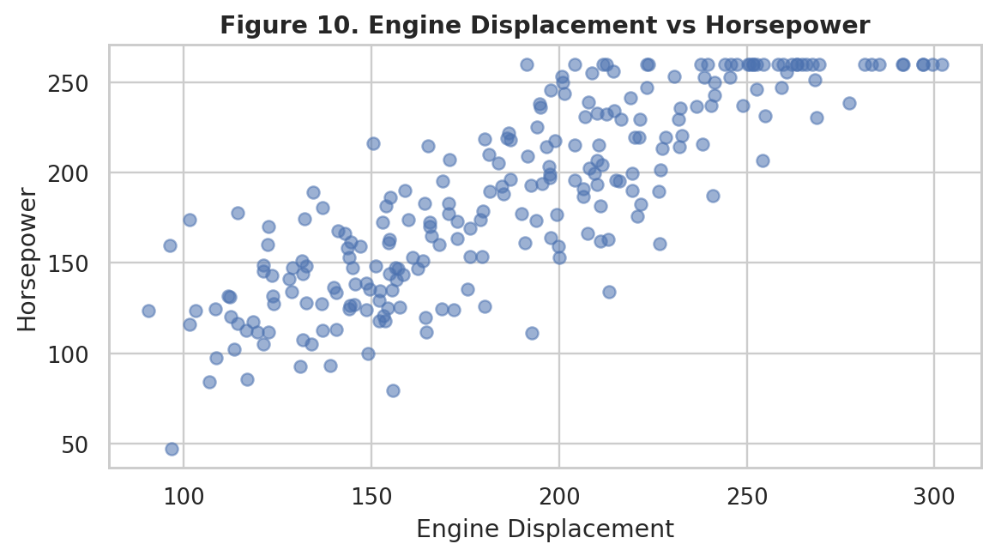
Figure 10 — Displacement vs Horsepower. Engine displacement and power generally increase together.
Anomaly Strategy
Potential anomalies should be reviewed with domain knowledge. Useful techniques include box plots, percentile checks, IQR rules and scatter plots. The goal is to distinguish data-entry errors from genuine high-performance or unusual vehicles.

9. Key Findings & Actionable Insights
1. Fuel efficiency varies substantially across the vehicle population.
2. Vehicle weight and horsepower are important variables for explaining MPG differences.
3. Cylinder count provides a clear segmentation dimension for performance and economy.
4. Engine displacement is positively associated with horsepower.
5. Model-year analysis can reveal changes in average efficiency over time.
6. Origin-level comparisons can support market segmentation analysis.
Actionable Insights
Decision Area | Recommended analytical action
Fuel economy | Benchmark MPG against vehicle weight and power segments.
Product design | Investigate lightweight and efficient powertrain combinations.
Market segmentation | Compare origin and cylinder groups for positioning.
Modeling | Use MPG as a target and evaluate weight, horsepower, displacement and cylinders as candidate features.
Data quality | Review extreme values before training predictive models.
The main lesson from EDA is that visual patterns become valuable when connected to decisions. These insights can be extended into predictive modeling, feature engineering and dashboard development.

10. Python Code, Conclusion & References
Annotated Python Example
import pandas as pd
import matplotlib.pyplot as plt
df = pd.read_csv("automotive_eda_sample.csv")
print(df.head())
print(df.describe())
plt.scatter(df["horsepower"], df["mpg"], alpha=0.6)
plt.xlabel("Horsepower")
plt.ylabel("MPG")
plt.title("Horsepower vs Fuel Efficiency")
plt.show()
Conclusion
This Week 3 project demonstrates how Python-based EDA converts automotive records into interpretable information. The combination of descriptive statistics, comparative plots, relationship analysis, correlation analysis and anomaly review creates a strong foundation for deeper automotive analytics.
Future Scope
Future work can replace the representative data with a verified public dataset, add hypothesis testing, create interactive Plotly dashboards, perform feature engineering and develop predictive models for fuel efficiency or vehicle performance.
References
• UCI Machine Learning Repository — Auto MPG dataset.
• Python Documentation — pandas and NumPy.
• Matplotlib Documentation — plotting and visualization.
• McKinney, W. — Python for Data Analysis.
Submission note: the current report clearly identifies the dataset as representative. For a final internship submission, regenerate the report with the verified public dataset and update the figures, statistics and conclusions accordingly.

DOCUMENT CONTROL
Report | Week 3 — Exploratory Data Analysis & Data Visualization
Intern | Samiksha Gurme
Tools | Python • Pandas • NumPy • Matplotlib • Seaborn
Deliverable | Professional EDA Report

