WEEK 2 TASK
AUTOMOTIVE DATA ACQUISITION
AND CLEANING
Practical Data Preprocessing using Python, Pandas and NumPy

SAMIKSHA GURME
B.E. – Computer Science and Engineering
Artificial Intelligence & Machine Learning
Bheemanna Khandre Institute of Technology, Bhalki

YuvaIntern – Automotive Data Analysis Specialist
Week 2 | September 2026

Executive Summary
This report presents a reproducible data acquisition and cleaning workflow for Indian automotive industry data. The practical dataset combines production, domestic sales and exports across five vehicle categories and six financial years. The workflow preserves raw data, performs structured quality checks, documents cleaning decisions, and produces a separate cleaned CSV for subsequent exploratory data analysis and predictive modelling.
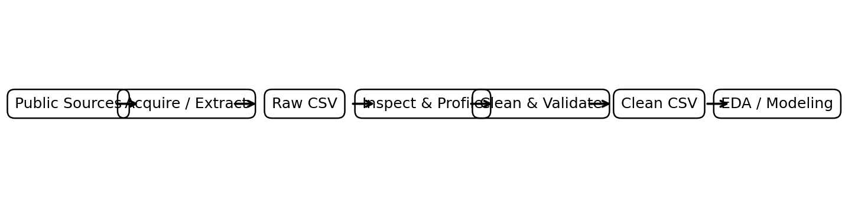
Figure 1. Reproducible automotive data pipeline.

1. Task Objectives
- Identify reliable public automotive data sources and justify their use.
- Acquire and structure automotive data for Python processing.
- Use Pandas and NumPy for inspection, transformation and validation.
- Identify missing, duplicate, inconsistent and logically invalid records.
- Apply transparent cleaning rules without inventing unsupported values.
- Produce a clean, reusable dataset for EDA, visualization and future predictive modelling.

2. Data Sources and Justification
The primary source is the Society of Indian Automobile Manufacturers (SIAM) Industry Trends dataset. It provides production, domestic sales and export statistics by vehicle category and financial year. SIAM's annual reports and statistical services can be used for cross-checking and future expansion. Government EV/Vahan data is an additional source for future electric-mobility analysis.
Source | Main data | Why selected | Role
SIAM – Industry Trends | Production, domestic sales, exports | Official industry-level statistics | Primary
SIAM – Annual Reports | Annual performance and sector context | Official published reports | Validation
SIAM – Statistical Services | Detailed automotive statistics | Official statistical service | Future expansion
Ministry of Heavy Industries / Vahan | EV registrations | Government data | Future EV module

3. Data Acquisition Process
- Source discovery: identify an authoritative public source rather than relying on an unverified third-party dataset.
- Scope definition: select FY2020-21 to FY2025-26 and the major vehicle categories used in the Week 1 project.
- Raw capture: preserve values exactly as acquired before applying transformations.
- Structuring: reshape the information into four consistent fields: Financial_Year, Vehicle_Category, Metric and Units.
- Storage: save the original data as a raw CSV and the processed data as a separate cleaned CSV.
- Traceability: record the source, date/scope and each non-obvious cleaning decision.

4. Python Environment and Libraries
Tool | Role | Practical use
Python | Core programming and automation | Loops, functions, conditions
Pandas | Tabular data handling | DataFrame, read_csv, filtering, grouping
NumPy | Numerical processing | np.nan, numeric conditions, calculations
Matplotlib | Quality and trend visualization | bar, line charts
Seaborn | Future statistical visualization | distributions/correlations
Jupyter Notebook | Interactive reproducible analysis | cells, outputs and documentation

5. Raw Dataset Structure
The working dataset contains 90 records and 4 columns. It represents 3 metrics × 5 vehicle categories × 6 financial years.
Field | Data type | Example | Meaning
Financial_Year | Text | FY2020-21 | Time period
Vehicle_Category | Text | Passenger Vehicles | Automotive segment
Metric | Text | Production | Measure
Units | Numeric | 3062280 | Number of vehicles
Sample raw records:
Financial_Year | Vehicle_Category | Metric | Units
2020-21 | Passenger Vehicles | Production | 3062280
2021-22 | Passenger Vehicles | Production | 3650698
2022-23 | Passenger Vehicles | Production | 4587116
2023-24 | Passenger Vehicles | Production | 4901840
2024-25 | Passenger Vehicles | Production | 5061164
2025-26 | Passenger Vehicles | Production | 5539115
2020-21 | Commercial Vehicles | Production | 624939
2021-22 | Commercial Vehicles | Production | 805527
2022-23 | Commercial Vehicles | Production | 1035626
2023-24 | Commercial Vehicles | Production | 1067504
2024-25 | Commercial Vehicles | Production | 1034947
2025-26 | Commercial Vehicles | Production | 1170150

6. Initial Data Profiling
df = pd.read_csv("automotive_data_raw_week2.csv")
print("Shape:", df.shape)
print(df.head())
print(df.info())
print("\nMissing values:")
print(df.isna().sum())
print("\nDuplicate rows:", df.duplicated().sum())
print("\nNumeric summary:")
print(df["Units"].describe())
Check | Result
Rows | 90
Columns | 4
Missing cells | 0
Exact duplicate rows | 0
Negative unit-count records | 1
Numeric minimum | -12
Numeric maximum | 26691916

7. Cleaning Strategy

7.1 Standardize text
for col in ["Financial_Year", "Vehicle_Category", "Metric"]:
df[col] = df[col].astype(str).str.strip()
df[col] = df[col].str.replace(r"\s+", " ", regex=True)

7.2 Convert numeric fields
df["Units"] = pd.to_numeric(df["Units"], errors="coerce")
This converts valid numeric strings into numbers and changes malformed values to NaN so they can be investigated instead of causing a processing failure.

7.3 Missing values
Missingness is measured before any treatment. The project does not automatically replace unknown values with averages because doing so can introduce artificial automotive volumes. If later modelling requires imputation, the method should be selected according to the variable and documented.
missing_report = df.isna().sum()
print(missing_report)

7.4 Duplicate records
duplicate_count = df.duplicated().sum()
df = df.drop_duplicates()
Result: 0 exact duplicate rows were detected in the working dataset, leaving 0 after the duplicate-removal step.

7.5 Invalid negative value
One negative unit-count observation was detected before cleaning. It is the Quadricycle domestic-sales value of -12 for FY2020-21 in the SIAM table. Because a number of vehicles sold cannot logically be negative, the observation was flagged and converted to NaN. The report does not invent a replacement value.
invalid = df[df["Units"] < 0]
df.loc[df["Units"] < 0, "Units"] = np.nan

7.6 Outlier identification using IQR
q1 = df["Units"].quantile(0.25)
q3 = df["Units"].quantile(0.75)
iqr = q3 - q1
lower = q1 - 1.5 * iqr
upper = q3 + 1.5 * iqr
outliers = df[(df["Units"] < lower) |
(df["Units"] > upper)]
Outlier detection is used as a review mechanism. Automotive data has legitimate scale differences, so a high two-wheeler value should not be deleted merely because it is numerically large.

8. Before vs After Data Quality Results
Quality check | Before | After | Treatment
Missing cells | 0 | 1 | Invalid value converted to NaN
Exact duplicates | 0 | 0 | Duplicate check/removal
Negative unit counts | 1 | 0 | Logical validation
Rows | 90 | 90 | No rows removed solely because of scale
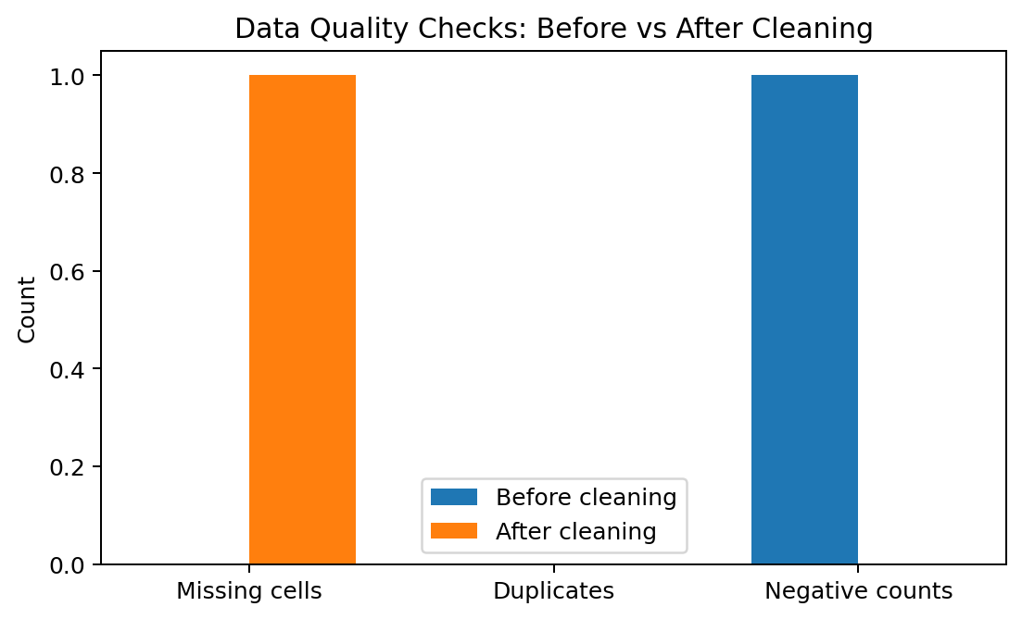
Figure 2. Data-quality checks before and after cleaning.

9. Validation Rules
Field | Rule | Reason
Financial_Year | Must match FY format | Prevents malformed time identifiers
Vehicle_Category | Must be in approved category list | Prevents spelling/category drift
Metric | Must be Production, Domestic Sales or Exports | Keeps measures consistent
Units | Must be numeric | Enables mathematical analysis
Units | Should not be negative | Protects logical validity
Rows | Duplicates should be checked | Prevents double counting
Source fidelity | Original values should be traceable | Supports reproducibility

10. Cleaning Code – Complete Reproducible Version
import pandas as pd
import numpy as np
# Load raw data
df = pd.read_csv("automotive_data_raw_week2.csv")
# Profile
print(df.shape)
print(df.isna().sum())
print(df.duplicated().sum())
# Standardize text
text_cols = ["Financial_Year", "Vehicle_Category", "Metric"]
for col in text_cols:
df[col] = df[col].astype(str).str.strip()
df[col] = df[col].str.replace(r"\s+", " ", regex=True)
# Convert Units to numeric
df["Units"] = pd.to_numeric(df["Units"], errors="coerce")
# Remove exact duplicates
df = df.drop_duplicates()
# Flag impossible negative counts
df.loc[df["Units"] < 0, "Units"] = np.nan
# Final validation
assert df["Units"].dropna().ge(0).all()
assert df.duplicated().sum() == 0
# Save clean data
df.to_csv("automotive_data_cleaned_week2.csv", index=False)

11. Visual Validation and Automotive Insights
Visual checks are useful after cleaning because they help identify unexpected scale changes or category errors. The following figures are validation-oriented; the full trend interpretation will be part of the subsequent EDA stage.
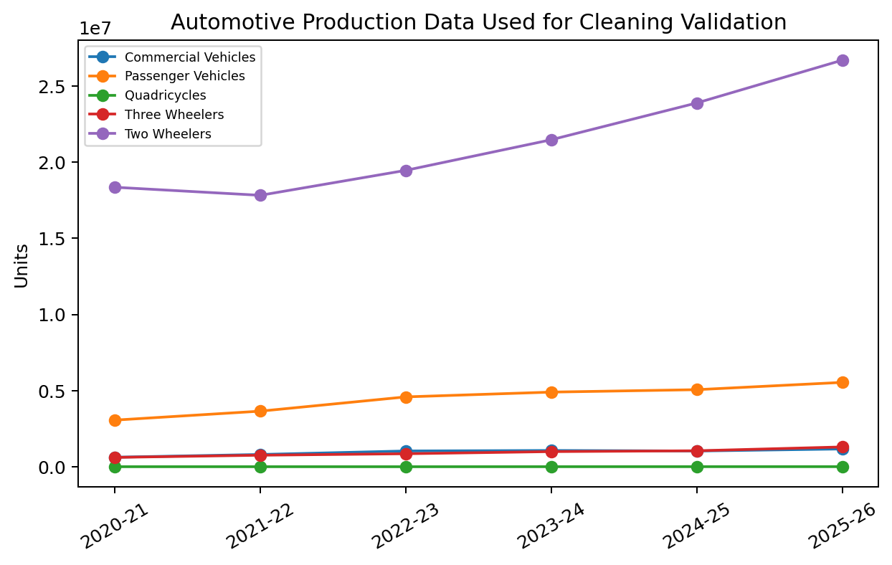
Figure 3. Production values after structuring for analysis.
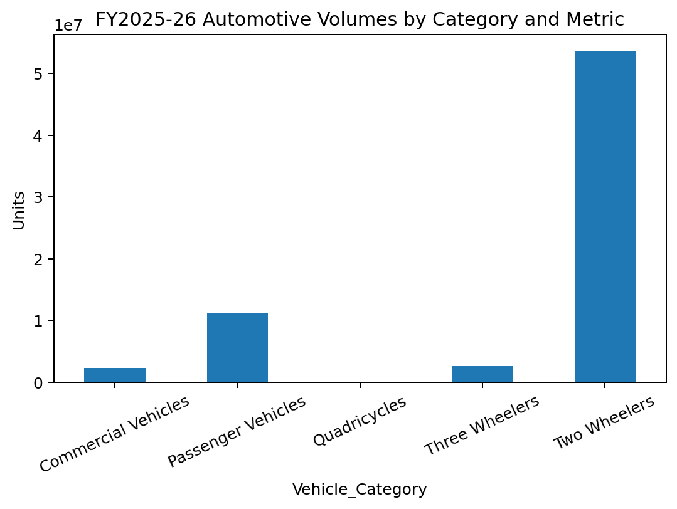
Figure 4. Category/metric scale in FY2025-26.

12. Challenges and Solutions
Challenge | Problem | Solution
Public-source formatting | Official tables may not be immediately analysis-ready. | Convert to a consistent long-format DataFrame.
Invalid value | A negative vehicle-count value appeared in one source cell. | Flag, document and convert to NaN rather than fabricate data.
Scale differences | Two-wheelers have much larger volumes than some other categories. | Analyze by category and use normalized measures when appropriate.
Missing values | Public datasets may have unknown or unavailable observations. | Measure first and avoid unjustified imputation.
Duplicates | Repeated records can inflate totals. | Use duplicated() and drop_duplicates().
Outliers | Large values can be legitimate industry observations. | Validate against source and domain context before removal.
Reproducibility | Manual cleaning is difficult to audit. | Save raw and clean files separately and use executable code.

13. How the Clean Dataset Supports Future Analysis
- EDA: calculate production, domestic-sales and export trends by year and category.
- Growth analysis: calculate year-on-year percentage changes.
- Visualization: create category-wise line charts and comparisons.
- Statistical analysis: investigate distributions and relationships after adding suitable variables.
- Predictive modelling: use the cleaned time-series and additional explanatory variables for forecasting experiments.
- EV expansion: merge compatible government/Vahan EV data with automotive industry indicators after matching time periods and definitions.

14. Key Learning and Insights
- Data cleaning requires domain knowledge; not every unusual number is an error.
- Negative vehicle-count values require validation because they violate the meaning of the measure.
- Missing values should be measured and documented before choosing an imputation strategy.
- Outlier detection should consider vehicle-category scale and industry context.
- Keeping raw and cleaned datasets separate improves reproducibility and auditability.
- Clean, consistently typed data is essential before calculating trends, correlations or predictive models.

15. 30–35 Hour Practical Work Plan
Activity | Hours
Automotive data-source research | 4
Source extraction and raw-data preparation | 5
Python environment and library setup | 3
Initial profiling and data-quality checks | 5
Cleaning, validation and anomaly handling | 8
Visualization and verification | 4
Documentation, screenshots/code and final formatting | 5
Total | 34

16. Deliverables Produced
Deliverable | Format | Purpose
Week 2 report | DOCX | Detailed acquisition, cleaning, validation and future utility
Raw dataset | CSV | Original structured values before cleaning
Cleaned dataset | CSV | Validated dataset for subsequent analysis
Python preprocessing code | Included in DOC | Reproducible cleaning workflow
Quality figures | PNG / embedded | Pipeline and before-after quality validation

17. Conclusion
The Week 2 workflow demonstrates practical data preprocessing rather than only theoretical discussion. Automotive data was structured, inspected, validated and cleaned using Python, Pandas and NumPy. Every important transformation has a documented reason, and the raw dataset is retained separately from the cleaned dataset. This creates a reliable foundation for the next stage of the internship: exploratory data analysis, visualization and eventually predictive modelling.

18. References
- Society of Indian Automobile Manufacturers (SIAM), Industry Trends – Production, Domestic Sales and Exports.
- Society of Indian Automobile Manufacturers (SIAM), Annual Reports.
- Society of Indian Automobile Manufacturers (SIAM), Statistical Services.
- Ministry of Heavy Industries / Vahan – Government electric vehicle registration information.

Appendix A – Recommended Folder Structure
Week_2_Automotive/
│
├── automotive_data_raw_week2.csv
├── automotive_data_cleaned_week2.csv
├── Week_2_Automotive_Data_Acquisition_and_Cleaning.docx
├── figures/
│ ├── data_pipeline.png
│ ├── quality_before_after.png
│ └── validation_charts.png
└── notebooks/
└── automotive_cleaning.ipynb

