WEEK 5 TASK
AUTOMOTIVE DATA SCIENCE
FINAL CAPSTONE REPORT
Performance Evaluation • Optimization • Critical Reflection • Future Roadmap
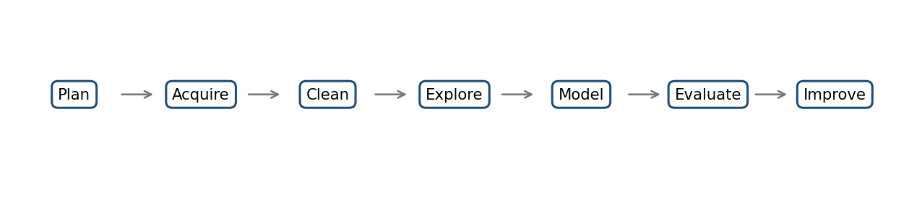
PREPARED BY
SAMIKSHA GURME
Automotive Data Analysis Specialist Internship
YuvaIntern | Week 5

Executive Summary
This capstone connects the five-week automotive data science workflow: strategic planning, data acquisition and cleaning, exploratory data analysis (EDA), predictive modeling, and performance evaluation. It evaluates not only model metrics but also data quality, reproducibility, interpretability, trade-offs, limitations, and practical next steps.
In the recorded Week 4 demonstration, Linear Regression achieved the lowest test RMSE (2.09 MPG) and highest test R² (0.797) among Linear Regression, Random Forest, and Decision Tree models. Important caveat: those results came from synthetic demonstration data, and the earlier EDA sample was also illustrative. These figures demonstrate how to interpret metrics; they do not establish real-world automotive accuracy or market trends.
The central recommendation is to keep a simple baseline, validate the pipeline on a documented public or approved dataset, use leakage-safe cross-validation, analyze subgroup errors, and only adopt more complex models when improvements are repeatable and useful for a defined business decision.

Capstone Objectives
- Evaluate EDA and model performance across the complete analytical lifecycle.
- Explain MAE, RMSE, R², and train–test differences in automotive context.
- Critically discuss methodology strengths, weaknesses, and trade-offs.
- Recommend practical improvements to data quality, features, validation, and modeling.
- Set out limitations and a staged future roadmap.

1. End-to-End Project Synthesis
The project uses a connected lifecycle: define the business question, acquire suitable data, clean and document it, explore patterns, train models, evaluate errors, and improve the process. Each stage depends on the previous one; a sophisticated model cannot repair a poorly defined target or unreliable data.
Figure 1. End-to-end analytical lifecycle.
Week | Focus | Evidence to review | Critical question
1 | Strategic planning and problem definition | Objectives, scope, data-source plan, timeline, risks | Is the question specific, measurable, and useful?
2 | Data acquisition and cleaning | Source details, schema, missing values, duplicates, outliers | Can the data and every transformation be traced?
3 | EDA and visualization | Summary statistics, distributions, relationships, chart interpretations | Are conclusions supported and appropriately cautious?
4 | Predictive modeling | Train/test strategy, candidate models, metrics, diagnostics | Does performance generalize beyond training data?
5 | Evaluation and improvement | Critical review, optimization actions, limitations, roadmap | What is proven, what remains uncertain, and what next?

1.1 Business framing
The demonstration modeling question is: “Can vehicle characteristics help estimate fuel efficiency (MPG) for a vehicle record?” This is a regression task because the target is continuous. In practice, such analysis could support vehicle benchmarking or exploratory engineering analysis, but predictions should not be used for regulatory, safety, or commercial decisions without domain-specific validation.

1.2 Success criteria
- Data provenance, license or access terms, units, schema, and transformations are documented.
- Each EDA chart has a clear question, interpretation, and limitation.
- A simple baseline is included and candidate models are compared fairly.
- The test set is not used for tuning or preprocessing decisions.
- Code, metrics, plots, and written conclusions are reproducible and consistent.

2. EDA Performance Evaluation
EDA helps assess data structure, identify quality problems, generate hypotheses, and choose candidate predictors. It is exploratory—not proof of causation. Since the earlier EDA work used representative sample data, its patterns should be described as method demonstrations unless they are regenerated from the final documented dataset.
EDA activity | Value | Risk or weakness | Recommended improvement
Schema and data types | Prevents invalid calculations and inconsistent variables | Units or categories may be ambiguous | Maintain a data dictionary and automated schema checks.
Missingness review | Shows where observations or fields are incomplete | Missingness may be systematic, not random | Report missingness by feature and relevant subgroup; justify imputation.
Duplicate checks | Prevents repeated records distorting counts or splits | Exact duplicates may not reveal near-duplicates | Define a unique key and log removed records.
Distribution analysis | Reveals skew, unusual ranges, and potential errors | Valid rare cases can look like outliers | Use domain rules; investigate before removing values.
Relationship analysis | Helps identify predictors and redundancy | Correlation does not prove causality | Check nonlinear relationships, confounding, and multicollinearity.
Group/time analysis | Can reveal changes by year, segment, or origin | Small groups can produce unstable conclusions | Show group sizes and use time-aware validation when appropriate.

2.1 Visualization quality checklist
- Use descriptive titles and label axes with units.
- Use consistent scales for comparisons and readable category labels.
- Add captions that explain the pattern, possible business meaning, and caveat.
- Do not infer causality from correlations or a scatterplot alone.
- Regenerate all charts if the dataset changes; do not reuse synthetic-data conclusions as real findings.

2.2 Overall EDA assessment
The EDA phase provides a useful foundation when it combines statistics with well-labeled visualizations and documented cleaning. Its main limitation is representativeness: a synthetic or convenience sample cannot support market-wide claims. The final Week 5 report should include exact statistics and plots from the final Week 3 dataset, with source details and any changes in row count explained.

3. Predictive Model Performance Evaluation
Week 4 compared three regression models on an illustrative synthetic dataset with MPG as the target and vehicle characteristics as predictors. The following values are the recorded demonstration results, not verified real-world automotive benchmarks.
Model | Test MAE (MPG) | Test RMSE (MPG) | Test R² | Train R²
Linear Regression | 1.566 | 2.091 | 0.797 | 0.854
Random Forest Regressor | 1.758 | 2.253 | 0.765 | 0.937
Decision Tree Regressor | 2.163 | 2.575 | 0.693 | 0.901

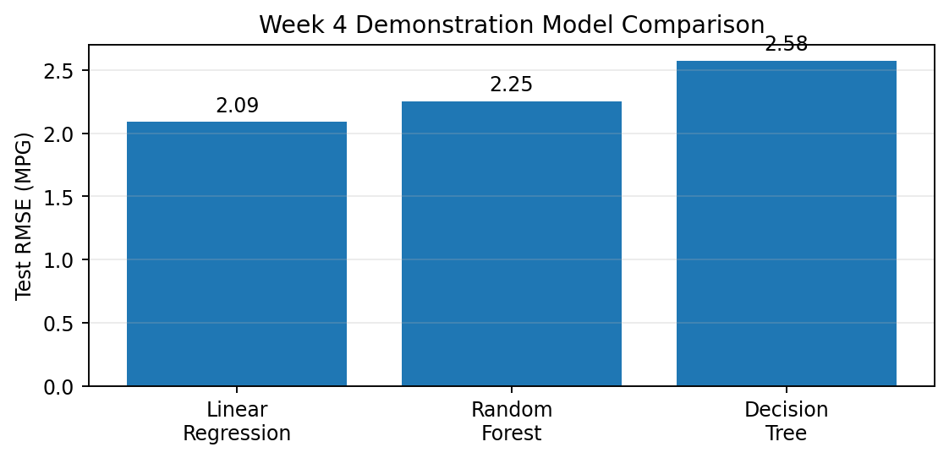
Figure 2. Test RMSE in the demonstration run; lower is better.

3.1 Meaning of the evaluation metrics
Metric | Meaning | Strength | Caution
MAE | Average absolute error in target units (MPG here). | Easy to explain to stakeholders. | Does not emphasize large errors as strongly as RMSE.
RMSE | Square root of mean squared error; large misses are penalized more. | Highlights unusually large prediction errors. | Sensitive to outliers; interpret in target units.
R² | Relative fit versus predicting the evaluation-set mean. | Useful for comparing fits on the same data. | Does not tell whether error is operationally acceptable; can be negative.
Train–test gap | Difference between training and test performance. | Can signal overfitting or distribution mismatch. | Not a diagnosis by itself; confirm with cross-validation and diagnostics.

3.2 Interpretation of recorded results
Linear Regression was strongest on this particular test split: MAE was about 1.57 MPG, RMSE about 2.09 MPG, and R² about 0.797. Random Forest had a training R² of 0.937 compared with a test R² of 0.765, a larger gap consistent with greater fit to the training sample. The Decision Tree had the highest test RMSE of the three. Thus, added model complexity did not improve test performance in this demonstration.
This is not evidence that Linear Regression is always best. Results depend on the data-generating process, sample size, split, random seed, feature quality, and evaluation design. A real model choice should use cross-validation on training data and one untouched test set.

3.3 What the model scores do not establish
- Whether the model works for modern EVs, hybrids, or vehicle classes missing from training.
- Whether errors differ by year, weight range, origin, or powertrain.
- Whether data reflect current driving conditions, regulations, or market composition.
- Whether performance will persist after vehicle designs or data collection change.
- Whether the error is acceptable for a specific stakeholder decision.

4. Critical Reflection Across the Workflow

4.1 Strengths
- The workflow progresses logically from planning to data preparation, EDA, modeling, and review.
- Three model families were compared rather than selecting a model without evidence.
- MAE, RMSE, and R² offer complementary views of predictive performance.
- Visual comparisons improve communication with technical and non-technical readers.
- The synthetic-data caveat is explicit, preventing unsupported claims.

4.2 Weaknesses and refinements
- Verify a public or approved data source and document URL, access date, terms, version, and data dictionary.
- Use consistent dataset versions and target definitions across Weeks 2–4.
- Add a DummyRegressor baseline; machine learning should beat a meaningful reference.
- Use cross-validation within training data; preserve the test set for final evaluation only.
- Audit for leakage, repeated entities across splits, and preprocessing fitted before splitting.
- Add residual plots, subgroup metrics, error examples, and uncertainty estimates.
- Record random seeds, package versions, model settings, and code so results can be reproduced.

4.3 Trade-offs
Choice | Benefit | Cost or risk | Recommended response
Linear vs. complex model | Simple, fast, interpretable baseline | May miss nonlinear effects | Keep baseline; adopt complexity only for validated gains.
Single holdout split | Easy and quick to explain | Scores may vary with split | Use cross-validation, then one untouched test set.
Imputation vs. row deletion | Imputation retains observations | May distort distributions | Compare methods and fit imputers on training data only.
Outlier removal vs. retention | Removing errors can improve quality | May discard valid rare vehicles | Use domain rules and maintain an audit trail.
Synthetic vs. public data | Synthetic data is convenient for code tests | Cannot support real-world claims | Use documented real data for final conclusions.
More features vs. simpler model | May add useful signal | More missingness, leakage, complexity | Add only with domain rationale and validation.

5. Optimization Recommendations
Optimization should start with trustworthy data and sound validation—not blind hyperparameter tuning. Data quality and evaluation design can matter more than switching algorithms.

5.1 Priority 1: Data foundation
- Choose a verifiable dataset aligned with the business question; document source, terms, scope, target, units, and version.
- Build schema checks for numeric ranges, category values, required fields, and units.
- Quantify missingness; compare imputation and exclusion with justified assumptions.
- Audit duplicates and use stable entity identifiers when available.
- Investigate extreme values instead of automatically deleting them.

5.2 Priority 2: Feature engineering
- Use only features available at the time a prediction would be made; exclude target-derived or post-outcome fields.
- Test justified nonlinear terms and interactions, such as weight interacting with engine characteristics.
- Encode categories consistently and fit encoders on training data only.
- Scale numeric features for algorithms that need it; tree models usually do not need the same scaling as linear or distance-based methods.
- If time data exist, evaluate on a later period to simulate future predictions.

5.3 Priority 3: Validation and tuning
- Keep preprocessing and modeling in one scikit-learn Pipeline to reduce leakage risk.
- Compare every candidate with a dummy baseline.
- Use k-fold cross-validation and tune a small, justified set of hyperparameters.
- Use time-based splits for future forecasting and grouped splits for repeated records of the same entity.
- Lock the selected pipeline before evaluating the final holdout test set.

5.4 Priority 4: Better diagnostics
- Report MAE and RMSE in target units alongside R².
- Define an acceptable error threshold with the intended stakeholder.
- Inspect residuals against predictions and important features for systematic bias.
- Compare errors across relevant groups only when subgroup sizes are adequate.
- Consider uncertainty estimates before using predictions in consequential decisions.

5.5 Models worth testing next
Candidate | Reason to test | Caution | Keep only if…
DummyRegressor | Sets a minimum reference level. | Not a production model. | Every candidate improves meaningfully over it.
Ridge / Lasso | Regularization can stabilize correlated predictors. | Scaling and tuning matter. | Cross-validated gains and stable behavior are observed.
Random Forest | Can learn nonlinearities and interactions. | Can overfit; less transparent. | Validation error improves without unacceptable subgroup errors.
Gradient boosting | Often competitive on tabular data. | Requires tuning and explanation. | Gains repeat across validation folds.
Interpretable nonlinear model | Can capture smooth effects while remaining explainable. | Needs diagnostics and careful setup. | Accuracy and interpretability both meet needs.

6. Implementation Plan and Future Roadmap
Stage | Action | Deliverable | Exit criterion
1. Verify | Confirm dataset source, terms, schema, units, and scope. | Data card and versioned source file. | Another analyst can identify the same data and definitions.
2. Rebuild EDA | Regenerate cleaning, statistics, and charts. | Reproducible EDA script/notebook. | Figures regenerate from the pipeline.
3. Baseline | Run DummyRegressor and reproduce Linear Regression. | Baseline metric table. | Repeat runs produce consistent results.
4. Validate | Run cross-validation and tune justified candidates. | CV results and selected pipeline. | Selection uses training data only.
5. Final test | Evaluate locked model on untouched holdout. | Metrics and residual diagnostics. | MAE, RMSE, R², and caveats are reported.
6. Business review | Discuss errors and tolerance with intended users. | Decision note. | Model links to a clear decision and error cost.
7. Monitor | Track drift and future performance if deployed. | Monitoring checklist. | Owner and review triggers are defined.

6.1 Suggested repository structure
- README.md: problem, data source, setup, run instructions, metrics, limitations.
- data/README.md: source and access instructions; never upload restricted data.
- src/ or notebooks/: reproducible cleaning, EDA, and modeling workflow.
- reports/: final Word report and generated figures.
- requirements.txt: package dependencies and versions.
- results/: model comparison CSV and outputs with run details.
- Clearly label synthetic examples and separate them from verified public-data results.

7. Limitations and Risk Register
Limitation / risk | Potential impact | Mitigation
Synthetic demonstration data | Cannot support real-market claims or real-world accuracy. | Replace with verified data; clearly label demo metrics.
External validity not established | May fail on other years, regions, classes, or powertrains. | Use representative holdout data and subgroup analysis.
Small sample / split sensitivity | Metrics may be unstable. | Cross-validation, repeated seeds, adequate test size.
Correlated predictors | Unstable coefficients and difficult interpretation. | Inspect correlation; consider regularization; avoid causal claims.
Missing or inconsistent values | Bias and reduced coverage. | Document missingness, units, and transformation choices.
Data leakage | Scores look better than real performance. | Split first; fit transformations on training data only.
Model drift | Accuracy can deteriorate as vehicles or markets change. | Monitor input and error drift; define retraining review.
Unclear decision threshold | Good metrics may not be useful operationally. | Agree acceptable error and error costs with stakeholders.

7.1 Responsible use
Predictions should support, not replace, engineering, regulatory, or safety judgment. State the intended use, exclusions, and uncertainty. Do not present associations as causes. Any future customer, location, or connected-vehicle data requires privacy, data minimization, and access-term review.

8. Critical Reflection and Lessons Learned
The main lesson is that a credible data science result is more than a high score. Metrics become meaningful only when the target is clear, data represent the intended use, validation prevents leakage, and results are reproducible. A straightforward model that performs consistently and is easy to explain may be preferable to a complex model with a small or unstable improvement.
EDA should narrow questions and expose data issues; modeling should quantify predictive usefulness; diagnostics should reveal where predictions fail; and the roadmap should turn those failures into specific experiments. A professional report makes uncertainty visible rather than hiding it.

8.1 Final submission audit
- Dataset provenance, access terms, units, target, and row count are verified.
- Report metrics match the code outputs exactly.
- Charts have titles, units, captions, and interpretations.
- Test data were not used for preprocessing fit, feature selection, or tuning.
- A baseline and fair model comparison are included.
- Synthetic-data limitations are prominent if real data have not replaced the demo.
- The Word file opens correctly, with no intentionally inserted blank pages or oversized spacer gaps.
- The repository includes only shareable files and runnable instructions.

9. Conclusion
This Week 5 capstone integrates planning, data preparation, EDA, predictive modeling, evaluation, and continuous improvement into one analytical narrative. The Week 4 demonstration shows how MAE, RMSE, R², and train–test differences can guide model comparison, but its synthetic data means the scores are illustrative rather than real-world evidence.
The strongest next step is to rerun the workflow on a verified, documented dataset and update every chart, table, and conclusion from that run. Prioritize reliable data and leakage-safe validation, retain an interpretable baseline, adopt more complex methods only when gains repeat, and evaluate model errors in the context of an actual automotive decision.

Appendix A. Metric formulas
Let yᵢ be the observed value, ŷᵢ the predicted value, ȳ the observed mean, and n the number of evaluated observations.
Metric | Formula | Meaning
MAE | (1/n) Σ |yᵢ − ŷᵢ| | Average absolute error in target units.
RMSE | √[(1/n) Σ (yᵢ − ŷᵢ)²] | Penalizes large errors more heavily.
R² | 1 − Σ(yᵢ − ŷᵢ)² / Σ(yᵢ − ȳ)² | Relative fit versus mean prediction; can be negative on test data.

Appendix B. Reproducibility checklist
- Record Python and library versions and random seeds.
- Save the split strategy and any time/entity boundaries.
- Use one preprocessing-and-model pipeline.
- Save parameters, metrics, and plots with run details.
- Run the workflow from a clean environment before submitting.

References and Further Reading
scikit-learn, Model evaluation: https://scikit-learn.org/stable/modules/model_evaluation.html
scikit-learn, Cross-validation: https://scikit-learn.org/stable/modules/cross_validation.html
scikit-learn, Pipelines and composite estimators: https://scikit-learn.org/stable/modules/compose.html
scikit-learn, Common pitfalls and data leakage: https://scikit-learn.org/stable/common_pitfalls.html
pandas documentation: https://pandas.pydata.org/docs/
Matplotlib documentation: https://matplotlib.org/stable/
UCI Machine Learning Repository, Auto MPG (potential public dataset for MPG replication; verify current metadata and terms): https://archive.ics.uci.edu/dataset/9/auto+mpg
Data integrity note: The Week 4 numerical metrics shown in this report are from the recorded synthetic demonstration run. Replace them with newly computed values if the final submission uses a verified public dataset.

