Movie Recommendation System

Project Report

**1. Introduction**

**1.1 Project Overview**

The Movie Recommendation System aims to suggest movies to users based on their input. By leveraging machine learning techniques, this system provides personalized movie recommendations to enhance the user experience.

**1.2 Objectives**

To build a recommendation system that suggests movies based on a given movie title.

To implement a user-friendly interface for seamless interaction.

To present recommendations in a clear and professional format.

**2. Literature Review**

**2.1 Recommendation Systems**

Recommendation systems are widely used to provide personalized suggestions to users. They use various algorithms and data sources to predict and recommend items of interest.

**2.2 Techniques Used**

Content-Based Filtering: Uses features of items (e.g., movie genre) to recommend similar items.

Collaborative Filtering: Leverages user interactions to suggest items based on the behavior of similar users.

Hybrid Methods: Combine multiple techniques to enhance recommendation accuracy.

**3. System Design**

**3.1 Architecture**

The system is designed to include:

Data Preprocessing: Handling and cleaning movie data.

Feature Extraction: Identifying key features for recommendations.

Recommendation Algorithm: Using K-Nearest Neighbors (KNN) for similarity-based recommendations.

User Interface: A Gradio-based web interface for user interaction.

**3.2 Tools and Technologies**

Programming Languages: Python

Libraries: Pandas, Scikit-learn, Gradio

Data Sources: Movie dataset (movies.csv, ratings.csv)

Development Environment: Jupyter Notebook, Anaconda

**4. Implementation**

**4.1 Data Preparation**

Data Loading: Importing movie and rating data from CSV files.

Data Cleaning: Removing unnecessary columns and handling missing values.

Feature Engineering: Creating features for movie recommendations.

**4.2 Recommendation Algorithm**

K-Nearest Neighbors (KNN): Utilized to find similar movies based on user input.

Distance Calculation: Measures similarity between movies to suggest the most relevant ones.

**4.3 User Interface**

Gradio Integration: Provides a web-based interface for users to input movie titles and receive recommendations.

Output Formatting: Recommendations are displayed in a well-aligned table format.

**5. Results and Evaluation**

**5.1 Evaluation Metrics**

Accuracy: Measures how well the recommendations match user preferences.

User Feedback: Collected feedback on the relevance and quality of recommendations.

**5.2 Results**

Sample Recommendations: Provided recommendations based on user input.

Interface Usability: Ensured that the interface is user-friendly and displays results effectively.

**6. Conclusion**

**6.1 Summary**

The Movie Recommendation System successfully provides movie suggestions based on user input. It utilizes KNN for similarity-based recommendations and features a Gradio-based interface for ease of use.

**6.2 Future Work**

Enhanced Algorithms: Explore additional recommendation algorithms for improved accuracy.

User Personalization: Implement user profiles to tailor recommendations further.

Scalability: Optimize the system to handle larger datasets and user queries.

**7. References**

Websites:

Gradio Documentation

Scikit-learn Documentation

**8 Sample Outputs**

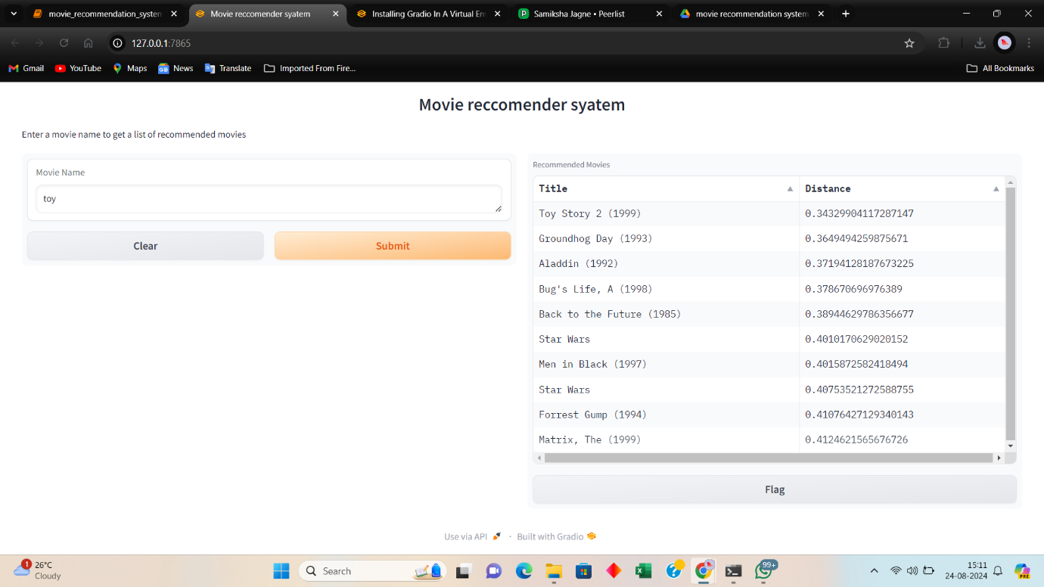Project Owner : Samiksha Jagne

[Portfolio](https://peerlist.io/samiksha_jagne)

[contact me](mailto:samikshajagne2@gmail.com)

[LinkedIn profile](https://www.linkedin.com/in/samiksha-jagne/)