### **Pizza Place Sales Analysis Using Excel**

### **Problems and background**

### **Problem:**

### The problem here is pizza shop faces challenges in optimizing menu offerings and driving profitability. Underperforming pizzas and a lack of targeted promotions hinder revenue growth and customer satisfaction.

### **Background:**

### To address these challenges, this project focuses on leveraging data-driven insights to refine our menu and craft strategic promotions. By analysing sales data and customer feedback, we aim to identify opportunities for improvement and enhance our competitive position in the market.

### **Solution**

**Data Analysis**:

Through comprehensive data analysis, we meticulously examine sales data, customer feedback, and profitability metrics. By leveraging Excel tools and techniques, we dissect sales trends, identify top-selling pizzas, and pinpoint underperforming menu items. Additionally, we delve into customer feedback to understand preferences, satisfaction levels, and areas for improvement. This rigorous analysis allows us to gain a deep understanding of our pizza shop's performance and identify key areas of focus.

**Data-Driven Insights:**

Armed with our data-driven insights, we uncover actionable recommendations to optimize menu offerings and drive profitability. By identifying bestsellers and analyzing profitability metrics, we strategically streamline our menu to feature top-performing pizzas while phasing out underperforming ones. Moreover, our analysis of customer feedback enables us to tailor promotions and offerings to meet customer preferences, enhancing overall satisfaction and loyalty. These insights empower us to make informed decisions that drive tangible results and position our pizza shop for sustained success.

**Stakeholder Engagement:**

Engaging stakeholders throughout the project is critical to ensuring buy-in and successful implementation of our recommendations. We present our findings and recommendations in a clear and compelling manner, highlighting the data-driven rationale behind each decision. By fostering open communication and collaboration with key stakeholders, including management, staff, and customers, we create a shared vision for the future of our pizza shop. This collaborative approach fosters alignment and empowers stakeholders to actively contribute to the success of our initiatives

### **Project scope**

**Scope:**

The objective of this project is to optimize menu offerings and identify strategic promotional opportunities for our pizza shop, ultimately driving profitability and enhancing customer satisfaction. Through rigorous data analysis and stakeholder engagement, we aim to streamline our menu, craft targeted promotions, and foster a culture of continuous improvement.

Step-by-Step Process:

Data Collection (Week 1-2): Gather sales data, customer feedback, and profitability metrics from the past year to inform our analysis.

Data Analysis (Week 3-4): Utilize Excel tools and techniques to analyze sales trends, identify top-selling pizzas, and pinpoint underperforming menu items. Concurrently, analyze customer feedback to understand preferences and areas for improvement.

Data-Driven Insights (Week 5-6): Translate our analysis into actionable insights. Identify bestsellers and opportunities for menu optimization. Craft targeted promotions tailored to customer preferences and profitability metrics.

Stakeholder Engagement (Week 7-8): Present our findings and recommendations to key stakeholders, including management, staff, and customers. Foster open communication and collaboration to ensure buy-in and alignment with project goals.

Implementation (Week 9-10): Execute recommendations, including menu adjustments and promotional campaigns. Monitor performance and gather feedback to iterate and refine strategies as needed.

Evaluation (Week 11-12): Assess the impact of implemented initiatives on sales revenue, customer satisfaction, and profitability. Identify lessons learned and areas for further improvement.

**If the problem statement is directly pointing to the business:**

This project focuses on analysing and optimizing the five key marketing domains - Product, Price, Promotion, Place, and People - within our business to ensure a seamless flow and maximize overall performance. Through systematic evaluation and strategic initiatives, we aim to enhance customer satisfaction, drive sales, and achieve sustainable growth in the competitive market.

**For Others:**

This project's insights and recommendations can be utilized across various departments and functions within the organization to make processes better and more effective, ultimately reducing the impact caused by the identified problem. Here's how:

Marketing Department: The analysis and optimization of the five marketing domains provide valuable insights for the marketing team to refine strategies and campaigns. By understanding customer preferences, optimizing pricing strategies, and enhancing promotional efforts, the marketing department can effectively target and engage with customers, driving sales and brand loyalty.

Operations and Supply Chain: Insights gained from evaluating distribution channels and product availability (Place domain) can inform supply chain and operations management. By optimizing distribution networks and improving inventory management processes, the organization can ensure timely delivery of products to customers, enhancing overall efficiency and customer satisfaction.

Sales and Customer Service: Evaluating the effectiveness of sales and customer service teams (People domain) allows for targeted training and development initiatives to enhance customer interactions. By equipping staff with the skills and knowledge to deliver exceptional service, the organization can improve customer retention and loyalty, ultimately driving long-term success.

Product Development: Analysis of the Product domain provides insights into product offerings, quality, and innovation opportunities. Product development teams can use this information to tailor new offerings to meet customer needs and differentiate from competitors, driving market penetration and revenue growth.

Strategic Planning: The project's strategic insights can inform overall organizational planning and decision-making. By aligning marketing strategies with broader business objectives and market trends, leadership can steer the organization towards sustained growth and success while mitigating the impact of potential challenges.

### **Stakeholders Summary:**

### Stakeholders in this project include management, the marketing department, sales and customer service teams, operations and supply chain staff, customers, and external partners. Each stakeholder group plays a vital role in addressing the identified problem and implementing solutions. Management provides strategic direction and support, while the marketing department drives marketing strategies and initiatives. Sales and customer service teams offer frontline insights, and operations and supply chain staff ensure smooth product flow. Customers' needs and preferences guide decision-making, and external partners contribute to project execution. Collaboration among stakeholders is essential for achieving project objectives and improving overall effectiveness.

### **Methodology**

### **Data Sources:**

### **SQL:** SQL databases serve as a primary data source, containing structured data such as sales records, customer information, and product details. Through SQL queries, we extract relevant datasets for analysis, including transactional data, customer demographics, and product attributes.

### **AWS**: Amazon Web Services (AWS) provides additional data sources, such as cloud-based databases or data lakes. These sources may include real-time data streams, customer interactions from web applications, or logs from operational systems. Utilizing AWS services allows for scalability, flexibility, and accessibility of data for analysis.

### **Data** Scraping: Data scraping techniques may be employed to gather data from external sources, such as competitor websites, social media platforms, or online reviews. Scraped data can provide insights into market trends, competitor strategies, and customer sentiment, complementing internal datasets.

### **Local Data Sources**: Local data sources encompass any internal systems or files that store relevant data, such as Excel spreadsheets, CSV files, or proprietary databases. These sources may contain supplementary information, such as promotional campaign data, customer feedback surveys, or product inventory records.

### **Data Wrangling:**

### **Data Understanding**: In this phase, we explore and assess the quality, structure, and relevance of the data from various sources. We identify key variables, understand data distributions, and document any anomalies or inconsistencies.

### **Data Cleaning**: Data cleaning involves pre-processing raw data to address issues such as missing values, outliers, or formatting errors. Techniques such as imputation, outlier detection, and standardization are applied to ensure data integrity and consistency.

### **Data Merging and Joining:** Data from different sources are integrated through merging and joining operations. Common identifiers, such as customer IDs or product codes, are used to combine datasets and create a unified view of the data for analysis.

### **Data Manipulation**: Data manipulation techniques are applied to transform and reshape the data as needed for analysis. This may involve aggregating data, creating new variables, or filtering observations based on specific criteria. The goal is to prepare the data for analysis and extract meaningful insights.

### **Data Analysis:**

### **Finding Trends and Patterns**: Using statistical analysis and machine learning algorithms, we uncover trends, patterns, and relationships within the data. This includes identifying sales trends over time, customer segmentation based on purchasing behaviour, or correlations between marketing initiatives and sales performance.

### **Data Visualization:**

### Data visualization techniques are employed to communicate insights and findings effectively. Charts, graphs, and dashboards are created to visually represent trends, patterns, and relationships discovered during the analysis phase. Visualizations enhance understanding, facilitate decision-making, and enable stakeholders to derive actionable insights from the data.

### **Goals and KPIs (3 - 4 Max)**

To measure the success of our project, we will establish key performance indicators (KPIs) aligned with our project goals. Here are the goals and corresponding KPIs:

* **Goal 1:** KPI -----> Achieve sales revenue of 6.5 Crores or more within the specified timeframe
* **Goal 2:** KPI -----> Attain a YOY growth rate of 10.5% or higher compared to the previous year's sales revenue.
* **Goal 3:** KPI -----> Increase customer retention rate to 50% or more, indicating improved customer loyalty and repeat business.

### **Technical Processes**

**VLOOKUP:** Relevance to Project: VLOOKUP is used in Excel to search for a value in the first column of a range and return a corresponding value from a different column. In our project, we might use VLOOKUP to match pizza IDs from the "Orders" dataset with pizza names and prices from the "Pizza Types" dataset. This allows us to calculate total revenue for each order by multiplying the quantity ordered with the respective pizza's price.

**Pandas Data Cleaning:** Relevance to Project: Pandas is a Python library commonly used for data manipulation and analysis. Data cleaning techniques taught in the module, such as handling missing values, removing duplicates, and standardizing data formats, are essential for preparing datasets for analysis. In our project, we would use Pandas to clean the raw data extracted from SQL databases, AWS, or local sources before performing further analysis.

**Schema Creation for Database**: Relevance to Project: Schema creation involves defining the structure of a database, including tables, columns, data types, and relationships between tables. In our project, we might design a schema for a SQL database to store information such as customer details, pizza orders, and sales transactions. The schema ensures data consistency and integrity, facilitating efficient data storage and retrieval for analysis.

**Business Concepts Used**

### **Market Understanding:**

### Use: We have conducted market analysis to gain insights into the pizza industry, including market trends, competitor strategies, and consumer preferences. By understanding the market dynamics, we can tailor our menu offerings and promotional strategies to better meet customer needs and stay ahead of competitors.

### **Customer Demographic:**

### Use: We have segmented our customer base based on demographic factors such as age, gender, income level, and location. This segmentation allows us to target specific customer groups with personalized marketing messages and offerings. For example, we may offer family meal deals to households with children or premium pizza options to higher-income customers.

### **Customer Behavior:**

### Use: We have analyzed customer behavior, including purchasing patterns, frequency of visits, and preferred pizza toppings. This analysis helps us understand customer preferences and identify opportunities to upsell or cross-sell additional products. For instance, if we notice that customers often order garlic bread with their pizzas, we may bundle these items together in a promotional offer to increase sales.

### **Customer Retention:**

### Use: We have implemented strategies to improve customer retention, such as loyalty programs, personalized discounts, and exceptional customer service. By focusing on retaining existing customers, we can build long-term relationships and maximize customer lifetime value. For example, we may offer a loyalty card program where customers earn points for every purchase, leading to rewards such as free pizzas or discounts on future orders.

### **New Customer Acquisition:**

### Use: We have implemented tactics to attract new customers, such as targeted advertising campaigns, referral programs, and special promotions for first-time buyers. By expanding our customer base, we can increase sales and grow our business. For instance, we may offer a "refer a friend" program where existing customers receive a discount on their next order for referring a new customer to our pizza shop.

### **Recommended Analysis:**

**Question 1:** How many customers do we have each day? Are there any peak hours?

This analysis aims to quantify daily customer traffic and identify peak hours of activity at our pizza shop. By understanding customer visit patterns, we can optimize staffing levels, inventory management, and promotional activities to better serve our customers during busy periods.

**Question 2**: How many pizzas are typically in an order? Do we have any bestsellers?

This analysis focuses on determining the average number of pizzas per order and identifying best-selling pizzas. By analyzing order composition and sales data, we can optimize menu offerings, pricing strategies, and promotional activities to maximize sales and customer satisfaction.

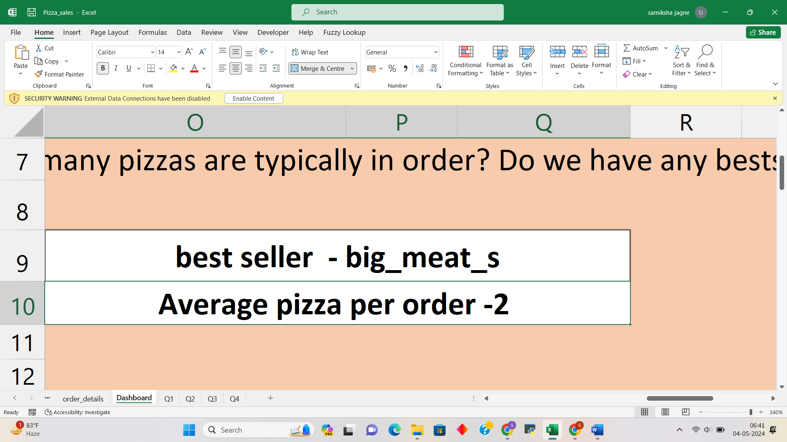

**Question 3:** How much money did we make this year? Can we identify any seasonality in the sales?

This analysis involves calculating total revenue for the year and identifying any seasonal trends or patterns in sales. By understanding sales fluctuations throughout the year, we can adjust marketing strategies, inventory levels, and staffing accordingly to capitalize on peak seasons and mitigate slowdowns.

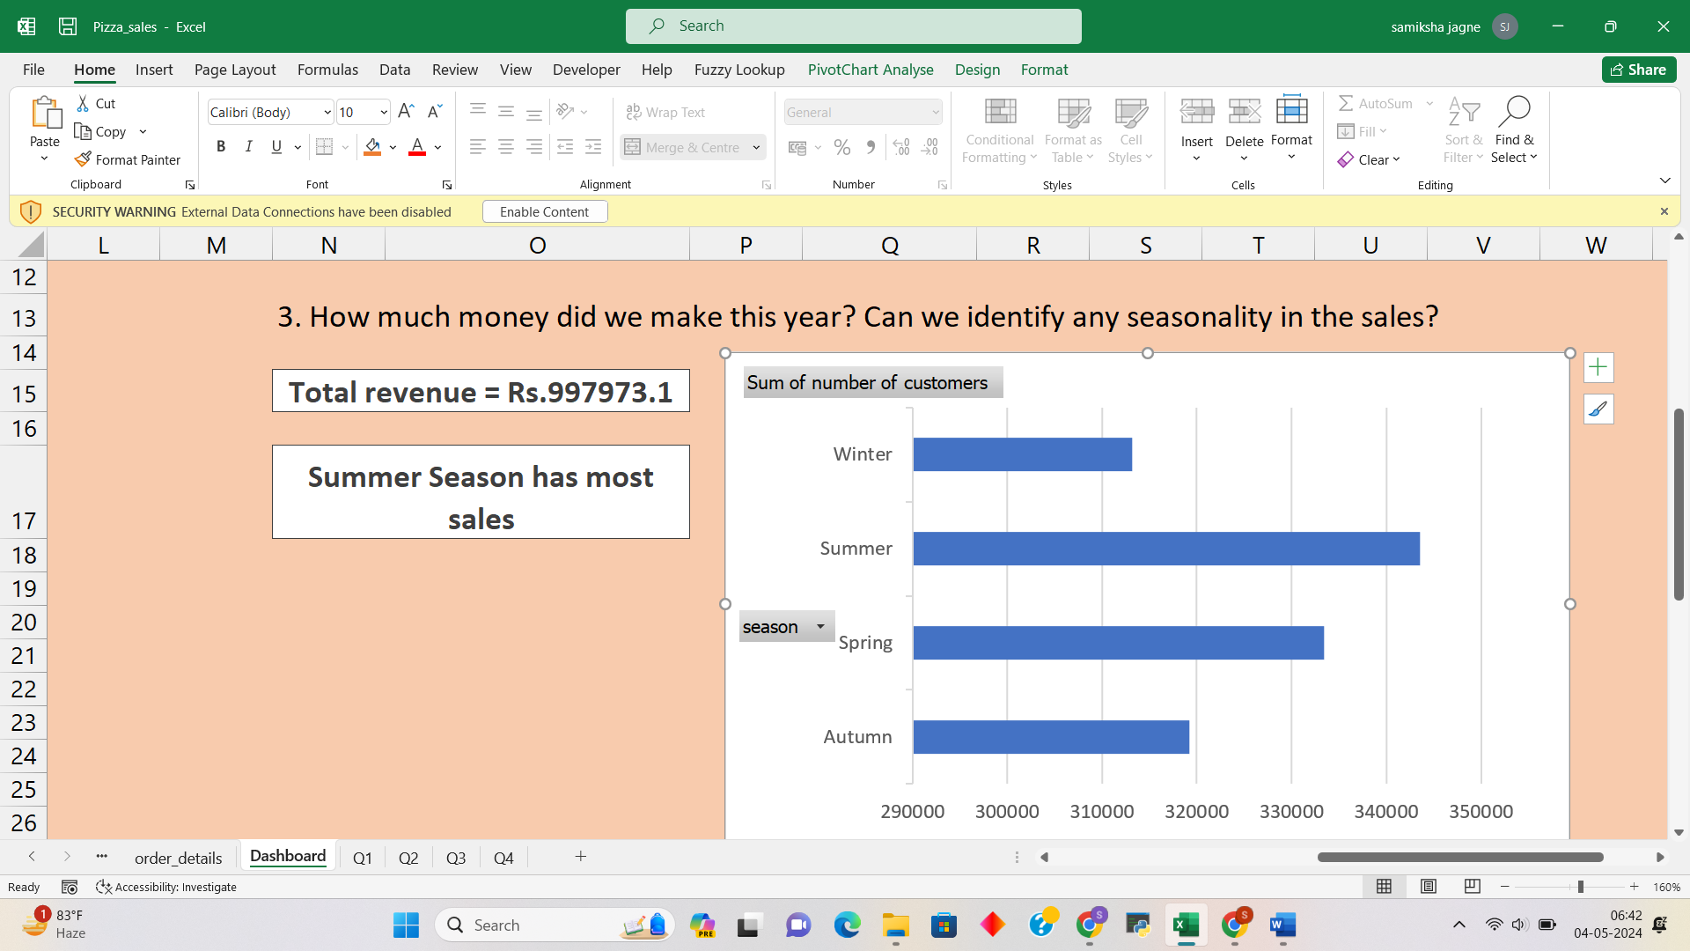

**Question 4:** Are there any pizzas we should take off the menu, or any promotions we could leverage?

This analysis evaluates the performance of individual pizzas and promotional activities to identify opportunities for optimization. By assessing sales data, customer feedback, and profitability metrics, we can determine which pizzas to remove from the menu and which promotions to leverage to drive sales and customer satisfaction.

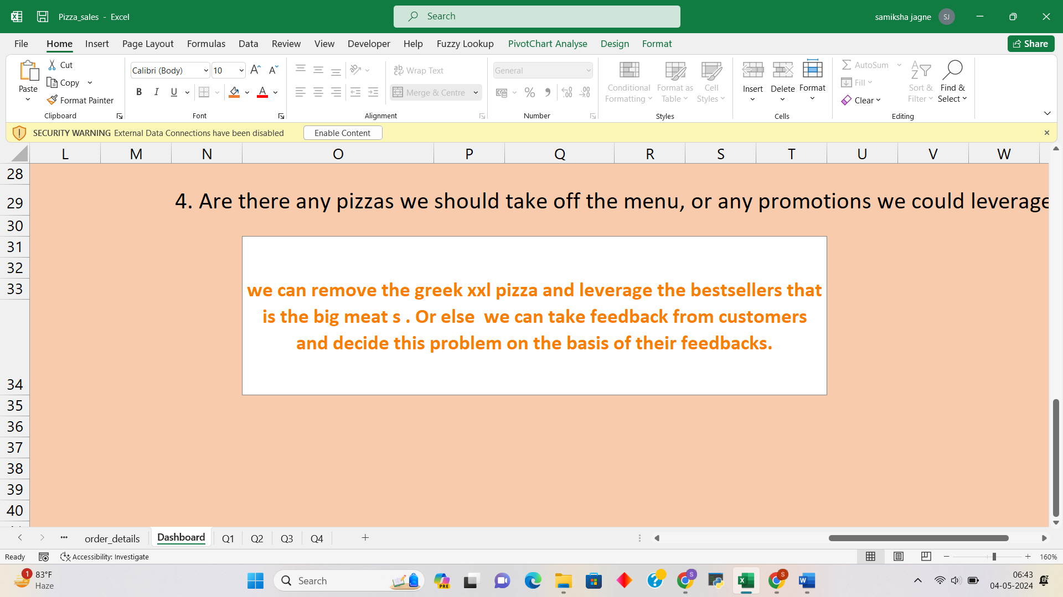

**Process of Working on the Recommended Analysis (Data to Output):**

**Data Collection:** Gather relevant data sources, including sales records, customer transactions, and promotional data.

**Data Cleaning and Preparation:** Cleanse the data to remove duplicates, handle missing values, and standardize formats. Prepare the data for analysis by structuring it into a format suitable for processing.

**Data Analysis**: Apply analytical techniques to answer each question, such as calculating daily customer counts, average pizzas per order, total revenue, and identifying seasonal sales patterns. Utilize Excel formulas, PivotTables, and statistical analysis to derive insights from the data.

**Data Visualization:** Present the analysis results using visualizations such as charts, graphs, and dashboards to communicate key findings effectively.

**Insights and Recommendations**: Interpret the analysis findings to draw actionable insights and recommendations. Identify areas for improvement, such as menu optimization, pricing adjustments, or promotional strategies, to address any identified issues or capitalize on opportunities.

**Impact of Solution:**

The analysis provides actionable insights to optimize operations, improve customer satisfaction, and drive profitability.

By identifying peak hours and customer visit patterns, we can adjust staffing levels and inventory management to meet demand more effectively.

Understanding order composition and best-selling pizzas helps optimize menu offerings and promotional activities to maximize sales revenue.

Identifying seasonal sales trends enables us to adjust marketing strategies and inventory levels to capitalize on peak seasons and mitigate slowdowns.

Removing underperforming pizzas from the menu and leveraging effective promotions can drive sales and enhance overall business performance.

**Project owner**

**Name:** Samiksha Umesh Jagne

**Date**: May 04, 2024

**LinkedIn**: <https://www.linkedin.com/in/samiksha-jagne/>

**Github:** <https://github.com/samikshajagne>

**Email:** [samikshajagne2@gmail.com](mailto:samikshajagne2@gmail.com)

**Peerlist:** <https://peerlist.io/samiksha_jagne>

### 