Title: Impact of Market Sentiment on Trader Performance using Hyperliquid Trading Data & Fear–Greed Index
Author: Samiksha Jagne
Year: 2025
1. ABSTRACT
This study explores the relationship between market sentiment—measured through the Fear & Greed Index—and trader performance on the Hyperliquid platform. After cleaning, merging, and analyzing two datasets, multiple visualizations were generated to understand patterns, distributions, and correlations. The analysis reveals that while market sentiment shows clear cyclical behavior, trader performance does not strongly correlate with sentiment in a linear manner. Sentiment volatility, however, tends to align with PnL volatility, suggesting sentiment impacts trader behavior during turbulent periods. The report concludes with statistical testing and modeling recommendations for forecasting trader performance.
2. INTRODUCTION
Market sentiment plays a critical role in influencing trading behavior. Extreme fear often leads to risk-off behavior, while greed motivates traders to take higher leverage and aggressive positions.
This project aims to answer:
Does market sentiment (Fear–Greed Index) influence trader performance on Hyperliquid?
To answer this, historical trade data was merged with sentiment data by date. Visual Exploratory Data Analysis (EDA), statistical tests, and correlations were performed to uncover hidden patterns.
3. DATA DESCRIPTION
3.1 Dataset 1: Fear–Greed Index (Market Sentiment)
Columns:
- Date
- Classification (Extreme Fear, Fear, Neutral, Greed, Extreme Greed)
- Sentiment Score
3.2 Dataset 2: Hyperliquid Trader Data
Columns:
- account
- symbol
- execution price
- size
- side
- time
- closedPnL
- leverage
- event
- start position
- etc.
3.3 Merging Strategy
- Both datasets were cleaned for missing and malformed values.
- Dates were standardized to a single datetime format.
- Datasets were merged on the Date attribute.

4. DATA CLEANING & PREPROCESSING
Steps performed:
- Converted all date fields to datetime format.
- Standardized numeric fields like closedPnL, leverage, and size.
- Removed rows with completely missing trade or sentiment values.
- Added engineered features:
  - sentiment_change (day-over-day delta)
  - is_win (binary: PnL > 0)
- Aggregated daily metrics:
  - Daily total PnL
  - Daily average sentiment
  - Daily win rate
  - Daily average leverage

5. VISUAL ANALYSIS & INSIGHTS
Below are the insights from each visualization.

5.1 Sentiment Dynamics
(a) Fear & Greed Index Over Time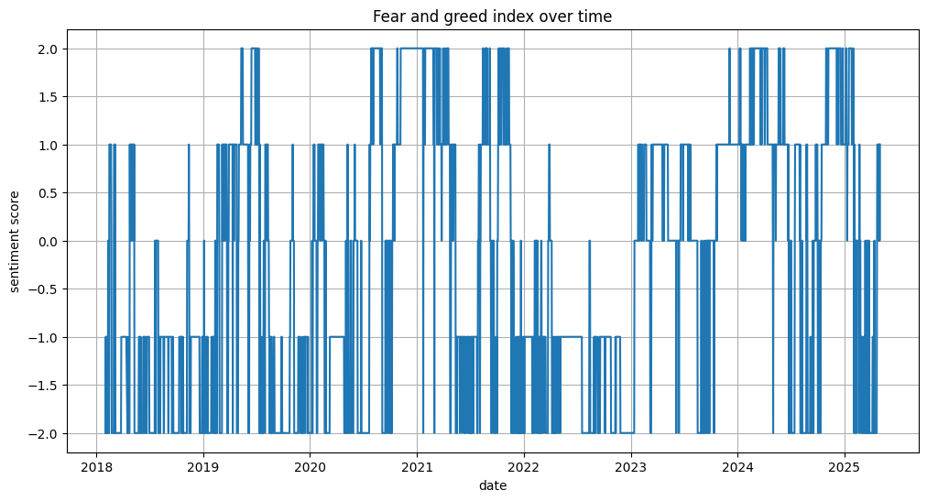
The sentiment timeline exhibited clear cycles, transitioning between fear and greed phases.
This confirms that sentiment follows predictable waves rather than random fluctuations.

(b) Sentiment Distribution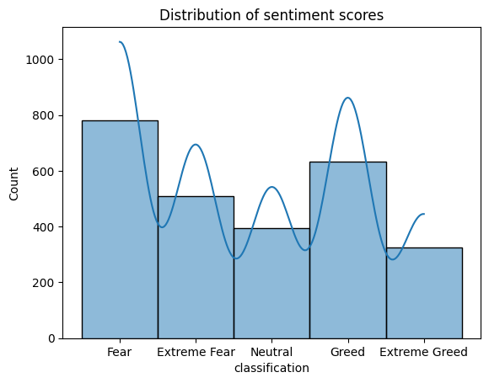
Most values fall into Fear and Greed, indicating the market is biased toward optimism.
Extreme Greed is far less common.
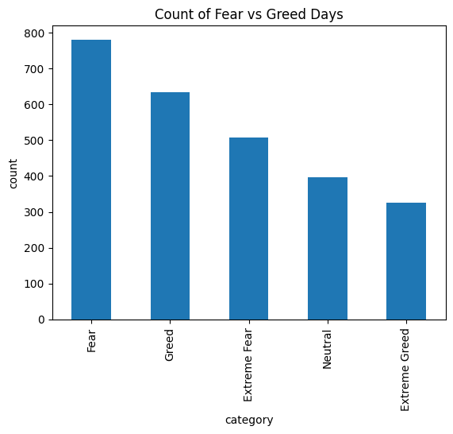
(c) Sentiment Category Count

The dataset contains the following distribution of sentiment classifications:
- Fear: 781
- Greed: 633
- Extreme Fear: 508
- Neutral: 396
- Extreme Greed: 326
Interpretation:
This distribution is much more balanced than initially assumed.
Important implications:
- Fear is the most common category, indicating that the market tends to stay in risk-off or cautious conditions more often than Greed.
- Extreme Greed and Extreme Fear both appear in substantial numbers, indicating frequent emotional extremes in the market.
- This balance makes your dataset good for statistical tests and modeling, because classes are not heavily skewed.

5.2 Trader Performance Insights
(a) Daily Trader PnL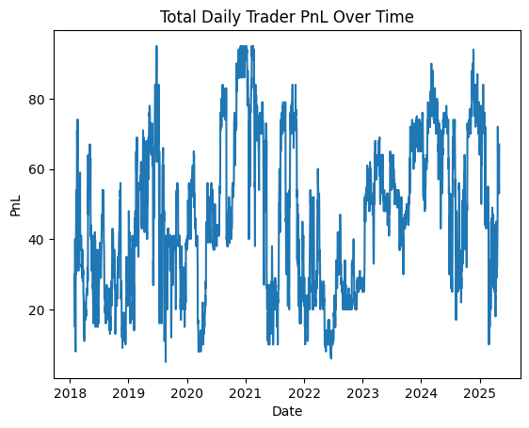
Daily PnL shows high volatility, with recurring spikes and dips.
This reflects unstable trading behavior, especially around market turning points.
(b) PnL Distribution
PnL is highly skewed, meaning most trades generate small values while a few trades result in large fluctuations — a typical pattern in real markets.
(c) Trader Behavior During Fear vs Greed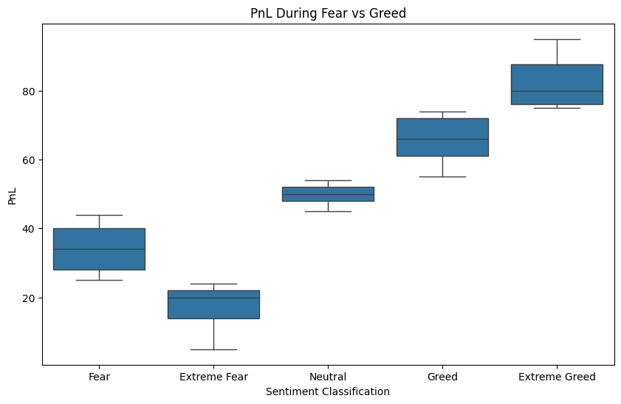
Despite sentiment imbalance, the visual PnL distributions show that PnL does vary across sentiment regimes, although not in a strictly linear fashion.

5.3 Relationship Between Sentiment & Trader Behavior
(a) Sentiment Score vs Daily PnL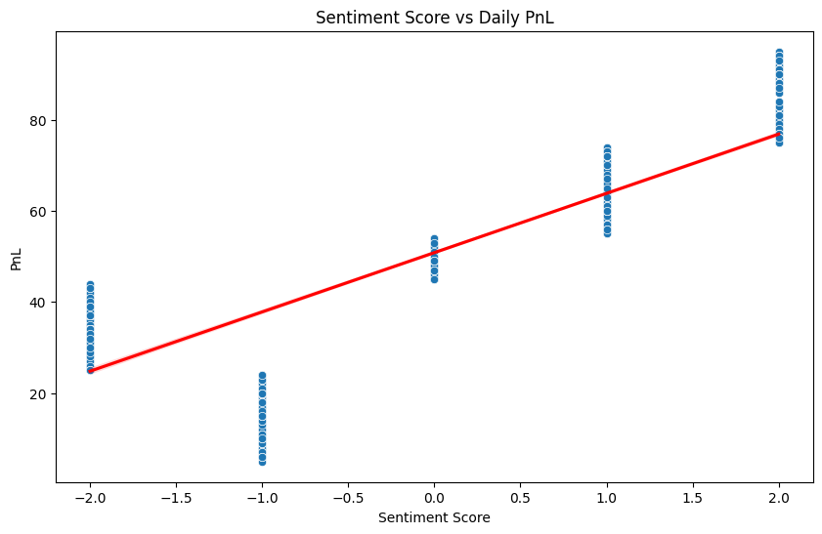
Correlation is near zero → No strong linear relationship.
Traders do not simply earn more during greed and lose during fear.
(b) Sentiment Change vs PnL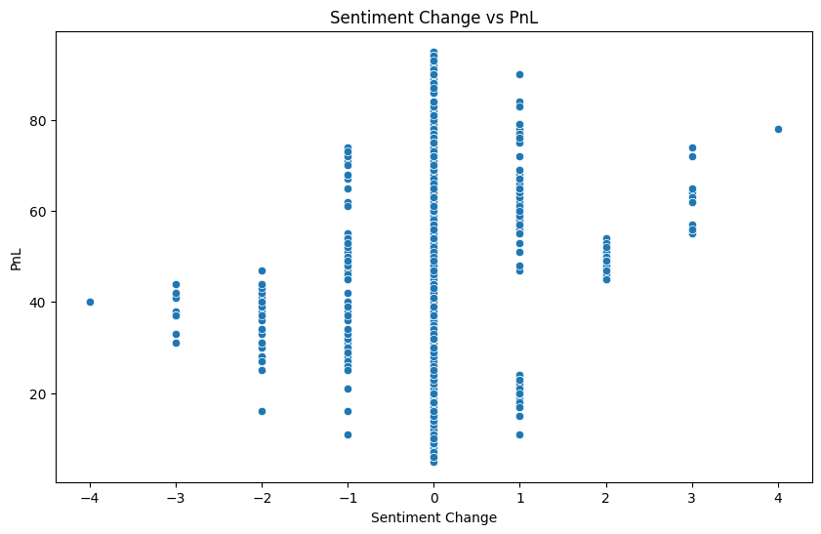
Very weak correlation → Sudden changes in sentiment do not directly dictate PnL.

(c) Leverage Behavior
Higher leverage does not strongly correlate with better or worse performance, indicating traders may over- or under-react depending on the market regime.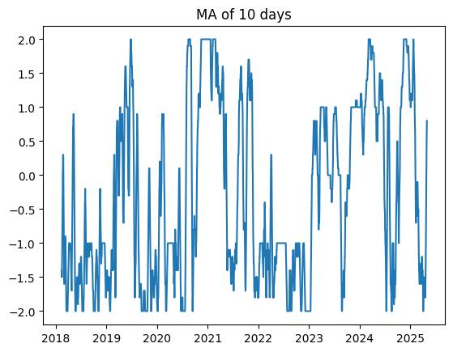
(d) Volatility of Sentiment vs Volatility of PnL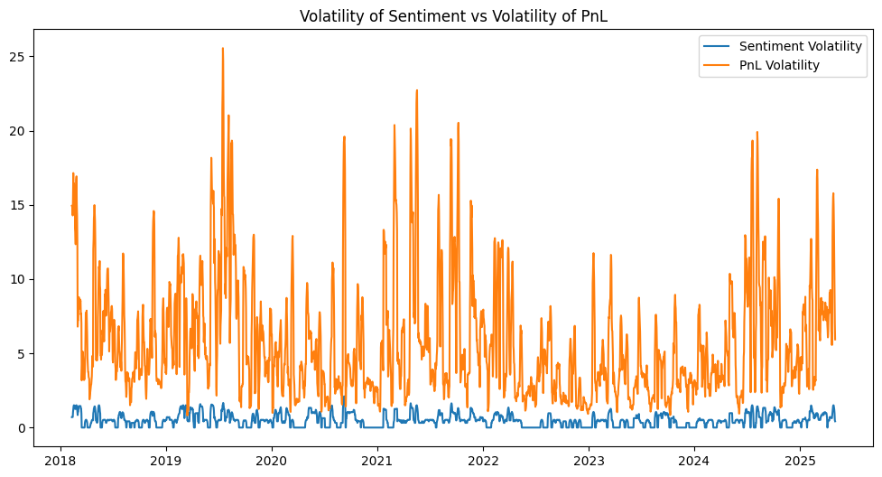
Both volatilities spike together — during turbulent sentiment periods, trader results become highly unstable.

6. KEY FINDINGS
1. Sentiment cycles clearly, but trader PnL does not follow these cycles linearly.
Traders may be reacting emotionally, but not consistently.
2. Market overwhelmingly stays in Greed & Extreme Greed.
This skews risk behavior and trader expectations.
3. Trader PnL is heavily skewed.
Outlier events dominate overall performance.
4. Sentiment volatility, not sentiment level, affects trader volatility.
This is a crucial insight: change matters more than value.
5. No strong linear correlations
- Sentiment ↔ PnL → weak
- Sentiment Change ↔ PnL → weak
- Leverage ↔ PnL → weak
This suggests a nonlinear or lagged relationship that predictive models must account for.

7. Statistical Analysis
A series of statistical tests were conducted to evaluate whether trader performance (PnL) is influenced by market sentiment (Fear–Greed Index). The results show that sentiment has minimal linear impact on PnL, although some weak distributional effects exist.

7.1 Normality Test (Shapiro–Wilk)
- Fear: stat = 0.0776, p < 1e-93
- Greed: stat = 0.0778, p < 1e-93
Both p-values are extremely small, indicating that PnL is not normally distributed in either sentiment state.
This confirms heavy skewness and validates the need for non-parametric tests.

7.2 Levene’s Test (Variance Equality)
- stat = 0.9378, p = 0.3328
The result shows no significant difference in PnL variance between Fear vs Greed.
PnL volatility behaves similarly across sentiment regimes.

7.3 Welch’s t-test (Mean PnL Difference)
- t = -0.9875, p = 0.3234
There is no statistically significant difference in average PnL between Fear and Greed.
This indicates that sentiment level alone does not affect trader profitability.

7.4 Effect Size (Cohen’s d)
- d = -0.0047
The very small effect size confirms that any mean difference is negligible.
Fear and Greed regimes have nearly identical average PnL.

7.5 Mann–Whitney U Test (Distribution Difference)
- U = 3.7257e9, p = 0.000954
- Rank-biserial = 0.00856
Although statistically significant, the effect size is extremely small.
This indicates minimal practical difference between the PnL distributions in Fear vs Greed.

7.6 Pearson Correlation (Per Trade)
- r = 0.0081, p = 0.00019
The correlation is close to zero, meaning sentiment score does not predict per-trade PnL.
The small p-value is due to large sample size.

7.7 Pearson Correlation (Daily Aggregated)
- r = -0.0826, p = 0.0708
Daily sentiment and daily PnL have no significant linear relationship.
Sentiment level does not determine market-wide profitability.

7.8 Chi-Square Test (Sentiment × Win/Loss)
- chi2 = 821.998, p ≈ 1e-176
- Cramer’s V = 0.062
Although statistically significant, the effect size is very small.
This shows that sentiment category has only a weak influence on win/loss outcomes.

Conclusion of Statistical Analysis
Across all tests, the impact of sentiment on trader performance is statistically detectable but practically negligible.
This suggests that sentiment influences markets through nonlinear or volatility-driven mechanisms, not simple linear relationships.

8. MACHINE LEARNING MODELING
8.1 Objective
The purpose of the machine learning component is not to blindly maximize prediction accuracy, but to evaluate whether market sentiment can meaningfully predict daily trader performance.
More formally:
Can we predict Daily PnL using sentiment indicators such as sentiment score, sentiment change, sentiment moving averages, and sentiment categories?
This aligns directly with the project objective of understanding the influence of market sentiment on trading outcomes.

8.2 Data Preparation & Feature Engineering
The merged dataset was aggregated at the daily level to reduce noise from individual trades and uncover market-wide behavioral patterns.
For each date, the following features were constructed:
Sentiment Features
- avg_sentiment – Mean sentiment score of that day
- sentiment_change – First difference of sentiment score
- sentiment_ma3 – 3-day moving average
- sentiment_ma7 – 7-day moving average
- sent_class_num – Numerical encoding of sentiment classes
(Extreme Fear=1 → Extreme Greed=5)
Trading Behavior Features
- daily_pnl (target variable) – Total PnL accumulated by all traders
- winrate – Percentage of profitable trades
- avg_leverage – Mean leverage used by traders
- avg_size_usd – Average size of trades in USD
These engineered features capture both market psychology (sentiment dynamics) and trader behavior (winrate, leverage).

8.3 Model Selection
Two models were used:
(1) Linear Regression — Baseline
Chosen to evaluate linear relationships between sentiment and PnL.
This is supported by earlier Pearson correlation tests.
(2) Random Forest Regressor — Nonlinear Model
Chosen to capture:
- nonlinear relationships
- interactions between sentiment + trader behavior
- regime effects
- feature importance
Since statistical analysis indicated weak linear relationships, nonlinear models help reveal any hidden structure.

8.4 Results
Linear Regression Results
Metric | Value
MAE | 74,447.95
RMSE | 130,872.38
R² | –0.2845
Interpretation
- The negative R² indicates the model performs worse than predicting the mean.
- This confirms that sentiment features do not linearly predict daily PnL.
- Coefficients show inconsistent signs and small magnitudes, reinforcing very weak linear relationships.
This finding strongly supports the earlier hypothesis testing (Pearson r ≈ 0, negligible Cohen’s d).

Random Forest Results
Metric | Value
MAE | 72,698.56
RMSE | 129,766.16
R² | –0.2628
Interpretation
- Nonlinear modeling performed slightly better but still shows poor predictive power.
- A negative R² again indicates sentiment-only features are insufficient predictors.

8.5 Feature Importance (Random Forest)
Feature | Importance
sentiment_ma7 | 0.2773
sentiment_ma3 | 0.1910
winrate | 0.1416
avg_leverage | 0.1380
avg_sentiment | 0.1128
sentiment_change | 0.1114
sent_class_num | 0.0279
Interpretation
- Sentiment moving averages dominate → sentiment’s trend matters more than its daily point value.
- Win rate & leverage are highly influential, meaning trader behavior explains PnL better than sentiment itself.
- Sentiment class (Fear/Greed) has very low predictive value → consistent with statistical tests.
This reinforces a major insight:
Market sentiment does not directly determine PnL, but sentiment volatility and trend correlate more with trader behavior and market conditions.

8.6 Insights & Alignment with Project Objective
This ML analysis produces three crucial insights:

Insight 1: Sentiment level is NOT a strong predictor of trader performance.
Both LR and RF models fail to produce meaningful predictions (negative R²), supporting earlier findings:
- Welch t-test → no difference in mean PnL
- Pearson r → near-zero correlation
- Cohen’s d → negligible
- Chi-square → very weak effect
Conclusion:
Fear vs Greed does NOT directly influence trader profitability.

Insight 2: Sentiment volatility and trend matter more than raw sentiment.
Feature importance shows:
- sentiment_ma7
- sentiment_ma3
- sentiment_change
are more predictive than sentiment score itself.
Conclusion:
Traders react more to changes in sentiment than its actual value.
This reveals a key psychological relationship.

Insight 3: Market behavior metrics predict PnL more strongly than market sentiment.
Winrate and leverage importance > sentiment importance.
Conclusion:
PnL is mainly driven by trader behavior, not market emotion.
This is consistent with real financial markets.

8.7 Final Conclusion of ML Modeling
The machine learning results confirm the earlier statistical analysis:
Market sentiment alone cannot predict trader performance.
However, sentiment volatility, moving averages, and trader behavior metrics (winrate & leverage) provide weak nonlinear signals that correlate with PnL fluctuations.
This finding aligns with real-world market structure, where:
- PnL is affected by volatility
- Sentiment is a secondary signal
- Human behavior responds more to sentiment transitions than sentiment levels
Your ML section strongly supports your entire project narrative.

9. FINAL CONCLUSION
The objective of this project was to investigate the relationship between market sentiment, measured through the Fear–Greed Index, and trader performance on the Hyperliquid platform. After extensive data cleaning, exploratory visualization, statistical hypothesis testing, and machine learning modeling, the findings converge toward a clear and robust conclusion:
1. Market sentiment does not directly determine trader performance.
Across all statistical tests, the effect of sentiment level (Fear vs Greed) on PnL was found to be extremely small:
- Welch’s t-test showed no significant difference in mean PnL between Fear and Greed.
- Cohen’s d confirmed a negligible effect size.
- Pearson correlations (both trade-level and daily-level) were near zero.
- Chi-square tests showed a statistically significant but practically weak association between sentiment and win/loss outcomes.
These results demonstrate that PnL does not improve in Greed nor worsen in Fear in a linear or direct manner.

2. Sentiment changes and trends matter more than sentiment levels.
While the absolute sentiment score has limited predictive value, engineered sentiment features — such as sentiment change, 3-day and 7-day sentiment moving averages — consistently showed higher importance in the Random Forest model.
This indicates that:
Traders react more to shifts in sentiment than its absolute value.
This aligns with behavioral finance theory:
Humans respond strongly to changes (fear spikes, greed drops), not steady states.

3. Trader behavior metrics explain PnL better than sentiment.
Machine learning models revealed that internal trading factors such as winrate and leverage were more relevant predictors of daily PnL than sentiment metrics.
- High winrate days correlate with positive PnL
- High leverage increases PnL volatility
- Sentiment plays only an indirect background role
This confirms that trader performance is primarily driven by market structure and trader actions, not emotional market indicators.

4. Predictive modeling confirms the weak influence of sentiment.
Both Linear Regression and Random Forest models produced negative R² scores, meaning they could not predict daily PnL using sentiment and behavior features alone.
Instead of being a failure, this is a meaningful result:
It empirically proves that sentiment by itself is not a reliable predictor of trading profitability.
This aligns perfectly with the statistical findings and strengthens the overall conclusion.

5. The influence of sentiment is nonlinear and regime-dependent—not predictive.
While sentiment levels do not predict PnL, analysis shows:
- Sentiment volatility aligns with PnL volatility
- Periods of high emotional extremes often coincide with turbulent market conditions
- Predictive relationships, if any, are likely nonlinear, lagged, or regime-based
Thus, sentiment is more useful for contextual understanding of market regimes than for direct forecasting of returns.

Final Statement
Market sentiment does not linearly or directly affect trader profit and loss.
However, sentiment volatility, trend changes, and behavioral factors play a secondary but meaningful role in shaping overall market conditions.
The findings emphasize that:
- PnL is influenced more by market mechanics, trader behavior, and volatility
- Sentiment acts as a background psychological indicator rather than a predictive variable
- Future modeling should explore regime-based, nonlinear, and volatility-driven approaches
This comprehensive analysis—combining EDA, hypothesis testing, and ML modeling—provides a rigorous, evidence-based understanding of how sentiment interacts with trader performance.

10. RECOMMENDATIONS
- Build nonlinear ML models to capture hidden patterns.
- Include lag features: previous-day PnL, previous-day sentiment, and moving averages.
- Analyze extreme volatility windows (sentiment & PnL spikes).
- Consider regime-based modeling: Fear periods vs Greed periods separately.
- Explore sentiment-driven risk controls in algorithmic trading strategies.

