Vivekanand Education Society's Institute of Technology
Department of Computer Engineering
Academic Year 2026-27

DBMS Micro Project Report
Digital Banking System Database
A Supabase PostgreSQL implementation with a role-aware web frontend

Course: Database Management System (DBMS)

Index
No. | Section
1 | Introduction and Background
2 | Problem Statement
3 | Objectives and Scope
4 | Requirements and Data Requirements
5 | ER Diagram
6 | Flow Diagram and System Architecture
7 | Implementation and Database Operations
8 | Results and Working System Screenshots
9 | Conclusion and Future Scope
This report is prepared according to the prescribed DBMS micro-project format. The implementation uses Supabase as the hosted PostgreSQL database and authentication platform.

1. Introduction and Background
Digital banking allows customers to access account information and perform financial operations through electronic channels. A banking database must maintain accurate account balances, transaction history, customer identity, branch information, and permissions. It must also preserve data integrity when multiple operations occur close together.
This project models a small digital banking system using Supabase. Supabase provides PostgreSQL tables, authentication, database functions, and Row Level Security. The system is designed to demonstrate how a real database supports online banking workflows rather than treating the interface as a collection of static screens.
The application separates the presentation layer from the data layer. The browser requests only the records that the signed-in user is allowed to see. A stored procedure performs transfers atomically so the debit, credit, and transaction record are treated as one logical operation.

2. Problem Statement
Small academic banking demonstrations often store customer and transaction details in unrelated files or in frontend variables. Such an approach makes it difficult to enforce relationships, prevent invalid balances, show transaction history, or explain how different users should access information.
The problem addressed by this project is the design of a normalized relational database that supports common digital banking tasks while protecting customer data. The solution must represent customers, branches, accounts, beneficiaries, and transactions; it must provide controlled access for customer, staff, and admin roles; and it must expose database operations through an understandable user interface.

3. Objectives and Scope

3.1 Objectives
• Design a relational schema for core digital banking entities.
• Apply primary keys, foreign keys, unique constraints, checks, indexes, and views.
• Implement authentication-aware access using Supabase Row Level Security.
• Provide an atomic money-transfer function using PostgreSQL transactions.
• Build a basic frontend for dashboard viewing, balance lookup, transfers, and activity history.
• Demonstrate SQL selection, joins, aggregation, updates, and stored procedure calls.

3.2 Scope
The project covers customer accounts, savings and current account types, branch association, beneficiaries, deposits, withdrawals, transfers, account status, and role-based visibility. It is an educational prototype and does not implement production banking integrations such as payment gateways, regulatory reporting, KYC document storage, OTP delivery, interest calculation, or a complete fraud-monitoring system.

4. Requirements and Data Requirements

4.1 Functional Requirements
Requirement | Description
Authentication | Users sign in through Supabase Auth.
Dashboard | Customers view their own accounts and balances.
Transfer | A signed-in customer can transfer to an active destination account.
History | Users view related completed and failed transactions.
Beneficiaries | Customers can maintain their own saved beneficiaries.
Staff review | Staff can review customer accounts and update account status.
Administration | Admins can manage operational records.

4.2 Non-Functional Requirements
The system should preserve confidentiality through RLS, consistency through constraints and foreign keys, availability through hosted database access, usability through a simple responsive UI, and maintainability through separated SQL scripts. Query performance is supported by indexes on account ownership and transaction timelines.

4.3 Data Requirements
Entity | Important attributes
Branches | branch code, name, address, city
Profiles | auth user ID, name, email, role, branch
Accounts | account number, owner, type, balance, status
Beneficiaries | owner, nickname, account number, bank, IFSC
Transactions | source, destination, amount, type, status, initiator, time

5. ER Diagram
The ER model uses profiles as the authenticated customer or employee identity. One profile can own many accounts and beneficiaries. Each account belongs to one branch. Transactions may reference a source account, a destination account, or both for transfers. Foreign keys enforce valid relationships.
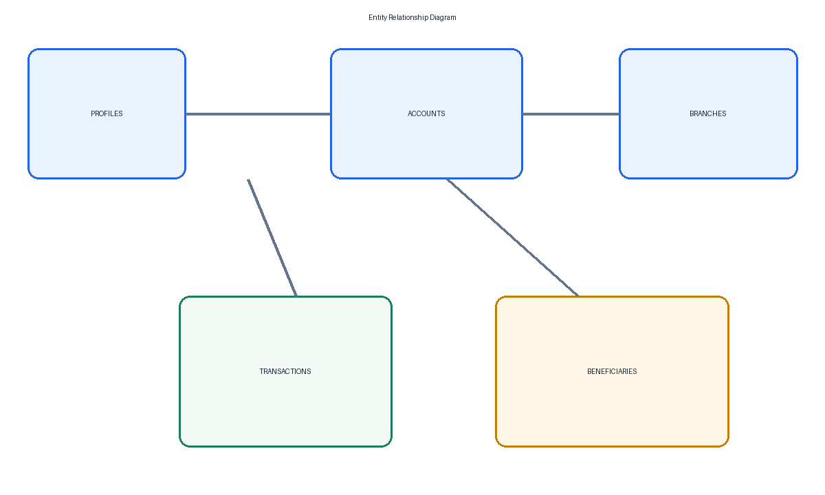
Figure 1: Entity relationship diagram for the Digital Banking System.
Relationship | Cardinality
Branch to Account | One branch can have many accounts.
Profile to Account | One profile can own many accounts.
Profile to Beneficiary | One customer can save many beneficiaries.
Account to Transaction | An account can appear as a source or destination in many transactions.

6. Flow Diagram and System Architecture
The frontend uses the publishable Supabase key. Authentication establishes the signed-in user. RLS policies then limit table access, while the transfer function validates ownership, balance, status, and destination account before updating records.
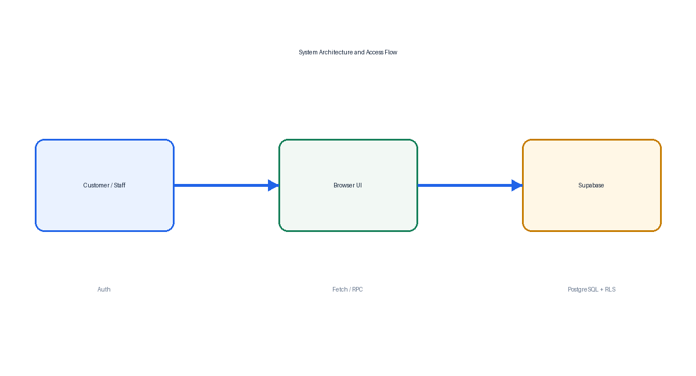
Figure 2: High-level architecture and access flow.

6.1 Access Control Flow
Customer requests are filtered by auth.uid(). Staff and admin access is determined by the role stored in profiles. The role helper function is security definer and uses a restricted search path. The browser never receives the service-role key; all frontend access is intended to occur through the publishable key and database policies.

7. Implementation and Database Operations

7.1 Schema Implementation
The database defines enum types for user roles, account types, account statuses, transaction types, and transaction statuses. Account states include active, frozen, and closed. These states are represented in seeded customer records so the interface can demonstrate how account access changes with status. Accounts use a non-negative balance check. Transactions require a positive amount and at least one related account.

7.2 Database Operations Demonstrated
Operation | Example used in project | DBMS concept
SELECT | Account summary and transaction history | Filtering and ordering
JOIN | Branch-wise balances | Relational association
GROUP BY | Daily transfer totals | Aggregation
INSERT | New beneficiary or transaction | Data creation
UPDATE | Profile phone or account status | Data modification
RPC function | Atomic transfer | Stored procedure and consistency
RLS policy | Own rows versus staff rows | Authorization

7.3 Atomic Transfer
The transfer_money function validates a positive amount and distinct accounts. It locks the source and destination rows in a consistent order, deducts the amount only from an active account owned by the signed-in user and with sufficient balance, credits an active destination, and inserts a completed transaction record. PostgreSQL executes the RPC statement within a transaction. If the client disconnects, the statement is cancelled, or a database error occurs before commit, the database rolls back every change from that statement.

7.3.1 Recovery Demonstration
The project includes a separate demo_interrupted_transfer function that performs a debit and inserts a pending transaction row, then deliberately raises an exception before a credit is made. The browser records the source balance and matching ledger-row count before calling the function. After the error, it reads both values again. The expected result is an unchanged balance and no additional pending row, demonstrating statement-level rollback and database consistency.

7.4 Security and Permissions
Role | Workspace and authority
Customer | Personal balances, account states, saved beneficiaries, transaction history, and transfers from active accounts.
Staff | Masked account review; may freeze an active account or reactivate a frozen account. Cannot change balances, assign roles, or close accounts.
Admin | System metrics, all account-state controls, account provisioning for existing customers, and role assignment for other users.
Row Level Security is enabled on the core tables. Direct account and ledger writes are revoked from browser roles; controlled security-definer functions perform transfers and management actions after checking the caller’s role. Profile updates are limited to contact fields, so a user cannot promote themselves by changing their role. The account summary view returns masked account numbers and does not include customer names or email addresses.

7.5 Frontend Implementation
The frontend provides a customer banking workspace, an operations workspace for staff, and a system control center for administrators. Staff controls are limited to freeze and reactivate actions. Administrators can manage account states, assign another user’s role, provision accounts, and view system-wide counts. Staff and administrator account lists use masked account numbers instead of customer names. The customer workspace includes a dedicated interrupted-transfer demonstration with before-and-after balance and ledger checks.

7.6 SQL Command Samples
The following commands are included in the project so the database can be demonstrated directly in the Supabase SQL Editor.
Command category | Demonstration
DDL | CREATE TABLE, CREATE TYPE, CREATE INDEX, CREATE VIEW
DML | INSERT branch, UPDATE profile, and stored transaction insert
DQL | SELECT account summary, JOIN branches, GROUP BY transfer totals
Security | ALTER TABLE ENABLE ROW LEVEL SECURITY and CREATE POLICY
Procedural | SELECT transfer_money(...) for an atomic transfer
A useful demonstration sequence is to run the account summary query as a customer, run the same query with a different user, and then run the branch-wise aggregation as staff. The result difference shows that database permissions are part of the system behavior.

7.7 Data Dictionary
Table | Key fields | Purpose
branches | branch_id, branch_code | Stores physical branch information.
profiles | user_id, role, branch_id | Connects Auth identity to banking profile and role.
accounts | account_id, account_number, balance | Stores customer accounts and current balance.
beneficiaries | beneficiary_id, user_id | Stores saved transfer destinations.
transactions | transaction_id, amount, status | Stores financial activity and audit history.

8. Results and Working System Screenshots
The frontend includes role-specific workspaces and seeded data for twelve customers. The sample accounts include active, frozen, and closed states, while beneficiaries and transaction history provide realistic records for the demonstration. Capture the following evidence after the Supabase project is configured:
• Supabase tables showing branches, profiles, accounts, beneficiaries, and transactions.
• SQL Editor showing schema, policies, sample data, and demonstration queries.
• Auth users and the twelve linked customer profiles.
• RLS policies and role-specific workspace access.
• Customer dashboard with active, frozen, or closed account status.
• Recovery demo error with unchanged before-and-after balance and ledger count.
• Staff account review showing masked numbers and limited status controls.
• Admin console showing system metrics, role assignment, account lifecycle controls, and account provisioning.
• Successful transfer with updated balances and a ledger record.

8.1 Expected Results
Test case | Expected result
Customer reads accounts | Only accounts owned by signed-in customer are returned.
Customer reads another profile | Request is rejected or returns no row.
Valid transfer | Source decreases, destination increases, transaction is inserted.
Interrupted transfer demo | The intentional error rolls back the debit and pending transaction row.
Insufficient balance | Function raises an error and balances remain unchanged.
Staff status action | Staff can freeze or reactivate; closing an account is rejected.
Admin control | Admin can assign another user’s role, manage all states, and provision an account.
Masked staff/admin view | Account summary displays only the final four account-number digits.
Invalid amount | Database check/function rejects zero or negative amount.

8.2 Test Plan and Demonstration Evidence
Testing combines database-level checks with interface-level checks. Each test should be run after the Supabase project has been configured with Auth users and sample accounts.
Test ID | Action | Expected evidence
T01 | Sign in as customer | Personal dashboard and role badge appear.
T02 | Load accounts | Only own accounts appear with their current state.
T03 | Run interrupted transfer | An error is shown; source balance and pending-row count are unchanged.
T04 | Complete a valid transfer | Balances and recent activity update.
T05 | Attempt an over-balance transfer | The function raises an error; no partial update occurs.
T06 | Sign in as staff | Masked review table and limited status actions appear.
T07 | Sign in as admin | Metrics, role assignment, account status, and account provisioning controls appear.
T08 | Inspect RLS | Unauthorized rows and direct writes are denied.
For the final viva, the demonstrator should show the UI action and then immediately show the corresponding database row or balance change in the SQL Editor. This connects the visible frontend behavior to the underlying DBMS operations.

8.3 Limitations of the Prototype
The academic prototype uses a simple browser client and a single database function for transfers. It does not claim to be a production banking application. Real deployment would require additional security review, secrets management, audit retention, rate limiting, monitoring, compliance controls, and integration testing.

Appendix A: Project Demonstration Procedure
• Run the idempotent schema and policy scripts, followed by the branch seed.
• Create twelve customer Auth users plus staff and admin users; link their Auth UUIDs to profiles.
• Run demo_customers.sql to add twelve accounts, beneficiaries, and sample transactions.
• Set the project URL and publishable key in frontend/app.js.
• Sign in as a customer and compare balances before and after the interrupted-transfer demonstration.
• Perform a valid transfer and verify both balances and the ledger record.
• Sign in as staff to demonstrate masked accounts and limited account-status duties.
• Sign in as admin to demonstrate system metrics, role assignment, account lifecycle control, and provisioning.

Appendix B: Submission Checklist
Item | Status
Supabase schema script | Included
Seed and setup guidance | Included
RLS policies | Included
Demonstration queries | Included
Frontend scaffold | Included
ER diagram | Included in report
System architecture diagram | Included in report
Live screenshots | To capture after Supabase setup
Final report formatting | Applied to DOCX draft

9. Conclusion and Future Scope
The Digital Banking System Database demonstrates how a relational database supports a realistic banking workflow. The design combines normalized entities, constraints, indexes, a summary view, a stored procedure, authentication, and Row Level Security. The frontend makes the database operations visible through a dashboard and transfer workflow.
The project also demonstrates an important DBMS principle: correctness and access control belong in the database layer as well as the application layer. A customer should not be able to see another customer’s balance merely because a frontend request was modified. The policies and ownership conditions provide that protection at the data source.

9.1 Future Scope
• Add OTP or multi-factor authentication for sensitive actions.
• Add beneficiary verification and transfer limits.
• Introduce an audit log for staff and admin actions.
• Add scheduled payments, bill payments, and notifications.
• Add fraud rules and unusual-activity alerts.
• Deploy the frontend through a secure hosting platform and connect it to a production Supabase project.

References
Supabase Documentation, PostgreSQL Documentation, and the supplied DBMS Micro Project Report format.

