Customer Shopping Behavior Analysis
1. Introduction
This project focuses on studying customer shopping behavior using transactional data collected from nearly 3,900 purchases across multiple product categories. The main objective is to understand how customers spend, what products they prefer, how subscriptions and discounts affect purchasing, and how customers can be segmented for better business decision-making. The insights derived from this analysis can help organizations improve marketing strategies, customer retention, and overall revenue.
2. Dataset Description
The dataset consists of detailed customer and transaction-level information.
- Total Records: 3,900 transactions
- Total Attributes: 18 columns
Key Variables:
- Customer Information: Age, Gender, Location, Subscription Status
- Purchase Information: Item Purchased, Product Category, Purchase Amount, Season, Size, and Color
- Behavioral Data: Discount Applied, Promo Code Usage, Number of Previous Purchases, Purchase Frequency, Review Rating, and Shipping Type
Data Quality:
- The dataset contained missing values only in the Review Rating column (37 entries), which were handled during data preprocessing.
3. Data Preprocessing and Exploratory Analysis (Python)
The initial phase of analysis was performed using Python to clean and prepare the data.
Steps Followed:
- Data Import: The dataset was loaded using the pandas library.
- Basic Exploration: Dataset structure and summary statistics were examined using functions like info() and describe().
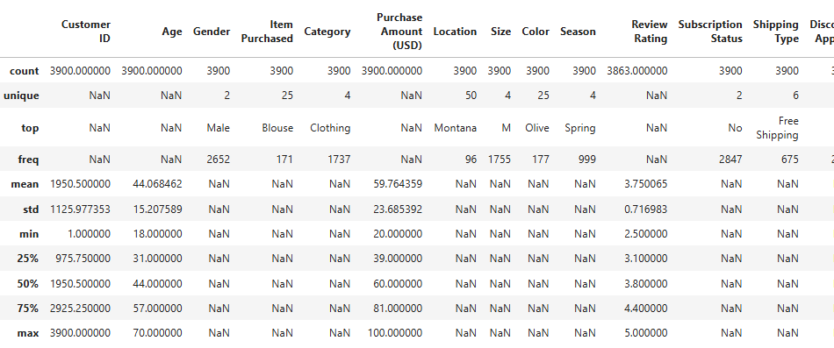
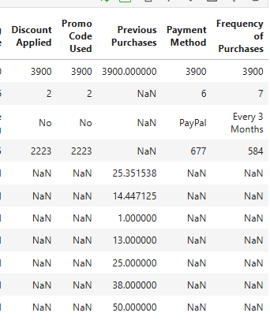
- Handling Missing Values: Missing review ratings were filled using the median rating calculated within each product category to maintain consistency.
- Column Renaming: All column names were converted to snake_case to improve readability and maintain coding standards.
- Feature Creation:
  - An age_group column was created by categorizing customers into age ranges.
  - A purchase_frequency_days feature was derived to better analyze buying patterns.
- Data Validation: Since discount_applied and promo_code_used conveyed similar information, the redundant column (promo_code_used) was removed.
- Database Storage: The cleaned dataset was exported to a PostgreSQL database for further SQL-based analysis.

4. Business Analysis Using SQL
Using PostgreSQL, several business-focused queries were executed to extract actionable insights:
- Revenue Distribution by Gender – Analyzed total revenue contribution from male and female customers.
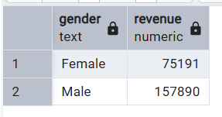
- High-Value Discount Customers – Identified customers who used discounts but still spent more than the average purchase value.
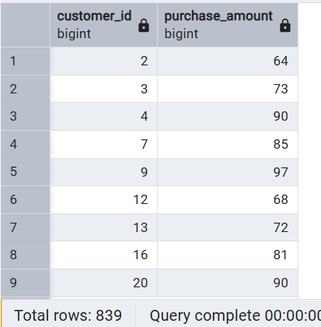
- Top-Rated Products – Retrieved products with the highest average customer ratings.
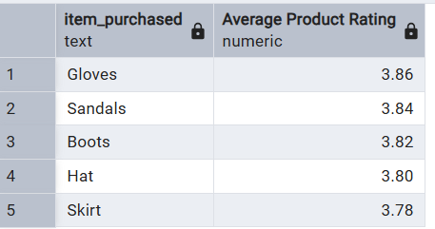
- Shipping Type Analysis – Compared average spending between standard and express shipping users.
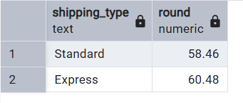
- Subscription Impact – Evaluated differences in average purchase amount and total revenue between subscribers and non-subscribers.
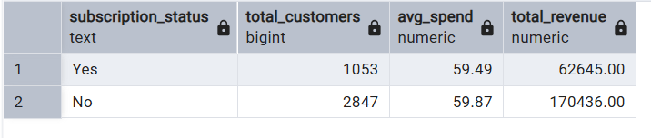
- Products Dependent on Discounts – Identified products with the highest proportion of discounted purchases.
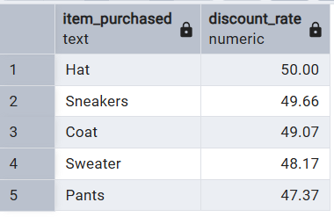
- Customer Segmentation – Categorized customers into New, Returning, and Loyal groups based on their purchase history.
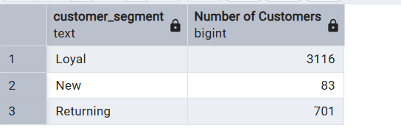
- Most Purchased Products per Category – Listed the top three best-selling items within each category.
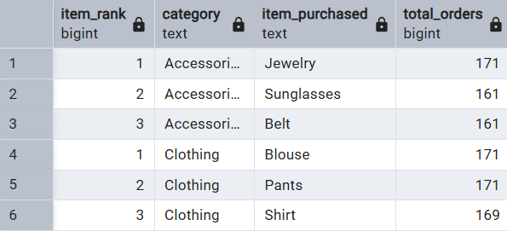
- Repeat Purchases vs. Subscription – Analyzed whether customers with more than five purchases are more likely to subscribe.
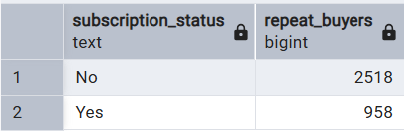
- Revenue by Age Group – Measured revenue contribution across different customer age segments.
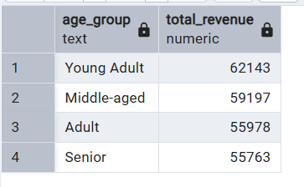

5. Visualization and Dashboard (Power BI)
To present the findings in a clear and interactive manner, a Power BI dashboard was created. The dashboard includes visuals such as revenue distribution, customer segments, top-performing products, and comparisons between subscribers and non-subscribers. These visuals help stakeholders quickly understand trends and patterns without technical complexity.
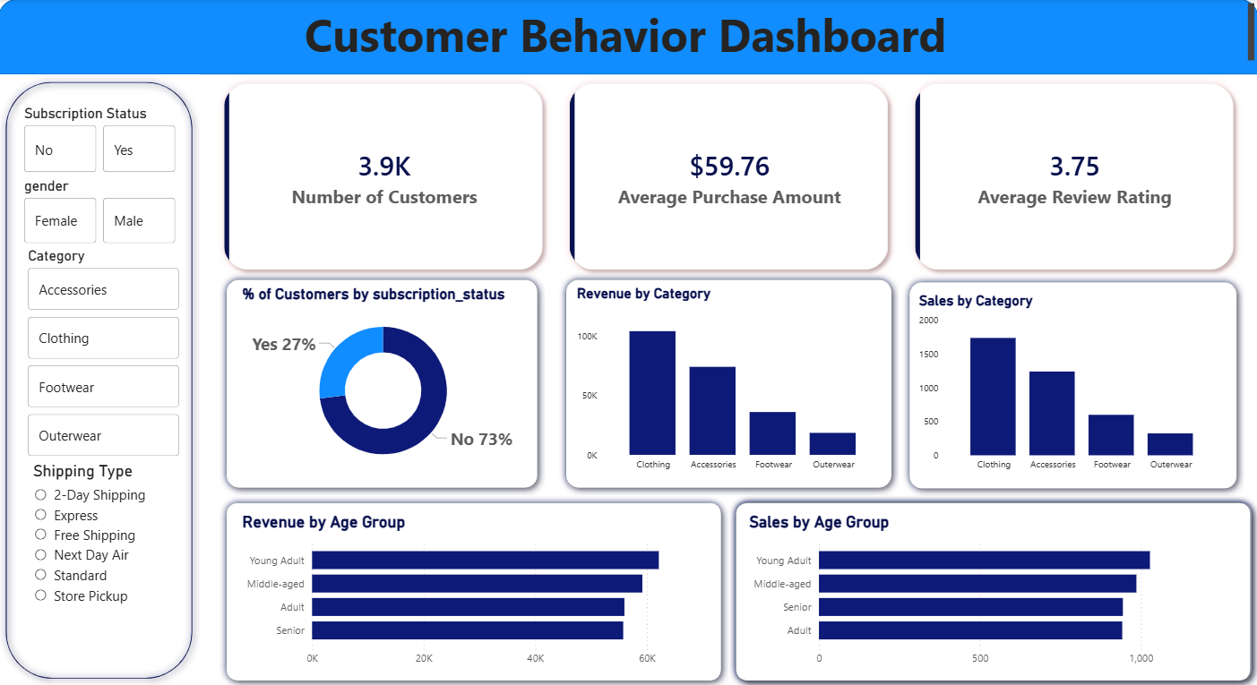
6. Key Business Insights and Recommendations
Based on the analysis, the following recommendations were made:
- Increase Subscription Adoption: Offer special benefits and exclusive deals to encourage more customers to subscribe.
- Strengthen Loyalty Programs: Reward repeat customers to convert them into long-term loyal buyers.
- Optimize Discount Strategies: Carefully manage discounts to increase sales while protecting profit margins.
- Promote High-Performing Products: Focus marketing efforts on top-rated and frequently purchased products.
- Targeted Marketing Campaigns: Direct campaigns toward high-revenue age groups and customers who prefer express shipping.

7. Conclusion
This project demonstrates how combining Python, SQL, and Power BI can deliver meaningful insights into customer shopping behavior. The analysis not only highlights current purchasing trends but also provides data-driven recommendations that can support better business planning and customer engagement strategies.

